Group 3
Members: James Buzzell, Noor Al salihi, Abram Denzlinger
10.1 - ERD, Python output, and SQL

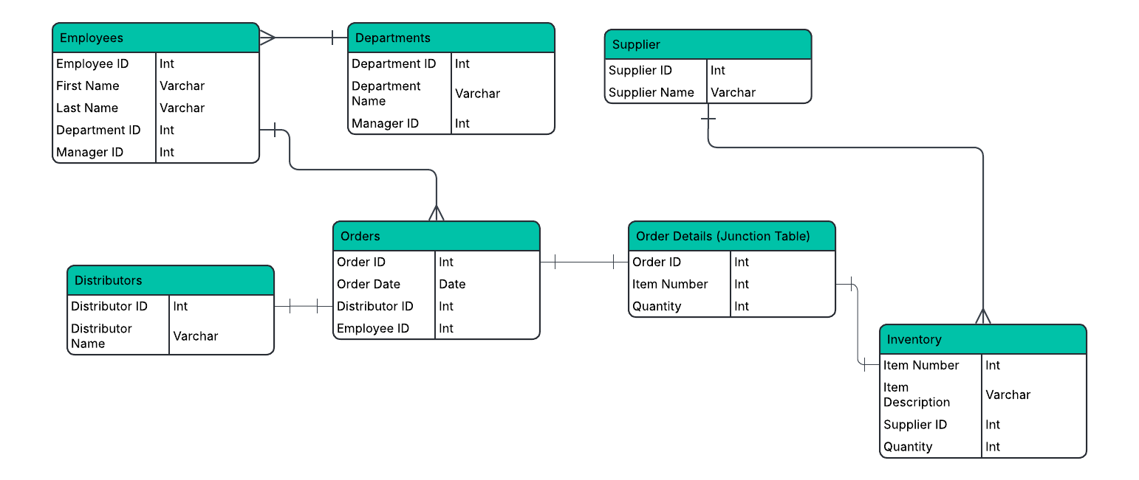

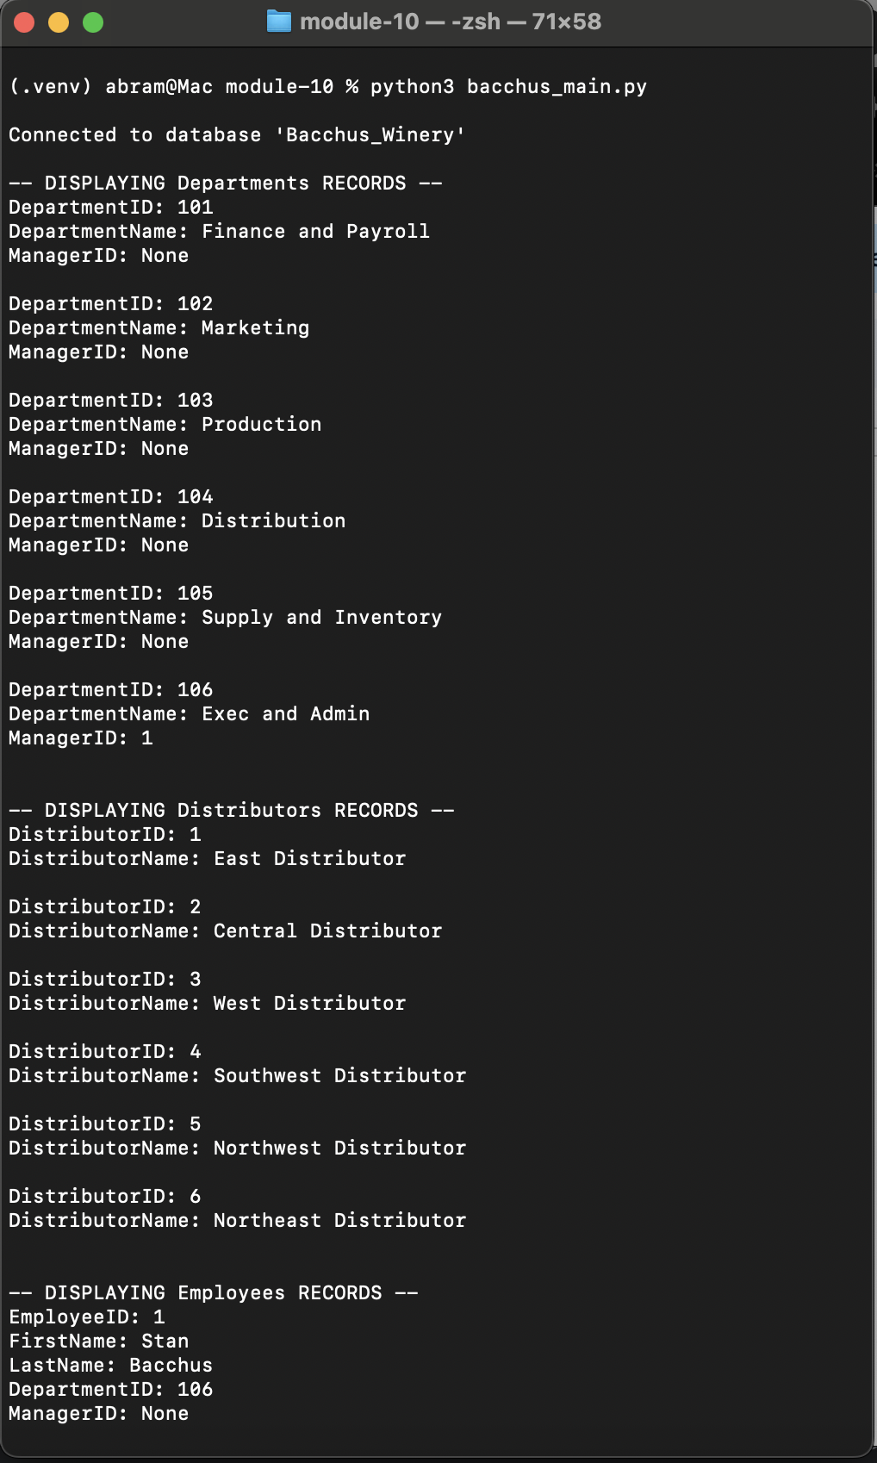

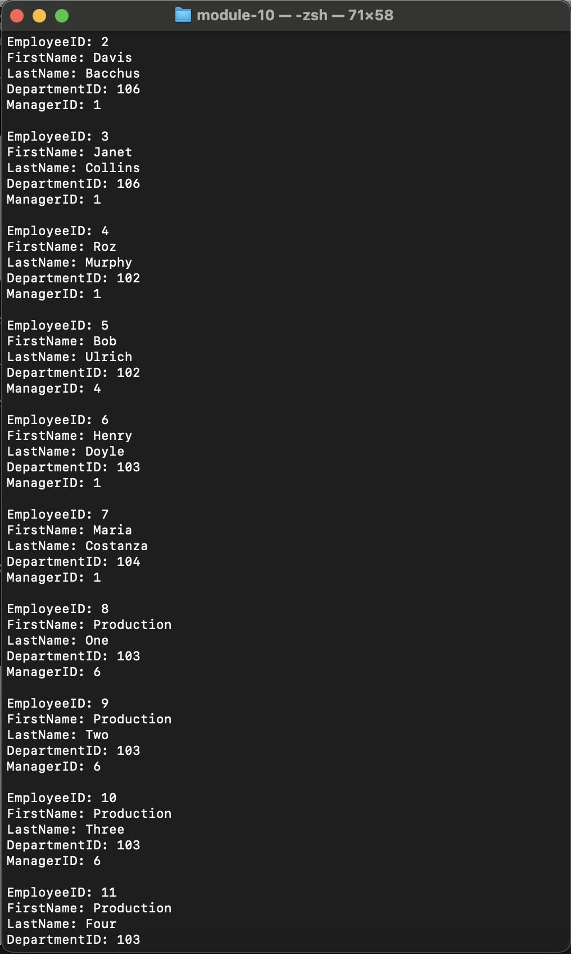

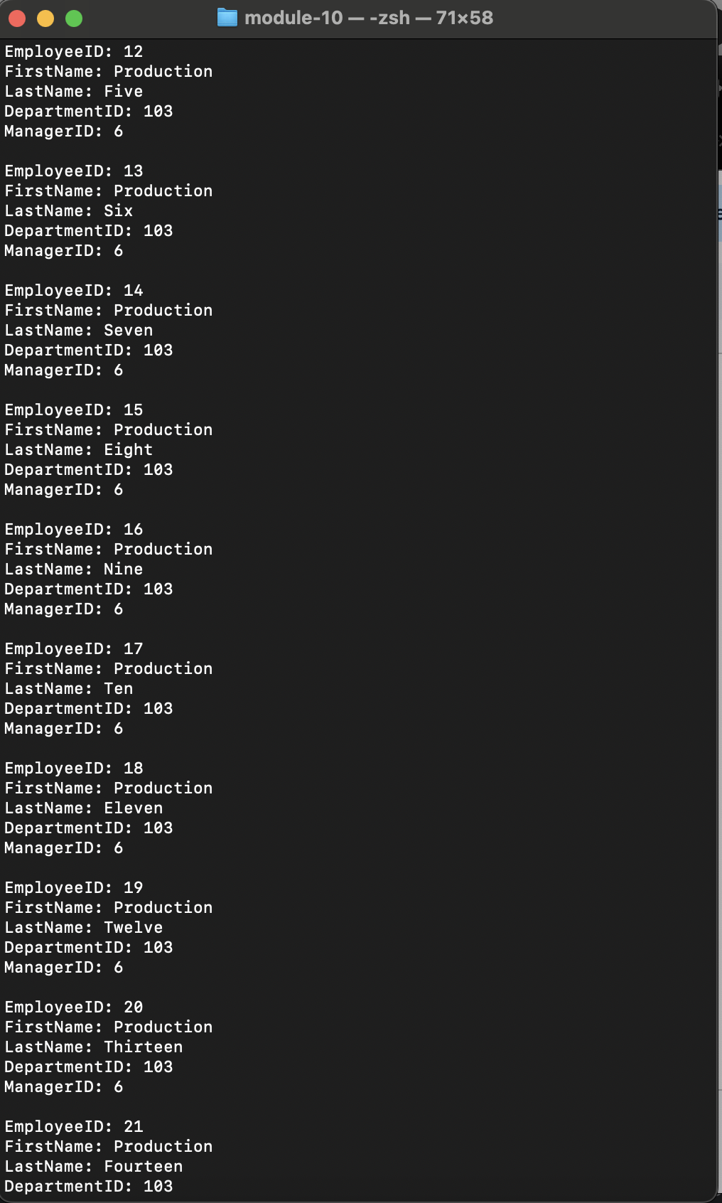

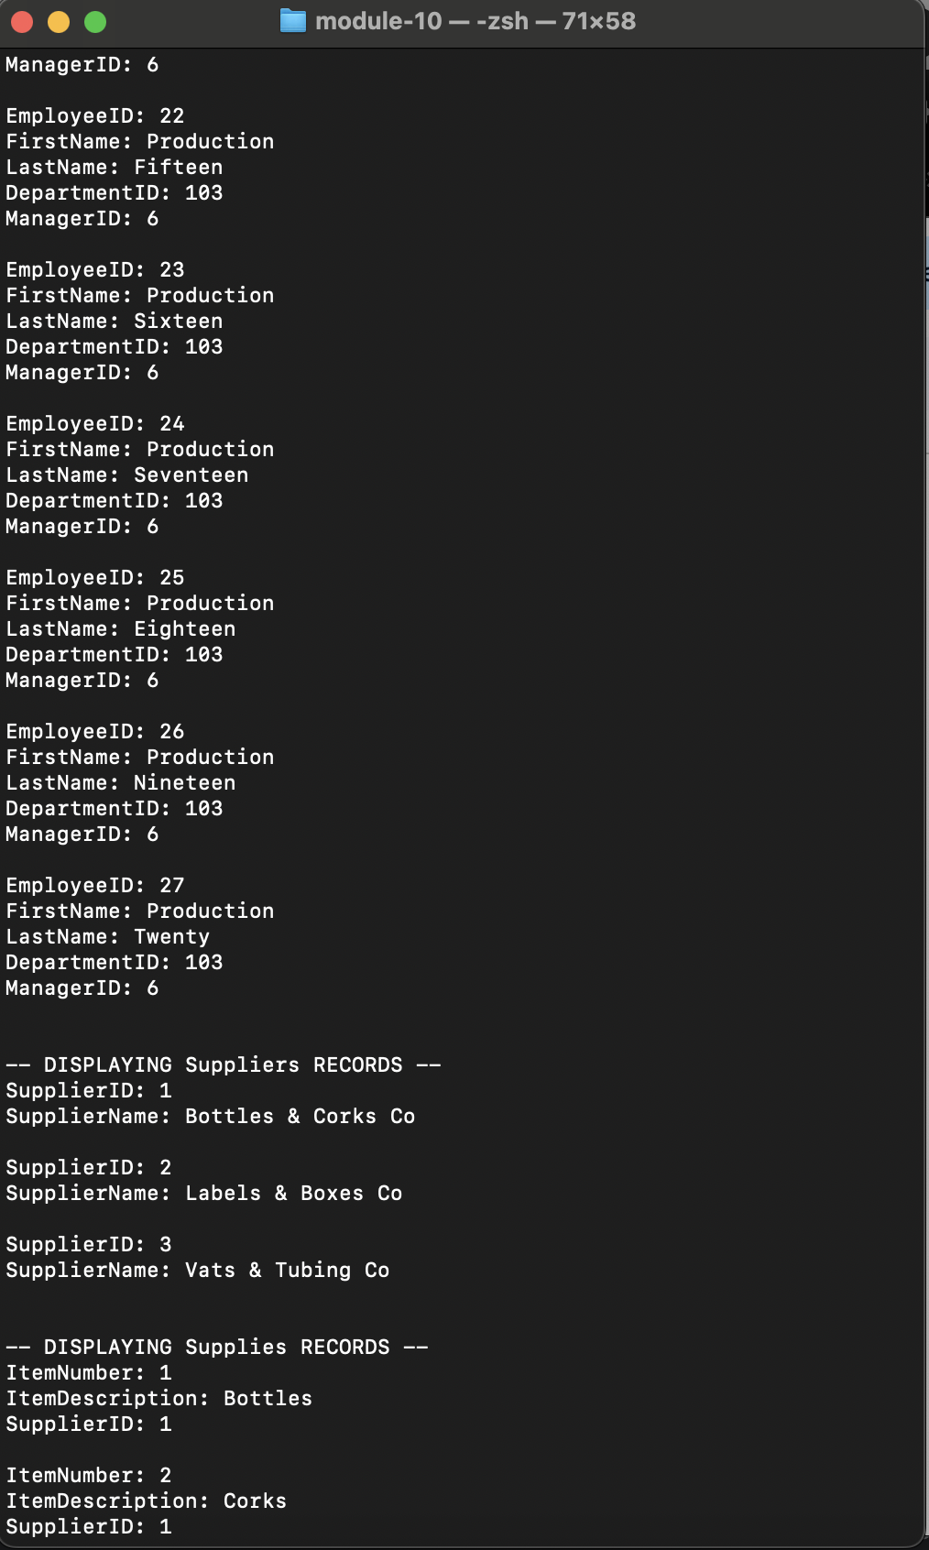

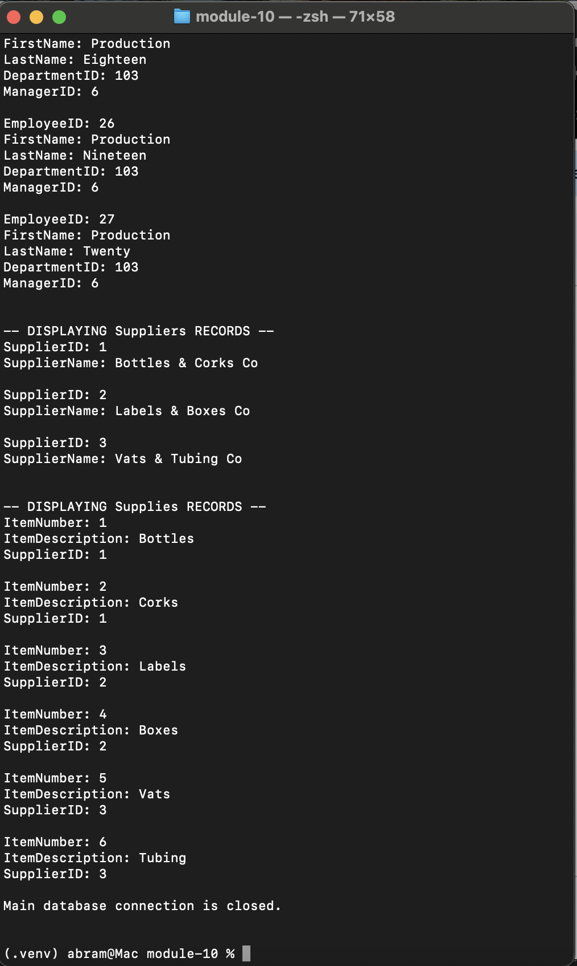

Creating the Database and Tables

CREATE DATABASE Bacchus_Winery

USE Bacchus_Winery;

-- *** Core Business Entities ***

-- 1. Suppliers Table
CREATE TABLE Suppliers (
SupplierID INT PRIMARY KEY,
SupplierName VARCHAR(100) NOT NULL
);

-- 2. Distributors Table
CREATE TABLE Distributors (
DistributorID INT PRIMARY KEY,
DistributorName VARCHAR(100) NOT NULL
);

-- 3. Departments Table (Parent table for Employees)
CREATE TABLE Departments (
DepartmentID INT PRIMARY KEY,
DepartmentName VARCHAR(100) NOT NULL,
ManagerID INT UNIQUE
-- FK to Employees.EmployeeID added later via ALTER TABLE
);

-- *** Operational Tables ***

-- 4. Employees Table (Contains self-referencing FKs for managers)
CREATE TABLE Employees (
EmployeeID INT PRIMARY KEY,
FirstName VARCHAR(50) NOT NULL,
LastName VARCHAR(50) NOT NULL,
DepartmentID INT NOT NULL,
ManagerID INT NULL,

CONSTRAINT FK_Employee_Department
FOREIGN KEY (DepartmentID) REFERENCES Departments(DepartmentID),

CONSTRAINT FK_Employee_Manager
FOREIGN KEY (ManagerID) REFERENCES Employees(EmployeeID)
);

-- 5. Supplies Table (Created with the correct name from the start)
CREATE TABLE Supplies (
ItemNumber INT PRIMARY KEY,
ItemDescription VARCHAR(255) NOT NULL,
SupplierID INT NOT NULL,
CONSTRAINT FK_Supplies_Supplier
FOREIGN KEY (SupplierID) REFERENCES Suppliers(SupplierID)
);

-- 6. Orders Table (Links an order event to a Distributor and an Employee)
CREATE TABLE Orders (
OrderID INT PRIMARY KEY,
OrderDate DATE NOT NULL,
DistributorID INT NOT NULL,
EmployeeID INT NULL, -- Employee fulfilling the order

CONSTRAINT FK_Order_Distributor
FOREIGN KEY (DistributorID) REFERENCES Distributors(DistributorID),

CONSTRAINT FK_Order_Employee
FOREIGN KEY (EmployeeID) REFERENCES Employees(EmployeeID)
);

-- *** Junction/Linking Tables ***

-- 7. OrderDetails Table (Manages the many-to-many relationship between Orders and Supplies)
CREATE TABLE OrderDetails (
OrderID INT NOT NULL,
ItemNumber INT NOT NULL,
Quantity INT NOT NULL,

CONSTRAINT PK_OrderDetails PRIMARY KEY (OrderID, ItemNumber),

CONSTRAINT FK_OrderDetail_Order
FOREIGN KEY (OrderID) REFERENCES Orders(OrderID),

CONSTRAINT FK_OrderDetail_Supplies -- Constraint name links to the Supplies table
FOREIGN KEY (ItemNumber) REFERENCES Supplies(ItemNumber)
);

-- *** Post-Creation Constraints (Resolves circular dependency) ***

-- Adds the constraint linking the Departments manager back to the Employees table
ALTER TABLE Departments
ADD CONSTRAINT FK_Department_Manager
FOREIGN KEY (ManagerID) REFERENCES Employees(EmployeeID);

Populating the Tables

INSERT INTO Suppliers (SupplierID, SupplierName)
VALUES
(1, 'Bottles & Corks Co’),
(2, 'Labels & Boxes Co'),
(3, 'Vats & Tubing Co');

INSERT INTO Distributors (DistributorID, DistributorName)
VALUES
(1, ‘East Distributor’),
(2, ‘Central Distributor’),
(3, ‘West Distributor’),
(4, ‘Southwest Distributor’),
(5, ‘Northwest Distributor’),
(6, ‘Northeast Distributor’);

INSERT INTO Departments (DepartmentID, DepartmentName, ManagerID)
VALUES
(101, ‘Finance and Payroll’, NULL),
(102, ‘Marketing’, NULL),
(103, ‘Production’, NULL),
(104, ‘Distribution’, NULL),
(105, ‘Supply and Inventory, NULL),
(106, ‘Exec and Admin, NULL);

INSERT INTO Employees (EmployeeID, FirstName, LastName, DepartmentID, ManagerID)
VALUES
(1, ‘Stan’, ‘Bacchus’, 106, NULL);

-- Update the 'Exec and Admin’ department to link its manager to Employee 1
UPDATE Departments
SET ManagerID = 1
WHERE DepartmentID = 106;

INSERT INTO Employees (EmployeeID, FirstName, LastName, DepartmentID, ManagerID)
VALUES
(2, ‘Davis’, ‘Bacchus’, 106, 1),
(3, ‘Janet’, ‘Collins’, 101, 1),
(4, ‘Roz’, ‘Murphy’, 102, 1),
(5, ‘Bob’, ‘Ulrich’, 102, 4),
(6, ‘Henry’, ‘Doyle’, 103, 1),
(7, ‘Maria’, ‘Costanza’, 104, 1),
(8, ‘Production’, ‘One’, 103, 6),
(9, ‘Production’, ‘Two’, 103, 6),
(10, ‘Production’, ‘Three’, 103, 6),
(11, ‘Production’, ‘Four’, 103, 6),
(12, ‘Production’, ‘Five’, 103, 6),
(13, ‘Production’, ‘Six’, 103, 6),
(14, ‘Production’, ‘Seven’, 103, 6),
(15, ‘Production’, ‘Eight’, 103, 6),
(16, ‘Production’, ‘Nine’, 103, 6),
(17, ‘Production’, ‘Ten’, 103, 6),
(18, ‘Production’, ‘Eleven’, 103, 6),
(19, ‘Production’, ‘Twelve’, 103, 6),
(20, ‘Production’, ‘Thirteen’, 103, 6),
(21, ‘Production’, ‘Fourteen’, 103, 6),
(22, ‘Production’, ‘Fifteen’, 103, 6),
(23, ‘Production’, ‘Sixteen’, 103, 6),
(24, ‘Production’, ‘Seventeen’, 103, 6),
(25, ‘Production’, ‘Eighteen’, 103, 6),
(26, ‘Production’, ‘Nineteen’, 103, 6),
(27, ‘Production’, ‘Twenty’, 103, 6);

INSERT INTO Supplies (ItemNumber, ItemDescription, SupplierID)
VALUES
(1, ‘Bottles’, 1),
(2, ‘Corks’, 1),
(3, ‘Labels’, 2),
(4, ‘Boxes’, 2),
(5, ‘Vats’, 3),
(6, ‘Tubing’, 3);

