Abram Denzlinger
November 12, 2025
5.2 - MySQL Functions

The MySQL functions I chose for this exercise are CONCAT_WS, COUNT, and DATEDIFF . I landed on these choices as I experimented with the data contained in the TABLES table from the information_schema database.
CONCAT adds two or more expressions together. After experimenting with CONCAT, I decided that CONCAT_WS was more useful in this case. CONCAT_WS is “concatenate with separator,” and so it provides a way to see where the first field stops and the second field starts. I used five dashes (“-----”) to make the separation between fields more obvious. Statement:
—--------------------
SELECT TABLE_CATALOG, CONCAT_WS("-----",TABLE_NAME, TABLE_TYPE) AS Combined_Fields
FROM information_schema.TABLES
ORDER BY Combined_Fields ASC
LIMIT 20;

—--------------------CONCAT_WS Results:
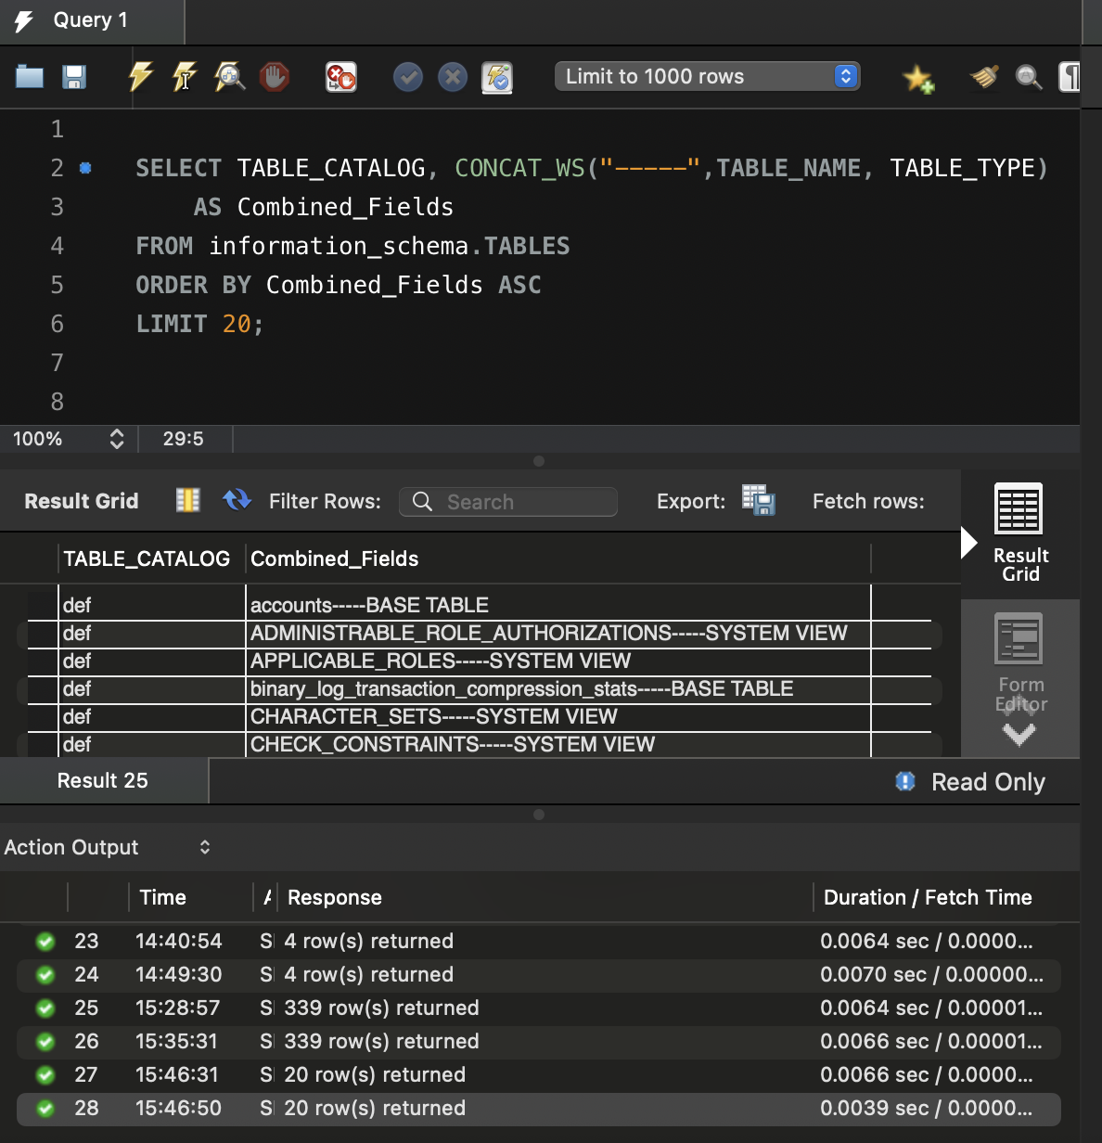

The next function I chose is COUNT. COUNT returns the number of records returned by the query. Using dialogue with Gemini, I played around with counting unique values of certain fields, and with displaying Grand Totals in the results. In Operations Management, it’s often useful to know quantities of related items, like items in a specific table. Statement:
—--------------------
SELECT
COALESCE(TABLE_TYPE, 'Grand Total') AS TableTypeValue,
COUNT(*) AS CountOfTableType
FROM information_schema.TABLES
GROUP BY TABLE_TYPE WITH ROLLUP
ORDER BY CountOfTableType ASC;
—-------------------- COUNT Results:
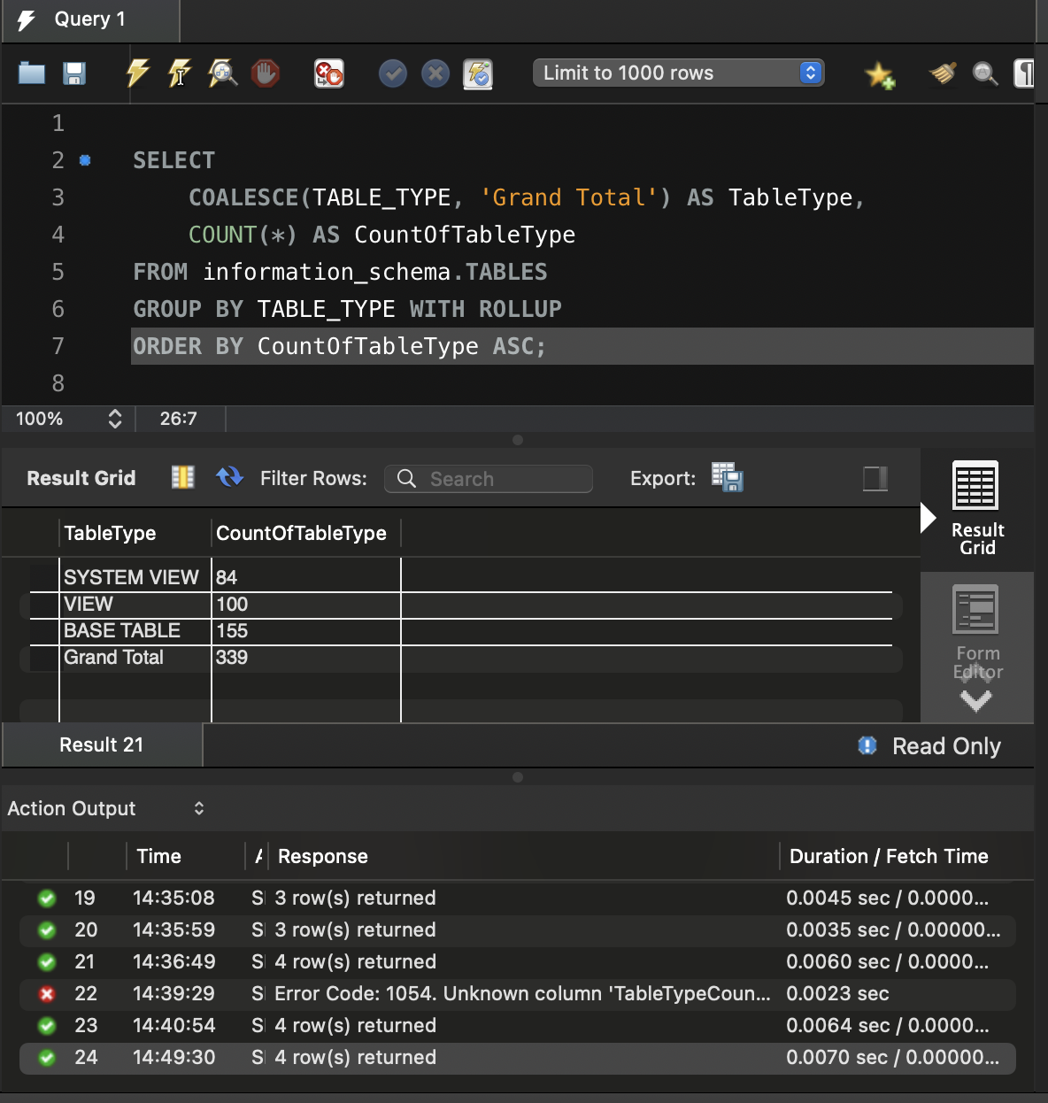
The final function I chose is DATEDIFF. DATEDIFF returns the number of days between two date values. A record’s age could be an indication of its validity - is the data stale? Is the table not updating correctly? This query shows the age in days of each record. This particular database was created 5 days ago, so all the records show the same date. Statement:
SELECT
TABLE_CATALOG,
CREATE_TIME,
DATEDIFF(CURDATE(), CREATE_TIME) AS `RecordAge(days)`
FROM
information_schema.TABLES;
—-------------------- DATEDIFF Results:
