Abram Denzlinger
November 20, 2025
6.2 Movies Setup

github repository: https://github.com/denzlinger-lab/csd-310/tree/main/module-6

Step 5
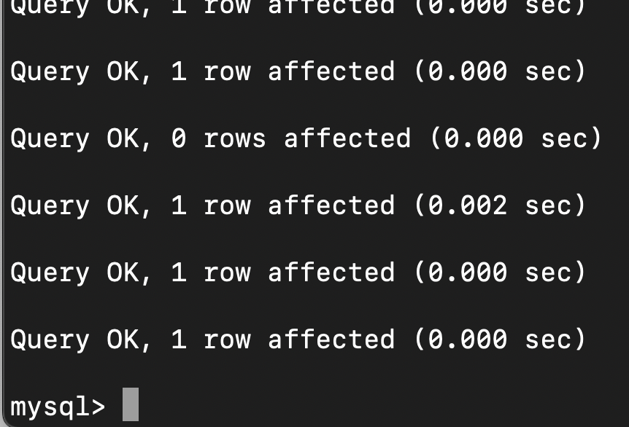

Step 6
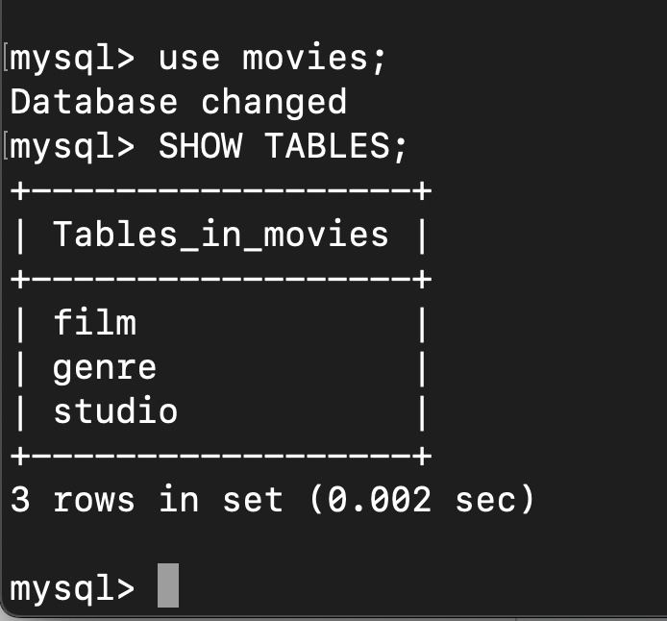

Step 9
