Abram Denzlinger
November 29, 2025
8.2 - Movies: Updates and Deletes

Database connected, query and formatting working
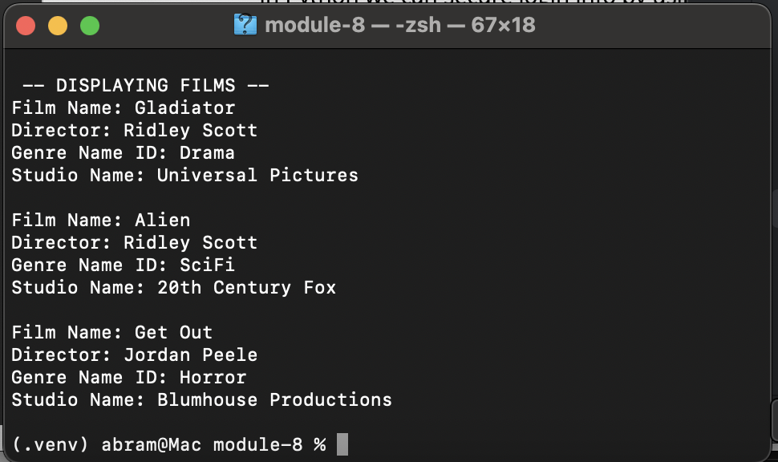

Inserted a new film title
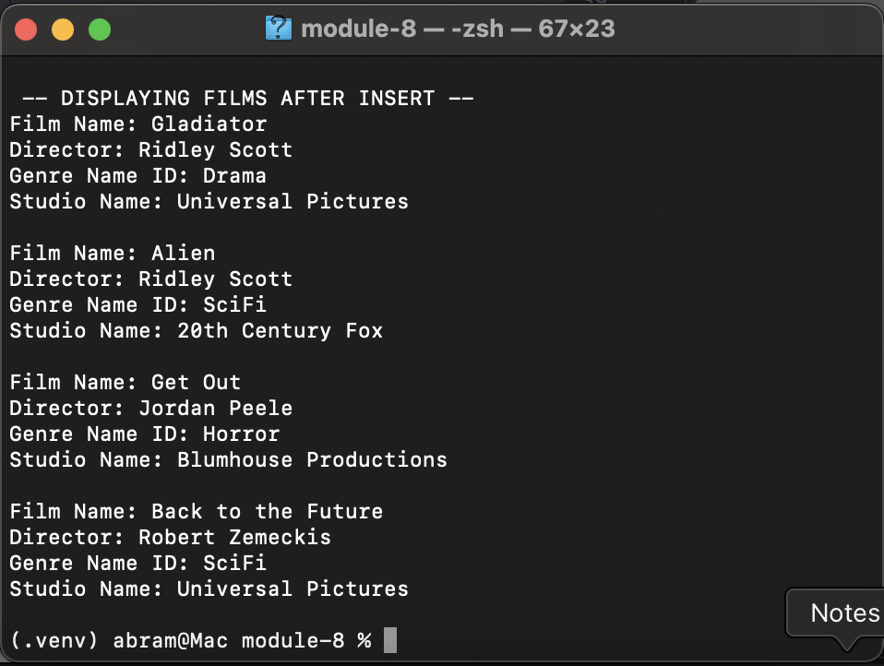
Changed Alien’s genre to Horror
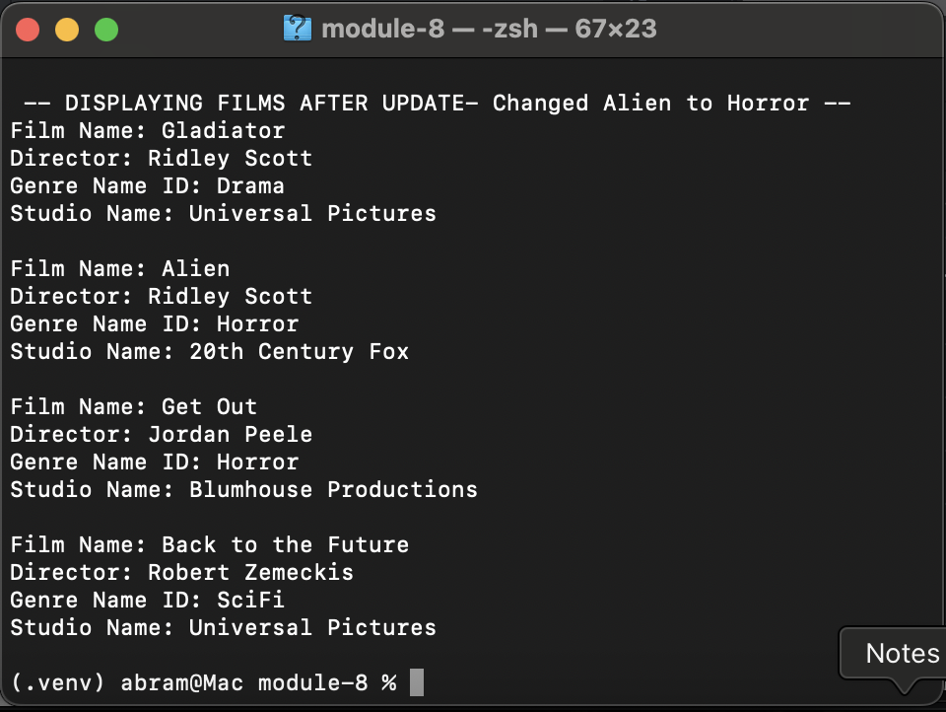

Deleted Gladiator film
