Abram Denzlinger
November 27, 2025
8.1 Discussion - SQL

Example #1
Here I’m listing the genre_name and film_director by inner joining the genre table and film table on the genre_id field, which is in both tables:

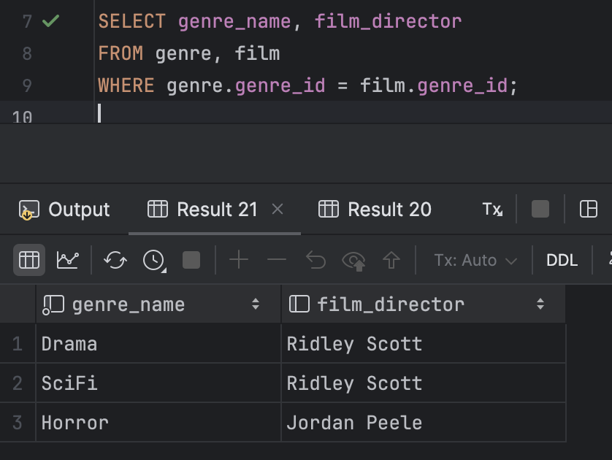

Here is another way to write this query. The output is the same.

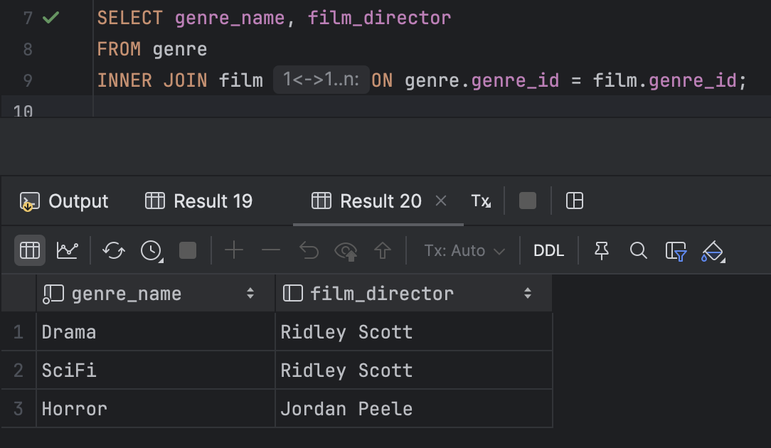

Example #2
Here I’m listing the film_runtime and genre_name by inner joining the genre table and film table on the genre_id field, which is in both tables:

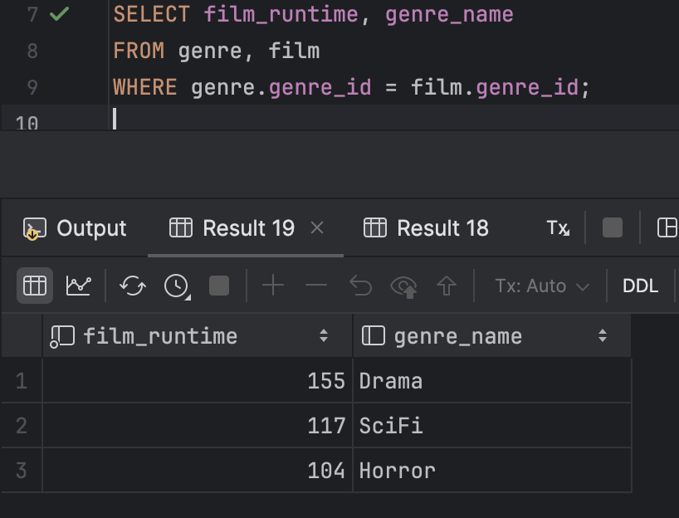

Here is another way to write this query. The output is the same.

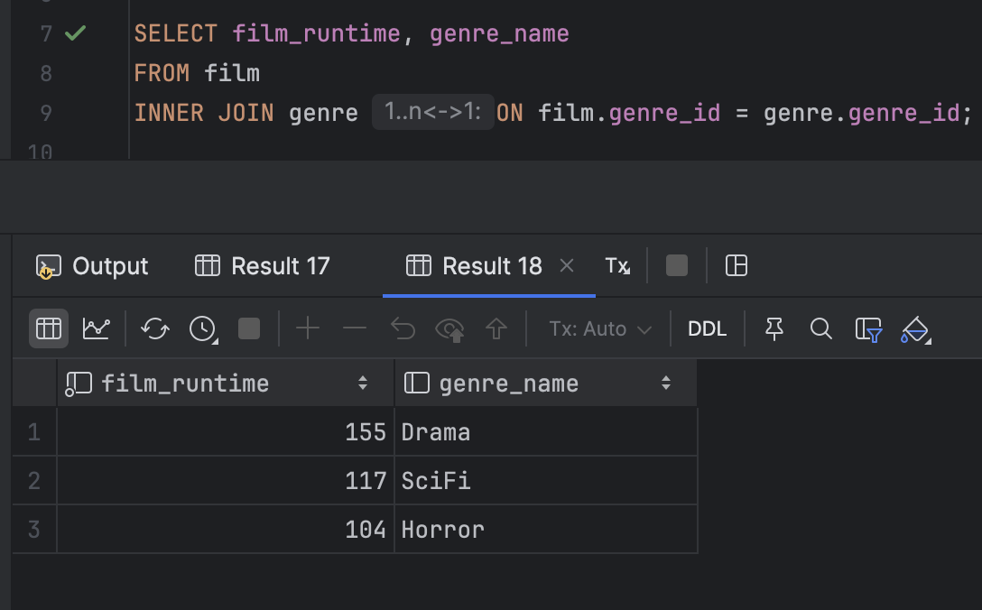

Tables used in examples:

movies.genre


movies.film


movies.studio


