Abram Denzlinger
November 17, 2025
7.2 - Test Cases

Screenshot #1 - Write the Function and call it 3x
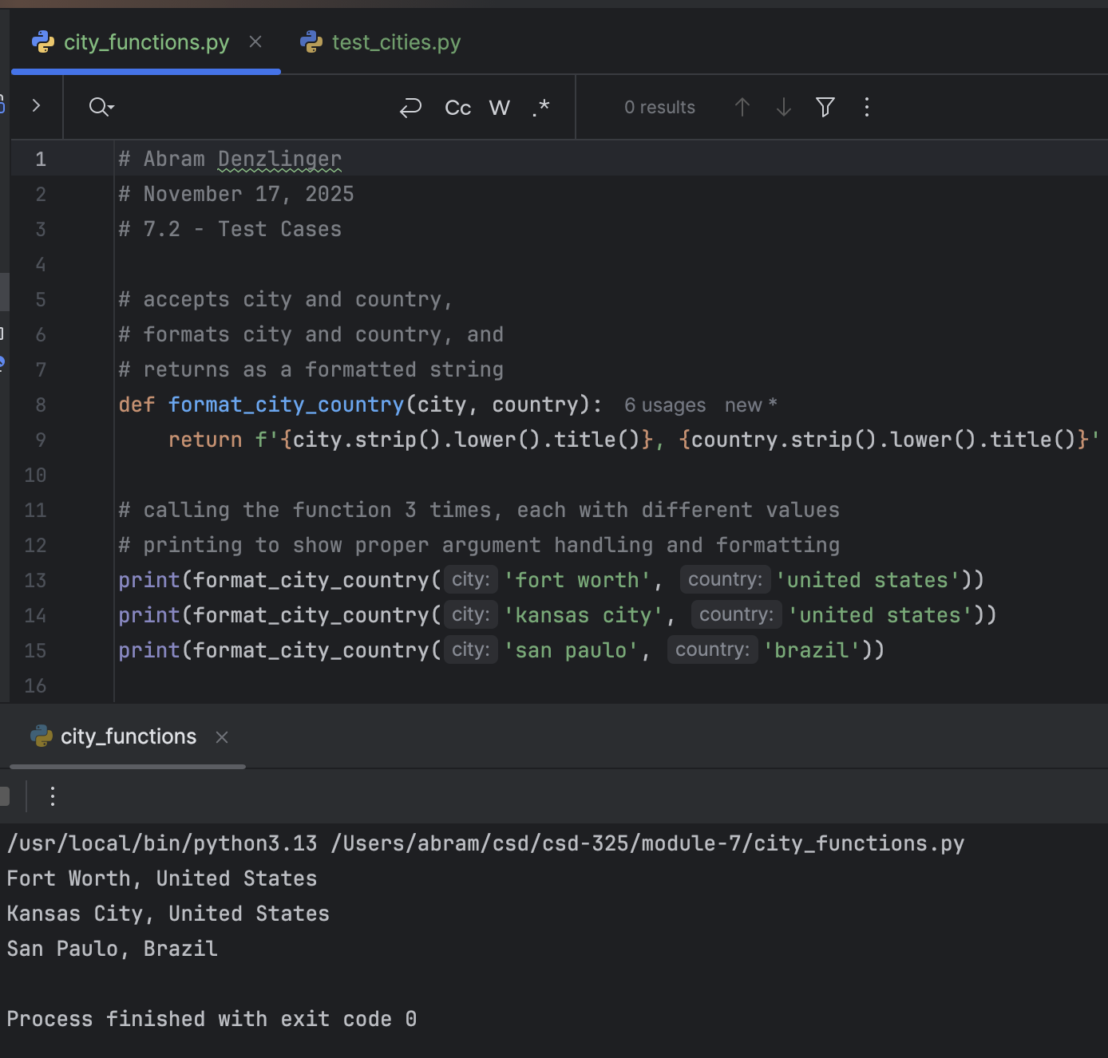

Screenshot #2 - Test the Function
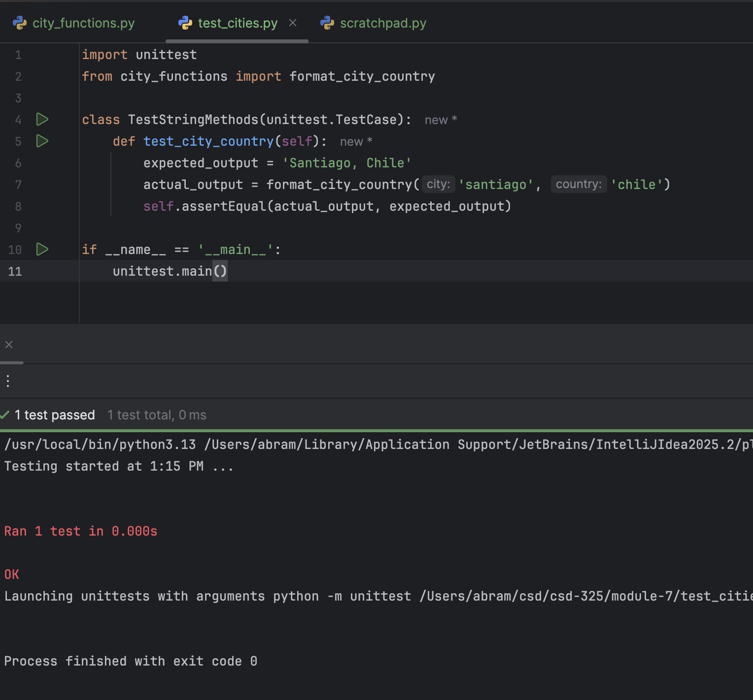

Screenshot #3 - Add Population and Re-test (fail)
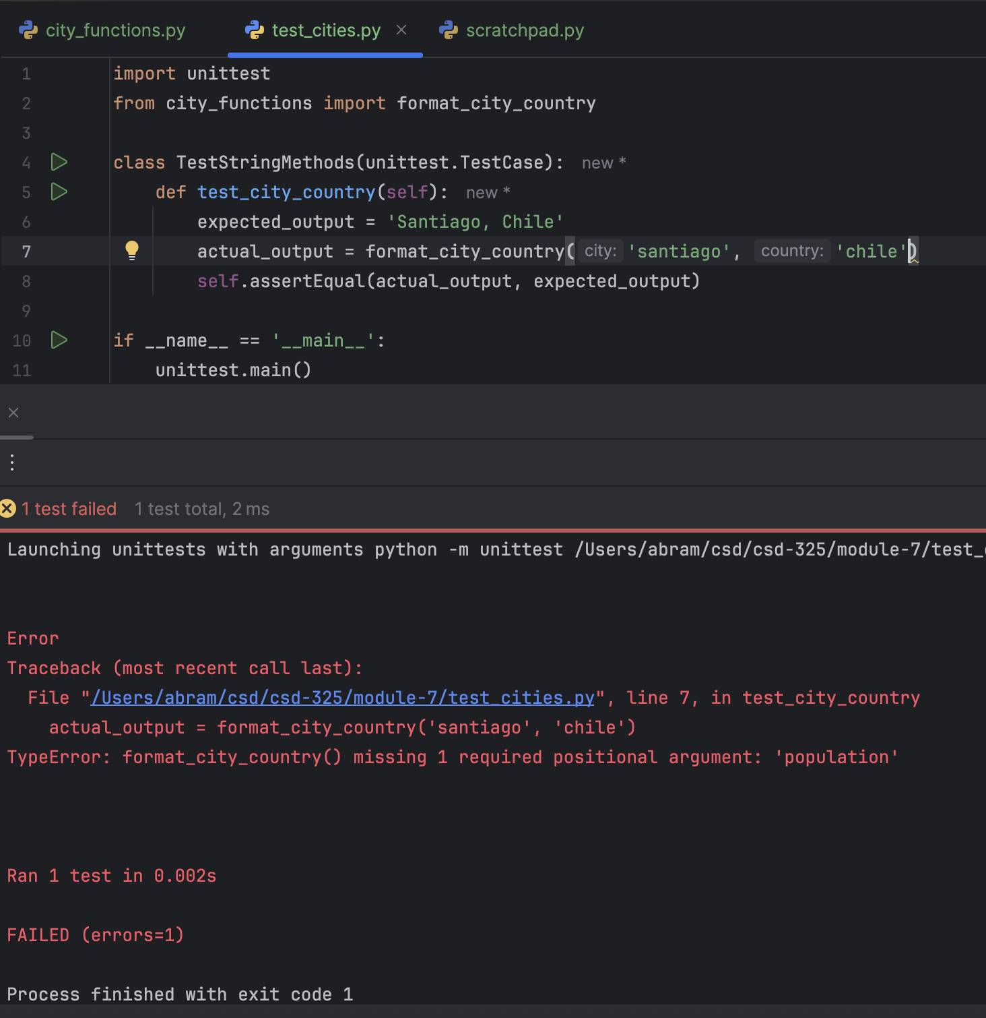

Screenshot #4 - Modify Function and Re-test (pass)
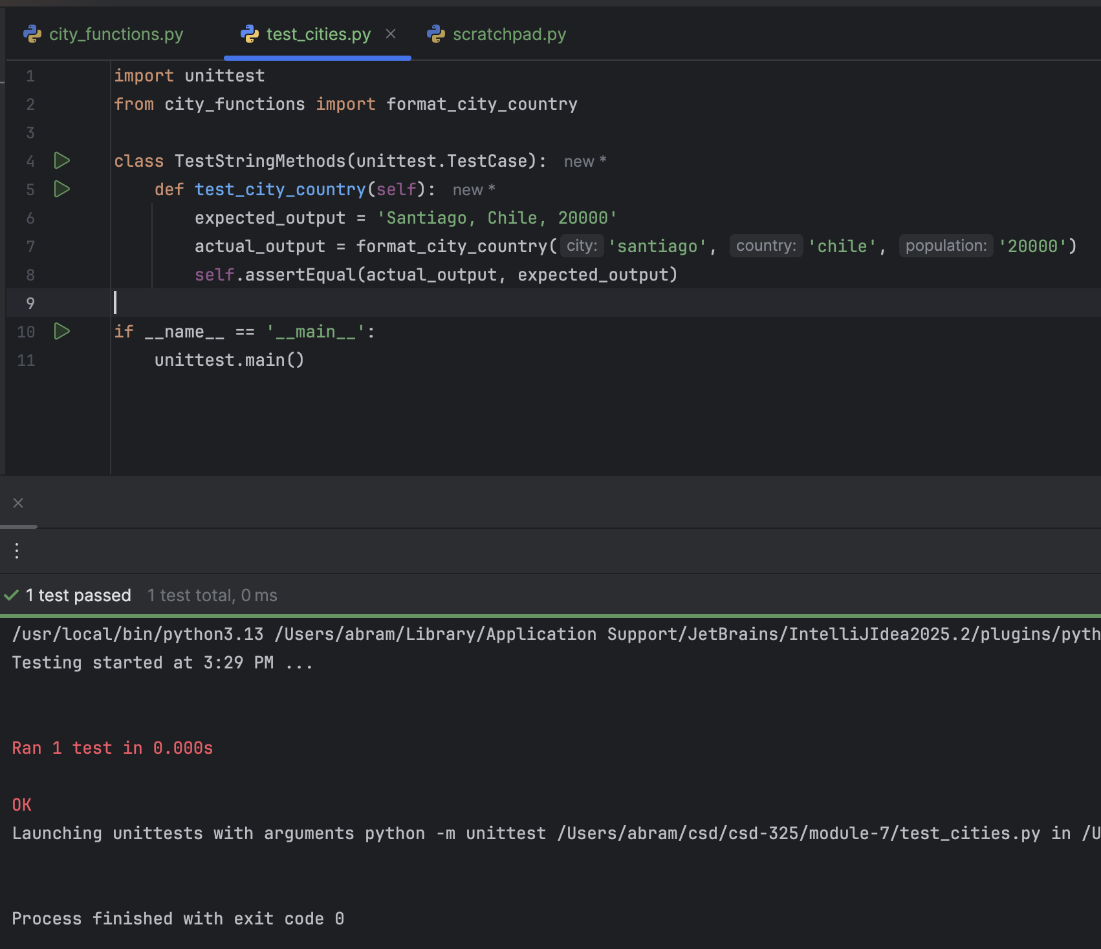

Screenshot #5 - Modify Function and retest (fail)
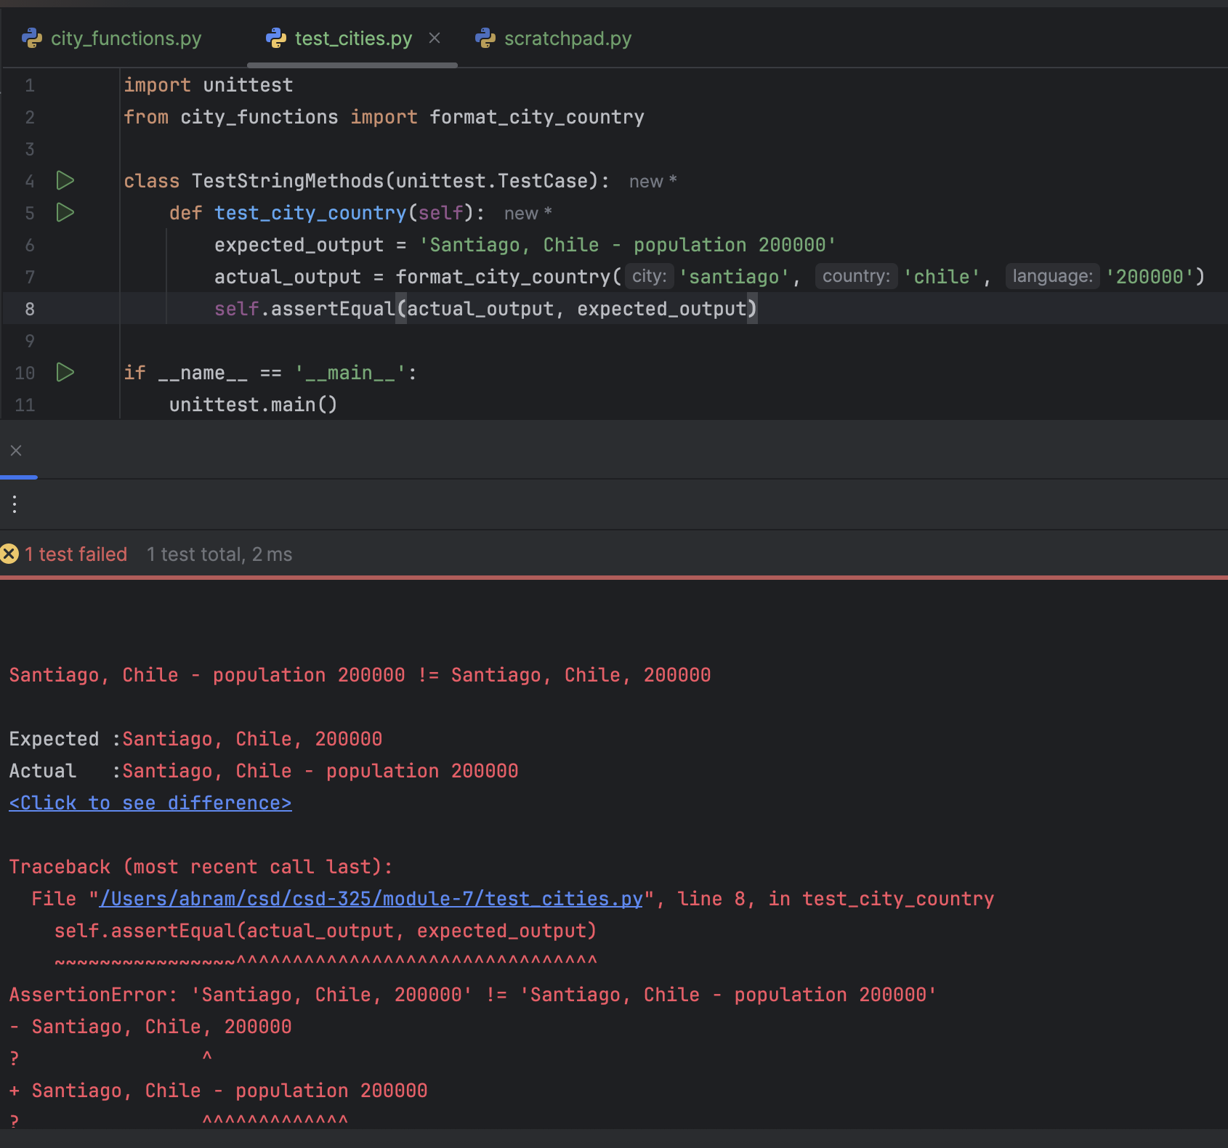

Screenshot #6 - Make Language Optional and retest (pass)
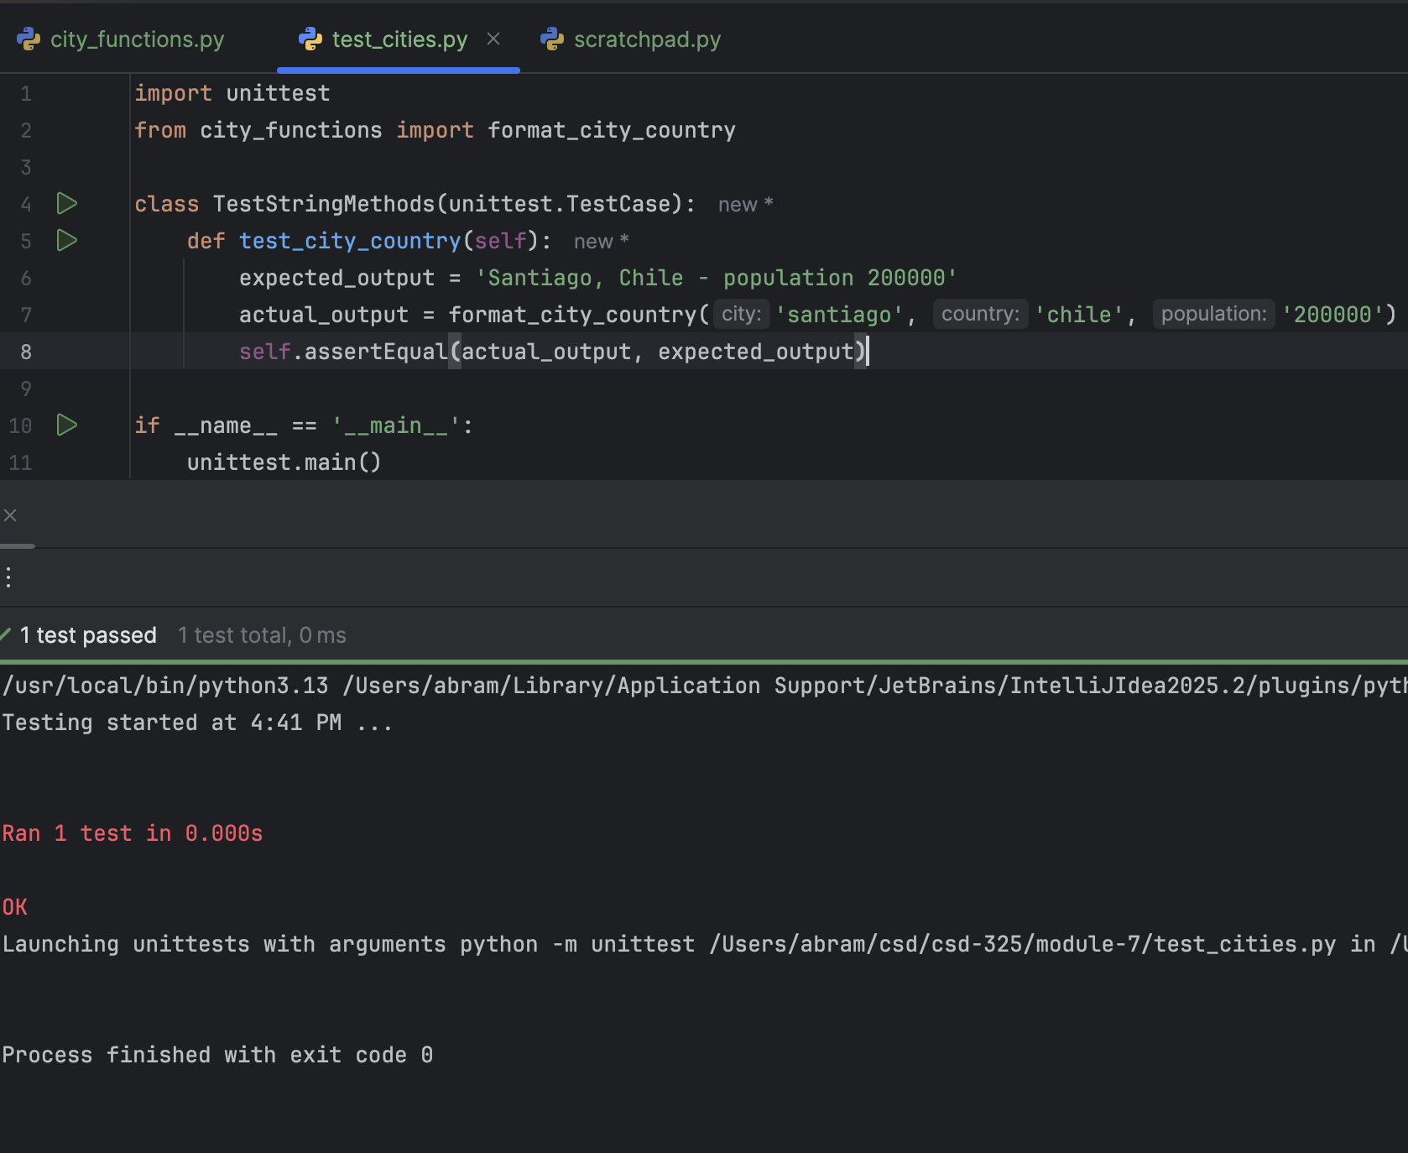

Screenshot #7 - Call 3x with specified arguments
