Abram Denzlinger
January 17, 2025
1.3 - Building a Web Page Exercise

Github link: https://github.com/denzlinger-lab/csd-340/tree/main/module-1
Screenshot #1
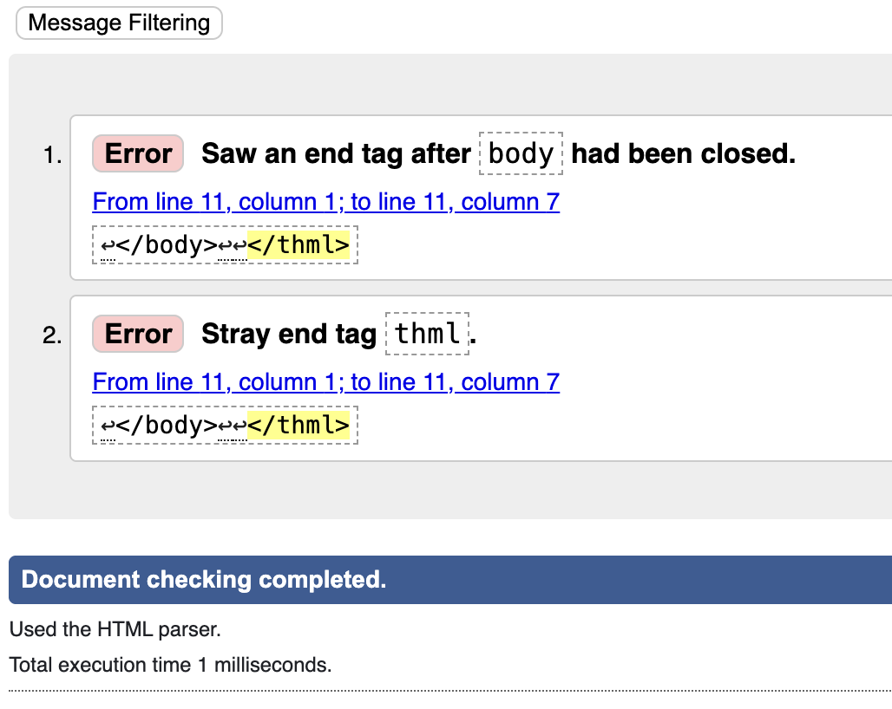

Screenshot #2
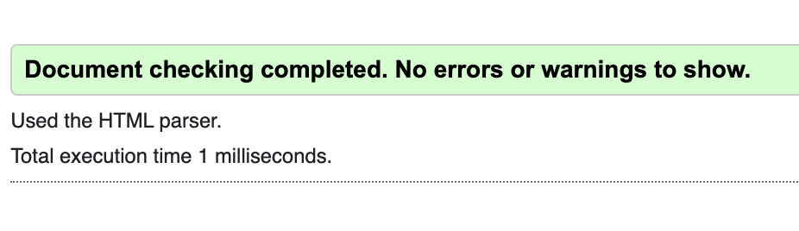
Screenshot #3
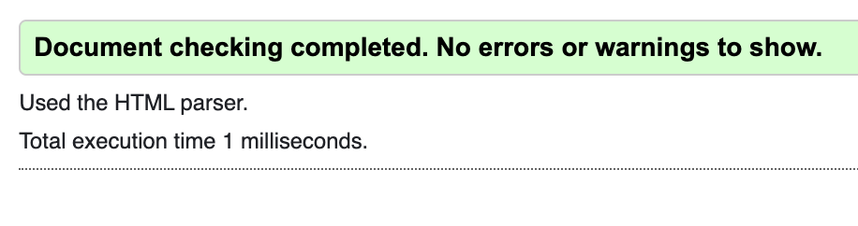
Screenshot #4
