Abram Denzlinger
January 17, 2025
1.2 - Github Repository Setup

Github Repository: https://github.com/denzlinger-lab/csd-340/tree/main
Screenshot #1 - repository csd-340 cloned
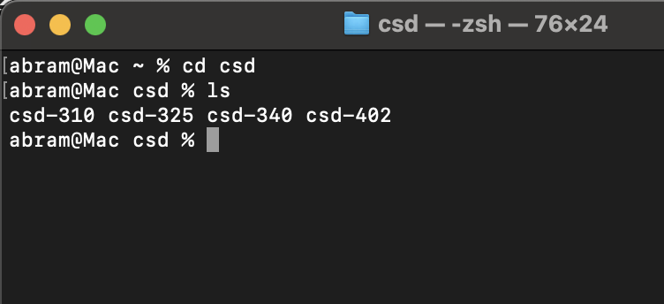
Screenshot #2 - Github repository
