Abram Denzlinger
January 25, 2026
Assignment 3.2

HTML Validation
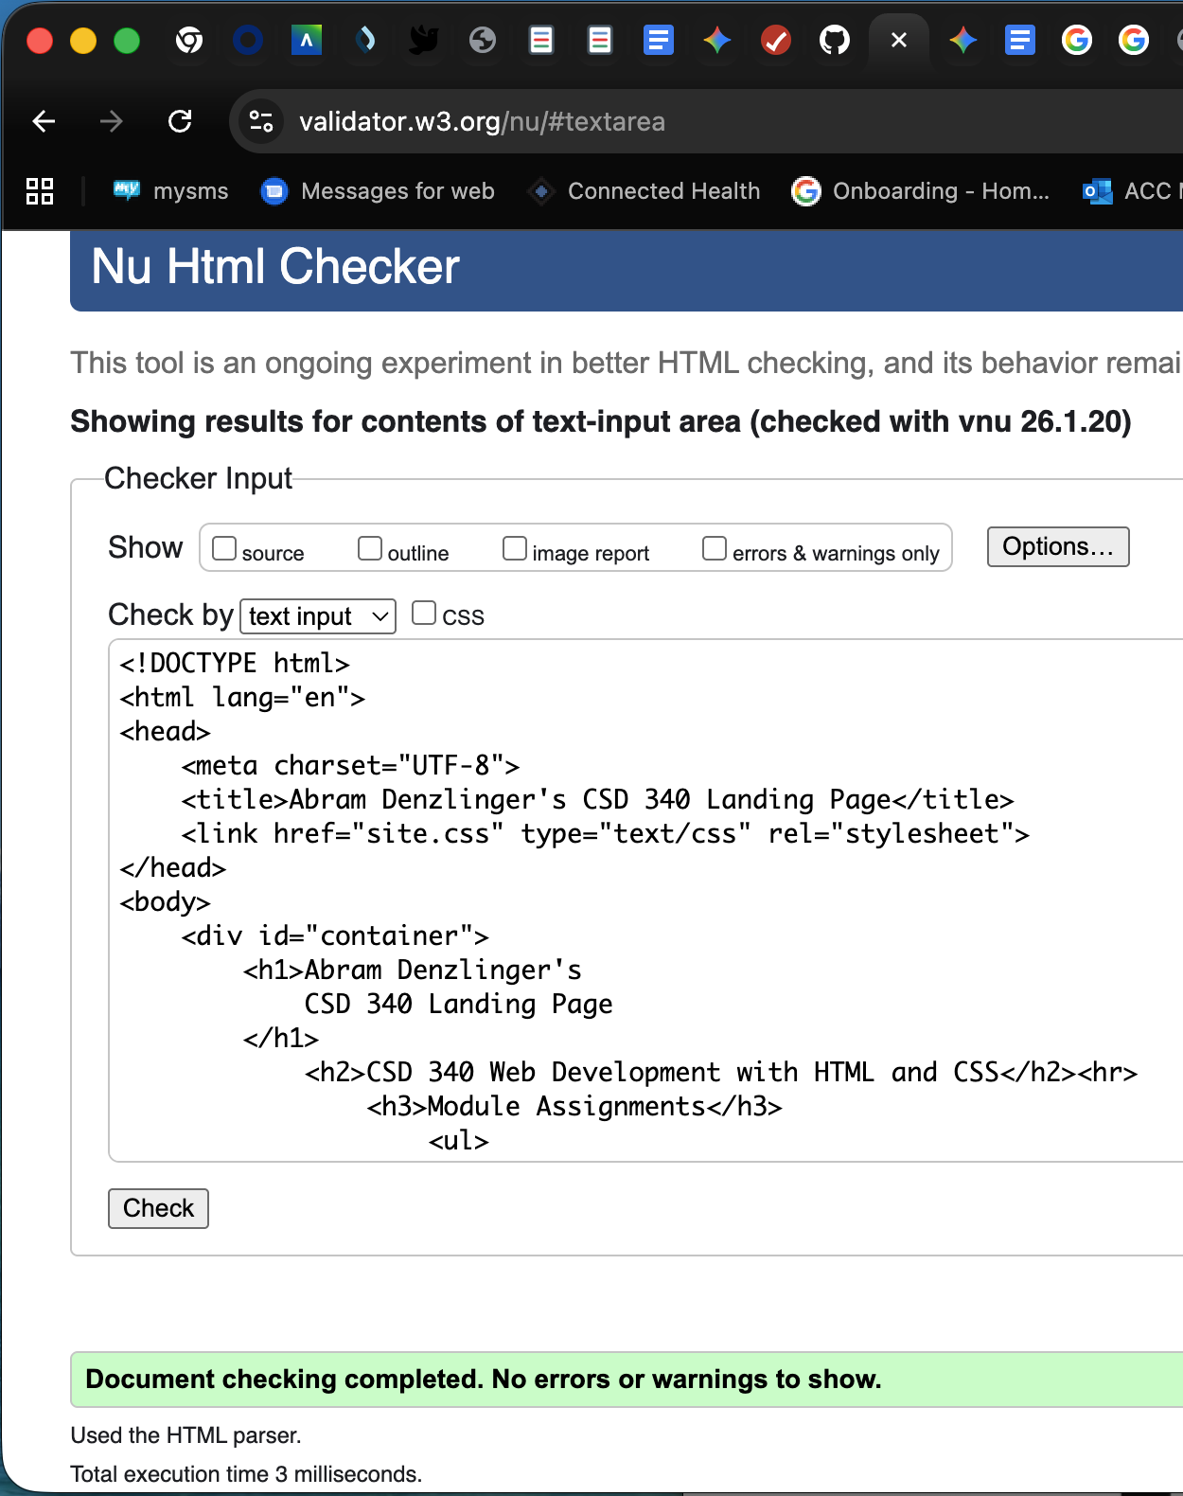
CSS Validation
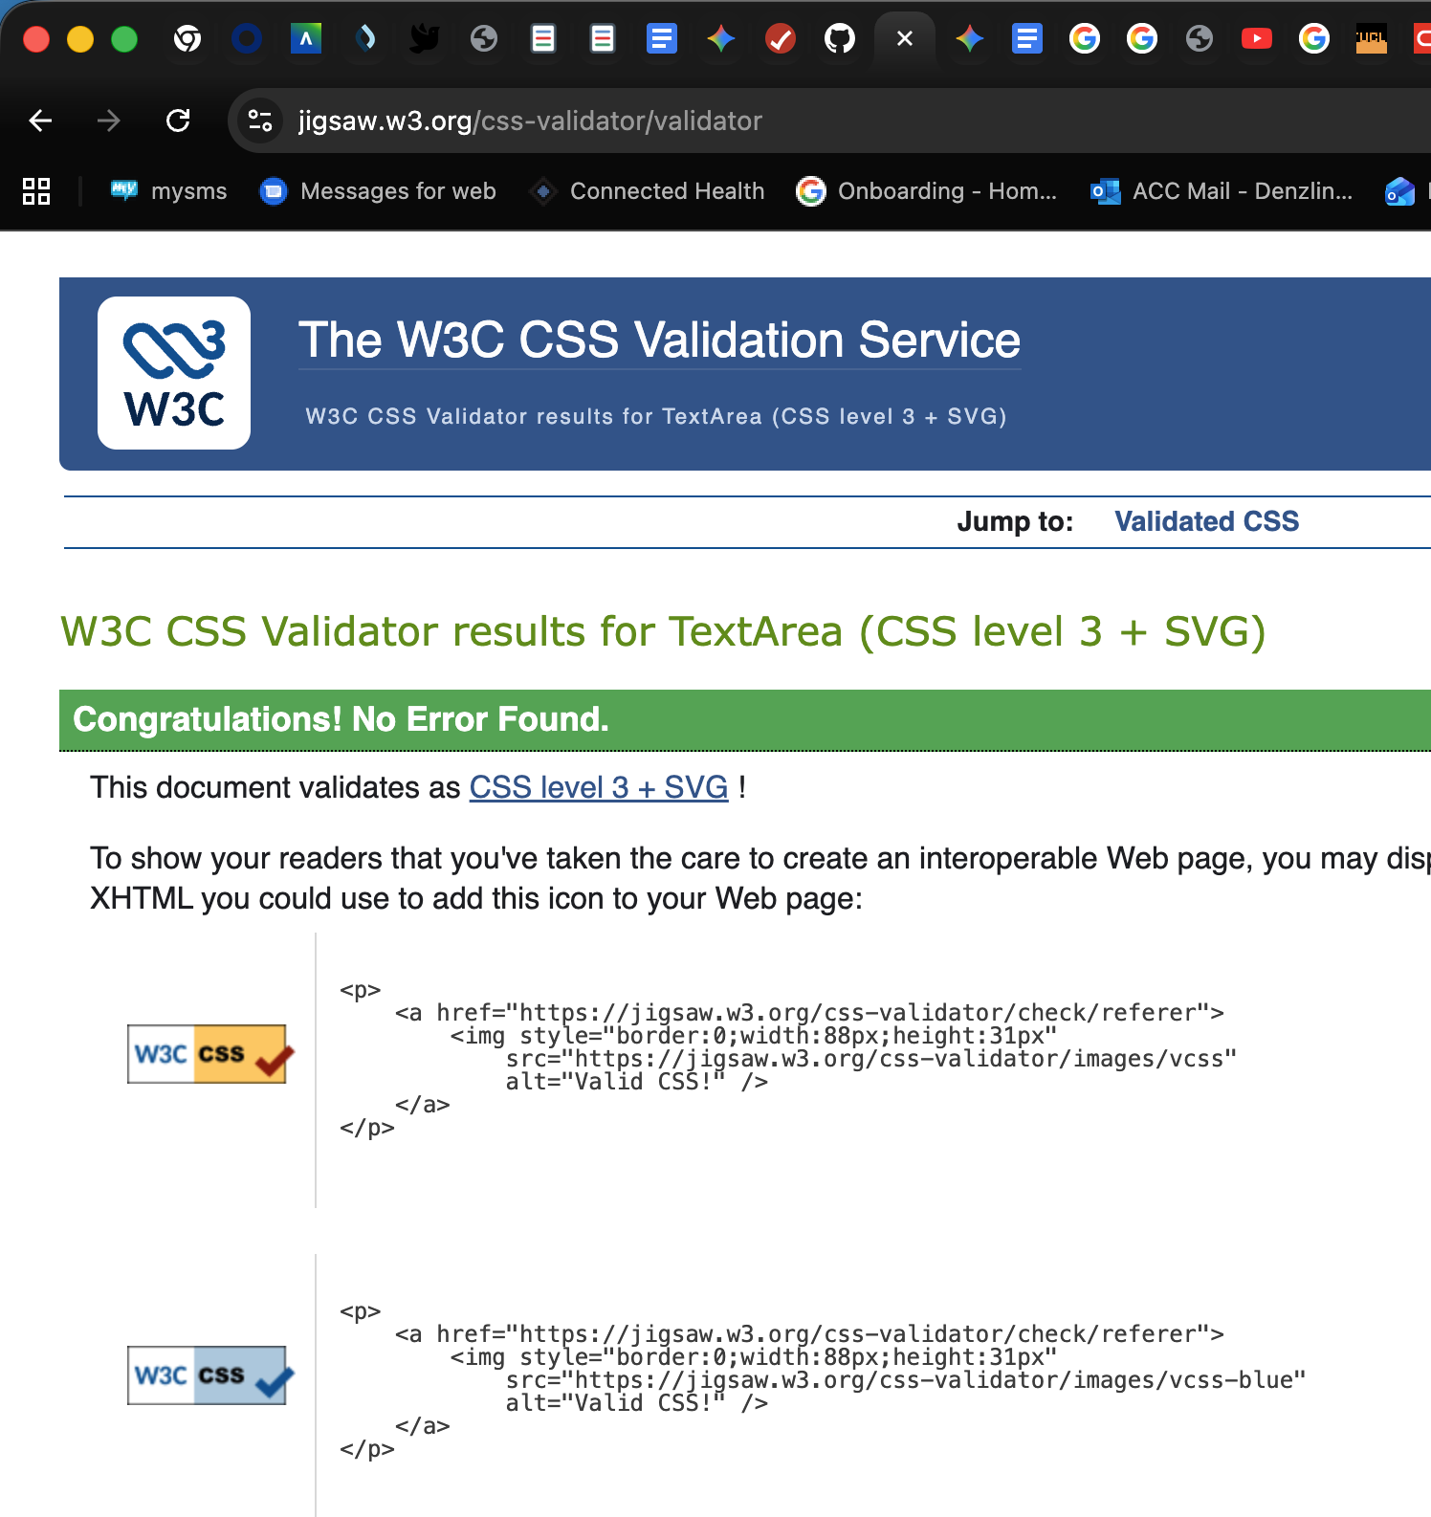

Browser screenshot:
