Abram Denzlinger
February 21, 2026
8.2 - Build a Web Page Part 6

HTML Validation
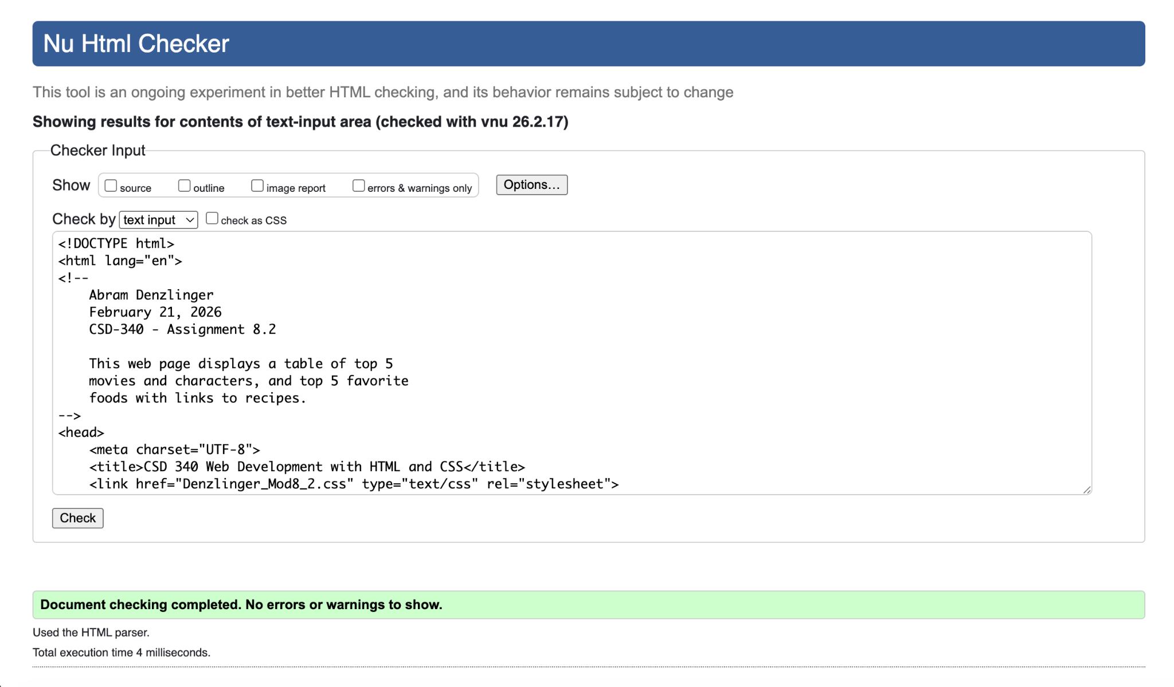

CSS Validation

