Abram Denzlinger
January 18, 2026
CSD-402 Module 1.2 - Github

Link to Github Repository: https://github.com/denzlinger-lab/csd-402.git
Git Repository Screenshot:
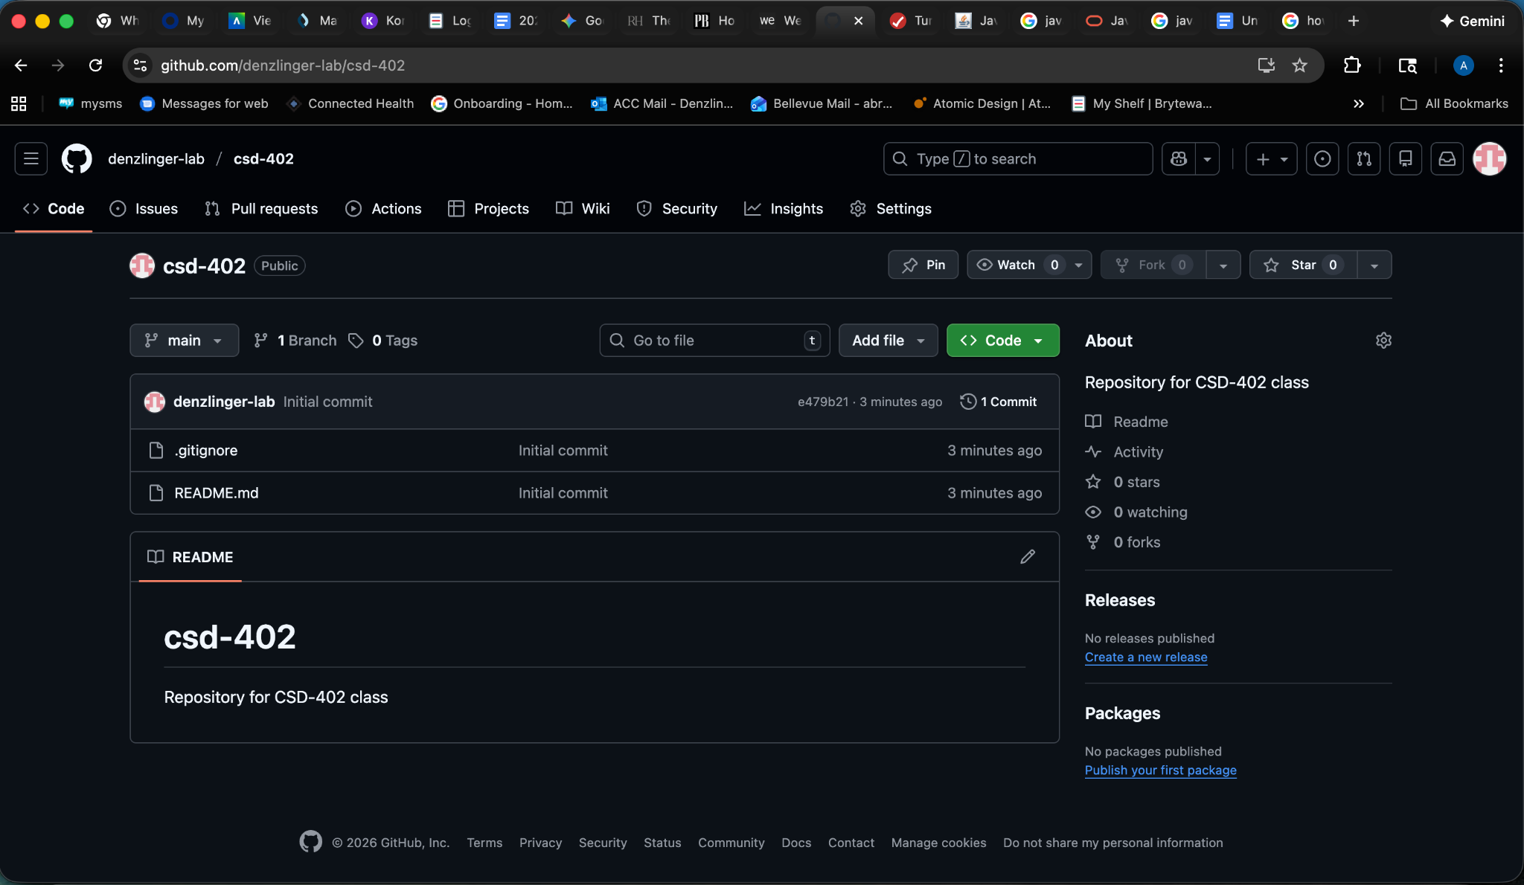
Screenshot of local directory:
