Test Plan - Todo Application
Drew Crockett
CSD 380
URL: https://buwebdev.github.io/todo/

Test Case ID: | TC-001
Test Name: | Access the Website via Standard URL
Requirement: | Req #10
Pre-Condition: | A web browser is open.
Step # | Action | Expected Result
1 | Open a web browser and go to https://buwebdev.github.io/todo/ | The Todo page loads without any errors.
2 | Check the browser tab title. | The tab shows 'Todo'.
3 | Refresh the page. | The page reloads correctly and the app is still visible.
4 | Check that the input field and task list area are on the page. | Both the input field and task list are visible.
Pass / Fail: | Pass  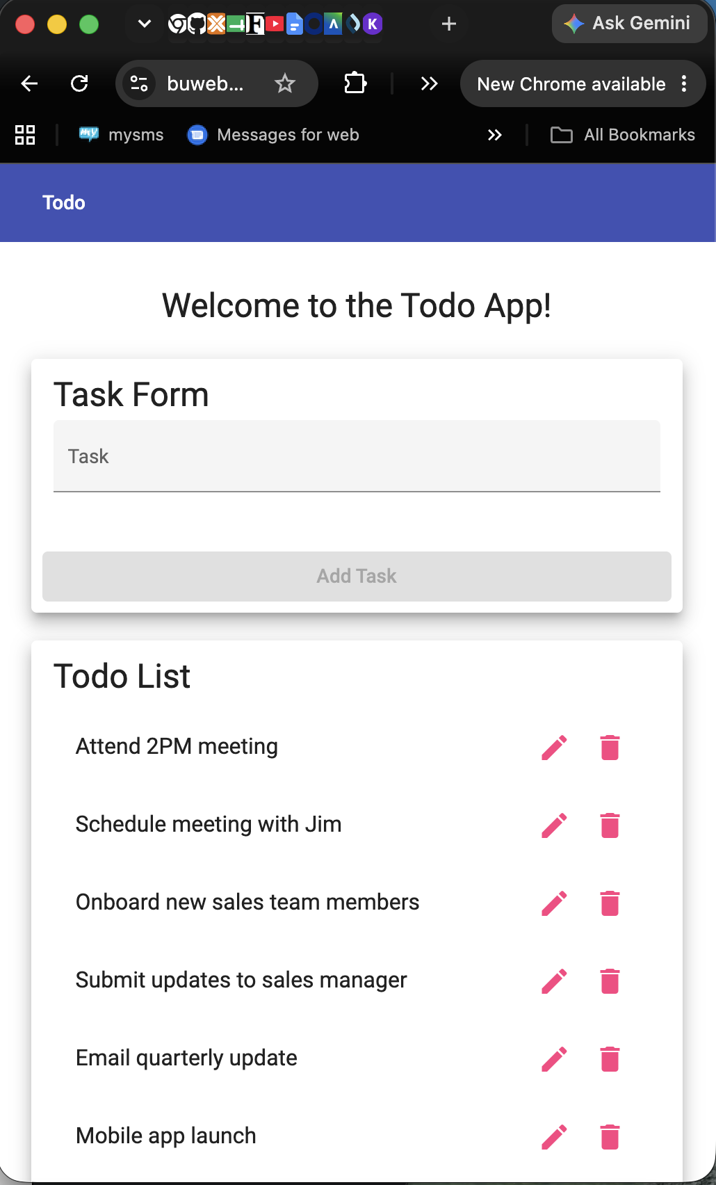
Notes: | Navigated to https://buwebdev.github.io/todo/. Confirmed browser tab title of “To Do.” Page refresh worked, and confirmed input field and task list area were present. Steps 1-4 passed.

Test Case ID: | TC-002
Test Name: | Create a New Todo Task Item
Requirement: | Req #2
Pre-Condition: | The Todo app is open at https://buwebdev.github.io/todo/
Step # | Action | Expected Result
1 | Click on the todo input field. | The input field is active and ready for text.
2 | Type 'Buy groceries' into the input field. | The text 'Buy groceries' shows in the field.
3 | Click the Add button or press Enter. | The form submits.
4 | Look at the task list. | 'Buy groceries' appears as a new item in the list.
Pass / Fail: | Pass  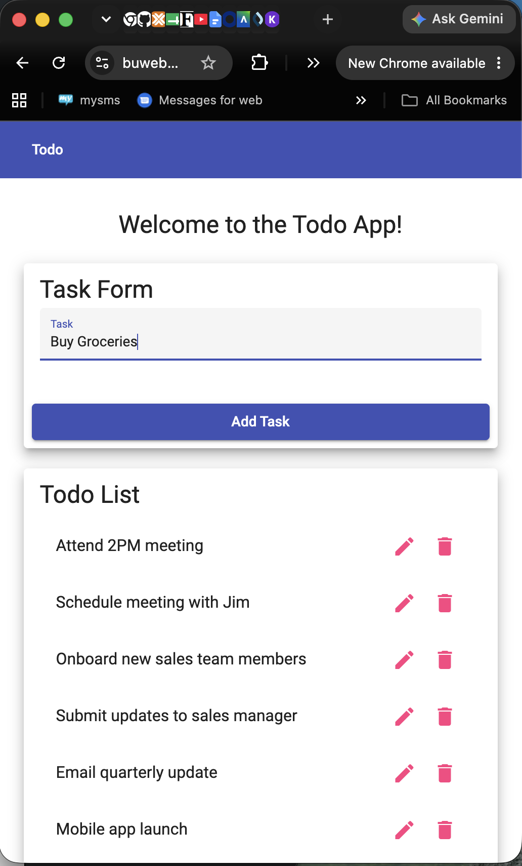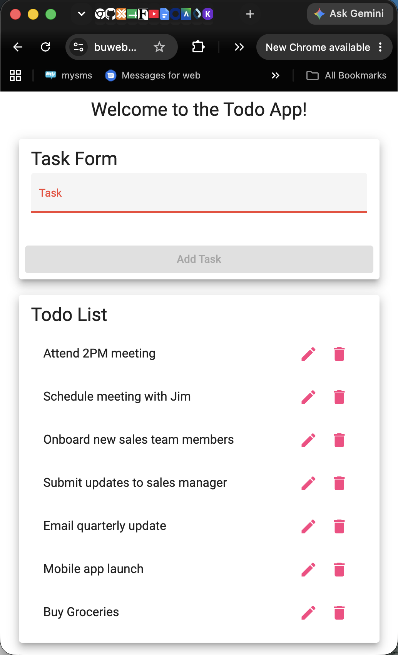
Notes: | Clicked into the to do input field and was able to type as expected. Clicked the Add button, and task was added to the bottom of the To Do list. Steps 1-4 passed.

Test Case ID: | TC-003
Test Name: | View the List of Todo Task Items
Requirement: | Req #1
Pre-Condition: | The Todo app is open and at least one task item exists from TC-002.
Step # | Action | Expected Result
1 | Look at the task list area on the page. | The todo list is visible with at least one item.
2 | Check that each task shows its text label. | Each item displays its task name.
3 | Refresh the page. | The task list is still visible after refreshing.
Pass / Fail: | Pass  
Notes: | Navigated to URL. Observed the task list was present and each showed its text label. Page refreshed as expected. Steps 1-3 passed.

Test Case ID: | TC-004
Test Name: | Edit a Todo Task Item
Requirement: | Req #3
Pre-Condition: | The Todo app is open and 'Buy groceries' exists in the list.
Step # | Action | Expected Result
1 | Find 'Buy groceries' in the list and click the Edit button. | An edit form opens with 'Buy groceries' already filled in.
2 | Clear the text and type 'Buy groceries and milk'. | The field now shows 'Buy groceries and milk'.
3 | Click Save or submit the edit form. | The edit form closes.
4 | Check the task list. | The item now reads 'Buy groceries and milk'.
Pass / Fail: | Pass
Notes:

Test Case ID: | TC-005
Test Name: | Delete a Todo Task Item
Requirement: | Req #4
Pre-Condition: | The Todo app is open and 'Buy groceries and milk' exists in the list.
Step # | Action | Expected Result
1 | Find 'Buy groceries and milk' and click the Delete button. | The item is removed or a confirmation prompt appears.
2 | If a confirmation appears, confirm the deletion. | The deletion is confirmed.
3 | Check the task list. | 'Buy groceries and milk' is no longer in the list.
Pass / Fail: | Failed  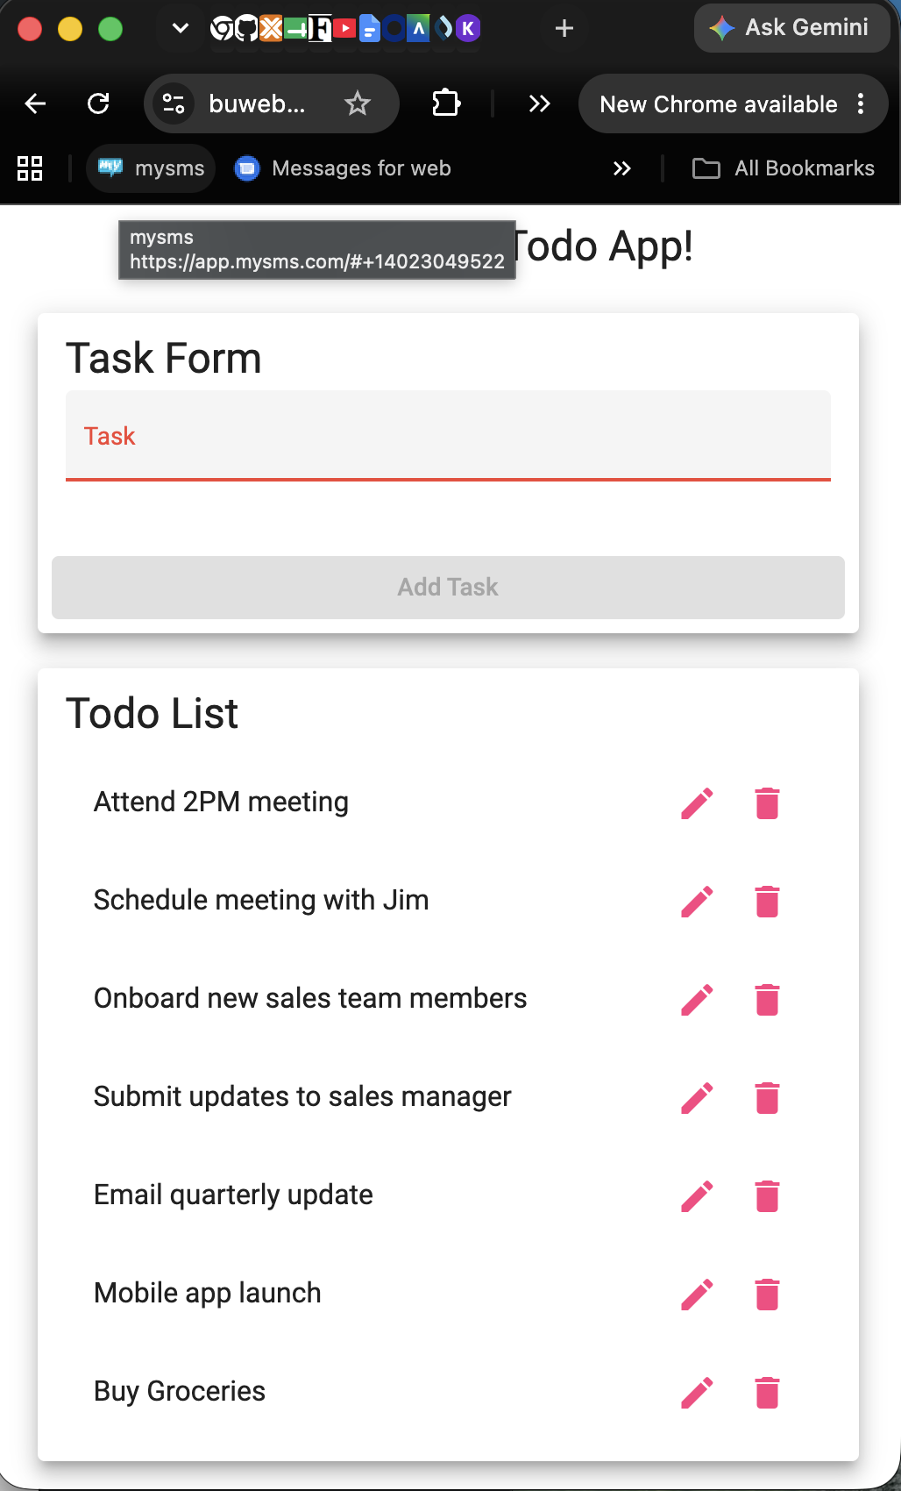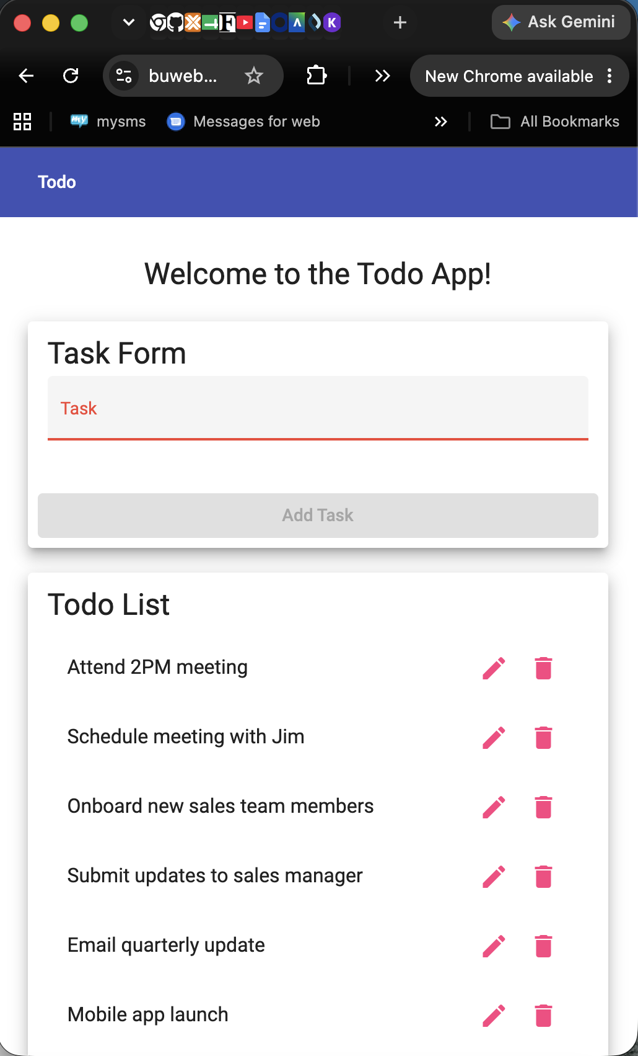
Notes: | Navigated to URL. Test poorly written. “Buy Groceries and Milk” task did not exist, so step 1 failed. Proceeded to test with “Buy Groceries” task. There is no confirmation functionality, so step 2 failed. All that said, the delete function works - item removed from list successfully. Step 3 passed - delete functionality works.

Test Case ID: | TC-006
Test Name: | Custom 404 Error Page
Requirement: | Req #5
Pre-Condition: | A web browser is open.
Step # | Action | Expected Result
1 | Go to https://buwebdev.github.io/todo/fakepage | The browser navigates to that URL.
2 | Look at what page loads. | A custom 404 error page is displayed instead of a generic browser error.
3 | Check that the 404 page has some kind of message or link. | The page has readable text or a way to get back to the app.
Pass / Fail: | Pass  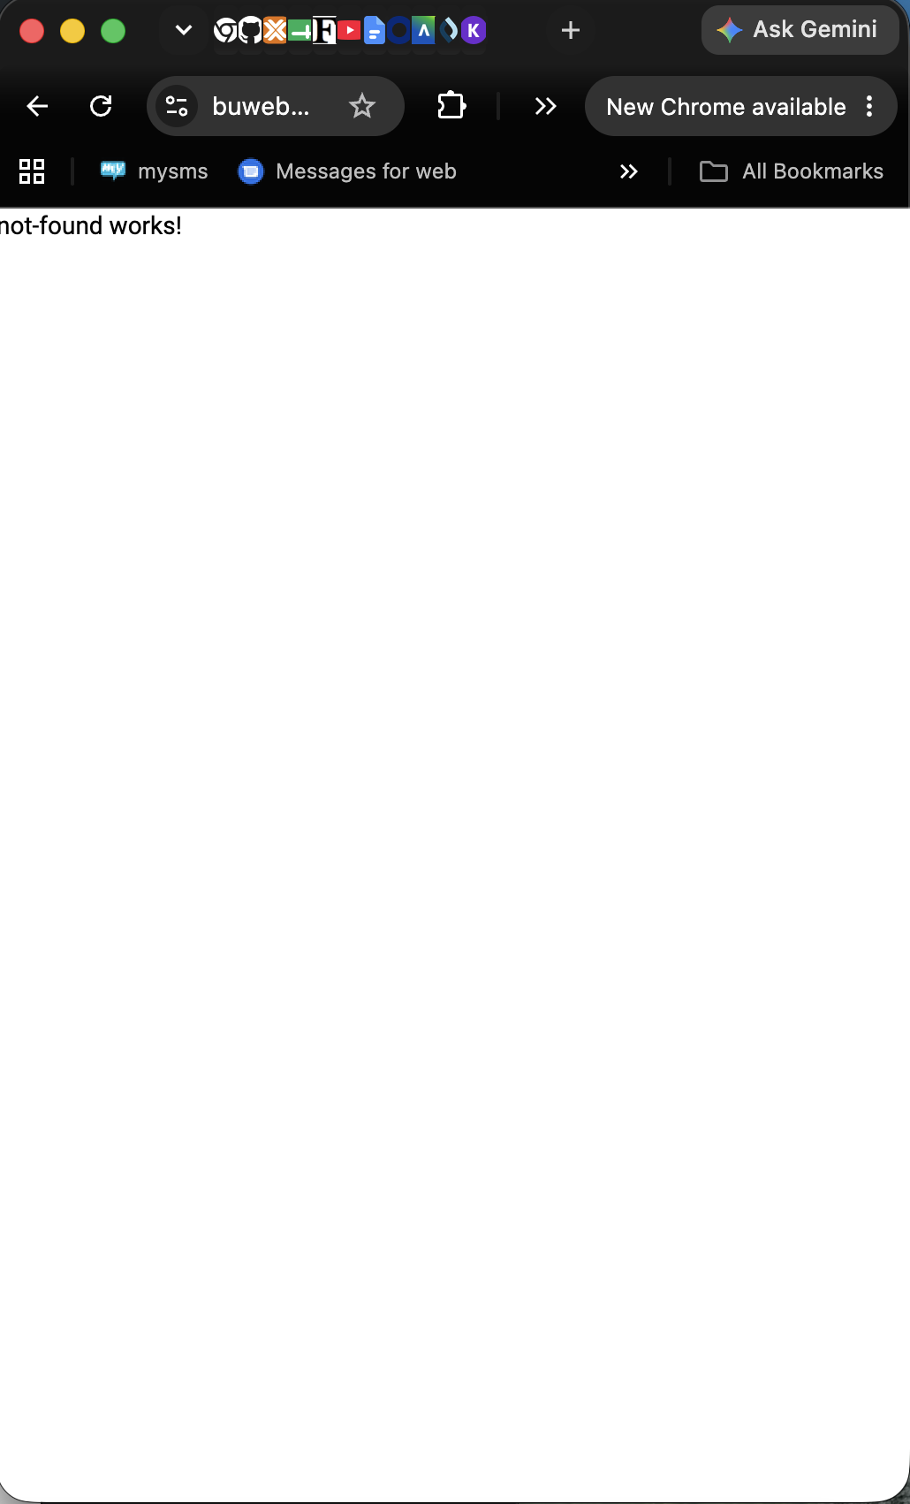
Notes: | Navigated to the modified URL, and observed the page. A custom error message appeared. Test passed.

