Project: Assignment 4.2 (Dan Rojas)
Course: CSD380
Description: test cases
Date: 2026/06/27
To complete the test case plan, fill out the information for Project, Course, Description and Date in the header below.
.
TABLE OF CONTENTS
<View a list of to-do task items> 2
<Delete a to-do task item> 3
<Edit a to-do task item> 4
<For invalid URLs, provide users with a custom 404 error page> 5
<Prevent users from submitting a task form without entering a to-do item> 6

For each test, the developer should: provide a test description, a test objective, the developer name and date tested. For each step, fill out the actions to be taken and describe the expected results, and indicate yes or no for each step depending upon the result. The peer tester should provide their name, date tested, indicate yes or no for each step depending upon the result, and a screenshot (thumbnail) of the result.

Test 1 | <View a list of to-do task items>
 | Test Objective: Verifies existing (default) to-do tasks are displayed to user | Developer: Dan  Date tested: 2026/06/27 | Peer tester: Abram Denzlinger  Date tested: 2026/06/18
Step | Action | Expected results: | Developer pass/fail | Tester pass/fail  + Screenshot
1 | Visit https://buwebdev.github.io/todo/ | Default set of tasks should be displayed | yes | yes  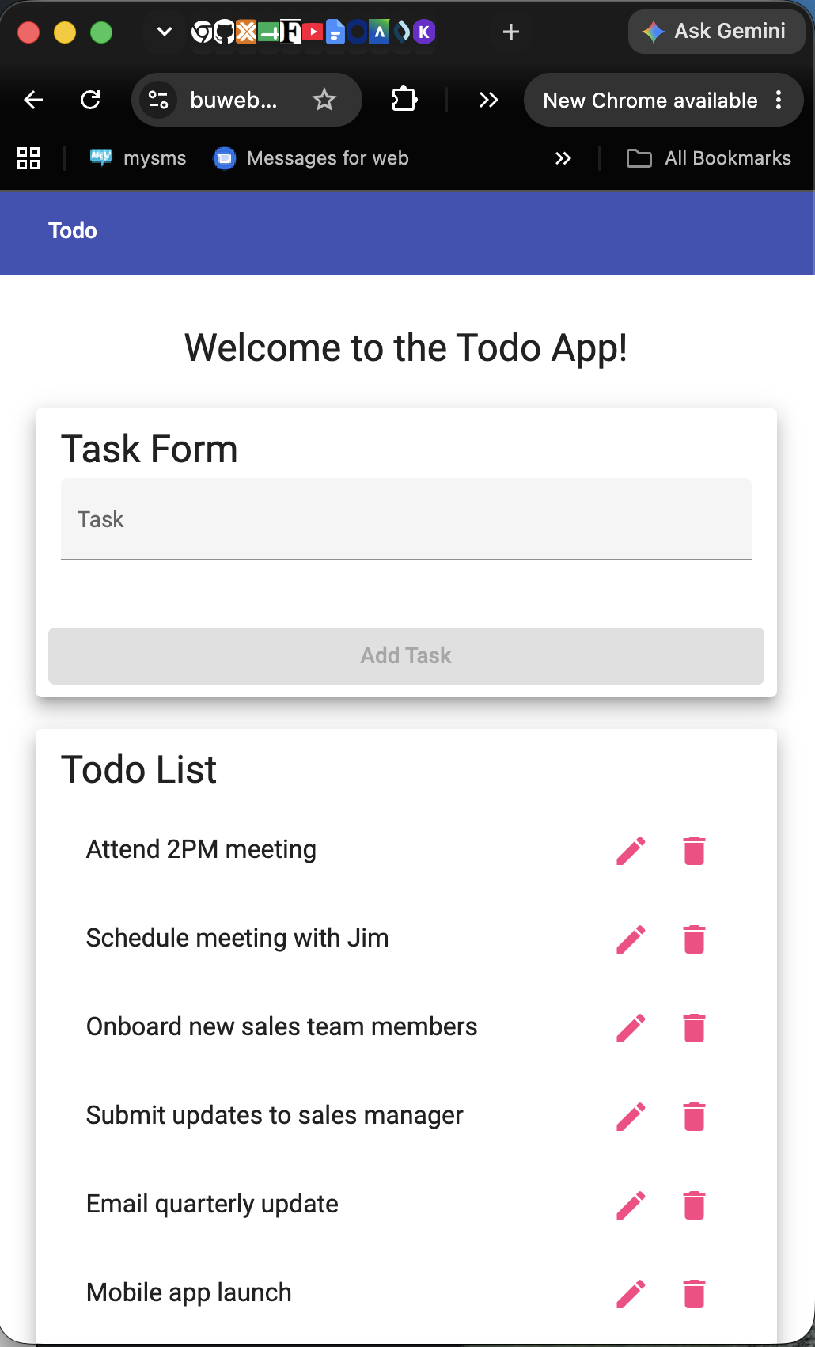
Comments | Peer tester: Navigated to the URL above. Page loaded as expected. Took a screenshot and posted here. Step 1 passed.

Test 2 | <Delete a to-do task item>
 | Test Objective: Verifies a to-do task item on the list can be deleted | Developer: Dan  Date tested: 2026/06/27 | Peer tester: Abram Denzlinger  Date tested: 2026/06/18
Step | Action | Expected results: | Developer pass/fail | Tester pass/fail
1 | Visit https://buwebdev.github.io/todo/ | Default set of tasks should be displayed | yes | yes  
2 | Click trashcan icon to right of a to-do item | Associated to-do item should be removed from list | yes | yes  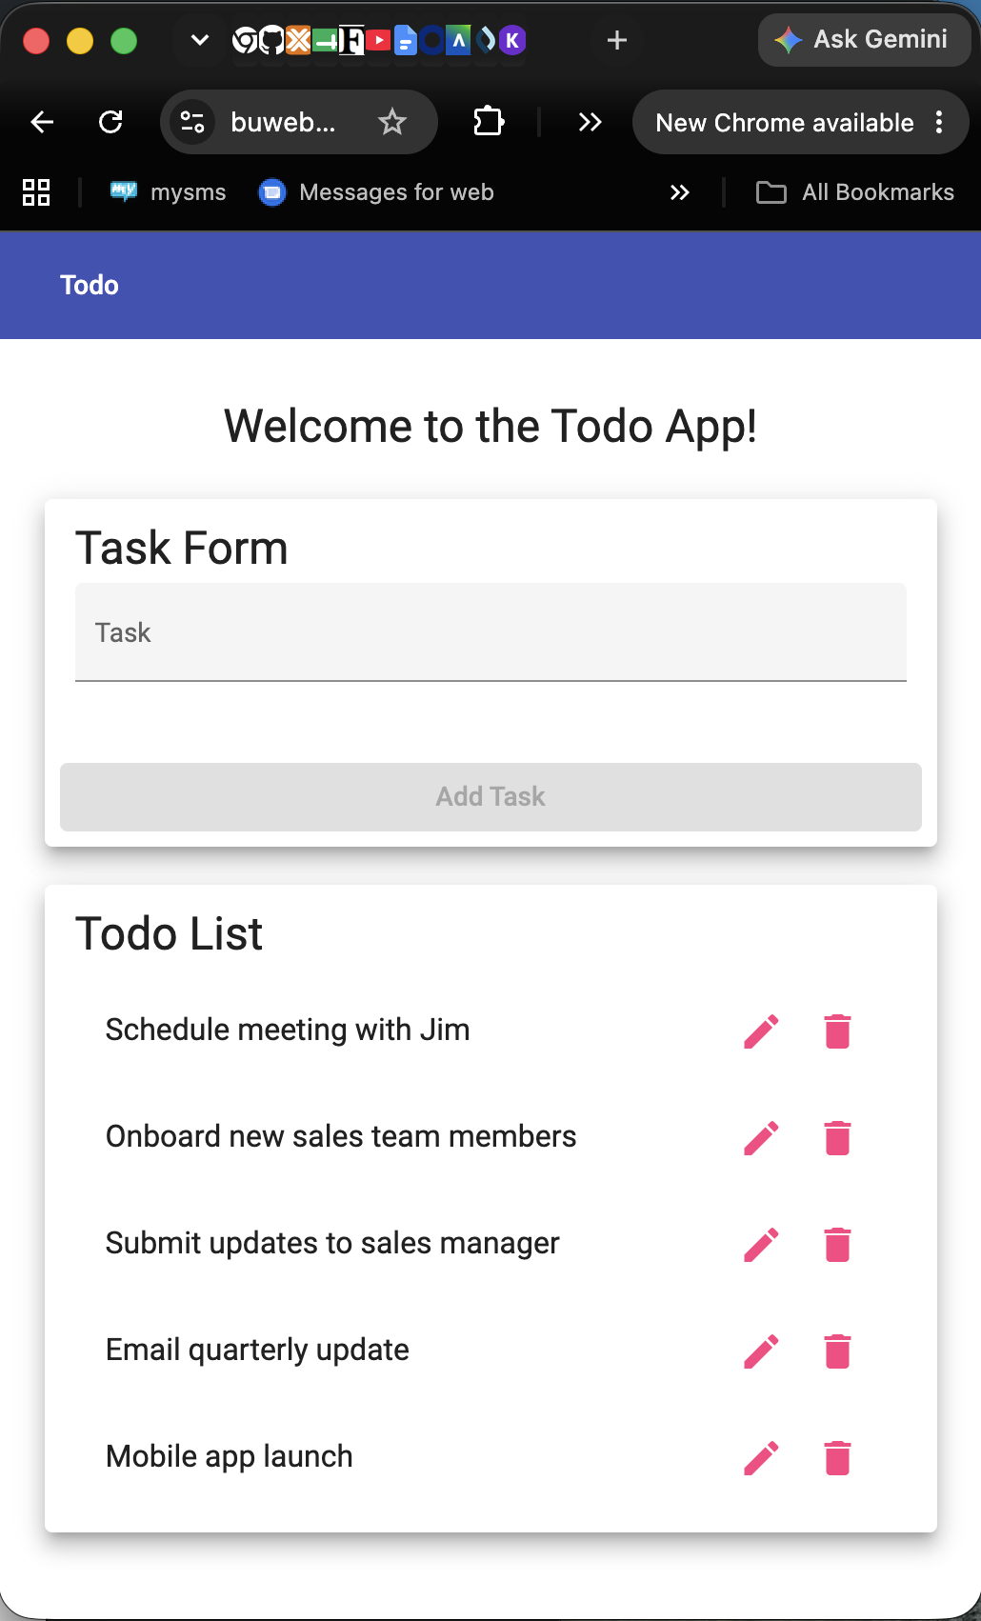
Comments | Peer tester: Navigated to the URL above. Page loaded as expected. Clicked on the trash can icon next to the 2pm meeting item. Item disappeared as expected. Steps 1 & 2 passed.

Test 3 | <Edit a to-do task item>
 | Test Objective: Verifies a to-do task item on the list can be edited | Developer: Dan  Date tested: 2026/06/27 | Peer tester: Abram Denzlinger  Date tested: 2026/06/18
Step | Action | Expected results: | Developer pass/fail | Tester pass/fail
1 | Visit https://buwebdev.github.io/todo/ | Default set of tasks should be displayed | yes | yes  
2 | Click pencil icon to right of a to-do item | Edit form should appear | yes | yes  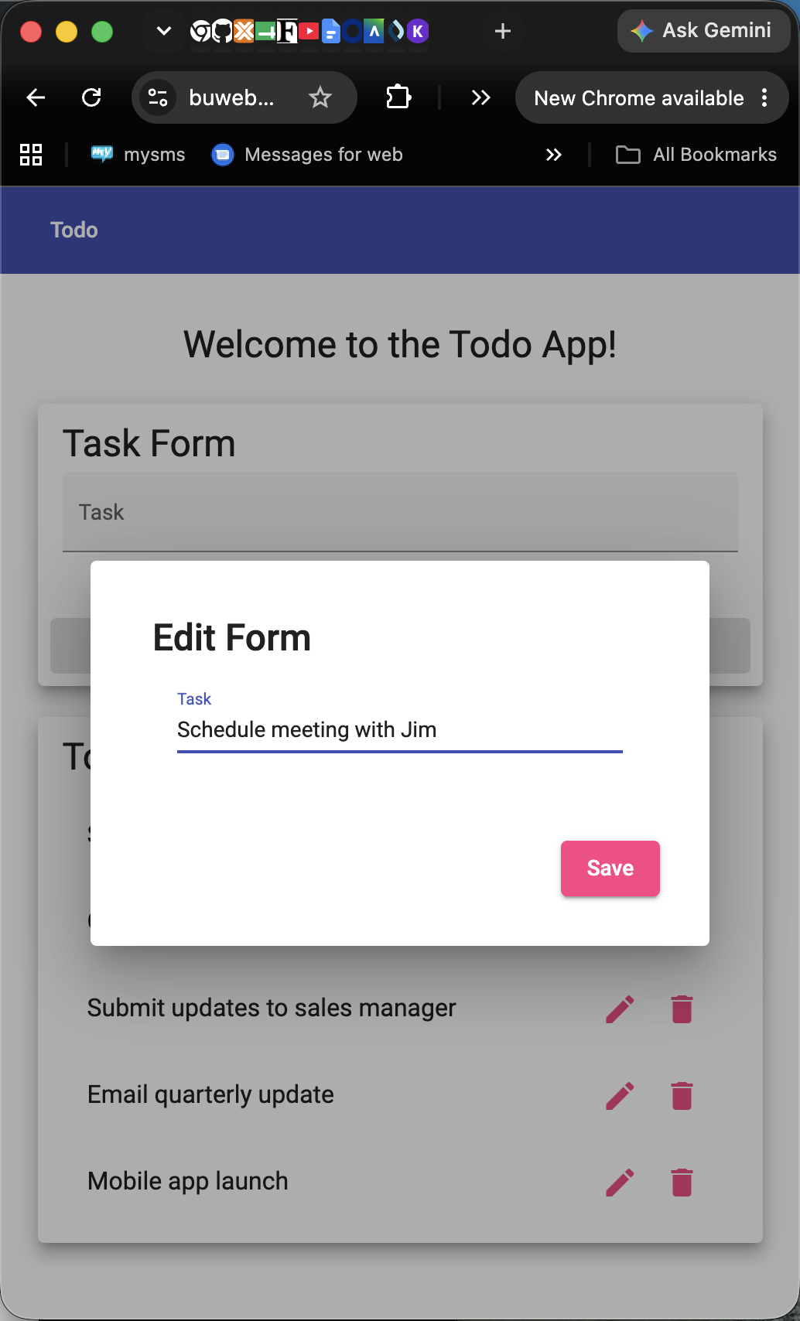
3 | Edit text as desired | Users are allowed to edit task | yes | yes  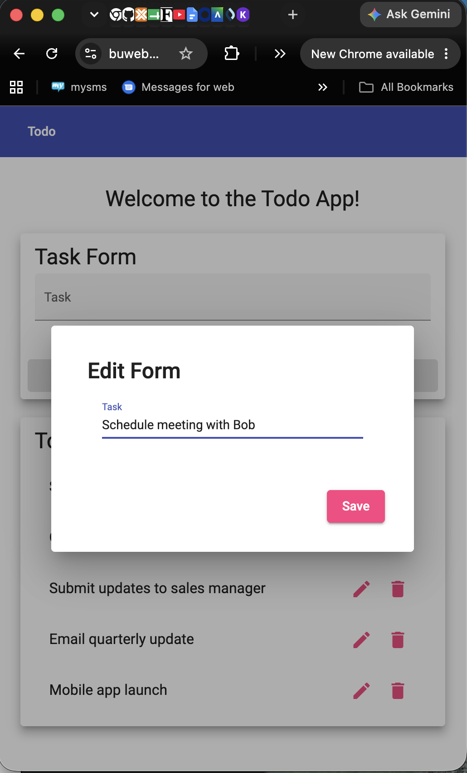
4 | Click the save button | Edit form closes, the list is displayed with edited task | yes | yes  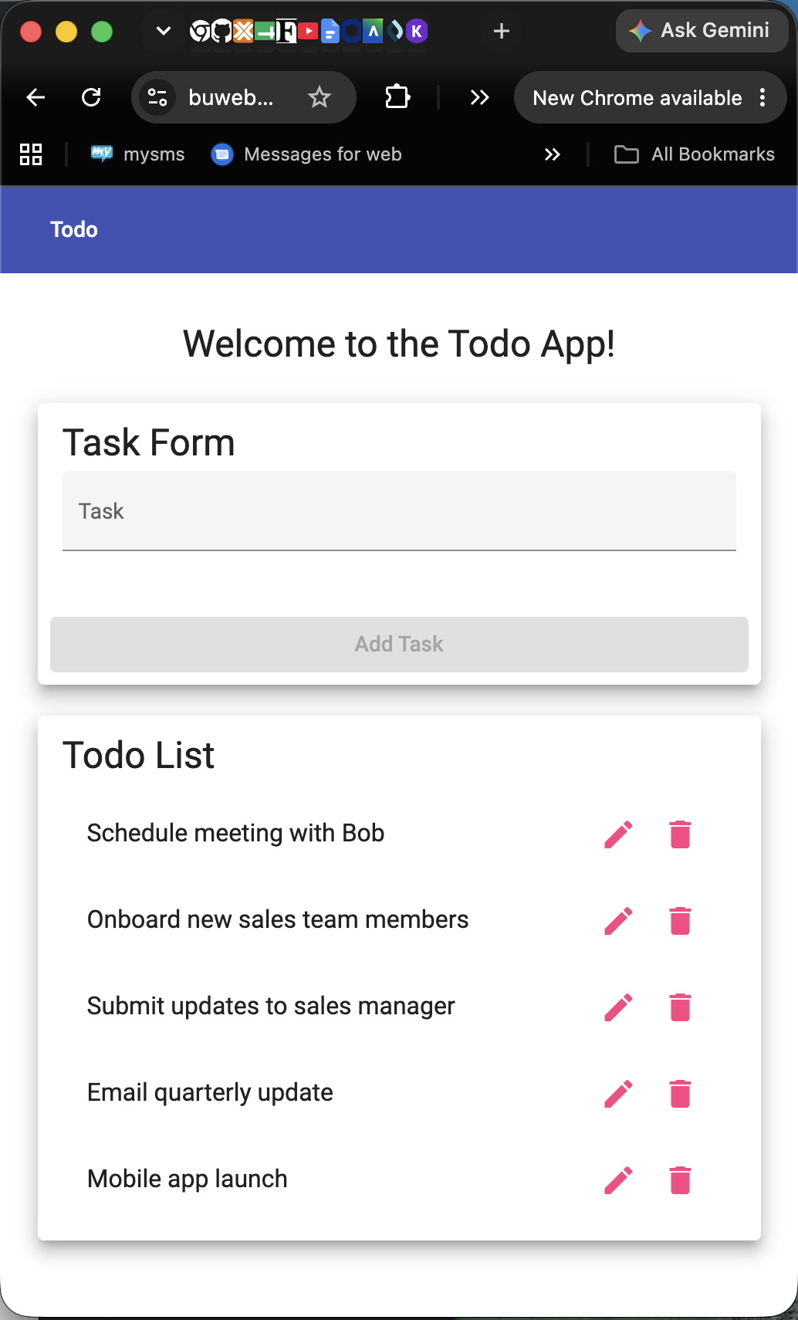
Comments | Peer tester: Navigated to the URL above. Page loaded as expected. Clicked the pencil icon and the edit form appeared. Edited text successfully. Clicked the save button, the form closed and the list displayed the edited list item. Steps 1-4 all passed.

Test 4 | <For invalid URLs, provide users with a custom 404 error page>
 | Test Objective: Verifies a custom 404 page is displayed if visiting the wrong URL | Developer: Dan  Date tested: 2026/06/27 | Peer tester: Abram Denzlinger  Date tested: 2026/06/18
Step | Action | Expected results: | Developer pass/fail | Tester pass/fail
1 | Visit https://buwebdev.github.io/todo/ | Default set of tasks should be displayed | yes | yes  
2 | Append text to end of the URL. | New page stating “not-found works!” is displayed | yes | yes (scroll for thumbnail)  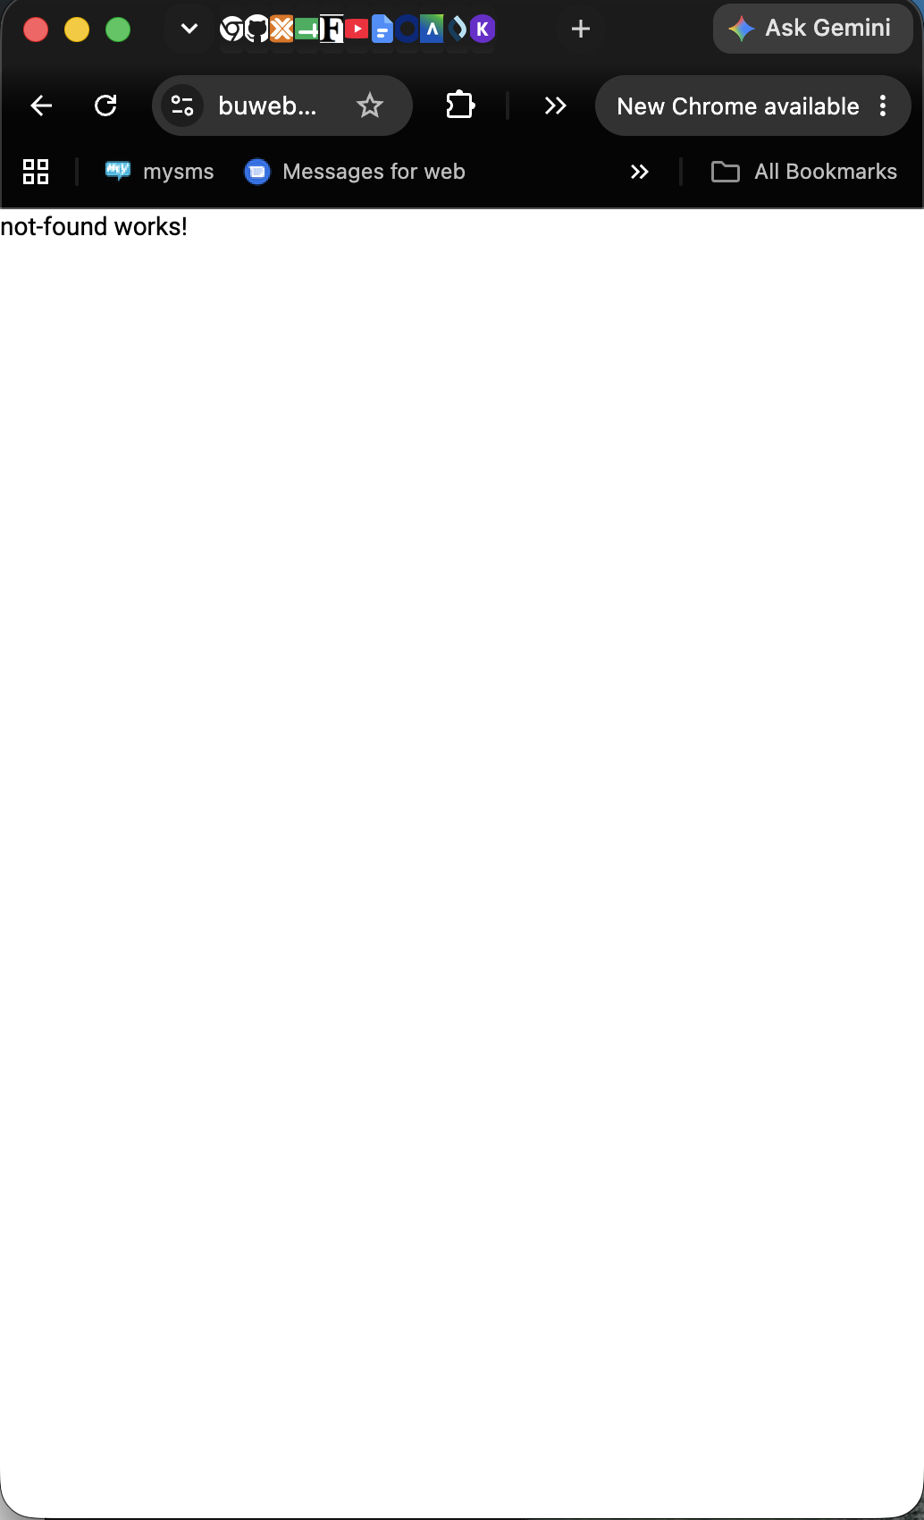
Comments | Peer tester: Navigated to the URL above. Page loaded as expected. Added “1” to the end of the URL to show https://buwebdev.github.io/todo/1. Page displayed the message “not-foundworks!” Steps 1 & 2 successful.

Test 5 | <Prevent users from submitting a task form without entering a to-do item>
 | Test Objective: Verifies a to-do item is included in the edit form before allowing submission | Developer: Dan  Date tested: 2026/06/27 | Peer tester: Abram Denzlinger  Date tested: 2026/06/18
Step | Action | Expected results: | Developer pass/fail | Tester pass/fail
1 | Visit https://buwebdev.github.io/todo/ | Default set of tasks should be displayed | yes | yes  
2 | Click pencil icon to right of a to-do item | Edit form should appear | yes | <yes/no>  
3 | Delete task text | Text should be removed | yes | yes  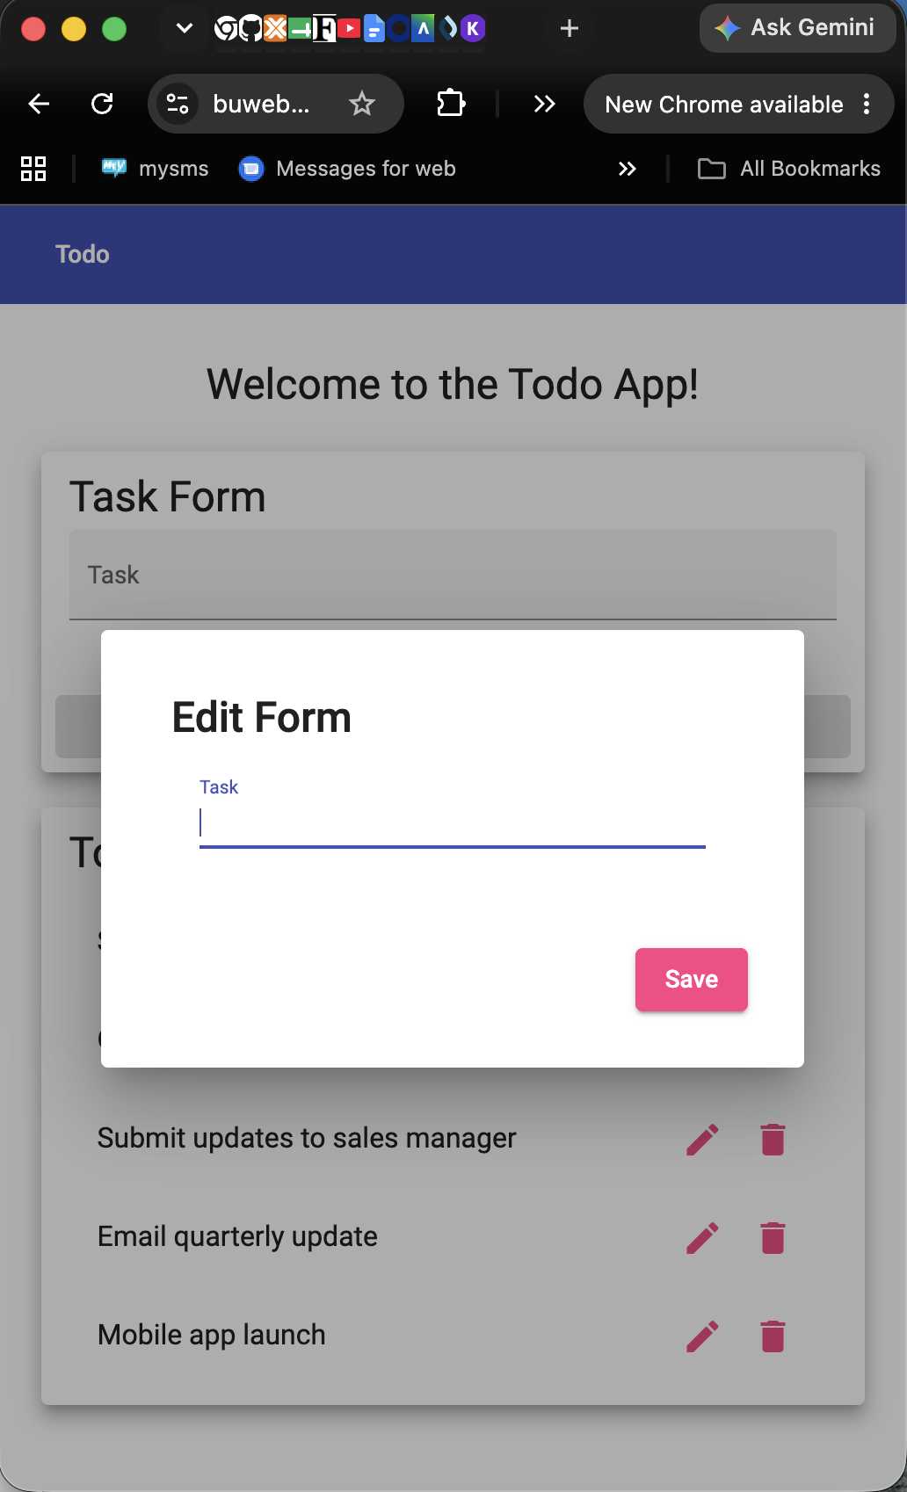
4 | Click save | Error modal informing users of need for text is displayed | no | no (scroll for thumbnail)  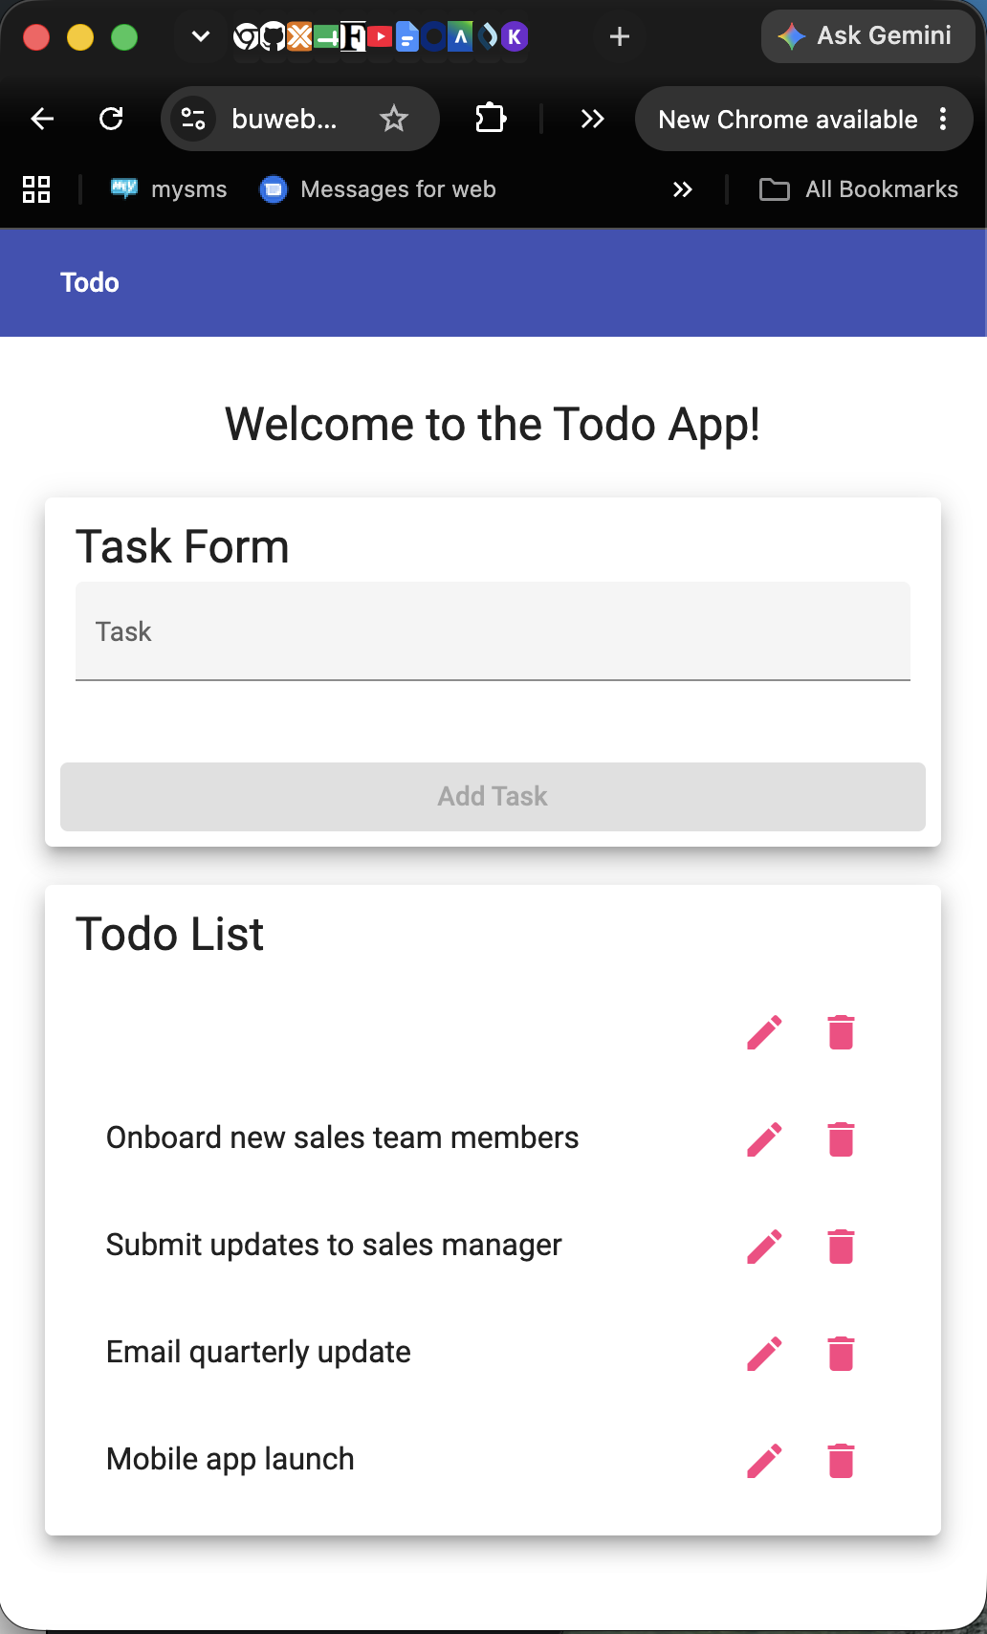
Comments | Peer tester: Navigated to the URL above. Page loaded as expected. Clicked the pencil icon to edit a task, deleted text, and clicked save. Item saved as a blank to-do. Steps 1-3 passed, step 4 failed.

