Abram Denzlinger
July 2, 2026
Assignment 5.2
Value Stream Mapping
Introduction
Value Stream Mapping (VSM) is an effective way to uncover process inefficiencies, even in normal, everyday routines. For this exercise I chose to map my monthly budgeting and bill paying processes. In general the steps are: check bank balance, pay bills, save, invest. The analysis below shows how VSM and Lean analysis can be used to improve efficiency.
Value Stream Mapping
I outlined my budgeting process on paper, and then used mermaid.live to generate code and the VSM graphic. Here is the Value Stream Mapping in graphic and grid forms:

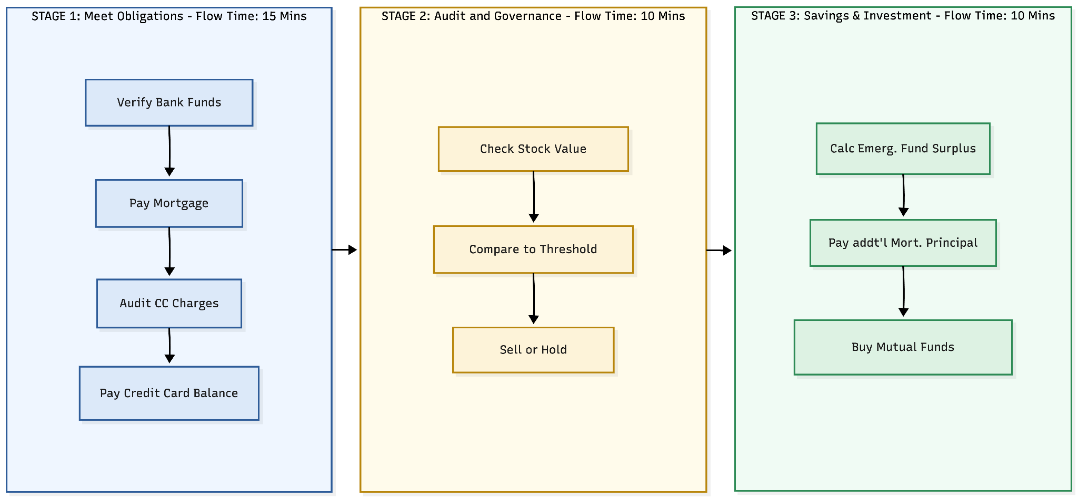

Stage | Activity | Portal/Platform | Description
Meet Obligations | Verify Funds -> Pay Mortgage -> Pay Credit Card Balance | Bank/Mortgage/CC Portals | Verify cash availability and pay scheduled debt obligations.
Audit & Governance | Check Stock Value -> Compare to Threshold | Company Stock Brokerage | As stock units vest monthly, inspect value to determine if current market prices align with personal "sell" thresholds.
Savings and Investment | Execute Investment/Principal Payment | Personal Brokerage/Bank | Ensure emergency funds, then move surplus cash into long-term investments or extra mortgage principal reduction.

Analyzing Lean Metrics: Estimated Average Flow Time
To analyze this, I’ve estimated the time required for each stage, including the added friction of logging in to different apps and navigating portals.
- Meet Obligations: 15 Mins
- Audit & Governance: 10 Mins
- Capital Allocation: 10 Mins
- Estimated Cycle Time: 35 Mins
Optimizing Processes: Lean Improvements
Using the data-driven approach outlined our reading, I’ve identified waste and potential orchestration and governance improvements.
- Eliminating Waste (also overlaps Governance)
Audit Frequency: The manual check of the credit card statement for anomalies is a recurring task. I’ve never found any errors, so theoretically I could move to a more passive approach, like only logging in if I receive an automated spending notification. This would save the manual review time each month, but also add some risk. An urgent risk is money-costing errors, or even fraud, slipping through the cracks. Another potential risk is developing spending blind spots by losing visibility to bad spending habits or recurring monthly charges.
- Workflow Orchestration (also overlaps Governance)
Automated Governance: I currently perform a manual inspection of stock prices. By implementing a standing limit order in my company brokerage account to sell automatically when a specific price is hit, I could orchestrate this step to happen without manual intervention. This transforms the Audit stage from a manual task to an automated system response. The risk here would be in missing out on potential gains by automated selling during growth-favorable conditions. However, since this money is reinvested anyway (albeit in a safer, more diversified way), the risk in making this change is essentially mitigated.
- Governance Models (also overlaps Workflow Orchestration & Eliminating Waste)
Threshold-Based Triggers: Since one of the last steps in my process is to verify the emergency fund balance and replenish it if needed, and emergency funds far exceed monthly obligations, verifying the account balance again at the beginning of the next cycle is essentially unnecessary. Instead of logging in to verify account balances, I could create a governance model where I only perform manual tasks when specific "failsafes" are tripped, such as an automated alert from my bank indicating liquid funds have fallen below my emergency fund threshold.
By adopting these optimizations, I could effectively reduce the number of logins and manual inspection steps, thereby lowering the total cycle time and moving closer to a "low-touch" financial management system.
Conclusion
This exercise illustrates how Value Stream Mapping can uncover latent inefficiencies in even well-established daily routines. It has demonstrated that Lean improvements rarely act in isolation; rather, they are deeply interconnected. For instance, leveraging robust governance models can simultaneously eliminate waste, while workflow orchestration can effectively automate governance. Consequently, sophisticated Lean implementations often optimize across these categories concurrently to drive process efficiency.
Finally, this process highlighted that Lean optimizations inherently involve risk, and this is a critical dimension not deeply explored in our reading. While risks for my second and third improvements are largely mitigated by existing downstream mechanisms, the potential blind spots introduced by Improvement #1 suggest that, in this specific case, the risks outweigh the benefits. Ultimately, this exercise underscores that while VSM provides the framework for optimization, the human element of risk assessment remains the final arbiter of change.

