Abram Denzlinger
June 7, 2026
Assignment 1.2

git repository: https://github.com/denzlinger-lab/csd-430
git screenshot:
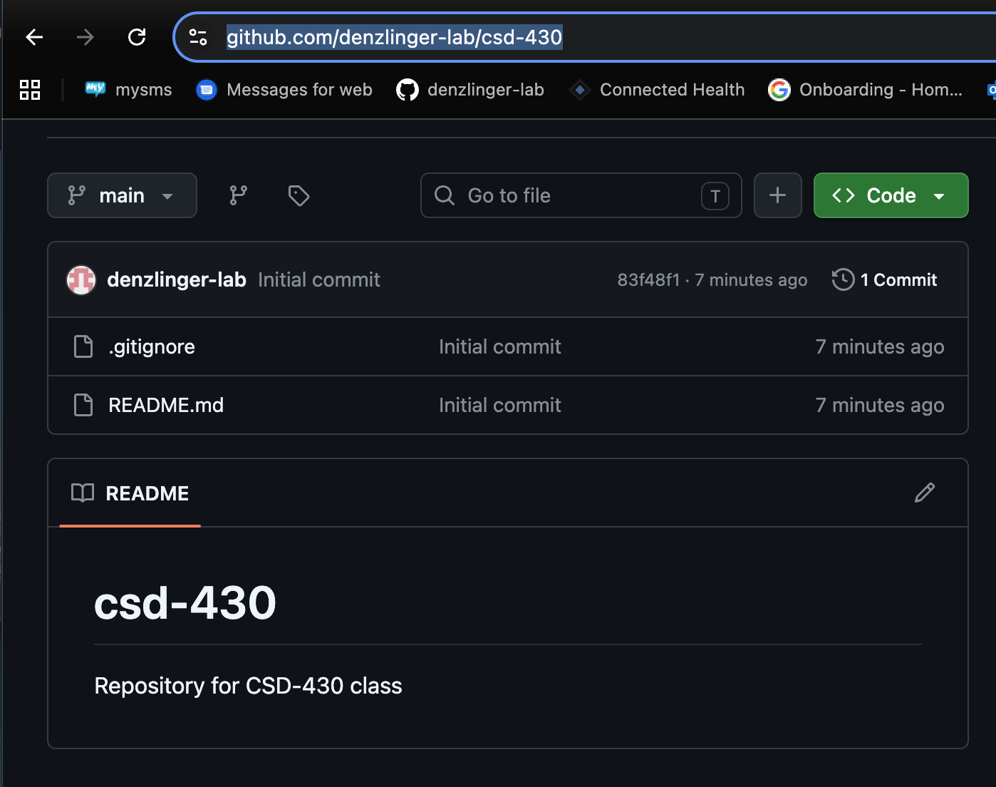
local csd folder contents:
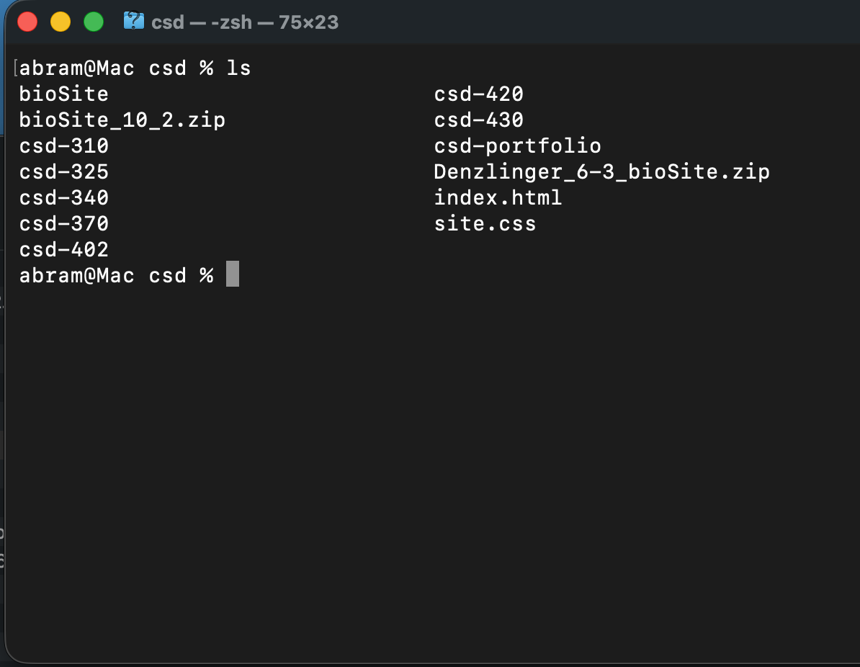
initial push complete:
