Abram Denzlinger
June 21, 2026
Assignment 3.2 - Working with JSP Forms

Java and Java compiler installed
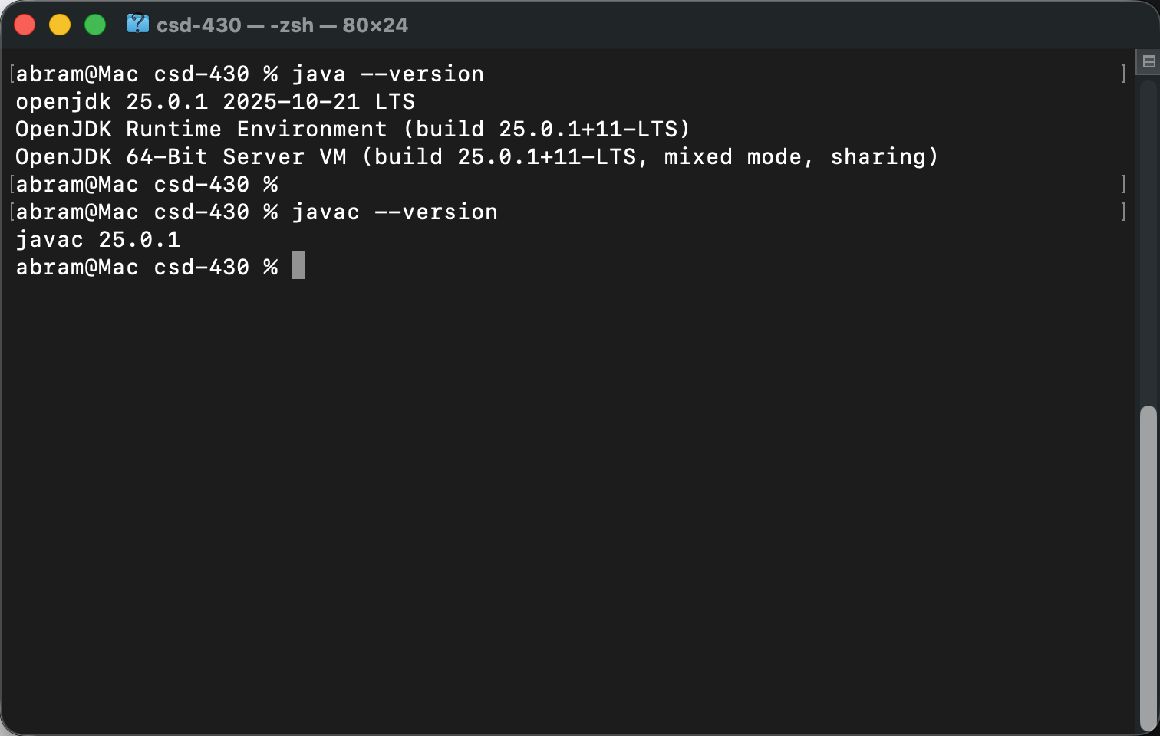
Libraries linked to module3Form project:
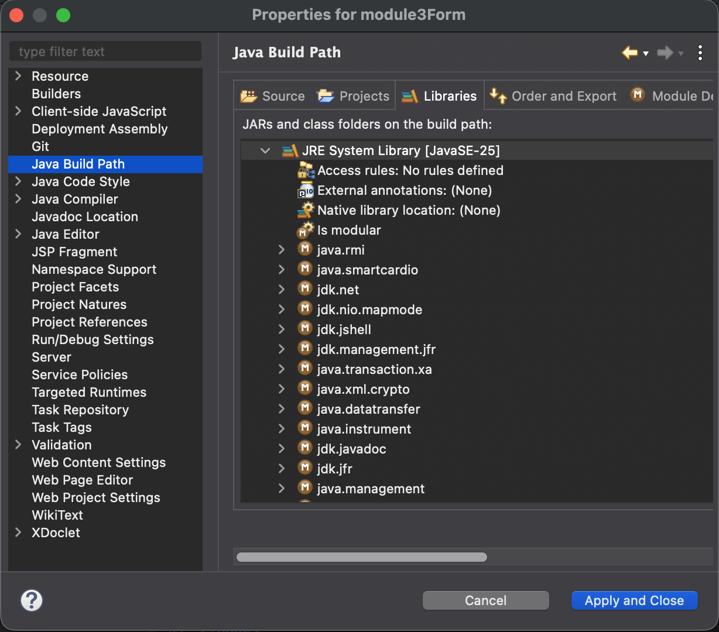

Form:
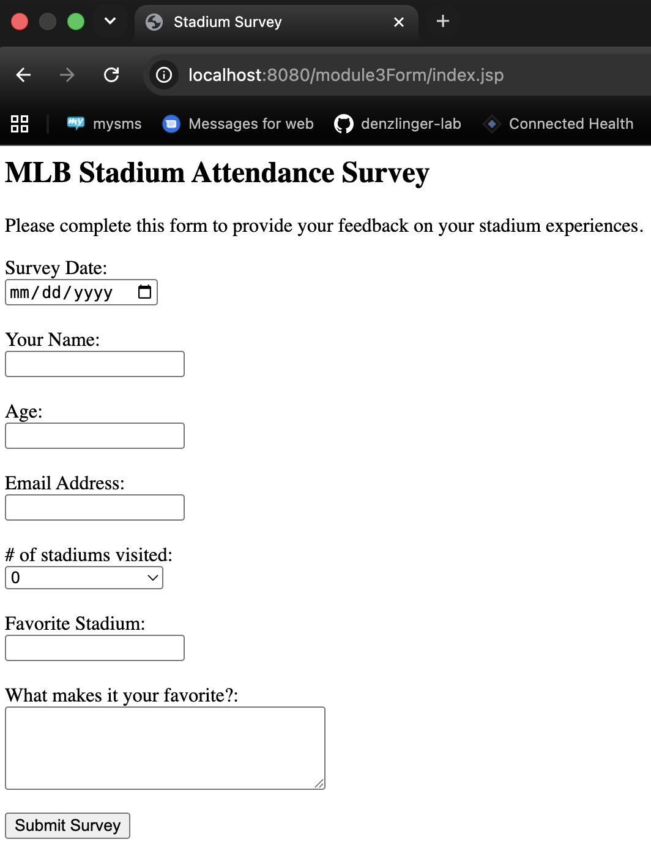
Results:
