Abram Denzlinger
July 2, 2026
Assignments 5.2 & 6.2

abram_setup.sql functions:
- Creates CSD430 database, if needed
- Drops abram_movies_data, if exists
- Creates abram_movies_data table
- Populates abram_movies_data table with 10 records
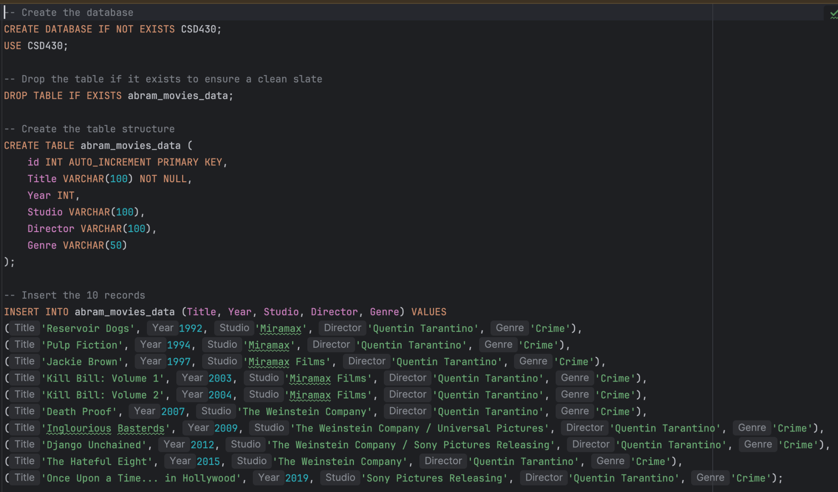

Using the command line:
- Ran abram_setup.sql with student1 credentials
- Logged in to MySQL with student1 credentials
- Selected database CSD430
- Showed abram_movies_data table is present
- Displayed abram_movies_data table records
