Abram Denzlinger
June 27, 2026
Module 4.2 - JavaBean

Java and Java compiler installed:
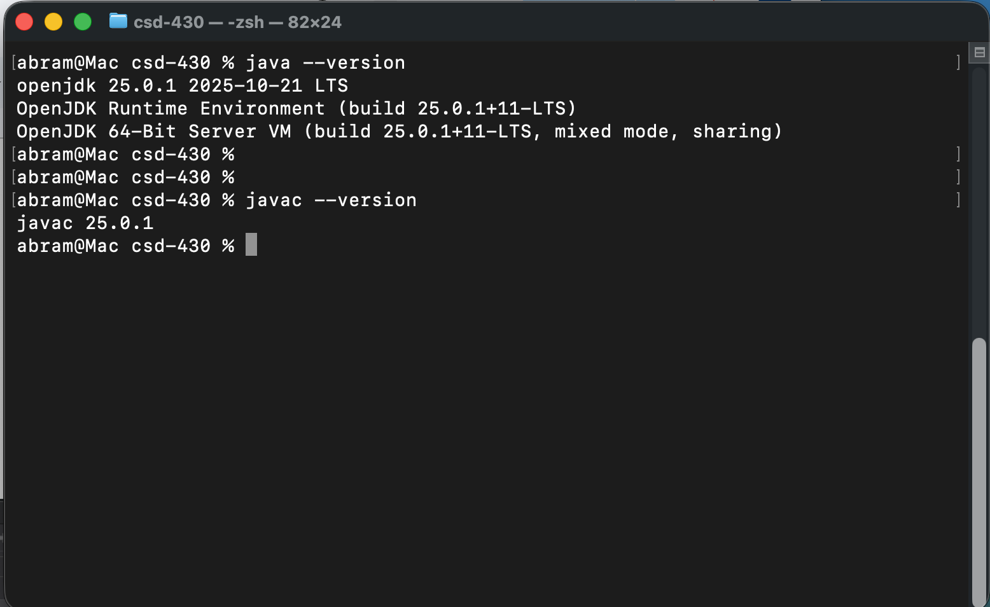

Java libraries linked to Module 4-2 project:
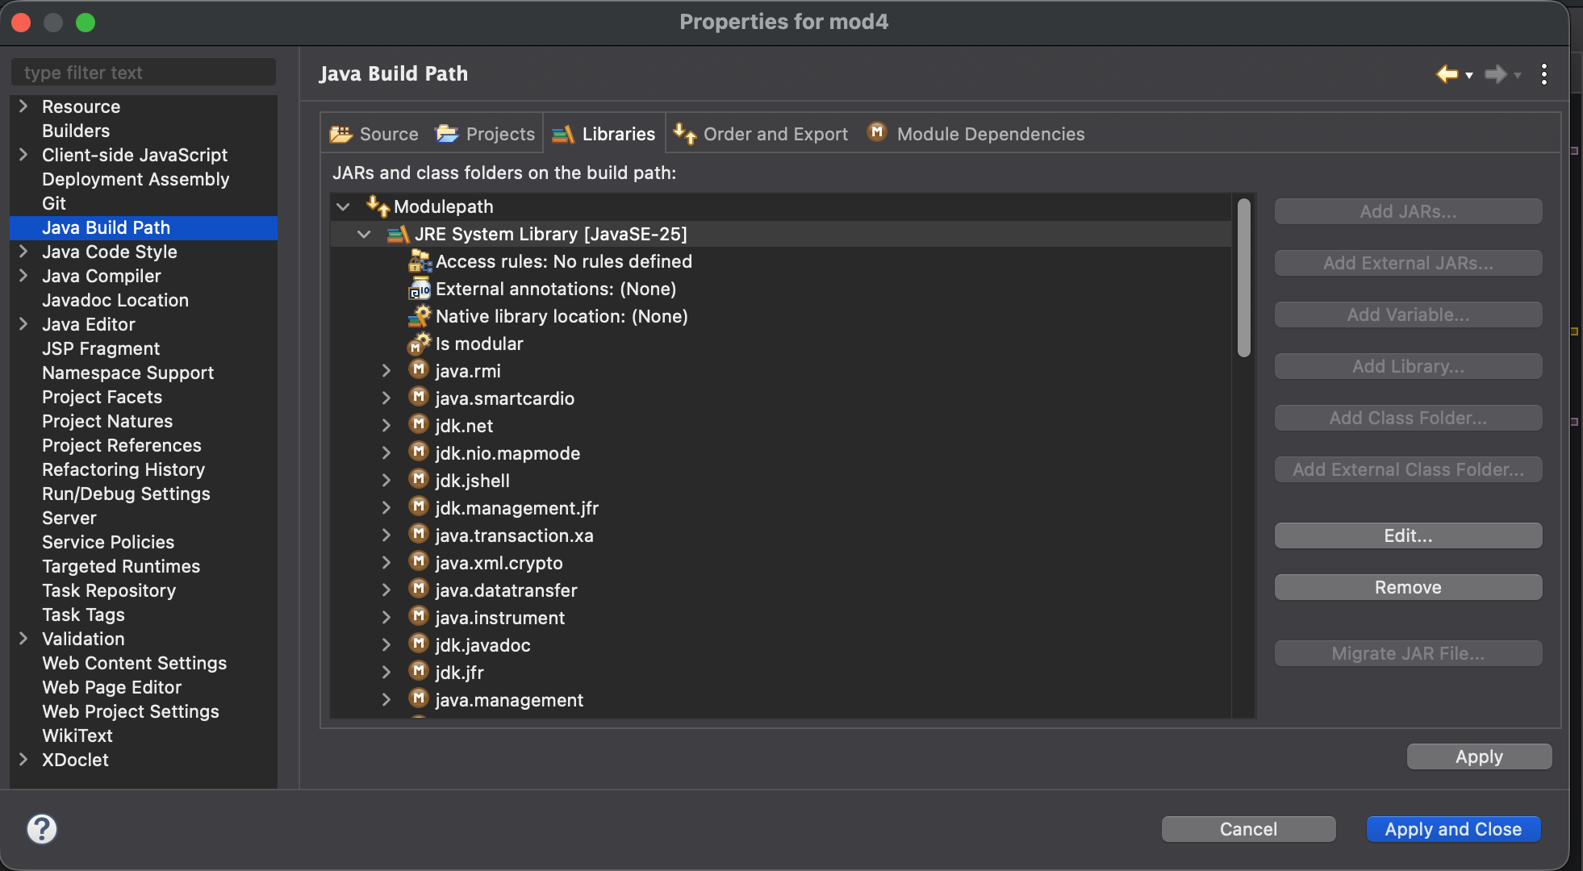

Web page launched from program run:
