Abram Denzlinger
June 13, 2026
Assignment 2.2 - Java Scriptlet - Data Display

Java and Java compiler installed:
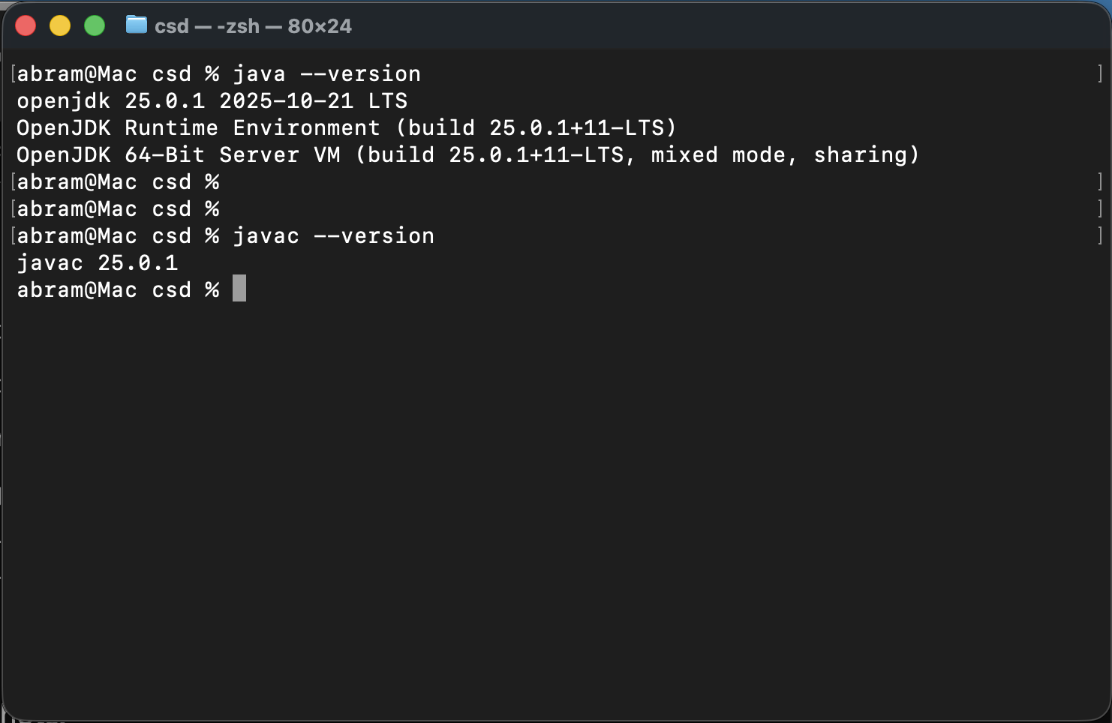

Java libraries linked to Module 2-2 project:
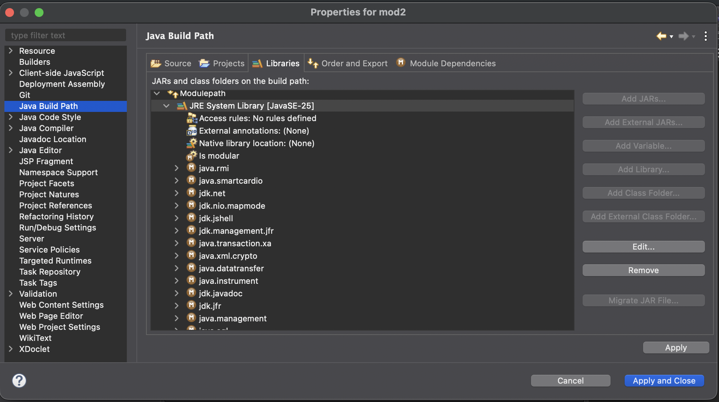
Web page launched from program run:
