Abram Denzlinger
August 12, 2026
CSD440 - Module 1.2 - GitHub Setup

Screenshot of your GitHub repository
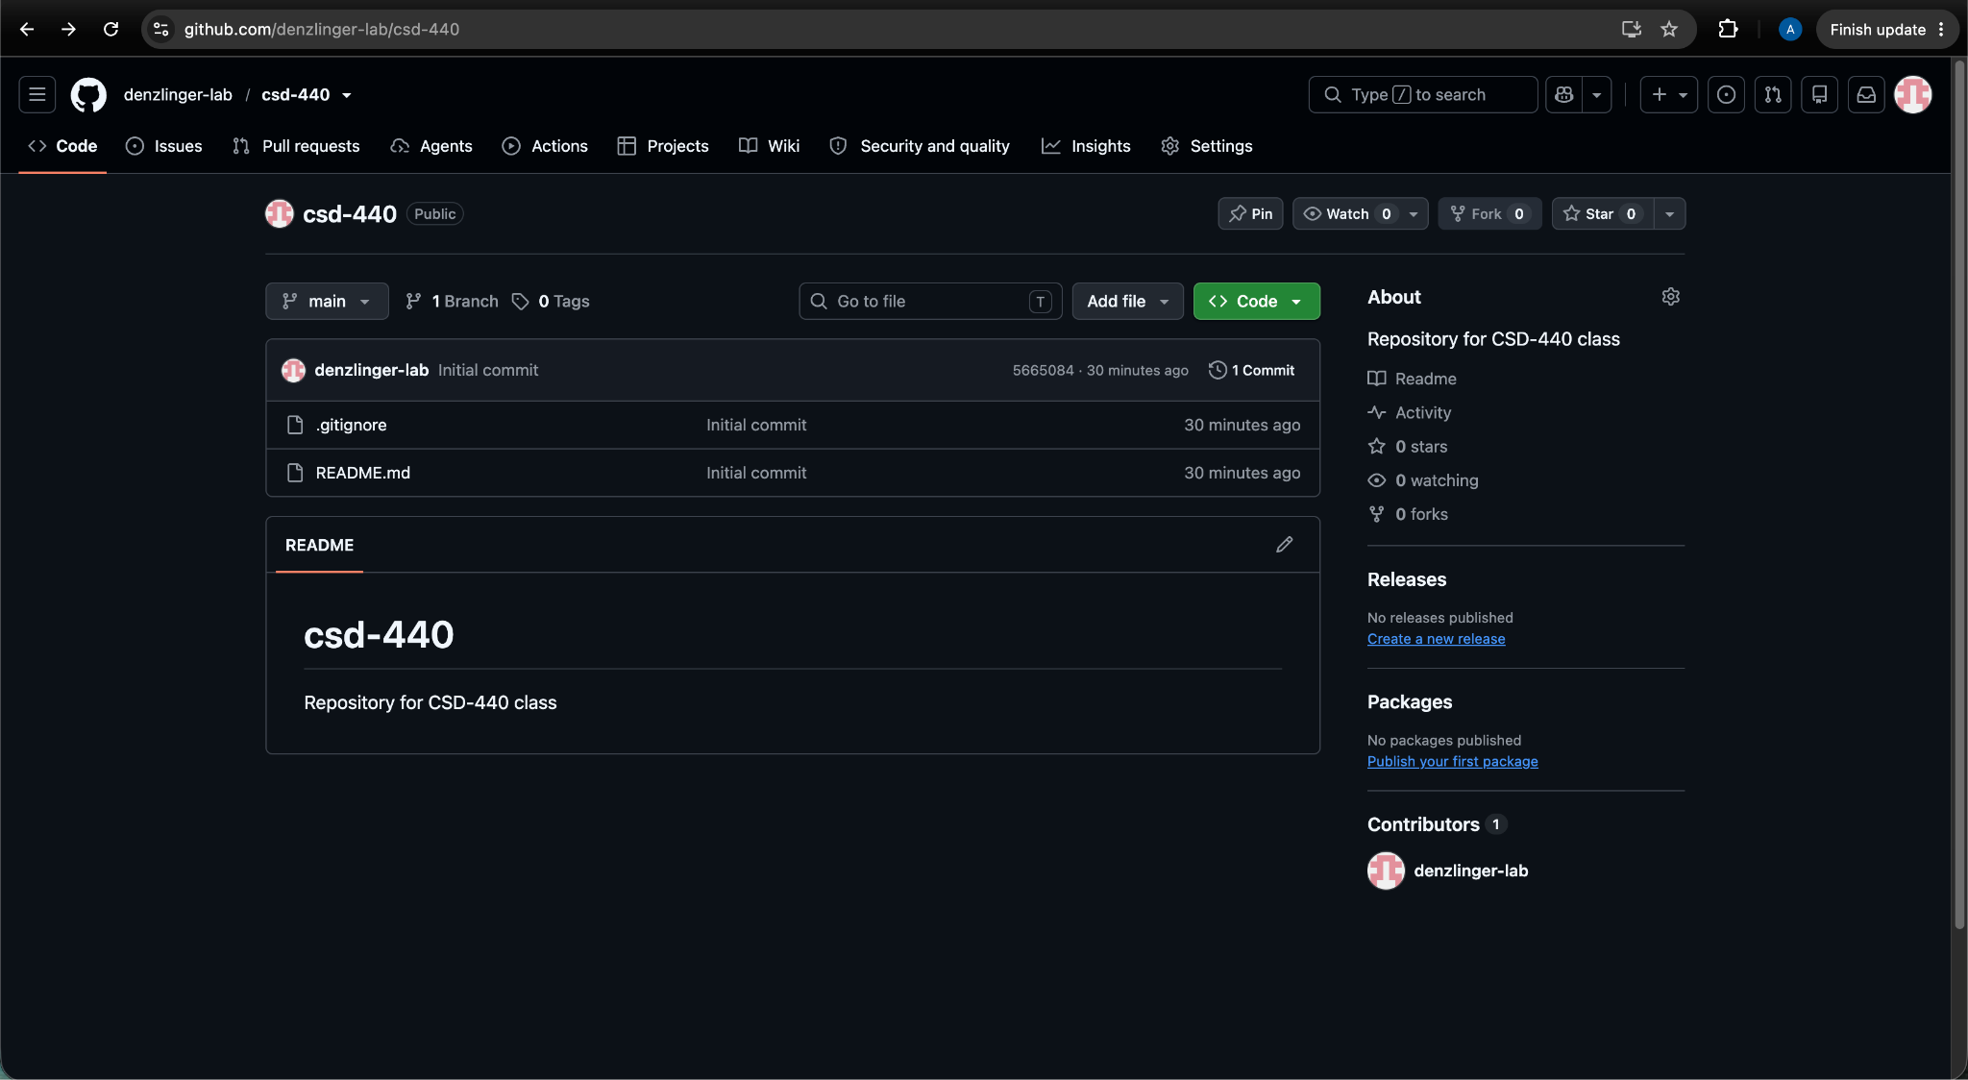

Screenshot of local directory, following the structure format provided in the instructions.
