Abram Denzlinger
September 26, 2026
CSD440 - 9.2 Assignment
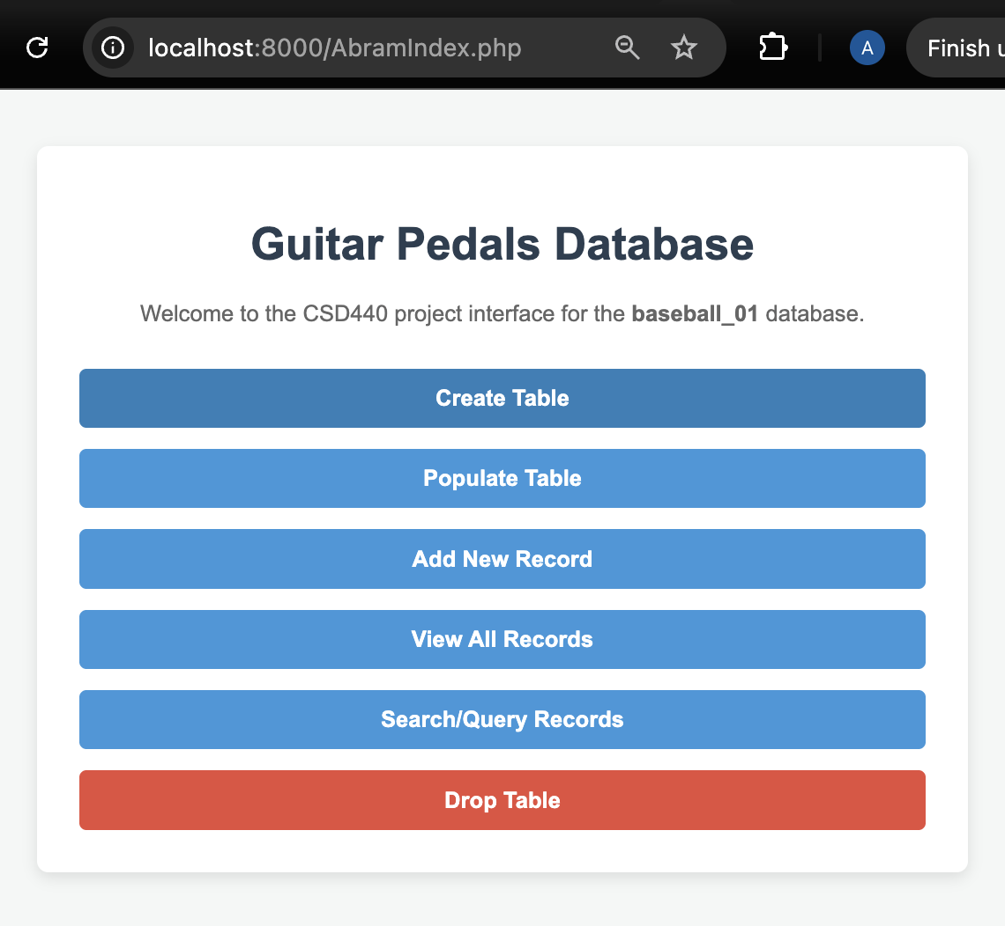
View Records demonstrates table is empty
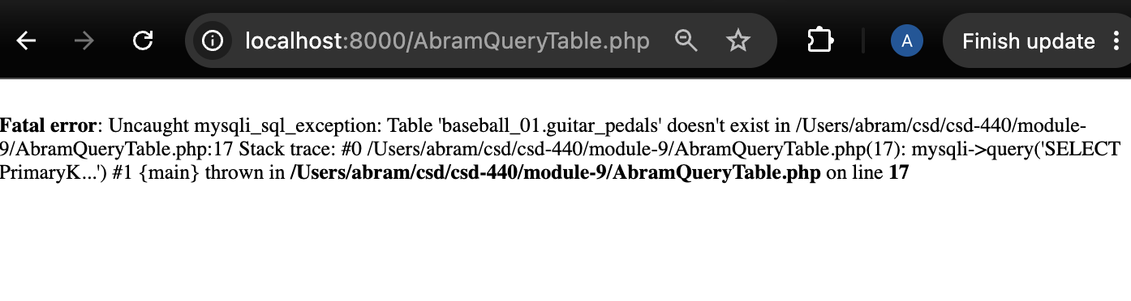
Table created
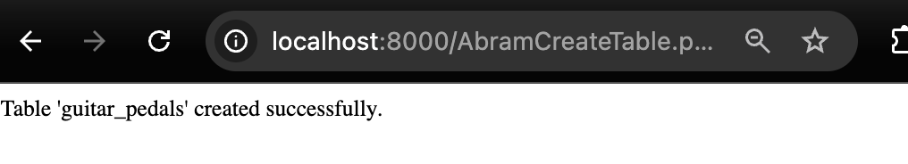
Table populated

Query table now returns records
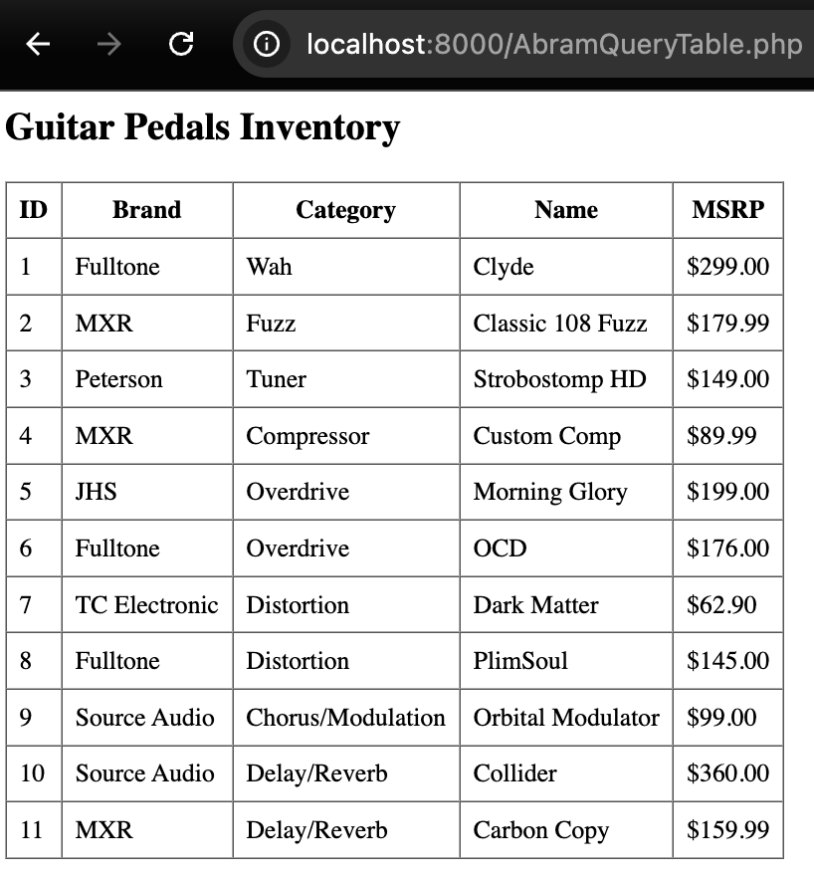
Add record
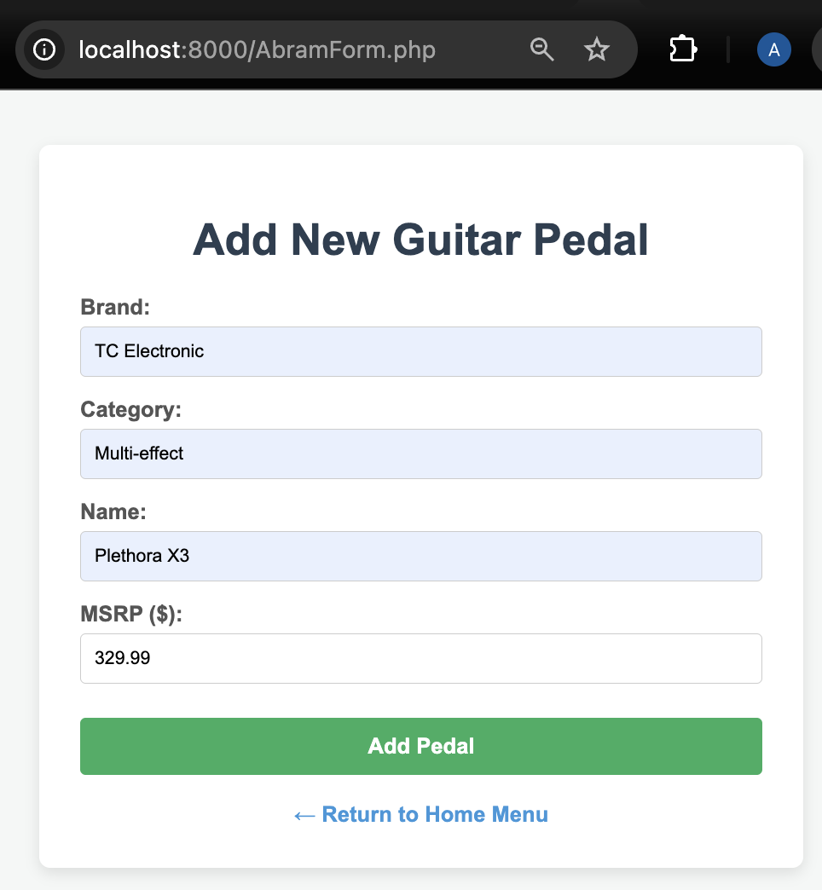
Record added successfully
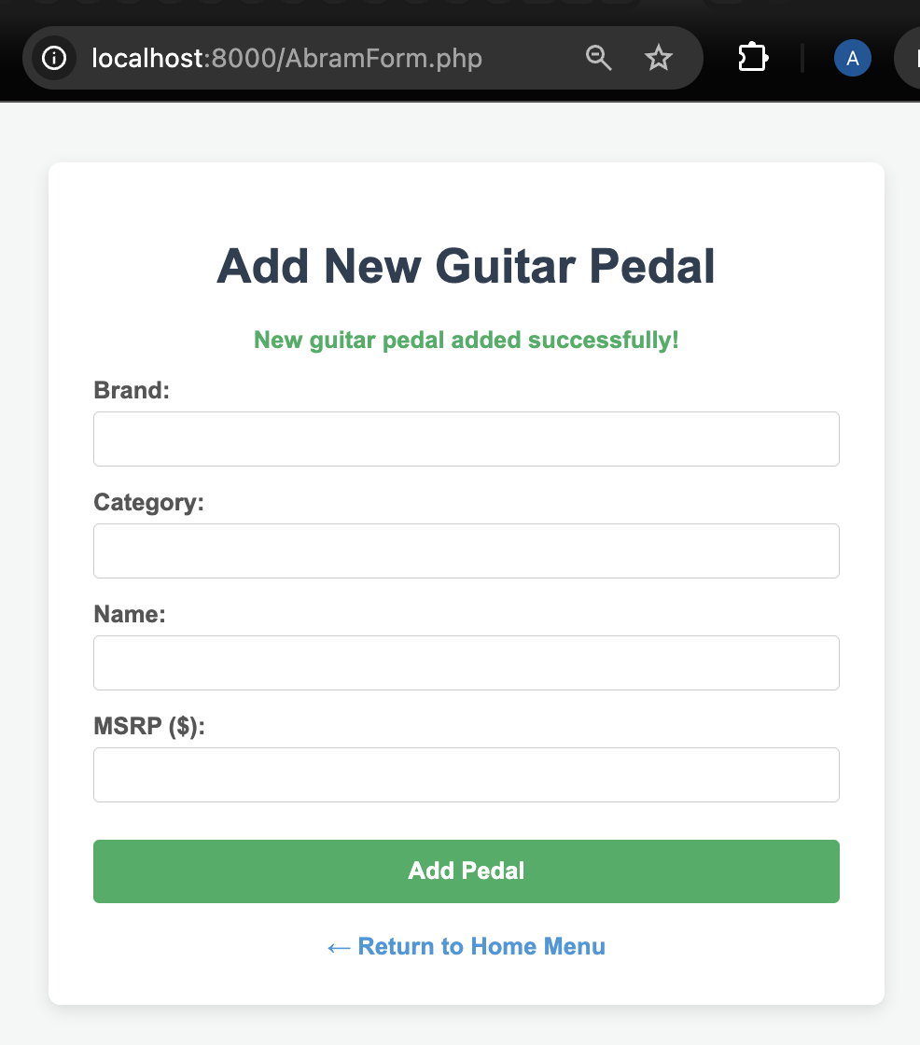
Query table includes newly added record
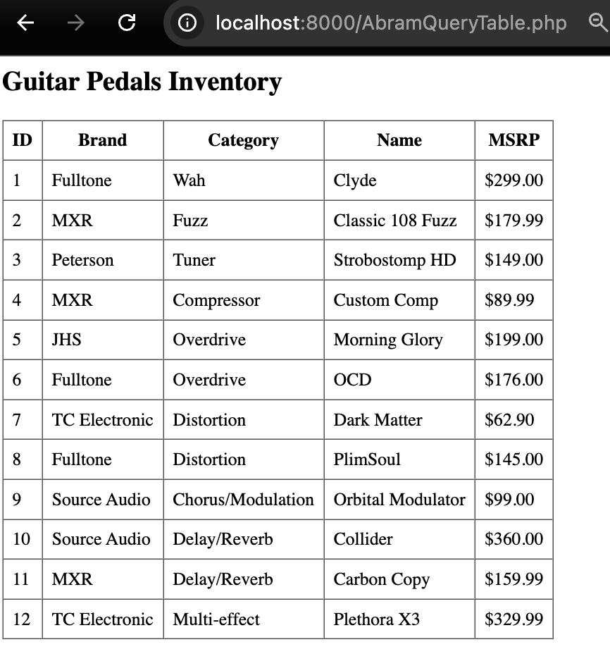
Search function works
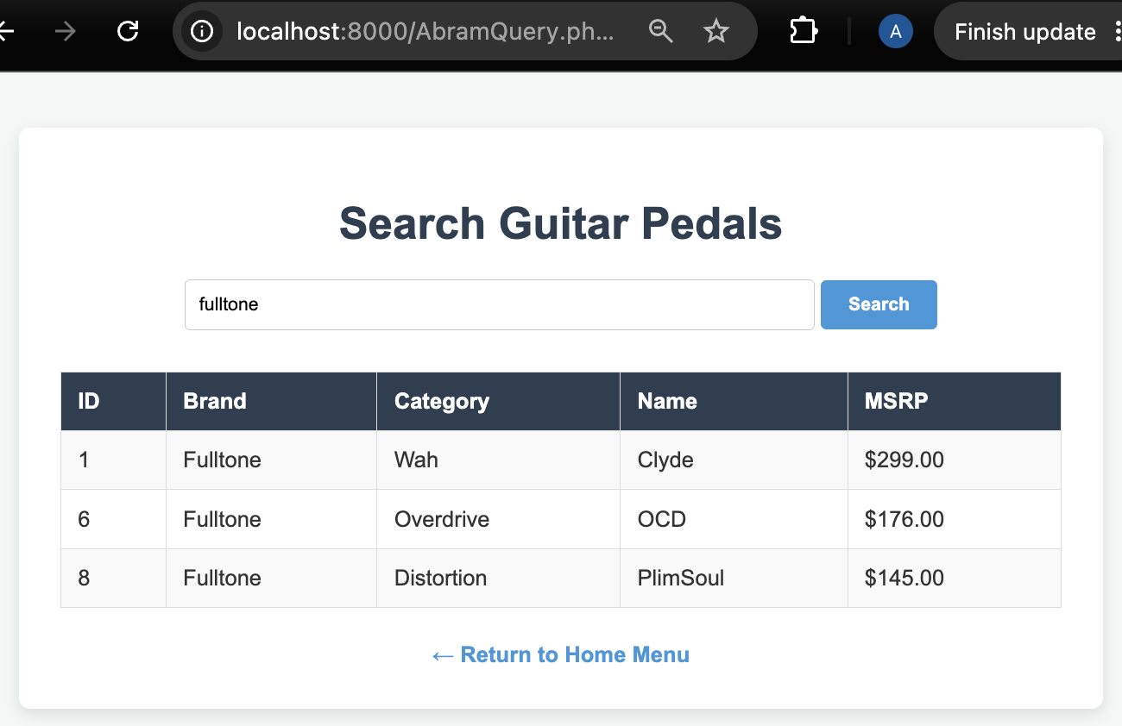
Drop table works


