Abram Denzlinger
October 1, 2026
CSD440 - Assignment 10.2

Fields require entry
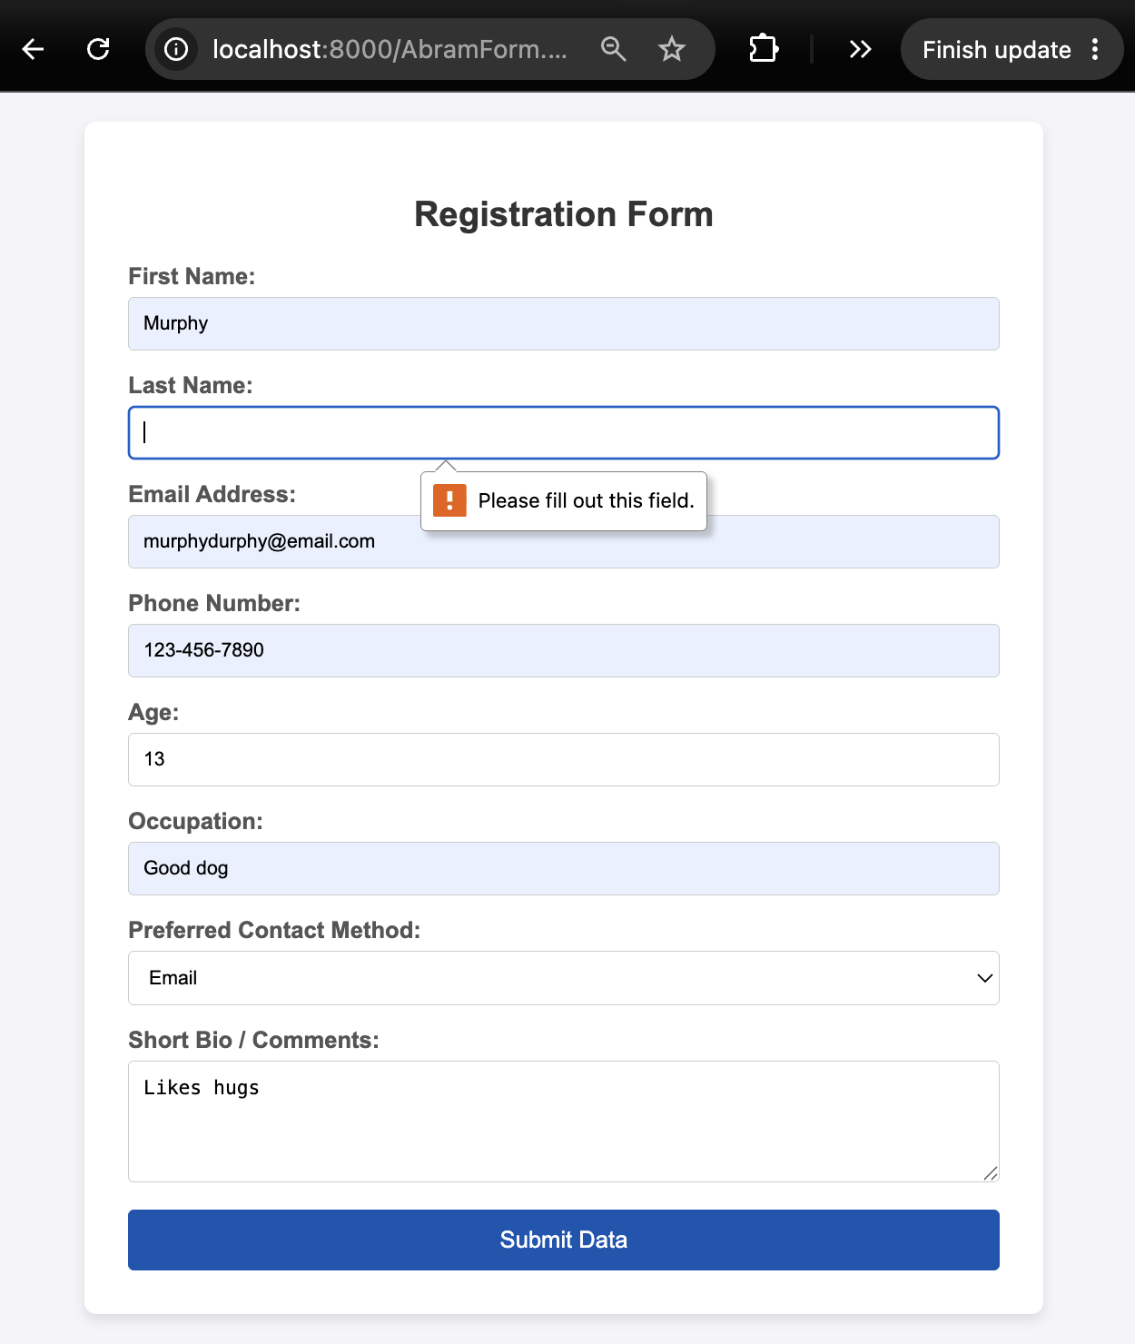

Output and formatting
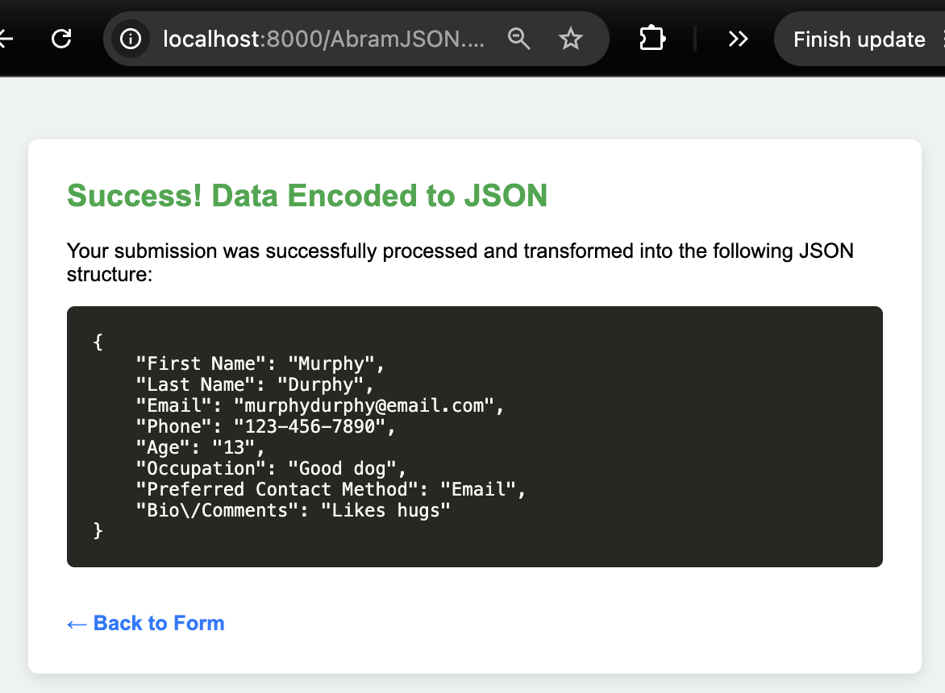
Email address requires an ‘@’
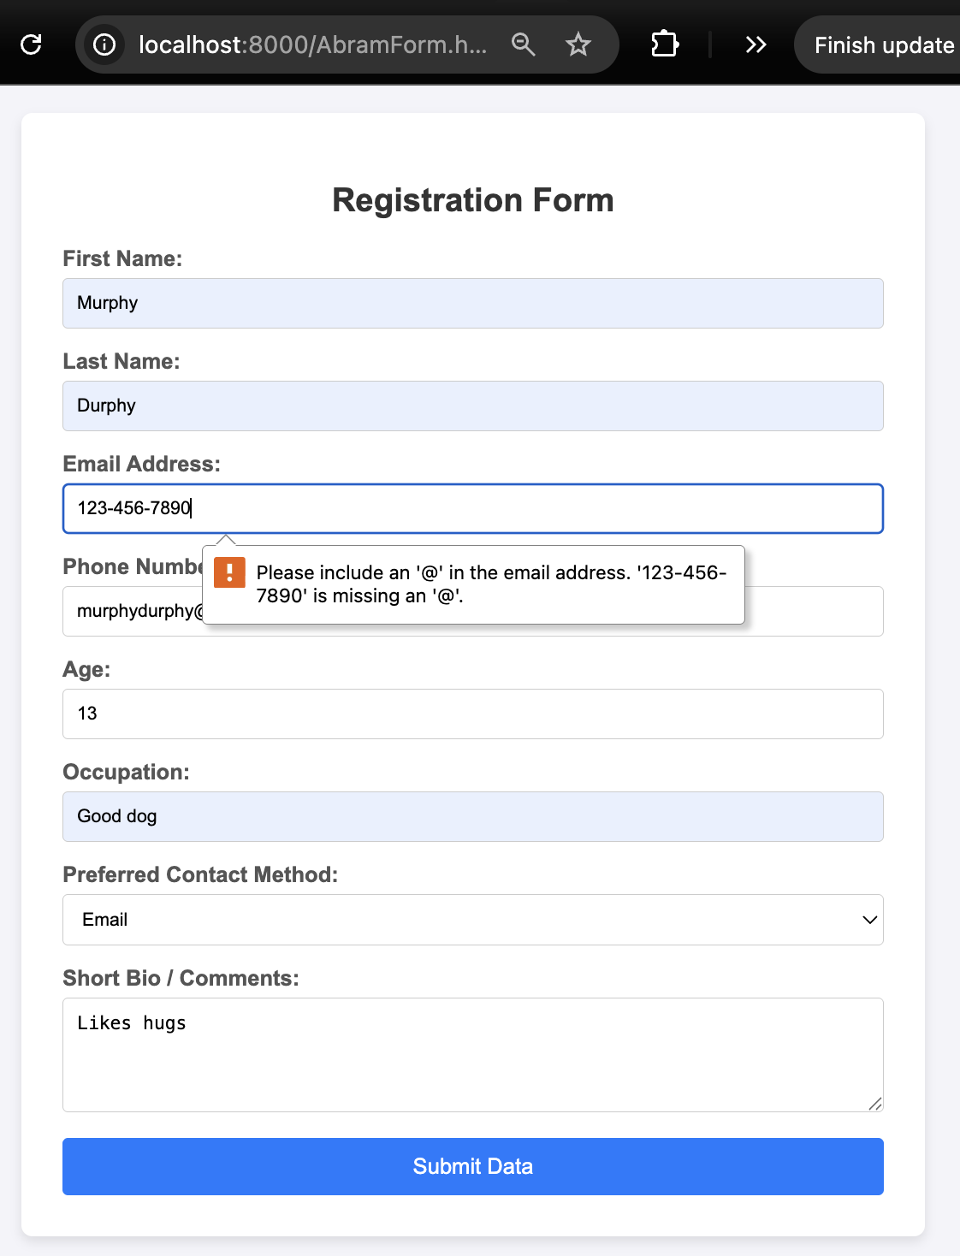
All fields required:
