Abram Denzlinger
September 20, 2026
CSD440 - Assignment 8.2

Table created, populated, queried, and dropped. Fatal error querying after drop, demonstrating effective drop.
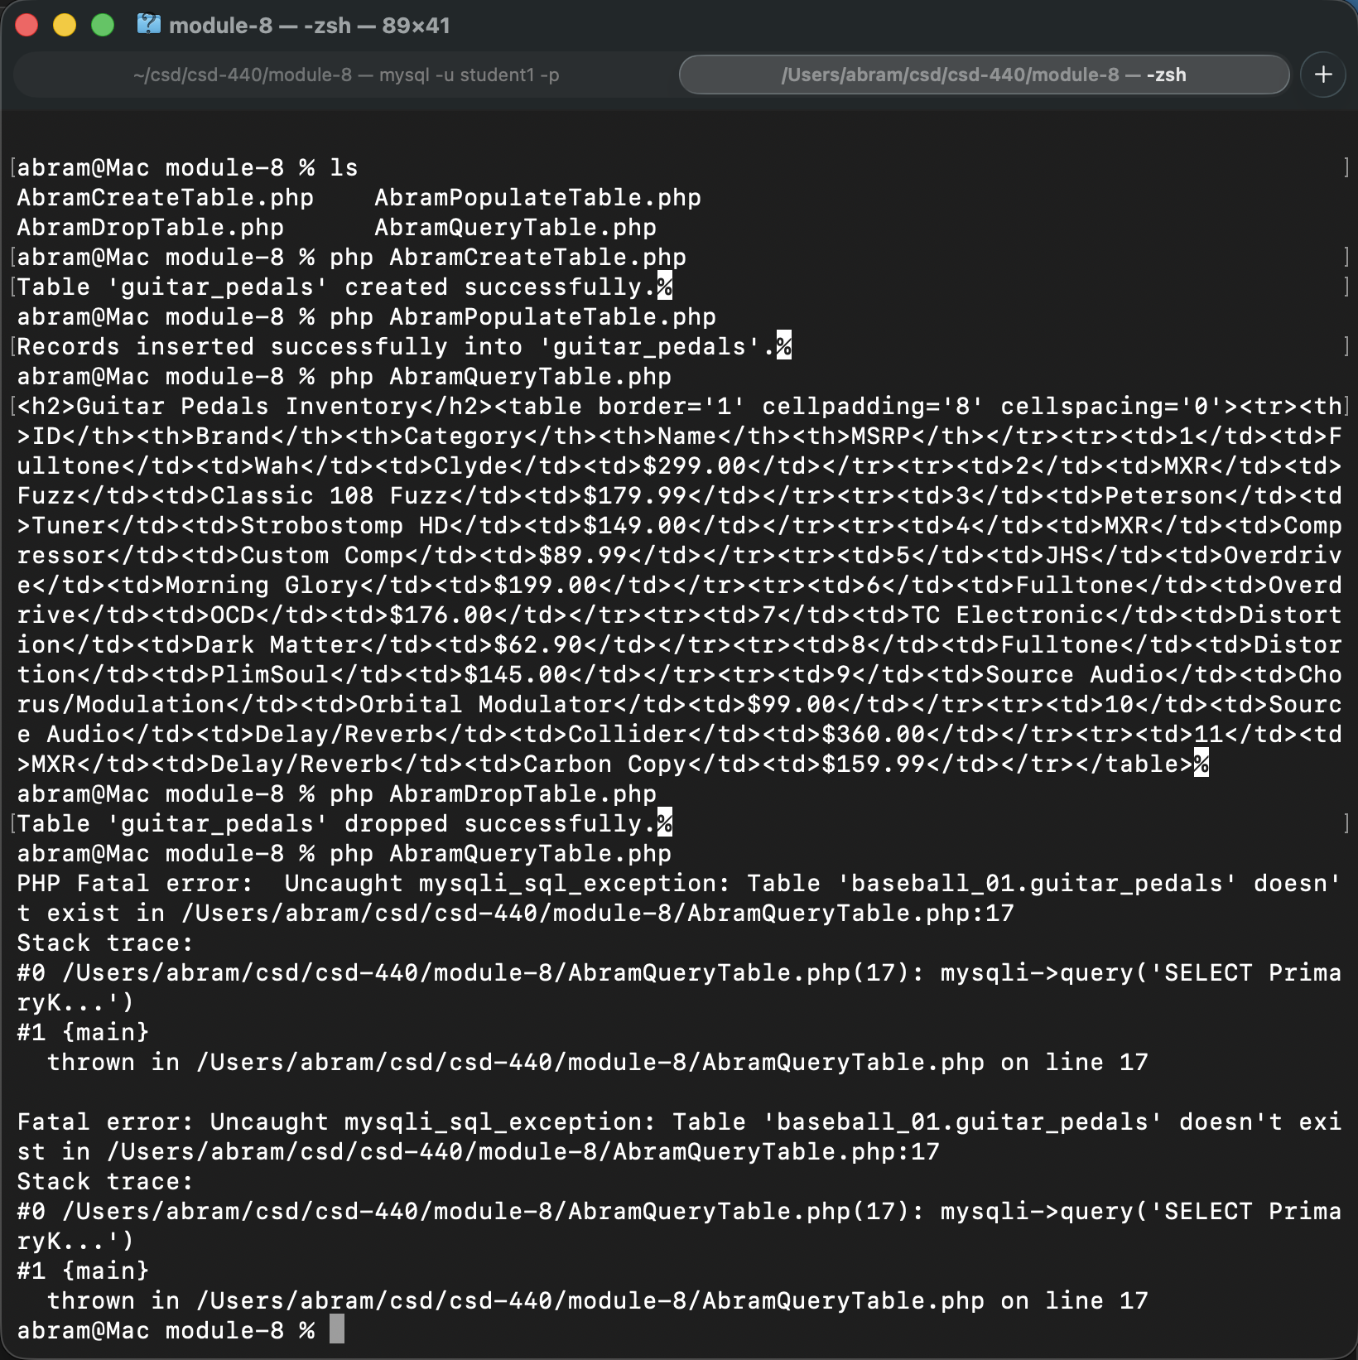
SQL commands demonstrating fields and records in guitar_pedals table in baseball_01 database.
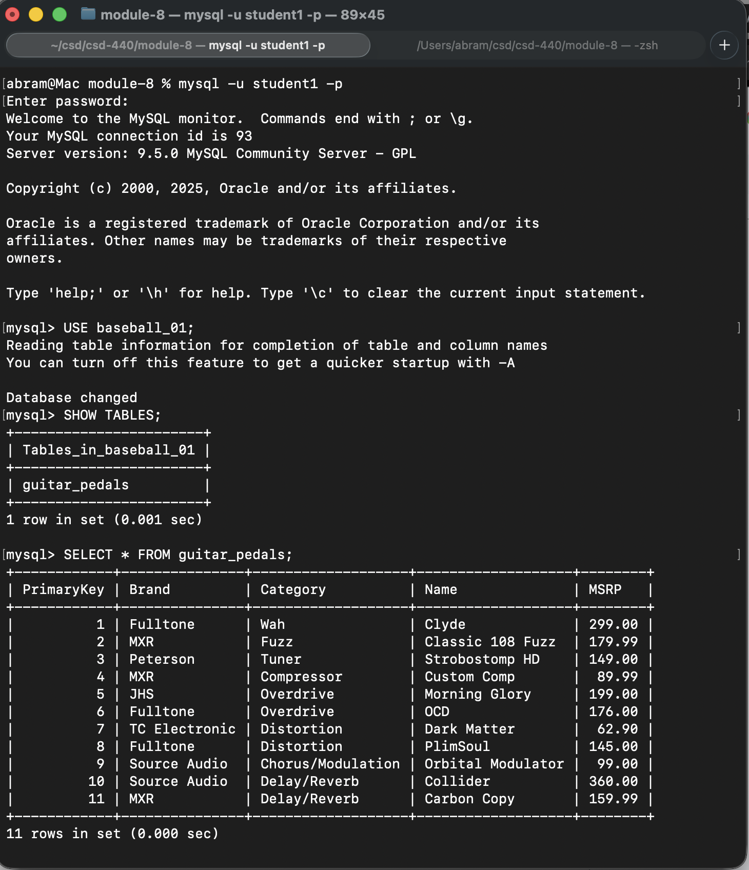

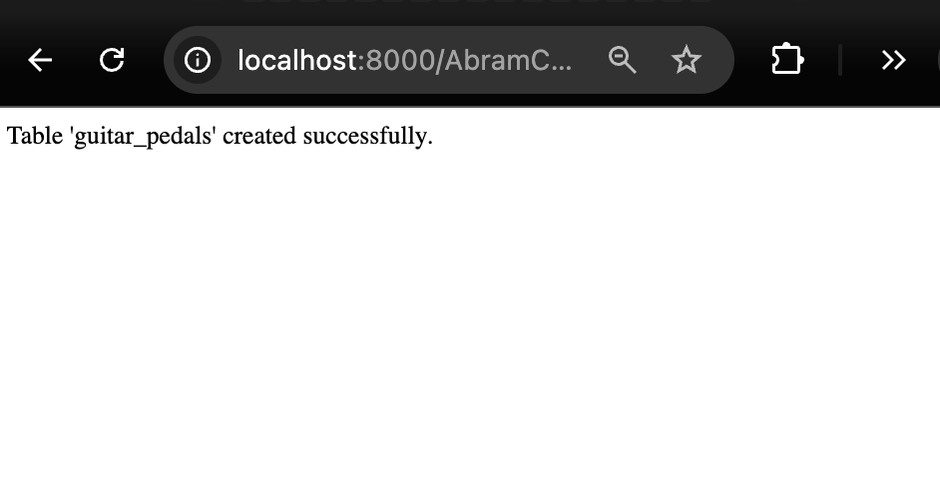
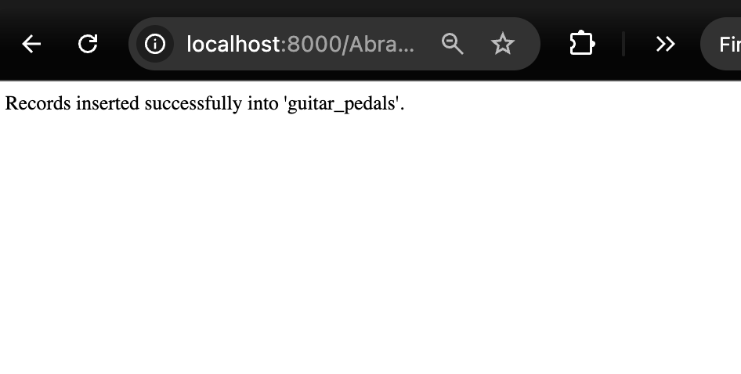
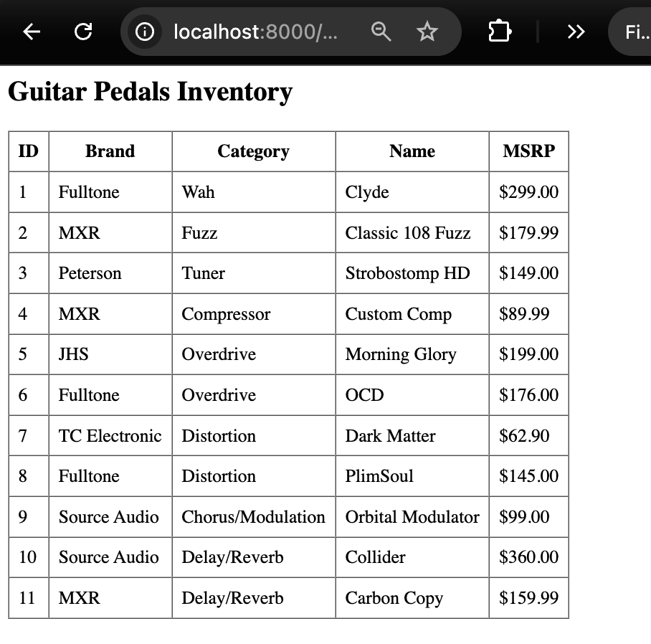

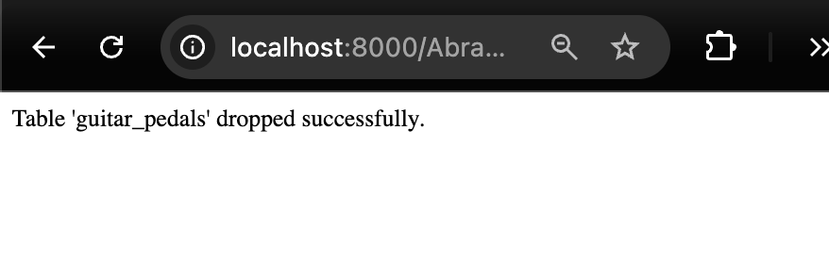
Fatal error on query after table drop, demonstrating effective drop:
