Abram Denzlinger
April 26, 2026
Assignment 6.2

Comparable - natural (ascending) order:
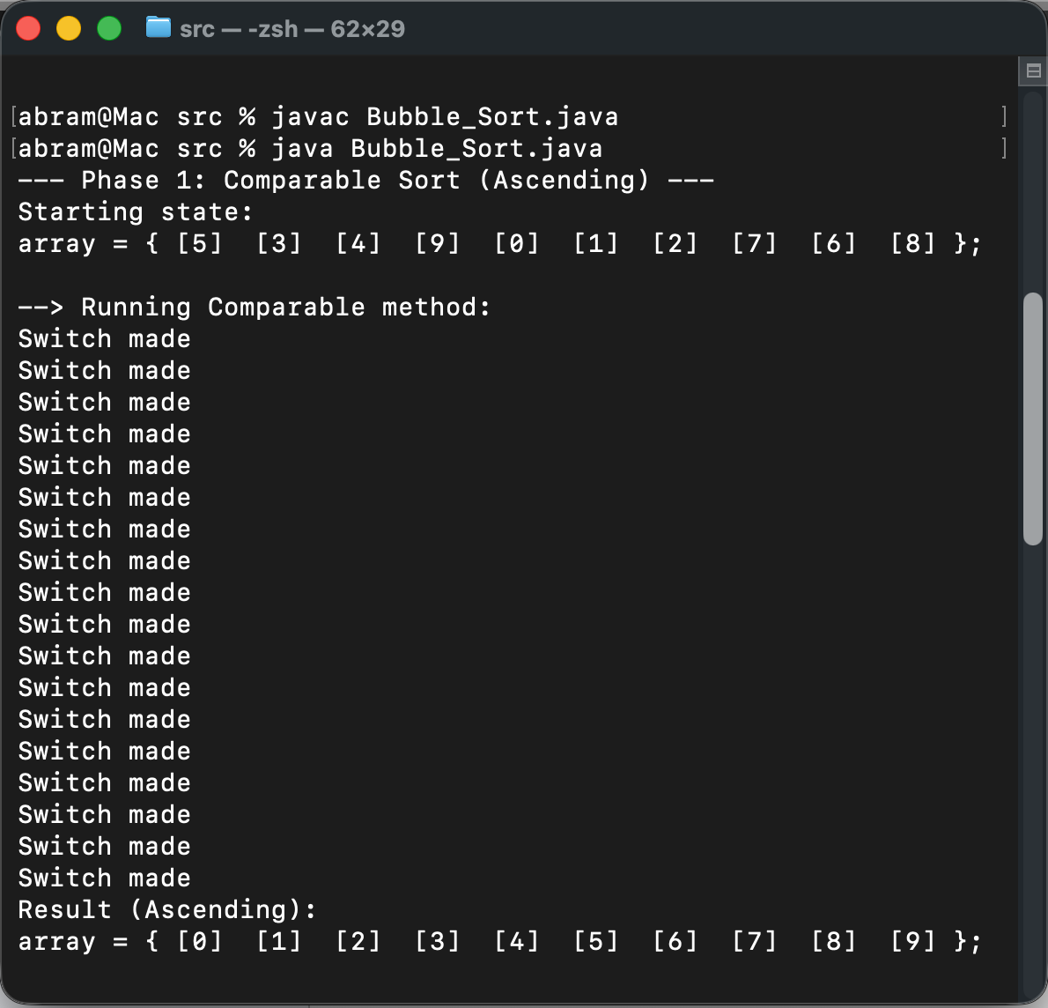

Comparator - custom (descending) order:
