Abram Denzlinger
April 19, 2026
Assignment 5.2

Showing error handling:
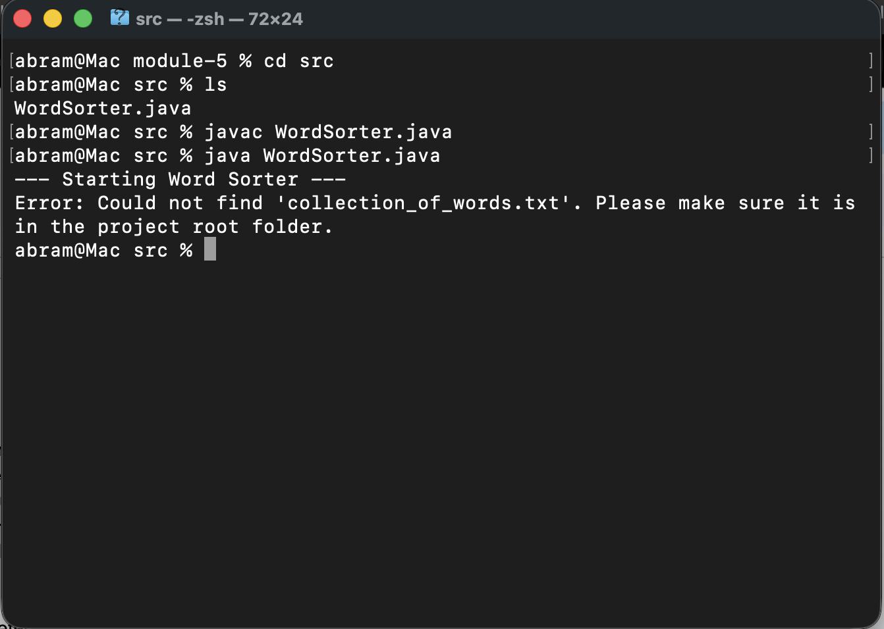

Showing expected results:
