Abram Denzlinger
April 4, 2026
Assignment 2.2 - Testing Code Functionality

File not present, DataReader.java program failed:

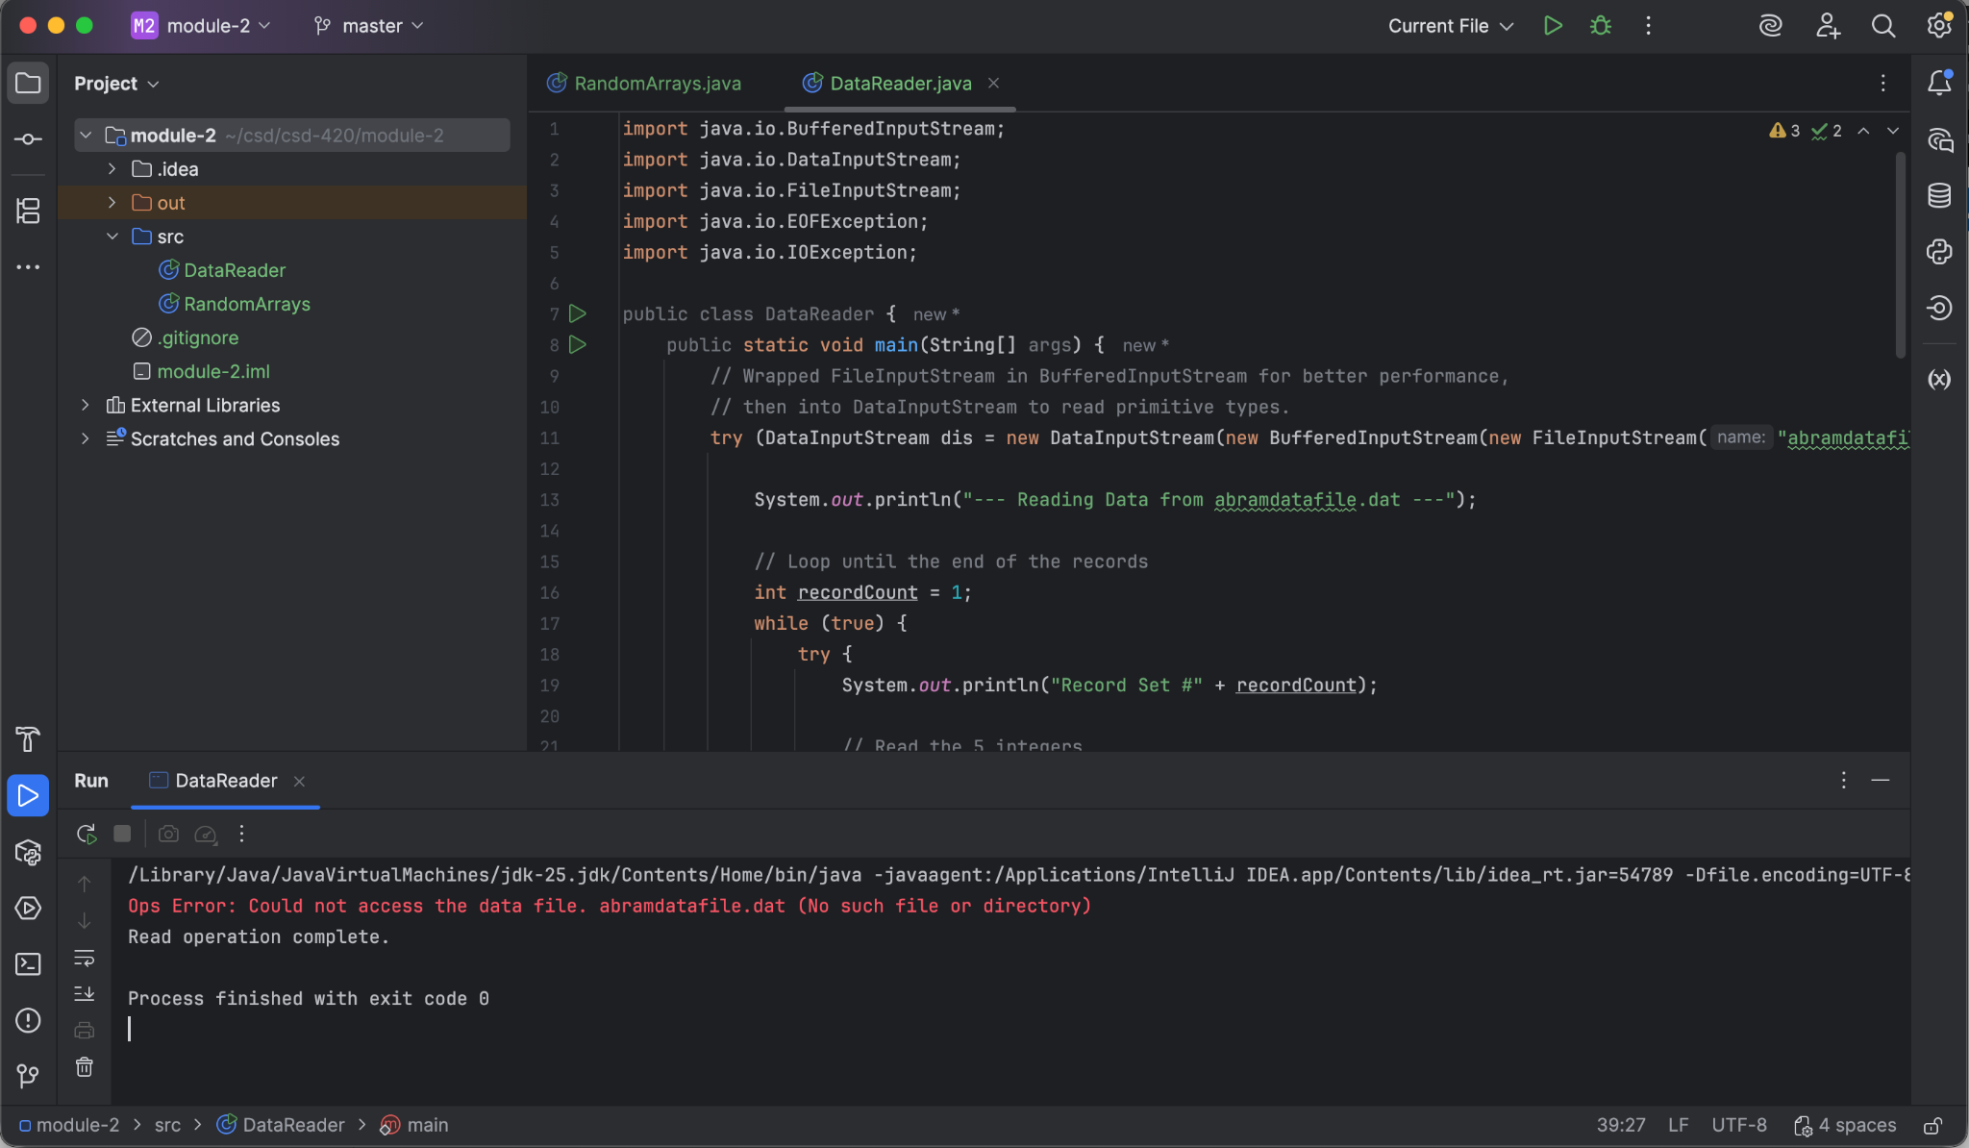

RandomArrays.java creates abramdatafile.dat:

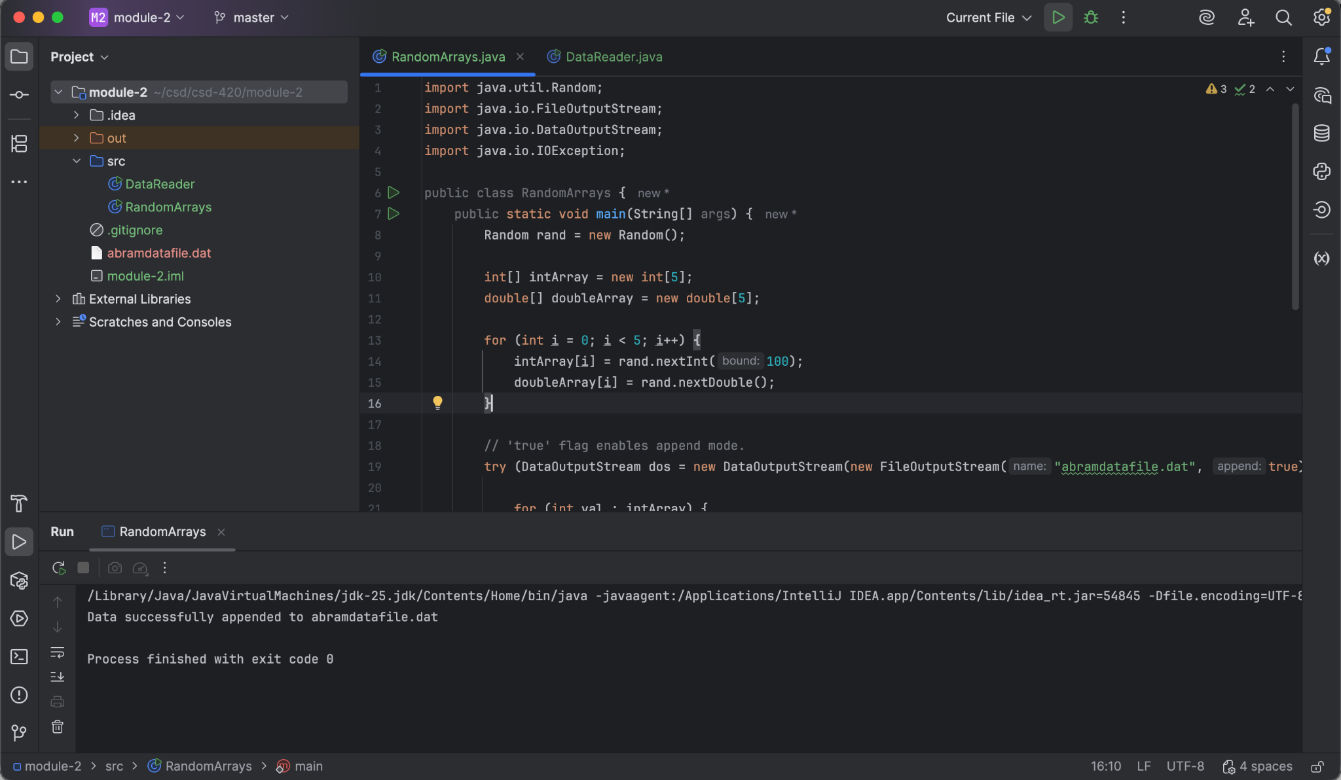

DataReader.java reads abramdatafile.dat:

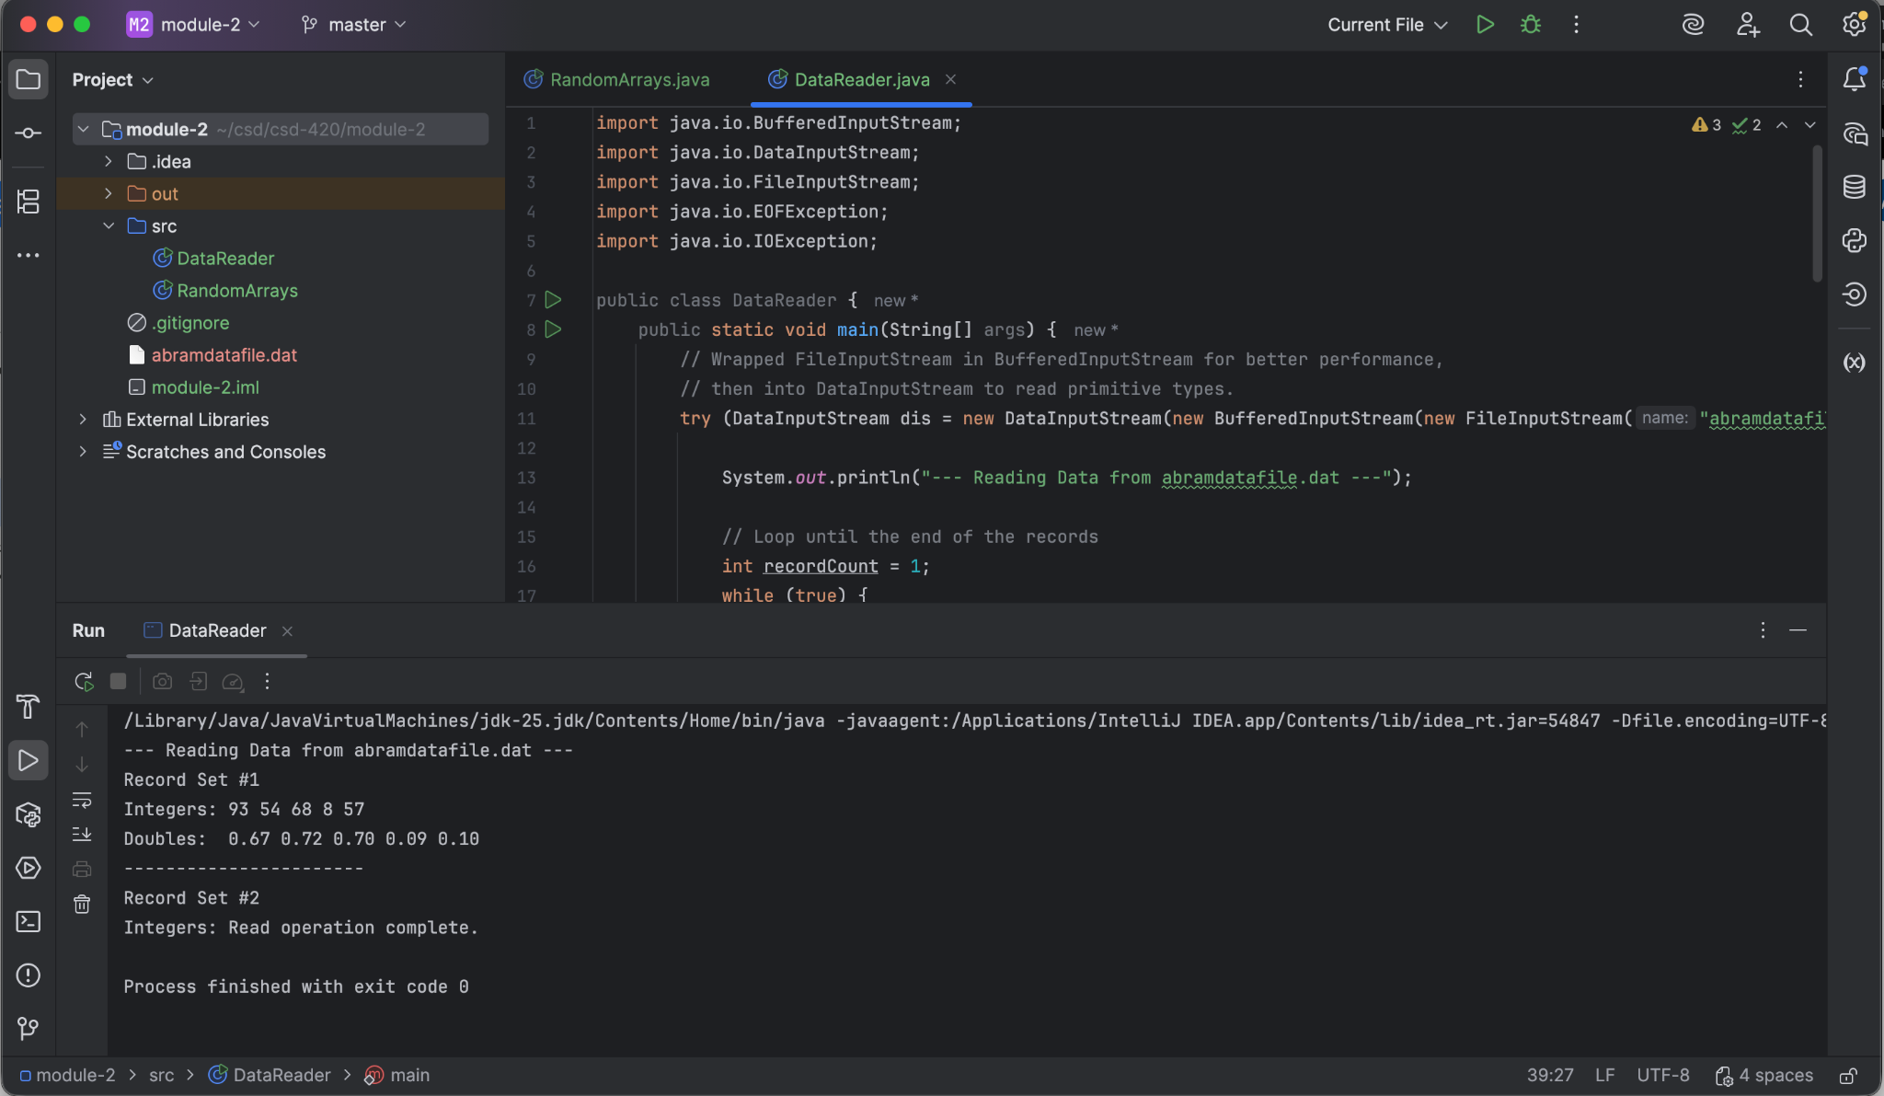

RandomArrays.java appends new to abramdatafile.dat; confirmed via DataReader.java

