Abram Denzlinger
May 9, 2026
Module 9.2 Assignment

NetBeans and MySQL installed
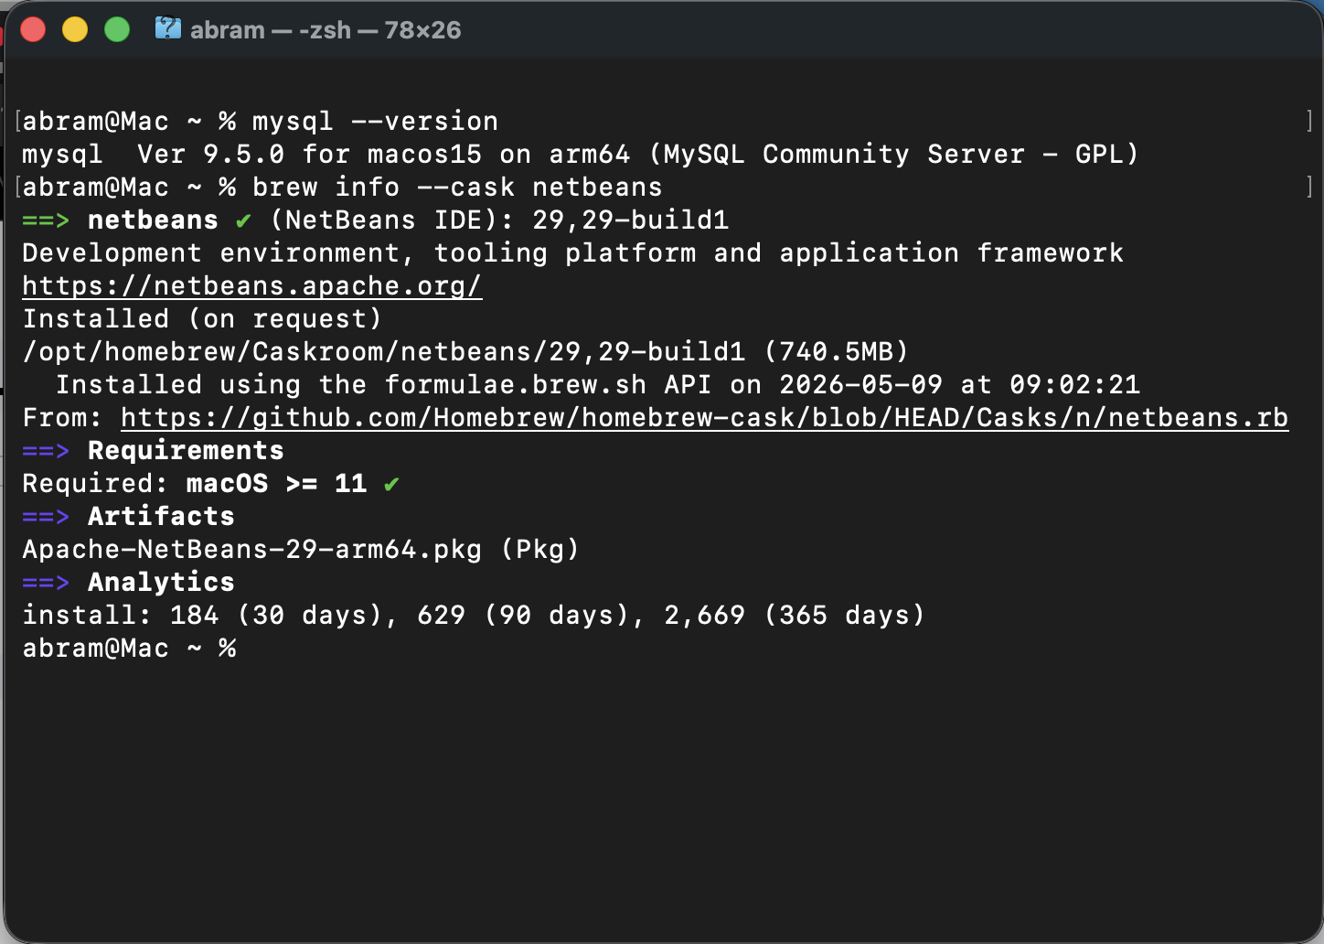
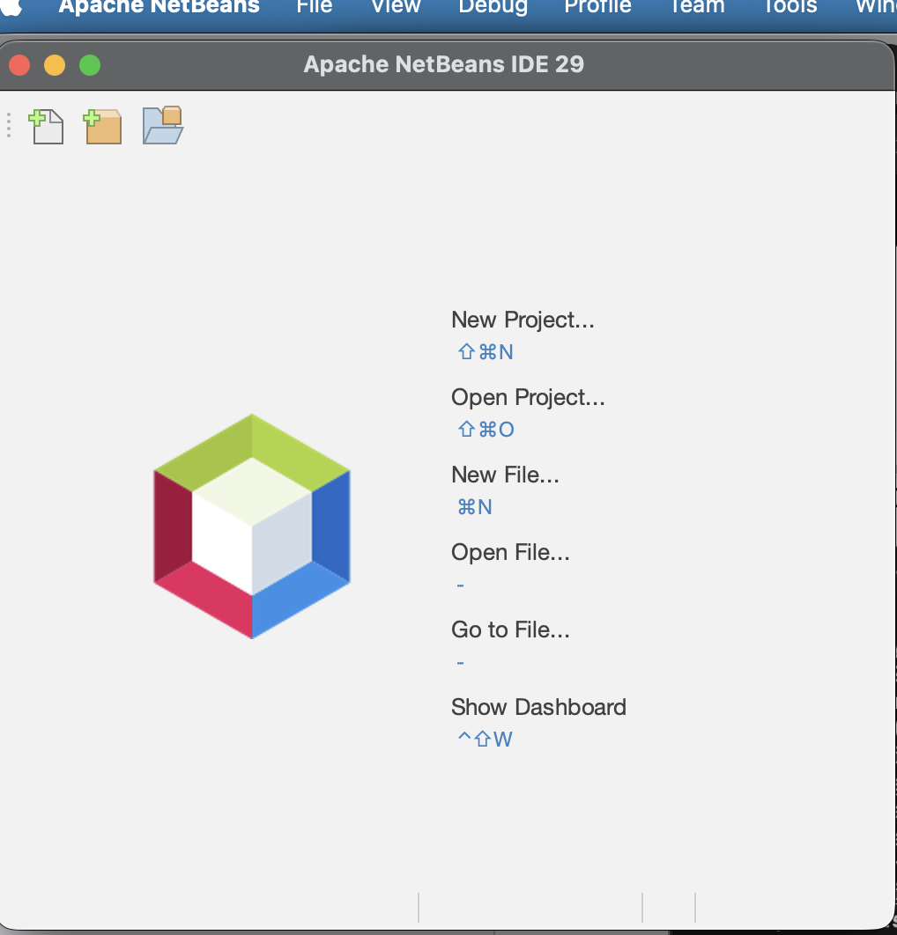

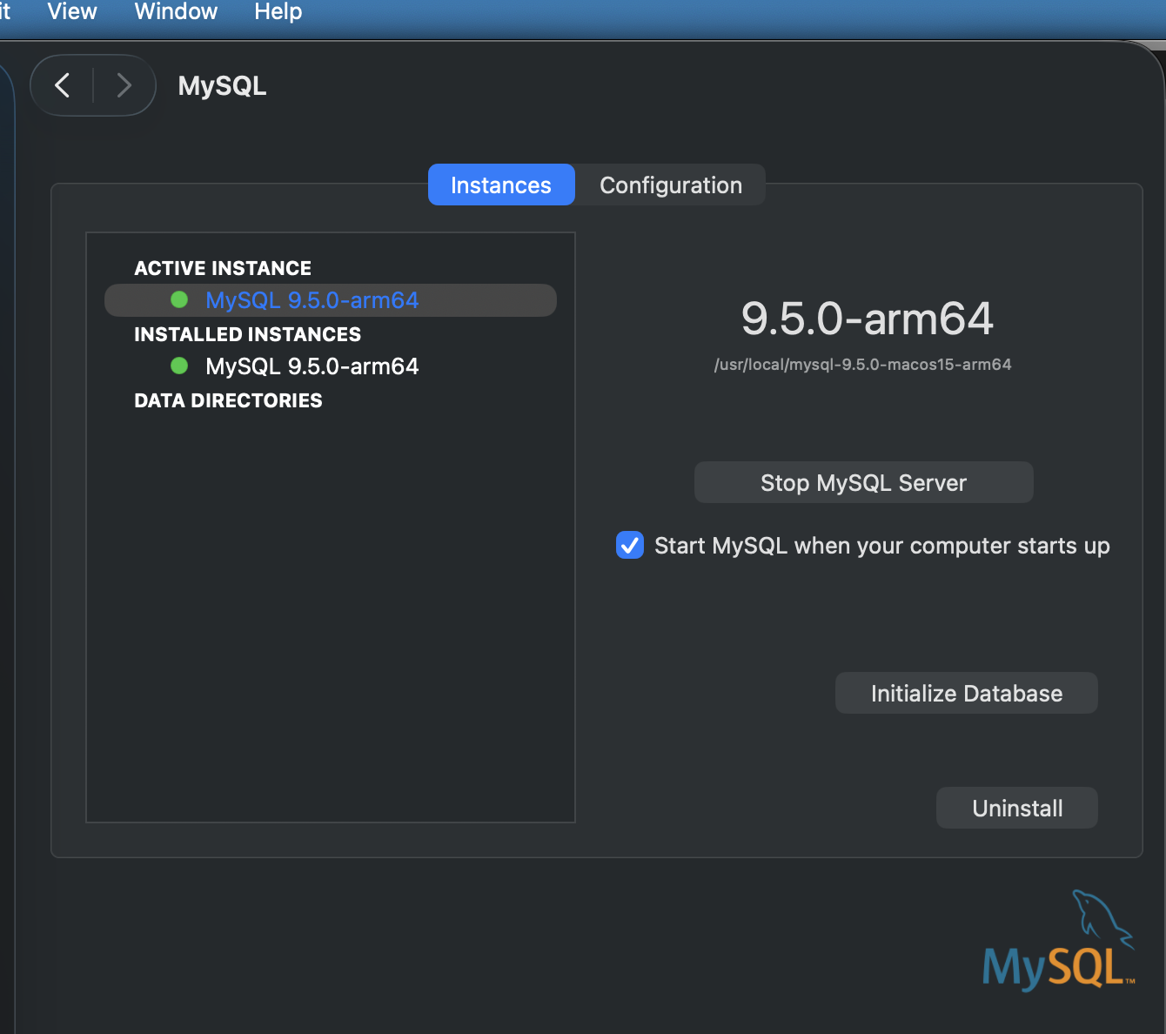

MySQL: logged in as root, creating user, granting permissions
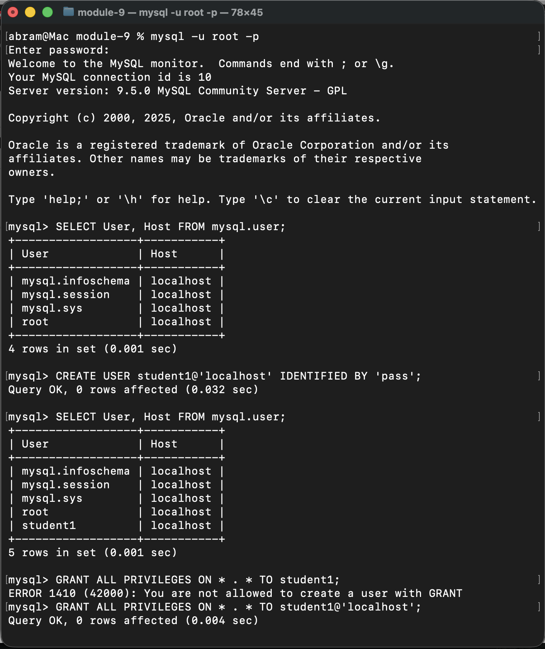

MySQL: logged in as student1, showing existing databases
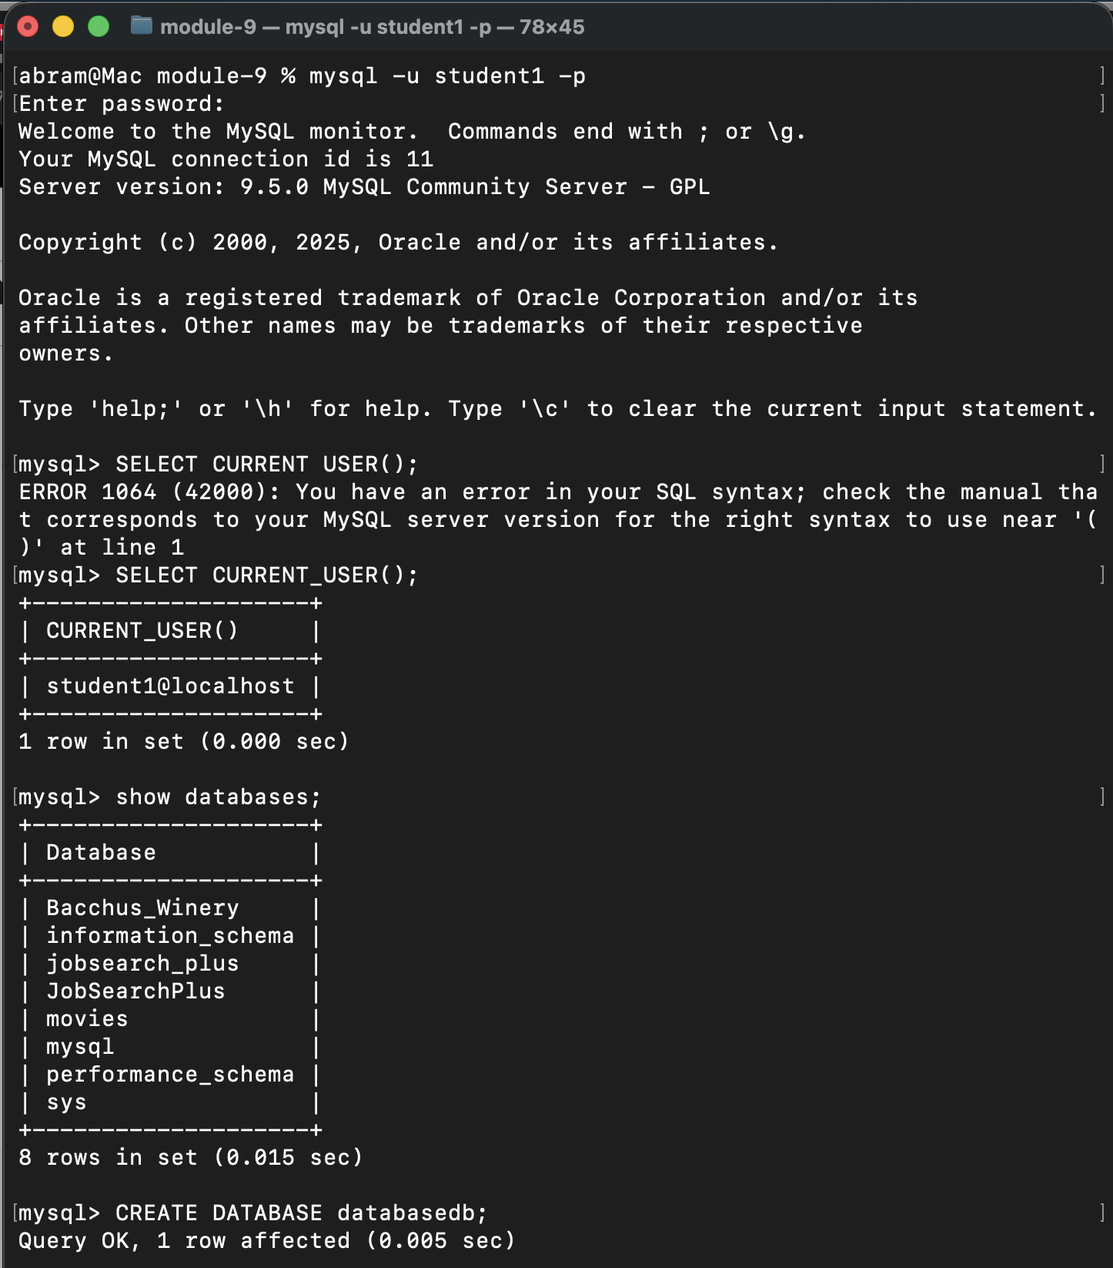

MySQL: creating databasedb
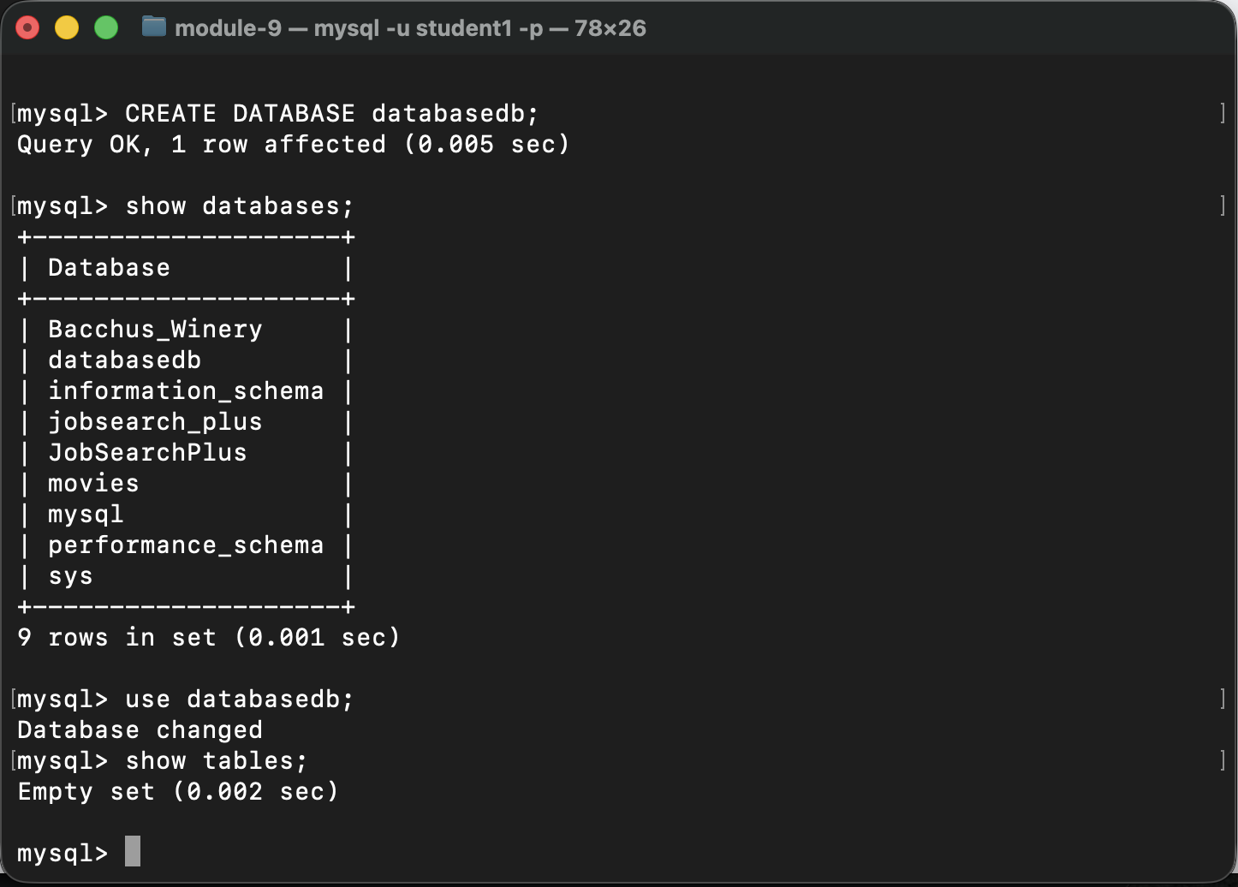

Running CreateTable.java from NetBeans:
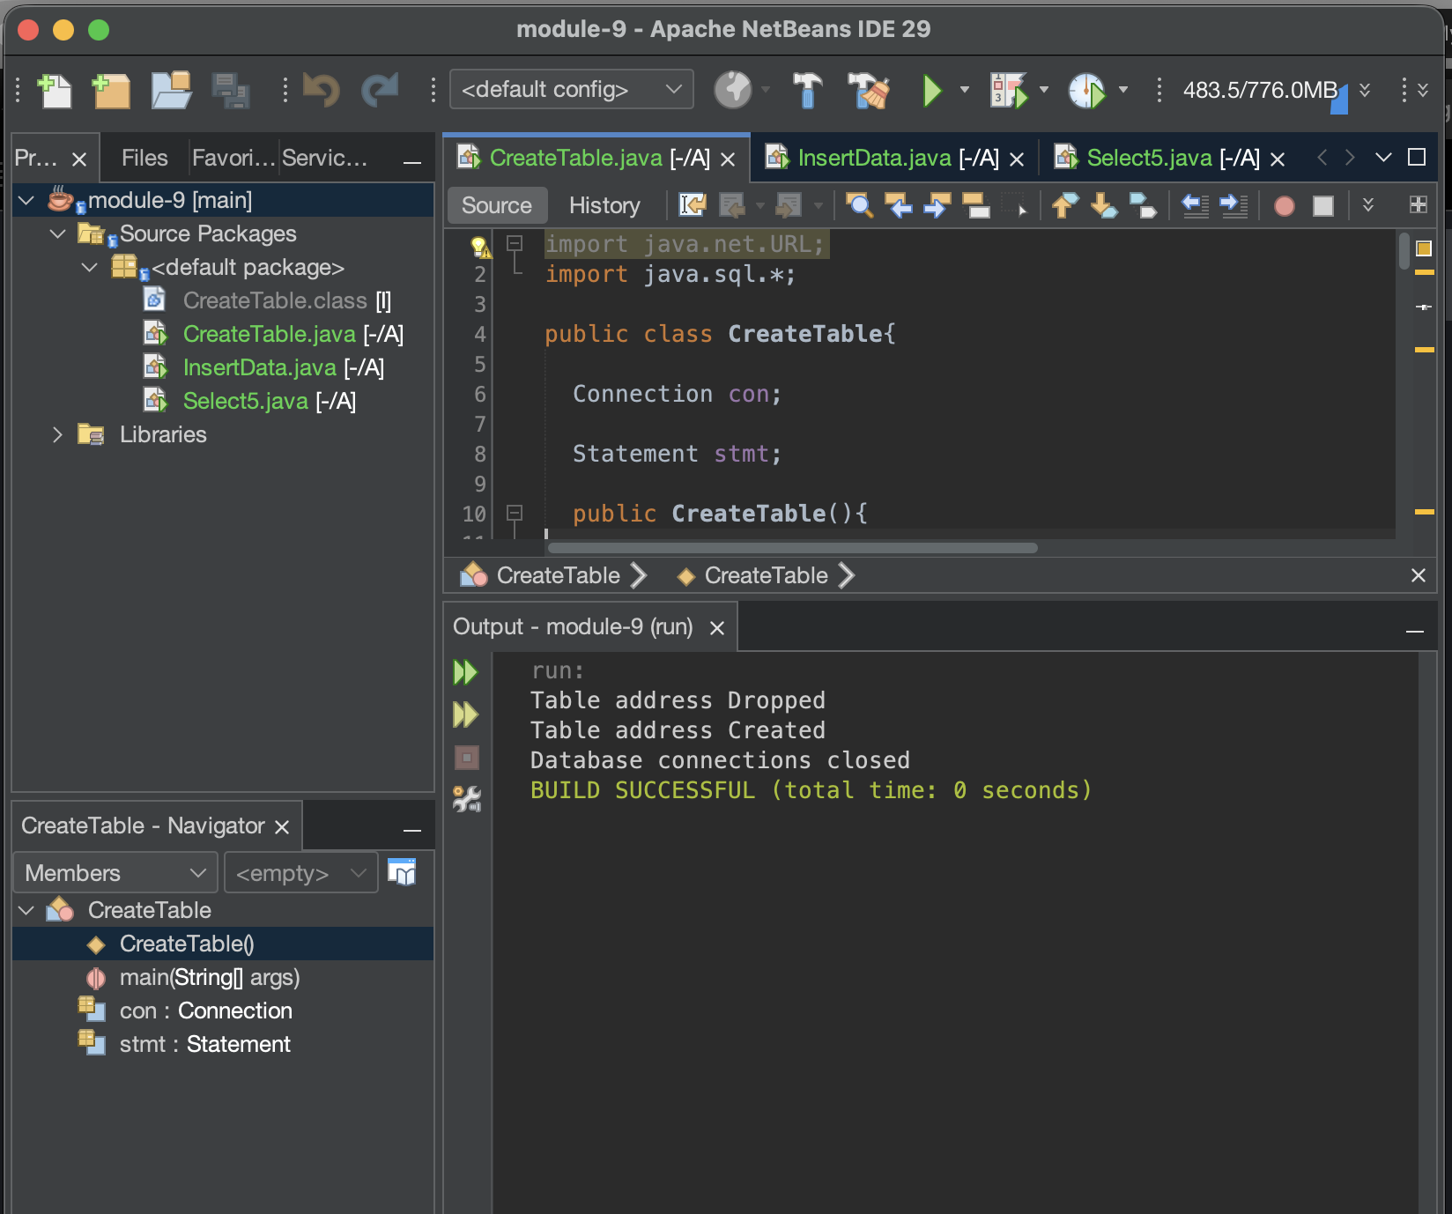

Running InsertData.java from NetBeans:
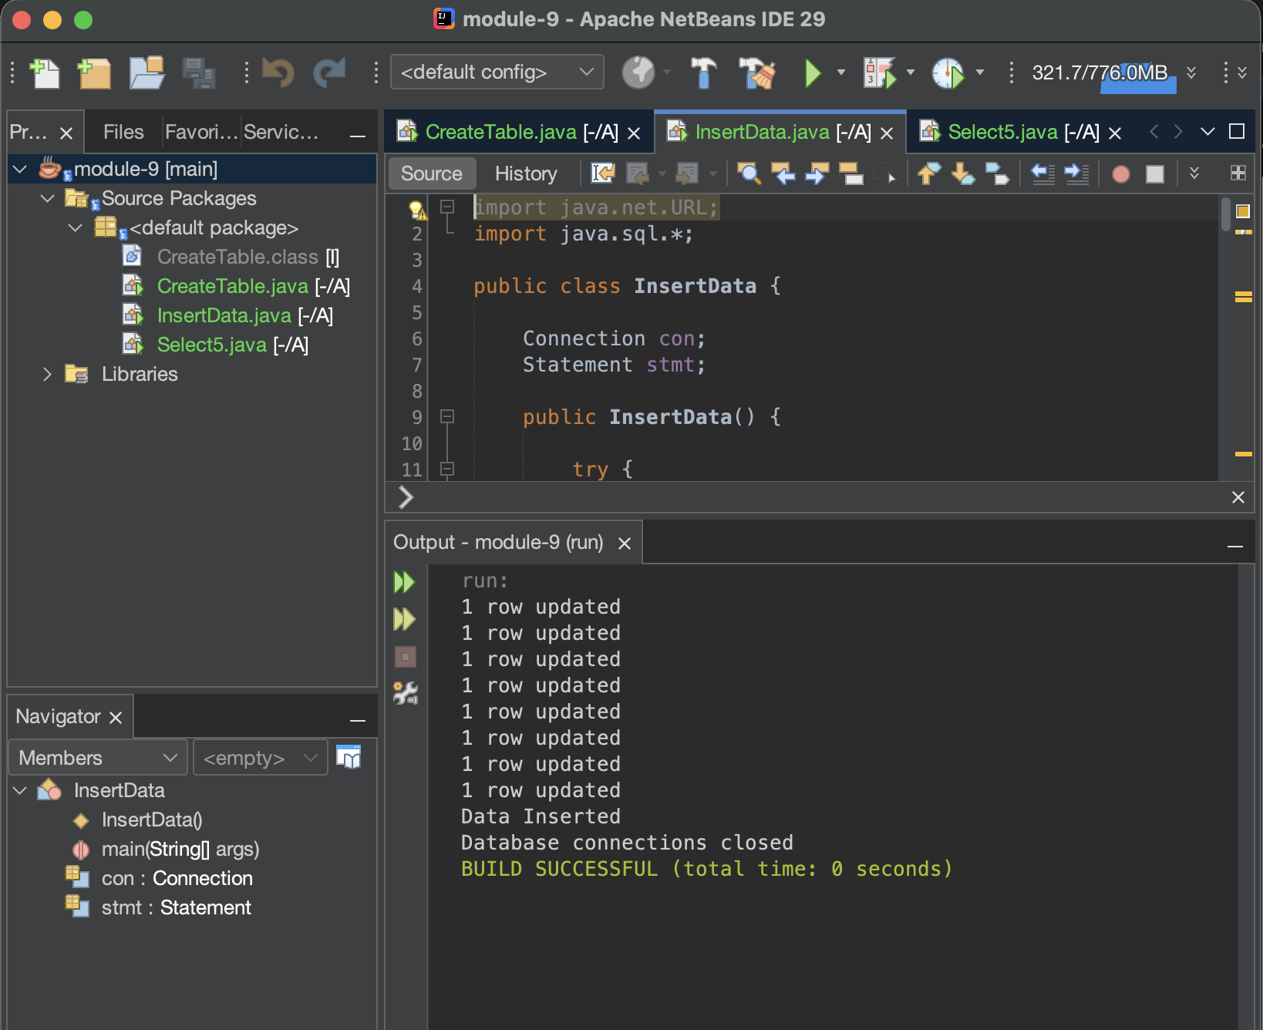

Running Select5.java from NetBeans:
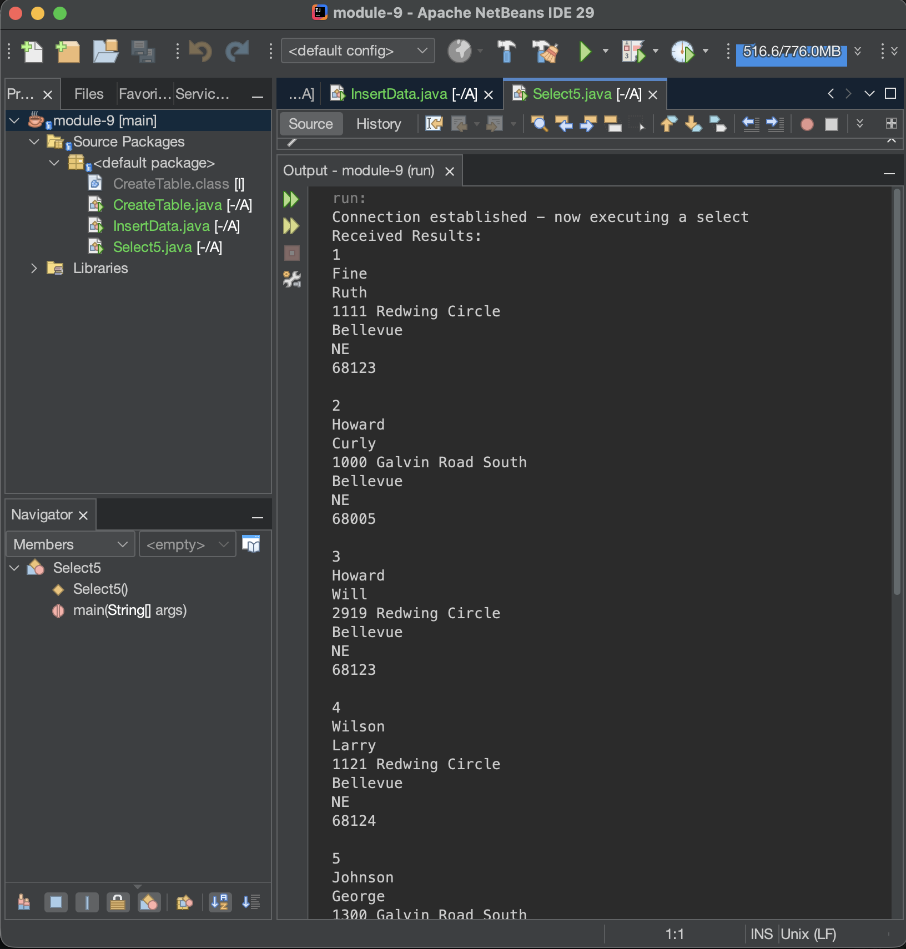

Select5.java continued…
