Abram Denzlinger
April 26, 2026
Assignment 6.2

The assignment instructions provided were for Windows exclusively, and I don’t own or have access to a Windows machine. My options were Chrome, Linux, or Mac, and so I fumbled my way through getting GPG Keychain and the Mail GPG extension configured on the Mac.

Keys listed
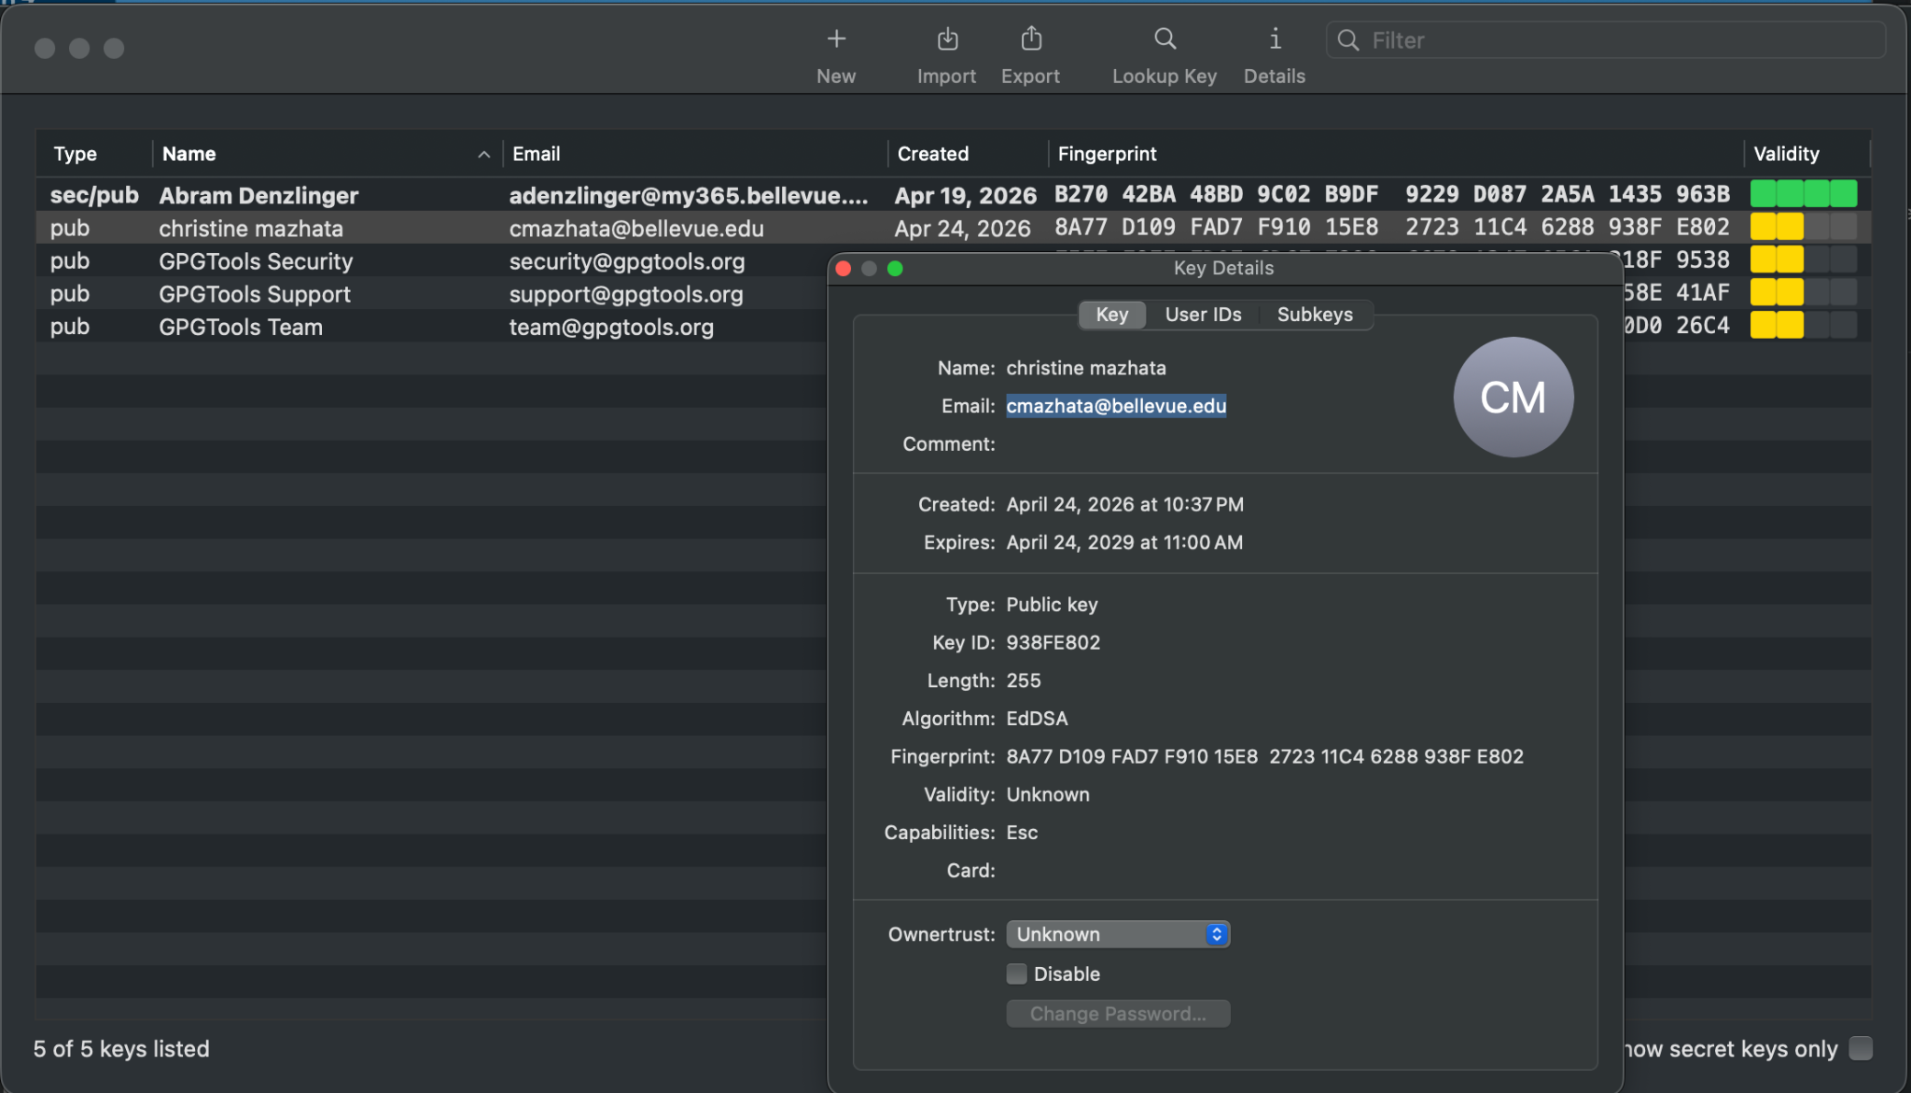

This is an email I sent to myself and then decrypted to validate setup and functionality:
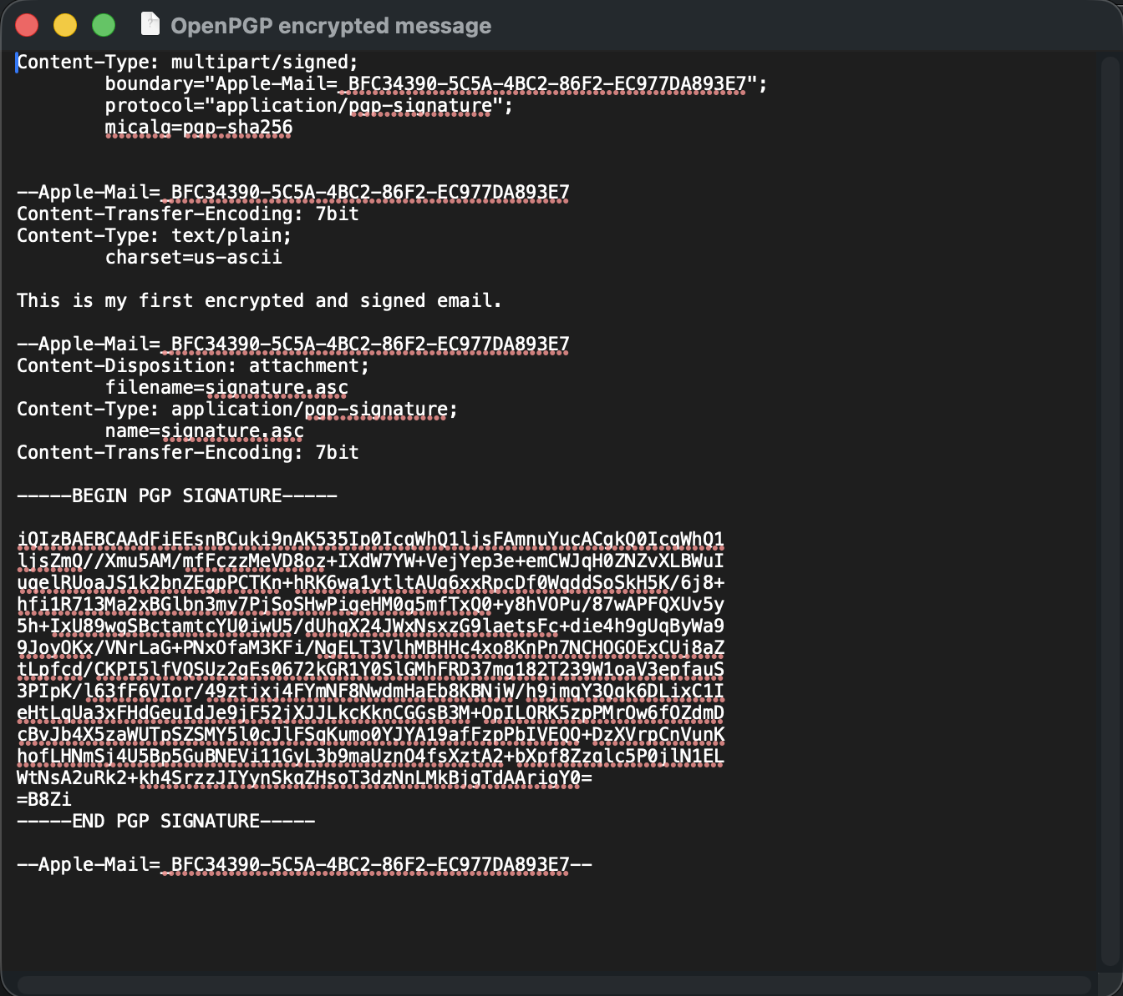

Signed & Encrypted email sent to professor - Outlook (Web) & Mac Mail Versions:

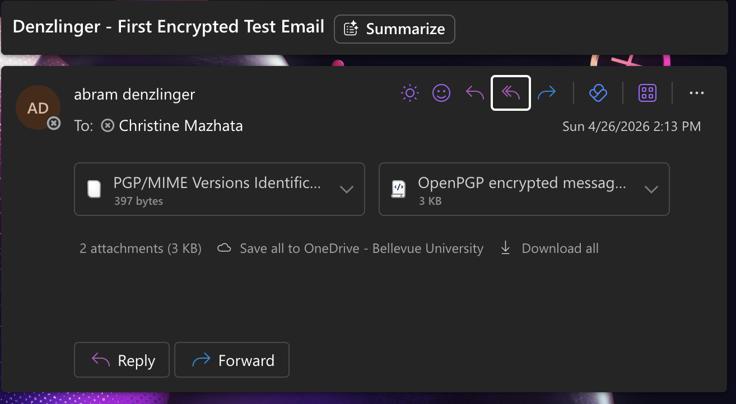

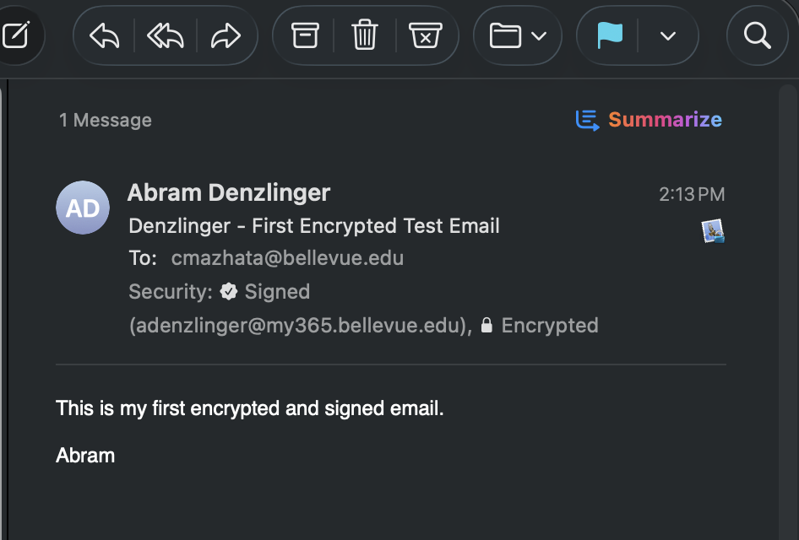

Step 2.2 - Decrypted Digest:

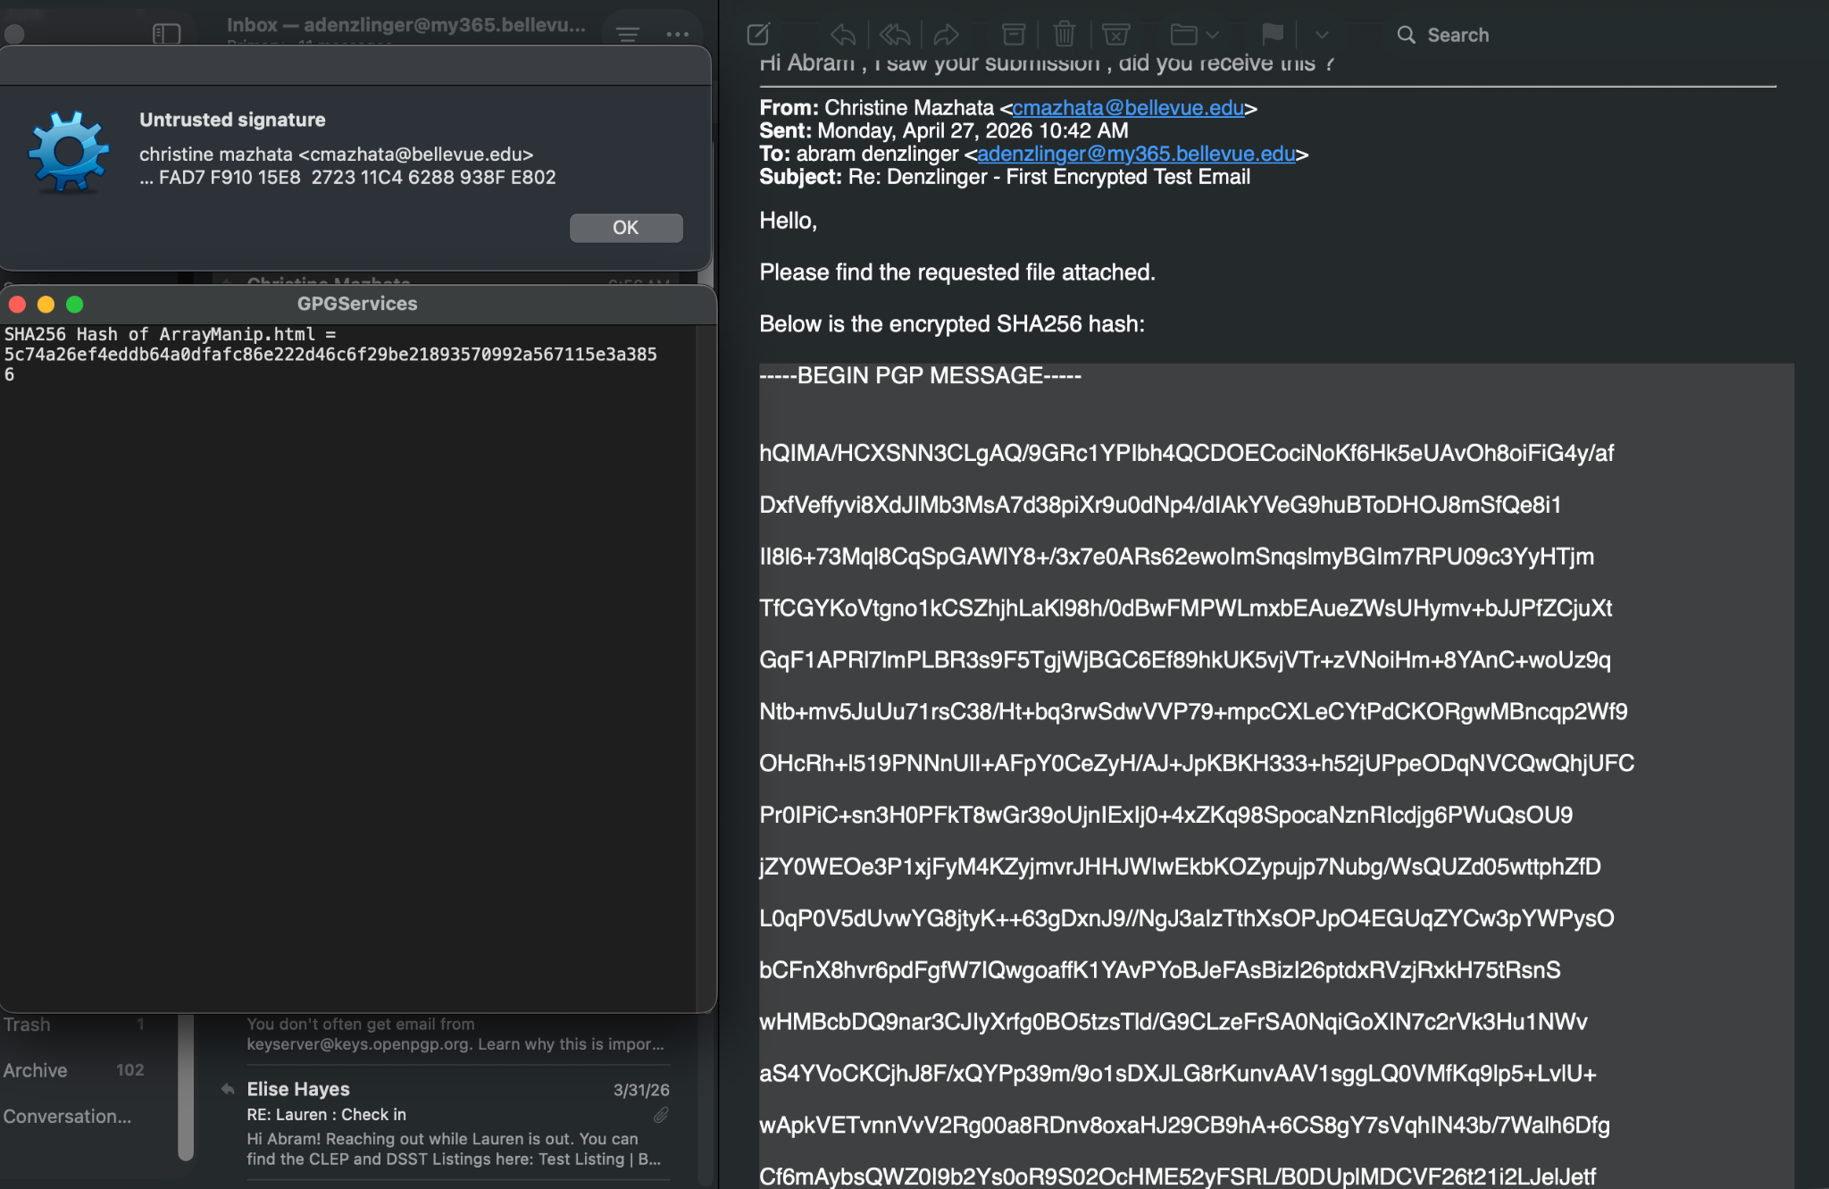

Step 2.3 - Generated digest from https://md5file.com/calculator:

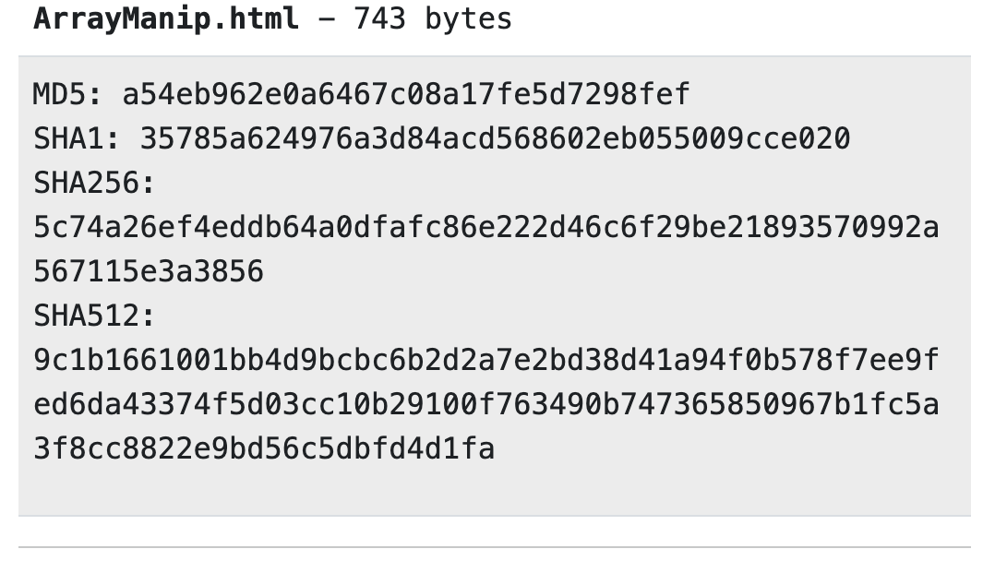

Step 2.4 - received digest and generated digests match.

Received SHA256 Hash of ArrayManip.html = 5c74a26ef4eddb64a0dfafc86e222d46c6f29be21893570992a567115e3a3856

Generated SHA256: 5c74a26ef4eddb64a0dfafc86e222d46c6f29be21893570992a567115e3a3856

