Dormitories

Dhamma Sineru Deep Clean Manual



About this document:

For the canonical Microsoft Word version of this document, speak to the Administration of Dhamma Sineru. To rebuild this document from open source, visit https://github.com/deobald/dhamma-sineru

## Introduction

What is “Deep Cleaning” and how is it different from regular cleaning? Daily cleaning is like your daily practice. It removes the dirt created that day, or perhaps a bit more. Deep Cleaning is more serious, like a serious meditation course. In the same way that Anapana and Vipassana lift very deep impurities to the surface, initial deep cleaning will make things dirtier at first because you are lifting up dust, dirt, and stains from places which haven’t been touched in a while. Once you are finished, though, the room will be totally free of dirt.

Goenkaji himself occasionally compares Vipassana to cleaning and these comparisons work both ways. When he compares repeatedly sweeping the floor to cleaning up mental impurities, it’s possible for an old student to examine this bi-directionaly and to see the value of working this way in daily life as one does in meditation. If you sweep your residence three or four times it will be much cleaner than sweeping it once.

Similarly, Goenkaji compares a new stain on an already-dirty shirt to a new stain on a perfectly clean white shirt. It is only noticable on the clean, white shirt. When the Vipassana centre is completely clean like this, it is very easy for the Dhamma Sevaks to spot a new stain and immediately remove it. The cleaner the centre is, the easier it is to clean!

## General Advice

* Always try to clean top to bottom.
* Always follow the checklist and check tasks as they are completed.
* Always wear a dust mask while sweeping and dry dusting.
* Always be very careful not to harm any visible creatures, no matter how small.

Tasks are organized by area and each area may take a different amount of time/effort. We have tried to estimate how many people can clean each area but it won’t always be possible to clean them all. The Administration can keep a log of the most recently deep-cleaned areas. If you can only clean one or two areas, you can enter these in the log so the the cleaning team for the next work period knows that they can deep clean something else. If there is no log, the next team can ask the Administration which area is best for them to clean.

Do not worry if you feel the time is limited or you are unable to finish. Because deep cleaning begins by making a bigger mess than was there to start with, just make sure you choose a small enough task that you can finish it before you leave. Even if only one residence is deep-cleaned in a service period, that one residence is that much better for the next service period.

## Supplies required:

### Tools

* broom
* dry mop
* vaccuum cleaner
* plastic duster
* dust pan
* dust bin
* cloths (towels for dry and wet dusting)
* mop
* bucket
* mug
* green scratch pads
* scrub brushes
* old toothbrush
* wire brush
* toilet brush
* squeegee

### Disposable Cleaners

* phenol
* harpic
* colin
* newspaper

## Cleaning Order

Most indoor areas will follow this rough order:

1. Pick up trash
2. Sweep
3. Dry dust all surfaces top to bottom
4. Sweep
5. Scrub all surfaces top to bottom. Wipe dry after scrubbing.
6. Sweep
7. Mop

## Dormitories

Each dormitory contains 12 beds, 2 or 3 curtains per bed, fans, light fixtures, 3 windows, and a countertop.

Estimated time required: 2 full days for 4-6 dhamma sevaks

### 1. Sweep up.

If the dining hall is particularly dirty, sweep it up first so dirt doesn’t come into the dorms as you move back and forth. Remove miscellaneous items (coat hangers, toothpaste, combs, pencils, laundry clips, wires, boards, garbage, water bottles, etc). Remove stools, then dust and wipe them outside. Sweep the floor.

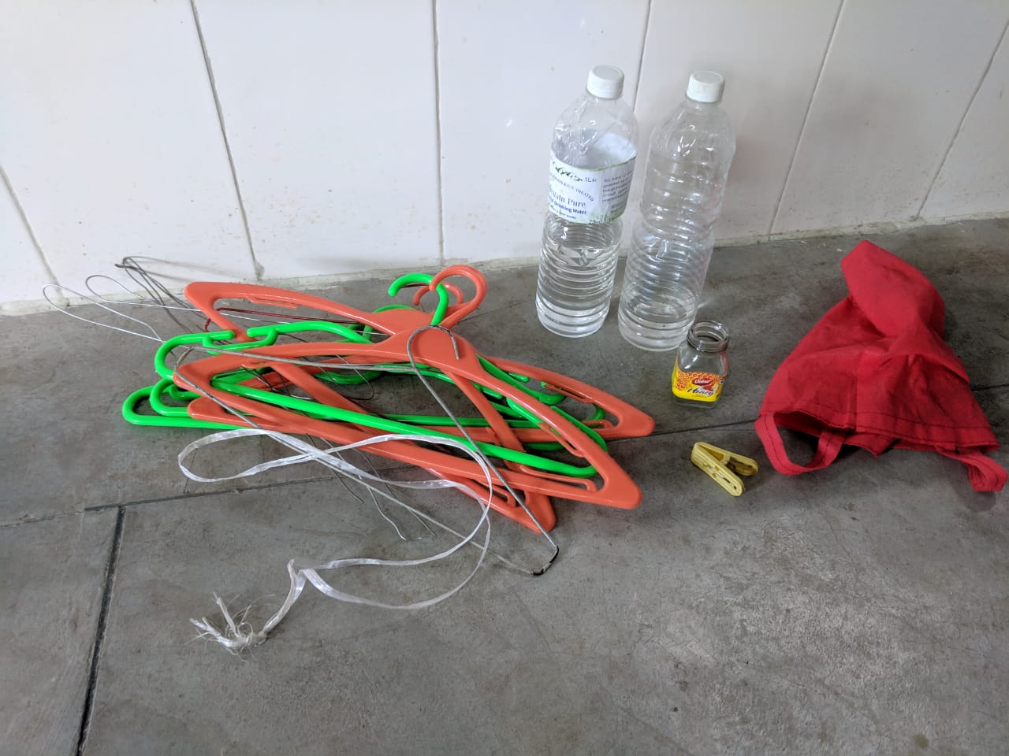

Miscellaneous items

### 2. Wash curtains.

Gently remove all the curtains from the curtain rods and curtain wires. Snap-dust curtains in a whipping motion outside (see photo) while they are dry to remove dirt. Wash all the curtains by soaking, scrubbing, and rinsing them in a clean residence bathroom. About 8 curtains fit comfortably in one bucket. Hang the curtains to dry in the sun. You will replace them when you replace the linens in the dormitory.

If you have more than 2 people on your dormitories cleaning team, have 1 or 2 people wash the curtains while the rest work in the dorms.

|  |  |
| --- | --- |
| Curtain rod  Curtain rod | Remove curtain gently  Remove curtain gently |

### 3. Move beds to one side.

Pick up all linens (sheets, pillow cases, duvet covers, pillows, duvets, and blankets) and hit them to remove any dust settled on top. Move all the linens to two beds on the far side of the dorm. Vacuum all the remaining mattresses with the upholstry brush. Take each mattress outside to dust it off on all five remaining sides (four edges and bottom). If you notice any stains (usually bird poop) on the mattress, scrub it with a damp cloth. Stack all mattresses on the remaining two beds on the far side of the room.

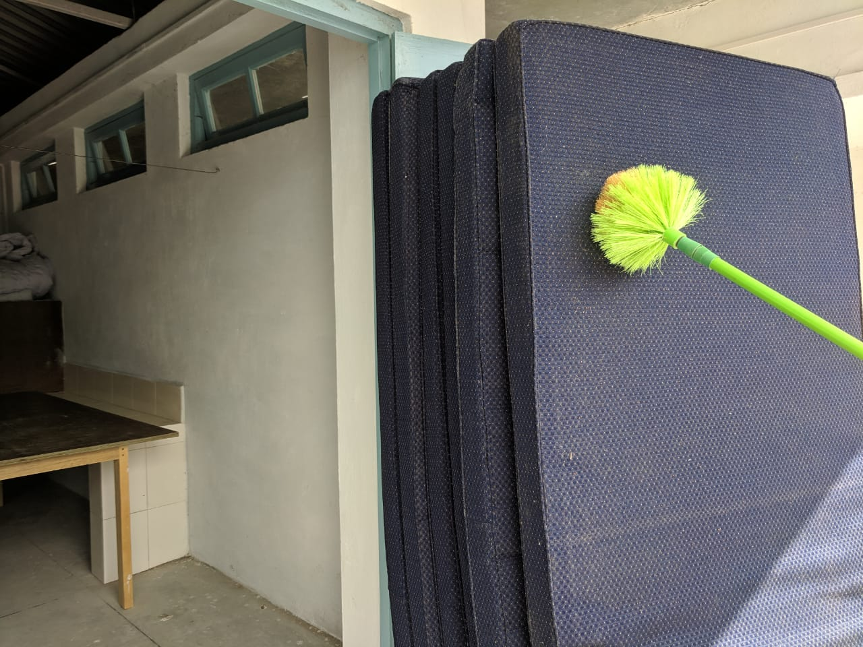

Dusting off mattresses

|  |  |
| --- | --- |
| Mattress stain  Mattress stain | Clean stain removed  Clean stain removed |

|  |  |
| --- | --- |
| Stack linens  Stack linens | Stack mattresses  Stack mattresses |

|  |  |
| --- | --- |
| Empty dorm, ready for cleaning  Empty dorm, ready for cleaning | How to stack linens/mattresses  How to stack linens/mattresses |

### 4. Clean half the dorm

In this step, clean the area occupied by six of the twelve beds. If you choose to clean the two beds closest to the linens and piled mattresses, be very careful not to spill dust on them.

|  |  |  |
| --- | --- | --- |
| First sweeping  First sweeping | Second sweeping  Second sweeping | Third sweeping  Third sweeping |

1. **Sweep.** Sweep from top to bottom: Tops of walls, rafters, fans, walls, windows, wooden wall planks, half-walls, countertops, beds (over and under), floor.

|  |  |  |
| --- | --- | --- |
| Sweep tops of walls  Sweep tops of walls | Sweep tops of wooden walls  Sweep tops of wooden walls | Sweep rafters  Sweep rafters |

|  |  |
| --- | --- |
| Sweep walls  Sweep walls | Sweep windows  Sweep windows |

|  |  |
| --- | --- |
| Sweep planks  Sweep planks | Sweep halfwall  Sweep halfwall |

|  |  |
| --- | --- |
| Sweep over bed  Sweep over bed | Sweep under bed  Sweep under bed |

Use the plastic broom or the vacuum to gently remove dust from the screens.

|  |  |
| --- | --- |
| Brush screen  Brush screen | …or vacuum screen  …or vacuum screen |

1. **Vacuum.** Use the vacuum’s blower function first! Vacuum all corners and cracks around wooden bedframes. Blow out all the spaces under the beds and alongside the beds. Sweep up what you can with a broom before using the vacuum to suck up the smaller dust. Sucking up large dust or debris with the vacuum will clog it. Sweep the beds and floor afterward.

|  |  |  |
| --- | --- | --- |
| Blow out cracks  Blow out cracks | Blow out wood on tile  Blow out wood on tile | Blow under bed  Blow under bed |

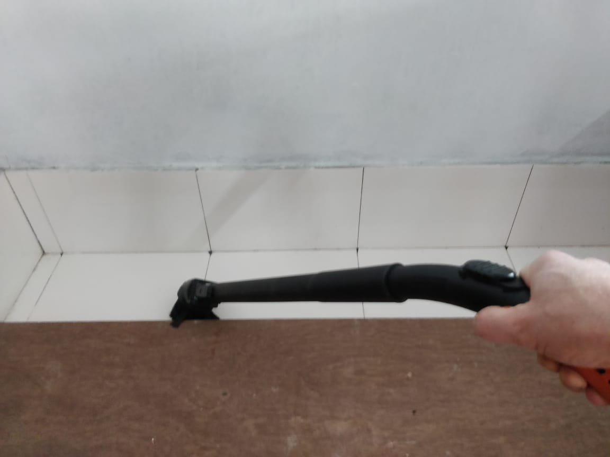

Vacuum bed last

1. **Dry dust.** Use a dry rag to dry dust: rafters, fans, curtain rods, windows (inside and outside), half-walls, and countertops. Sweep the beds and floor afterward.

|  |  |
| --- | --- |
| Rafter before cleaning  Rafter before cleaning | Rafter after cleaning  Rafter after cleaning |

|  |  |
| --- | --- |
| Fan after before cleaning  Fan after before cleaning | Fan after cleaning  Fan after cleaning |

1. **Wet dust.** Use a damp rag to dust fans and windows (inside and outside). Wipe up any water after wet dusting with a dry rag. Sweep the beds and floor afterward.
2. **Clean window glass.** Spray Colin on glass and wipe off with newspaper.
3. **Scrub countertops.** Use a plastic brush, green scratchy pad, and wire brush (if needed) to scrub stains and paint splatters off of any exposed tile. Mix a small amount of phenol and water in a mug as a cleaner. Sweep the floor afterward.

### 5. Clean the other half of the dorm

In this step, clean the remaining six beds and the rafters above them. Move all linens and mattresses to the clean half of the dorm and repeat Step 4. The four mattresses with bedding (linens and other mattresses) on them should be vacuumed and dusted outside before moving if they weren’t cleaned in Step 3.

### 6. Replace beds and curtains

Put one mattress back on each bedframe. Place one type of linen on each mattress: At the head of the bed, put one pillow with duvet cover, sheet, and pillowcase on it. At the foot of the bed, put one duvet with one blanket on it. Replace all the blue curtains with seams facing toward the bed. Replace all white curtains with seams facing toward the window.

|  |  |
| --- | --- |
| Unhook curtain rods  Unhook curtain rods | Widen curtains to dry  Widen curtains to dry |

### 7. Sweep & Mop

Sweep the floor one or two times with the normal broom. Sweep the floor with the dry mop – by this point the floor should be clean enough that it collects almost no dust. Mop the floor. Replace the stools.

You’re done! Hooray!