Dear Communauto Team,

I am applying via your “Spontaneous Application” option. My profile is an odd one: I was a software developer and Tech Lead for the first ten years of my career. A bicycle crash and eye injury in 2014 took me away from daily software development and moved me into management. Since then, I’ve spent time on project management, product management, product ownership, sales, marketing, branding, recruiting, and more. Most of this effort was spent on open source products and services (XTDB, Endatabas, GNOME, etc.) but my interest in open source isn’t abstract — I believe in products and services which serve the common good.

And that brings me to Communauto! I received your Communauto Atlantic (I live in Halifax) newsletter today and it left me wondering if Communauto had job openings which might align with the kind of work I do. You don’t, currently, but between your website, backend systems, and mobile app, there are plenty of places where I might get involved.

I spent the better part of a decade living in Bangalore, India, where traffic grinds the city to an absolute halt on a daily basis. As the population gets wealthier, everyone buys larger vehicles, adding to congestion and pollution. I can see the same thing happening here in Canada: from Vancouver to Montreal to Halifax. Obviously we all want to see our government invest more in public infrastructure, as part of the solution. But I really love the Communauto approach: it grows organically and as car ownership becomes increasingly unpleasant, it’s only bound to see more success. Communauto’s survival over 30 years also demonstrates that it’s a sustainable business and not just an environmentalist’s pipe dream.

The company I started in Bangalore is called Nilenso, and it’s India’s first worker-owned cooperative. Although Communauto isn’t legally a co-op, I believe it embodies the same spirit. While I realize Communauto doesn’t have a role for me today, I wanted to write to you folks to let you know that I am (and will remain) interested in working with you and helping with your mission, should an opportunity ever arise.

If you would ever care to chat with me about my work history or potential opportunities at Communauto in the future, my door is always open.

All the best,

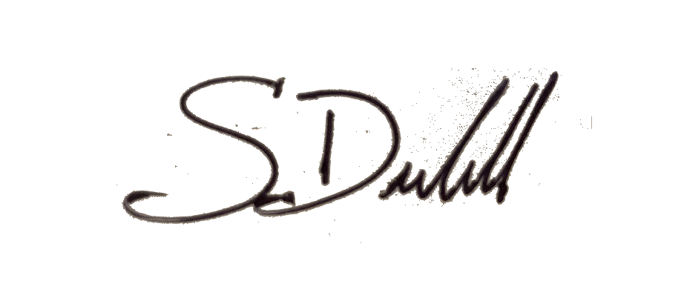

Steven Deobald

306-671-7179
707-336-2253
steven@deobald.ca

