Steven Deobald
+1 306-671-7179
steven@deobald.ca

February 23, 2026

Hello Jon and the OpenSSL Foundation team,

My work experience diverges from what you may expect in a candidate, but I am definitely comfortable with scheduling, costing, managing travel, managing inventory, and general research. I’ve also spent a lot of time on communications tasks in recent years, from weekly Foundation Updates while I was Executive Director at the GNOME Foundation, to the entirety of the documentation for Endatabas (https://docs.endatabas.com). When I joined the GNOME Foundation, there was no documentation to speak of. I created document archival policies for Nextcloud, organized the entire organization’s documents, and built an internal/private documentation system with Sphinx, similar to the GNOME Handbook (https://handbook.gnome.org).

I have worked in hybrid settings since 2008. I worked in fully remote environments from 2020 onward, including XTDB, Endatabas, and the GNOME Foundation. Each of these workplaces included some in-person time at quarterly meetings or conferences.

While at the GNOME Foundation, I was shocked to find that none of the long term directors on the board was concerned about the organization’s six-year, ~$300,000/year budget deficit. In the span of two months, I recruited a competent treasurer, started meeting regularly with Foundation accountants, met with fundraising advisors, started a new fundraising campaign focused on recurring revenue (https://donate.gnome.org), reached out to marketing partners, and began the process of cutting costs. As of November 2025, the board has fully implemented my initial financial plan and the YoY budget is balanced, thanks to recurring revenue and cost savings (https://discourse.gnome.org/t/foundation-budget-report-2025-26/32629).

When I worked as a software consultant, my standard hourly rate was $200/hour USD. I appreciate this rate is probably too high for the types of work mentioned in the job description. I am particularly excited about the possibility of continuing work in the F/OSS nonprofit space and I’m happy to discuss what a reasonable hourly rate might be if the OpenSSL Foundation chooses to pursue a conversation with me.

Regarding my nonprofit experience, I manage the volunteer software team at Pariyatti, a 501(c)(3). I’m also the Centre Manager for Atlantic Canada Vipassana Meditation (ACVM), a small Canadian nonprofit that organizes secular 10-day meditation courses. These courses are free for students — entirely financed by donation and operated by a team of 20+ volunteers. I have been volunteering with these organizations for six years and three years, respectively.

Regards,
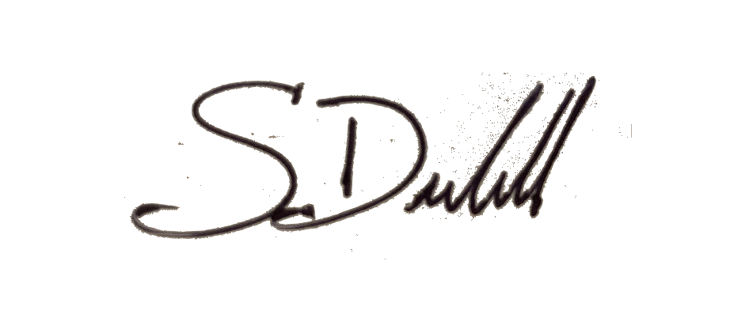

Steven Deobald

