Steven Deobald
+1 306-671-7179
steven@deobald.ca

November 25, 2025

Dear Framework team,

I’m excited about an opportunity to work at Framework. I’ve been working with Rails since the pre-1.0 days, I have significant experience with e-Commerce, I worked for ThoughtWorks in the heyday of agile software development, and I’ve worked on multiple successful startups. Although I’m aligned to the role in many ways, the thing that excites me the most is Framework’s mission.

First, a bit about me: From 2012 to 2018, I started and built Nilenso Software, India’s first worker-owned technology company. While building Nilenso, I mentored our team in Ruby and Clojure. We built and maintained large data-oriented backend and ML systems for companies like Staples and Gojek. At Staples, we used AI to enhance their e-Commerce pricing, delivery estimate services, and others. We built a local-first syncing engine, in Rails, for the life-saving app at Simple.org. As Nilenso’s founder, I’m proud of the part I played in building the teams that built those systems. I enjoy building teams just as much as I enjoy building tools. After growing Nilenso to ₹15 Crore ARR, I left to travel for two years, then from 2020 to 2024, worked on XTDB and founded Endatabas — two immutable, time-traveling database products with all-remote teams. Over my entire career, I’ve spent a lot of time aligning technical goals to business and product strategy.

Prior to starting Nilenso, I worked at ThoughtWorks and DRW Trading from 2005 to 2011. I worked on some of the first Rails and JRuby projects in the world. While at ThoughtWorks, I was actively involved in the emergence of CI/CD with CruiseControl.NET, and the maturation of TDD and the “testing pyramid”. I was a tech lead for teams as large as 30 and as small as 2, teaching folks design and architecture. I left high finance and moved to India. It’s a long story I’m happy to share.

Going back even further, I’ve been excited about the Right to Repair, F/OSS, and Linux since the early 2000s. In 2025, I served as Executive Director for the GNOME Foundation and had an opportunity to get directly involved with the Linux desktop, including the development of a partnership with Framework! Framework’s approach to its business and products is excellent. I would love to help make Framework the success it deserves to be.

I live in Halifax, Canada. Halifax is one timezone east of EST and can easily collaborate with Europe, US/Canada Eastern, and California.

I look forward to hearing from you about this role — or any other role at Framework in the future.

All the best,
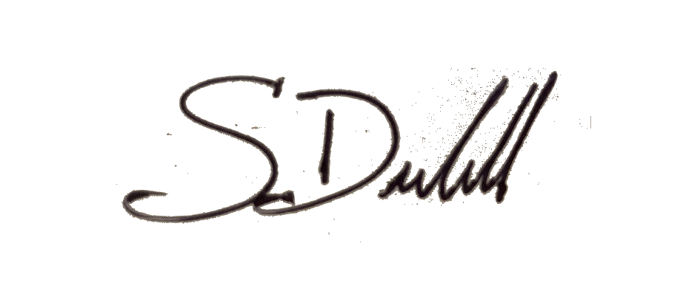

Steven Deobald

