Steven Deobald
+1 306-671-7179
steven@deobald.ca

November 25, 2025

Dear iNaturalist team,

I have been excited by the iNaturalist platform for years and I’m honored to have the opportunity to apply to serve the iNaturalist mission. My partner is a biologist and she introduced me to iNaturalist about a decade ago, while we were both living in South India. The iNaturalist platform represents a necessary tool for citizen science and democratized learning in a global ecosystem constantly under threat from human activity. Additionally, it’s wonderful that iNaturalist is open source software, adding additional transparency and resilience to its nonprofit mission. I’ve written about the future of open source, with some articles and keynotes listed on the second page of my resume.

My experience with nonprofits spans multiple 501(c)(3)s, such as Pariyatti, IVTA, and the GNOME Foundation. I manage Pariyatti’s digital library project and I served the GNOME Foundation as Executive Director. I also volunteer with Atlantic Canada Vipassana Meditation (ACVM), a nonprofit providing free, donation-funded 10-day meditation courses here in Nova Scotia. Across all these organizations I have managed staff and volunteers to ensure successful fundraising and project outcomes.

From 2020 to 2024 I worked on XTDB and founded Endatabas, two immutable, time-traveling database products with remote teams. As a result, I’m also intimately familiar with database systems, data hygiene, and how data practices have changed in the past two decades. Although I was involved in product management for Endatabas, I also managed all fundraising and wrote all our documentation. I’ve worked with CRM tools both as a consumer and producer: I built CRM software at my first job at Adxstudio (since acquired by Microsoft) and used CRM tools for my fundraising work with XTDB, Endatabas, ACVM, and the GNOME Foundation.

Throughout my software career, I’ve always managed production operations for the systems I’ve built. While at the GNOME Foundation, I led the team that built the new donate.gnome.org landing page, which has already grown to $9000 MRR in a few short months.

Having worked on data science, ML, and reporting tools for trading and e-Commerce at DRW Trading and Staples Labs, respectively, I would love an opportunity to apply my experience in data-oriented revenue growth to a mission-driven organization like iNaturalist.

I look forward to hearing from you.

All the best,
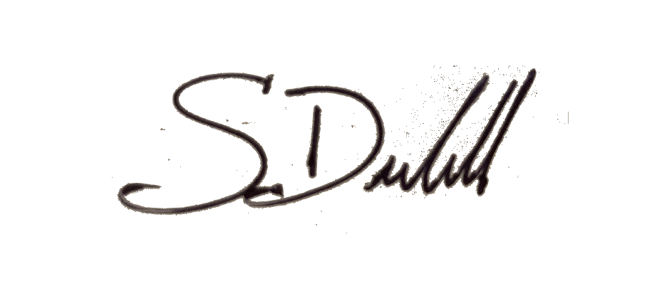

Steven Deobald

