Steven Deobald
+1 306-671-7179
steven@deobald.ca

March 12, 2026

Hello OpenSSL Foundation team,

I was encouraged by Jon to apply for the Deputy Executive Director role, after expressing interest in the Foundation’s Executive Support role. I’m aware these roles are quite different. I’m very interested in continuing to contribute to the free and open source software nonprofit ecosystem.

While I was Executive Director at the GNOME Foundation, I defined the strategy the board continues to execute on today: a year-on-year balanced budget, a clear user-focused fundraising strategy, the design and implementation of a fellowship program, re-evaluation of programmes (fiscal sponsorship, infrastructure, events, and internships), staff mentorship and coaching, and alignment of GNOME’s contributor community — as well as corporate, nonprofit, and government partners — with the Foundation’s operation and overall strategy.

The GNOME Foundation’s 501c3 Public Support Test was in jeopardy when I joined, due to financial mismanagement. My strategic approach to individual giving and user-focused fundraising was therefore both strategic and tactical: solve the Foundation’s compliance issue while simultaneously preparing for larger donations in the future. Individual giving was narrowly and intentionally focused on monthly recurring revenue. First, I designed and choose a team to implement https://donate.gnome.org. The second phase was twofold: add a “donate” option (and notification) within GNOME’s software itself, which every user would see, and significant public appearances both at conferences and in user-focused technology media, such as podcasts and YouTube.

During my time as GNOME Foundation ED, I spent significant time meeting with community members, meeting partners (such as Ubuntu developers, Universal Blue organizers, and management from hardware manufacturers like Framework Computer and Slimbook), offering the wider community previously-unavailable social spaces such as ED Office Hours, and a strategy-focused keynote at GUADEC, GNOME’s yearly conference. It was important to balance the Foundation’s fundraising needs with exercises in building trust.

I managed the GNOME Foundation’s responsibility as a fiscal sponsor to projects like the GIMP and Black Python Devs, resolving years-long confusion and adding expense authorization processes to financial transactions which were previously ad-hoc. Because the GNOME Foundation is itself a 501c3, it was never fiscally sponsored, but I am familiar with the relationship between fiscal sponsors and the sponsored organization.

I’m happy to discuss the other problems I helped solve during my time at the GNOME Foundation. Most are available in detail in my Foundation Updates on https://blogs.gnome.org/steven/ — however, I should note that my tone in these posts was directed primarily at casual community contributors, who were frustrated with a lack of transparency, not donors or partners.

Outside of the GNOME Foundation, my experience aligns closely with the qualities you are looking for in a Deputy ED. I’m located in Halifax — one timezone east of New York, and a short hop for either USA or EU travel. I’ve been working in hybrid settings since 2008 and remote-only since 2020. I vastly prefer lean teams with cross-functional team members. I’ve lived outside of Canada for 15 of the last 20 years, with the majority of that time in India, so I am very comfortable in cross-cultural and globally diverse environments. During my time running Nilenso, I was the primary person responsible for marketing, business development, and sales. I dovetailed this into branding, sales, and fundraising at XTDB, Endatabas, and the GNOME Foundation. I’ve spent many hours speaking to lawyers on sensitive issues. I’ve managed AGMs, conferences, RFPs, vendor relationships, and all of the coordination that entails.

With respect to fundraising, one of the most difficult software choices for any organization is that of CRM: too simple, and the processes become manual and brittle, too complex, and fundraisers spend their days configuring Salesforce object models instead of raising money. While I appreciate there are open source CRM tools which may align more closely with the OpenSSL Mission, I have heard nothing but good things about Little Green Light. It’s encouraging to hear the OpenSSL Foundation has chosen a tool based on the intersection of open source and nonprofit ideals.

Regarding my nonprofit experience, I manage the volunteer software team at Pariyatti, a 501c3. I’m also the Centre Manager for Atlantic Canada Vipassana Meditation (ACVM), a small Canadian nonprofit that organizes secular 10-day meditation courses. These courses are free for students — entirely financed by donation and operated by a team of 20+ volunteers. I have been volunteering with these organizations for six years and three years, respectively.

I’m more than happy to answer any other questions you have.

Regards,
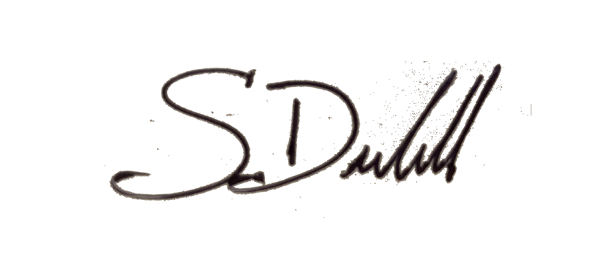

Steven Deobald

