Steven Deobald
+1 306-671-7179
steven@deobald.ca

January 22, 2025

Dear Stripe Hiring Team,

Let me just say, I like this format.

- https://endatabas.com - I made this website. It uses M4 for templating.
- https://docs.endatabas.com - I wrote every word of this documentation.
- https://github.com/endatabas/endb - I reviewed every line of code that went into this.
- https://pariyatti.app - I lead the team that builds this digital library app for a 501(c)3 non-profit.
- https://github.com/pariyatti/mobile-app - I supervised this Flutter app and I modify it sometimes
- https://github.com/pariyatti/kosa-clj - I thought I needed a triple-store and Clojure. I didn’t.
- https://github.com/pariyatti/kosa2 - Rails, as it turns out, is fine. I rewrote the Clojure in a week.
- https://xtdb.com - I ran the team that made this website and all the docs. (Archive.org 2022)
- https://www.deobald.ca/essays - I wrote about immutable databases a lot for a while.
- https://github.com/simpledotorg - I was EM for both the Android and Rails teams for a while.
- https://gojek.com - I sold us into Gojek to build all Clojure services and train their staff on it.
- https://nilenso.com - “Us” was Nilenso, the company I founded, grew, and let fly on its own.
- https://github.com/nilenso/cooperative-agreement - Open source matters to more than just code.
- INSERT YEARS OF CLOSED-SOURCE JAVA, JS, C#, RUBY, AND CLOJURE HERE
- https://github.com/deobald/Insomnia - I made a graphical MUD when I was a child.

I look forward to hearing from you about this or future roles.

All the best,

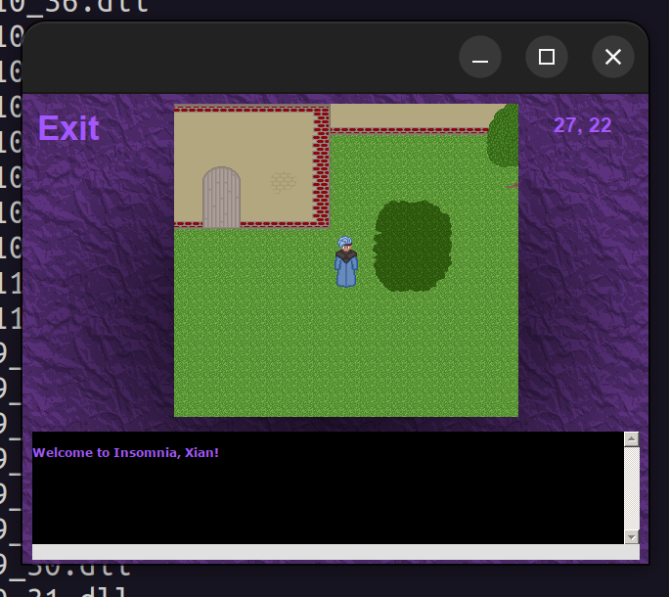Figure 1: Much to my amazement, the MUD runs on Wine.

Steven Deobald

