SYNOPSIS

VIDYALANKAR APPLICATION

**INTRODUCTION:**

We have developed an application for our Final year project named as **VIDYALANKAR.** This application contains the information about **VIDYALANKAR POLYTECHNIC**. This App covers details related to the College Administration, Perspective of Students, Courses, about us, Contact Details and many more things.

In this advance age there is great demand for Android application due to its ease of use. Android is a new mobile operating system (OS) based on the Linux Kernel and currently developed by Google. With User Interface based on direct manipulation, Android is designed primarily for touchscreen mobile devices such as smartphone and tablet computers. The OS uses touch input that loosely correspond to real-world actions, like swiping, tapping, etc.

Android is popular with technology companies, organizations and educational institutes which requires a readymade low cost and customizable operating system (OS) for high tech devices. Android’s open nature has encouraged a large community of developers and enthusiasts to use the open source code as a foundation for community driven projects.

Android is the most widely used mobile OS, so we decided to build an application of our college that reduce complexity of interaction between students and the college, we have investigated the use of an “**VIDYALANKAR APPLICATION**” to support student interaction with the college.

Since Android devices are usually battery powered Android is designed to manage memory (RAM) to keep power consumption at a minimum, in contrast to desktop operating systems which generally assume they are connected to unlimited mains electricity. When an Android application is no longer in use, the system will automatically suspend it in memory; while the application is still technically "open", suspended applications consume no resources (for example, battery power or processing power) and sit idly in the background until needed again. This brings a dual benefit by increasing the general responsiveness of Android devices, since applications do not need to be closed and reopened from scratch each time, and by ensuring that background applications do not consume power needlessly.

**OBJECTIVE:**

* Android is most widely used mobile operating system so we developed this application to interact student with college.
* To provide our college related information through the Android app.
* Student can get detailed information in quicker and most effective manner then traditional posters and hoardings.
* The aim of this app is to provide detailed information about the college, its infrastructure, curriculum, administration, location and many more other details.

**TECHNICAL DETAILS:**

**Hardware Requirements**

Our project is just a onetime investment product, which has the minimum requirements that every user already possess.

* 256 MB RAM
* Minimum Phone Memory Required – 30MB.
* Mobile Phone with Android operating system

**Software Requirements**

The software requirements of our project consisted of the following:

For Mobile:

* Android 2.2 (Froyo) to Android 5.0 (Lollipop).

For Desktop:

* Flash Professional CC
* Bluestack Android Mobile Emulator

**FEASIBILITY ANALYSIS OF PROJECT:**

1. **Time Feasibility:**

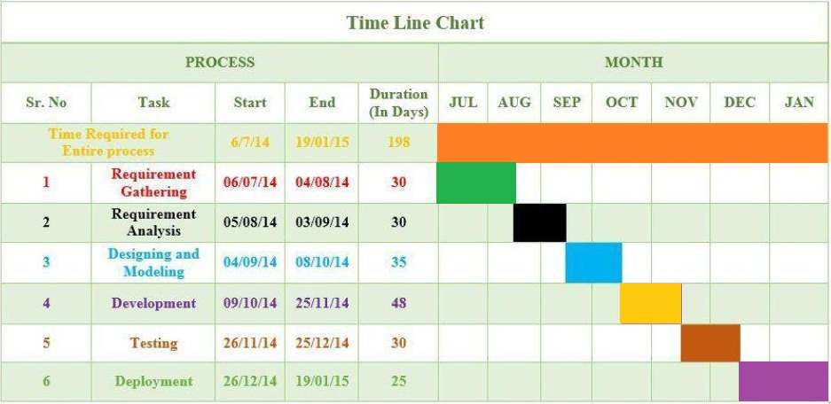

1. **Software Availability:**

To develop the application we needed the **Flash Professional CC** software, the cost of the license key for the software is $250(Rs.15000). The college provided the license key for the ease of the application development

**ADVANTAGES:**

* It will help students to interact with college easily via app.
* It will help other students and their parent’s to know about college easily.
* It is easy to access through mobile phones.

**DISADVANTAGES:**

* It only operates on Android supported devices.

**FUTURE EXPANTION:**

* It will be uploaded on play store for ease of downloading it.
* It will be made dynamic.

**REFERENCES:**

* <http://blogs.adobe.com/flashpro/2013/05/14/what-is-flash-pro-cc/>
* <http://helpx.adobe.com/flash/using/whats-new.html>
* <http://tv.adobe.com/watch/creative-cloud-for-web/showcasing-a-modern-adobe-flash-professional-cc/>
* <http://searchsoa.techtarget.com/definition/XML>
* <http://groups.engin.umd.umich.edu/CIS/course.des/cis400/xml/xml.html>
* <http://programmers.stackexchange.com/questions/213316/xml-based-programming-languages>

**GROUP MEMBERS:**

1. **Rohin J. Singh**
2. **Wasim Idrisi**
3. **Farhan Shaikh**
4. **Sonali Ghanekar**