**BRAIN MACHINE INTERFACE**

**1.** **Introduction:**

Brain Machine Interface (BMI) is a domain concerning recording, interfacing and interpretation of the electroencephalogram. Electroencephalogram (EEG) is a record of the electric signal generated by the cooperative action of brain cells, or more precisely, the time course of extracellular field potentials generated by their synchronous action. EEG can be measured by means of electrodes placed on the scalp or directly on the cortex. In the latter case, it is sometimes called electrocorticogram (ECoG). In a physiological sense, measured EEG power reflects the number of neurons that discharge synchronously. Because brain volume and the thickness of the cortical layer is positively correlated with intelligence, it is tempting to assume that EEG power too, is a measure that reflects the capacity or performance of cortical information processing. .

**2. Theoretical Background:**

Neurons in the brain can impact all aspects of human life including completing motor activities, performing mental thought, memories, and dreaming. The electroencephalogram (EEG) is a recording from the surface of the scalp generated by many biopotentials in the cerebrum of the brain. More specifically, it is a recording of the action potentials and the postsynaptic potentials of cortical cells. Since we are recording from the surface of the scalp, we are measuring potentials from many cells at the same time. The potentials of the neurons in the brain can vary as a function of the emotional, mental, or physiological state of the person. At first glance, EEG data may look like an unstructured, non-stationary, noisy signal. However, advanced signal processing techniques can be used to separate different components of the brain waves. These separate components can then be associated with different brain areas and functions.. The frequencies and typical amplitudes of these components are shown in the table 2.1. Alpha waves are generally found in the EEG when the individual is awake in a quiet, resting state with their eyes closed. The alpha wave can be detected primarily from the occipital lobe but also from the parietal and frontal regions of the cerebral cortex. During sleep, however, the alpha waves disappear.

|  |  |  |
| --- | --- | --- |
| **Rhythm** | **Typical Frequencies (Hz)** | **Typical Amplitude (µV)** |
| Α | 8-13 | 2-100 |
| Β | 13-22 | 5-10 |
| Δ | 0.5 – 4 | 20-100 |
| Γ | 4-8 | 10 |

Table 2.1. EEG Brain Rhythms

Beta waves are recorded from the parietal and frontal lobes. They appear when the individual performs some specific type of mental activity or are attentive to an external stimulus. They are lower in amplitude than the alpha rhythms, but this is not due to there being less electrical activity. Instead, desynchronization, also known as alpha block, occurs, reducing the amplitude of the net signal recorded from the scalp. As mentioned previously, non-synchronized potentials tend to cancel each other, resulting in a lower amplitude signal. Figure 2.1 shows the generation of EEG signal through a neuron.

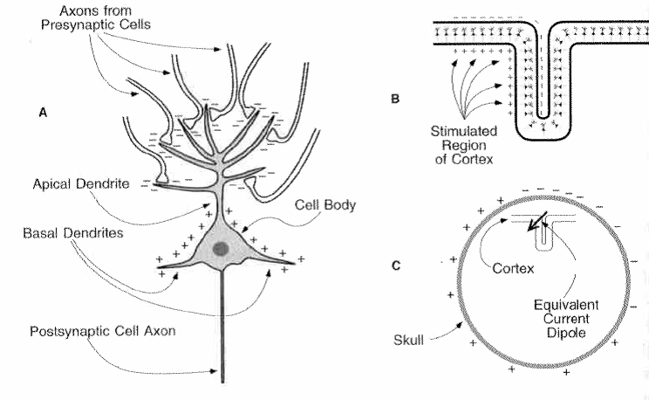

Figure 2.1 Potential generation through neural activity

Theta waves occur mainly in the parietal and temporal regions. These occur sometimes during emotional stress and often in degenerative brain states. Delta waves are the very low frequency components of an EEG. Deep sleep and certain brain diseases give rise to delta waves.

**3. EEG Signal Processing:**

In Brain Machine Interface EEG signals are the signatures of neural activities. They are captured by multiple-electrode EEG machines either from inside the brain, over the cortex under the skull, or certain locations over the scalp, and can be recorded in different formats. There have been many algorithms developed so far for processing EEG signals. The operations include, but are not limited to, time-domain analysis, frequency-domain analysis, spatial-domain analysis, and multi-way processing. The membrane potential increases when the membrane is polarized with a net negative charge lining the inner surface and an equal but opposite net positive charge on the outer surface. This potential may be simply related to the amount of electrical charge *Q*, using

*E* = *Q/C*m

Where *Q* is in terms of coulombs/cm2, *C*m is the measure of the capacity of the membrane in units of farads/cm2, and *E* is in units of volts. In practice, in order to model the action potentials (APs) the amount of charge *Q*+ on the inner surface (and *Q*− on the outersurface) of the cell membrane has to be mathematically related to the stimulating current *I* stim flowing into the cell through the stimulating electrodes. The electrical potential (often called the electrical force) *E* is then calculated using above Equation.

**4. Design Concept and Block Diagram:**

In this model the brain signal source is derived from a single user being the researcher. These signals are acquired through selected brain computer interfaces, raw brain signals (amplified brain signal) are then passed to an operating environment. In this research, the operating environment consisted of a PC running a Windows XP/ 7 operating system. This system was selected as it is commonly accessible to general users. It is widely used by many users for standard daily operation and access to other relevant applications. A suitable BMI solution can be extended to function in other operating environments and embedded hardware devices.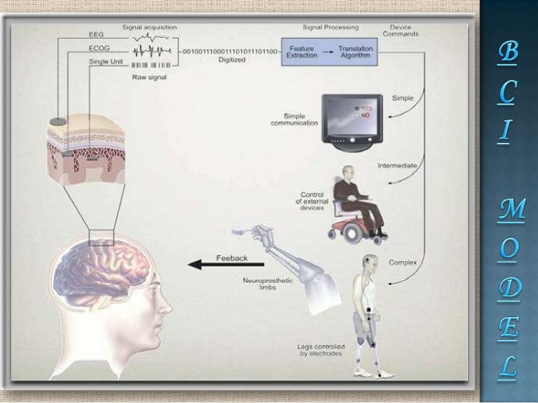 Figure 4.1. Block Diagram of Brain Machine

**5. Applications:**

* EEG signal processing and analysis in diagnosis of brain diseases.
* Robotic limb controlling for paralyzed people
* Mainstream robotics devices controlling
* Mind controlled gaming using assisted modules
* Produce biofeedback situations

**6. Conclusion:**

The field of BMI research is growing and developing at great speed. This research has shown that it is possible to develop a reliable, cost-effective and efficient in-home BMI application.