**Assignments**

**TASK ONE: BASIC EXERCISE**

1. Swap two numbers using third variable as result name and do the same task without using any third variable.

2. Write a program to print the value given by the user.

3. Write a program to complete the task given below:

* Ask the user to enter any 2 numbers in between 1-10 and add both of them to another variable call z.
* Use z for adding 30 into it and print the final result by using variable results.

4. Write a program to print values if the user enters a Floating point number.

5. Write a program to take input from user and check if it is divisible by 3 and 5 or not.

6. Write a program for String formatting of the input data: (Hint: System.out.printf will be used), justify with 15 spaces and add 0 in front if the number is 2-digit.

Input:

java 100

cpp 65

python 50

Output:

================================

java                100

cpp                065

python          050

================================

Output Format

In each line of output there should be two columns:

* The first column contains the String and is left justified using exactly  characters.
* The second column contains the integer, expressed in exactly  digits; if the original input has less than three digits, you must pad your output's leading digits with zeroes.

**TASK TWO: OPERATORS AND DECISION MAKING STATEMENT**

1. Write a program in JAVA to perform the following operation:

* If a number is divisible by 3 it should print “Consultadd” as a string
* If a number is divisible by 5 it should print “JAVA Training” as a string
* If a number is divisible by both 3 and 5 it should print “Consultadd JAVA Training” as a string.

2. Write a program in JAVA to perform the following operator based task:

* Ask user to choose the following option first:
  + If User Enter 1 - Addition
  + If User Enter 2 - Subtraction
  + If User Enter 3 - Division
  + If User Enter 4 - Multiplication
  + If User Enter 5 - Average
* Ask user to enter the 2 numbers in a variable for first and second(first and second are variable names) for the first 4 options mentioned above and print the result.
* Ask user to enter two more numbers as first1 and second2 for calculating the average as soon as user choose an option 5.
* At the end if the answer of any operation is Negative print a statement saying “Oops option X(1/2/3/4/5/) is returning the negative number”
* NOTE: At a time user can perform one action at a time.

3. Write a program in JAVA to implement the given flowchart: 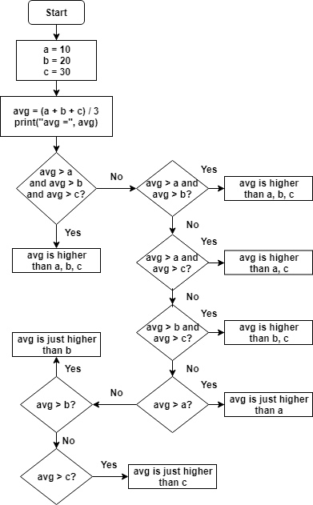

4. Write a program in JAVA to break and continue if the following cases occurs:

* If user enters a negative number just break the loop and print “It’s Over”
* If user enters a positive number just continue in the loop and print “Good Going”

5. Write a program that prints all the numbers from 0 to 6 except 3 and 6.

       Expected output: 0 1 2 4 5

6. Given an integer , perform the following conditional actions:

* If  is odd, print NEW
* If  is even and in the inclusive range of 2 to 5 , print OLD
* If  is even and in the inclusive range of 6 to 30, print NEW
* If  is even and greater than 30, print OLD

Complete the stub code provided in your editor to print whether or not is weird.

7. Write a Java program that reads a floating-point number and prints "zero" if the number is zero. Otherwise, print "positive" or "negative". Add "small" if the absolute value of the number is less than 1, or "large" if it exceeds 1,000,000.

8. Write a JAVA program which takes character input from the user,

* If the character is from **r, a, n, d, o, m** (consider both upper and lower cases), then print FOUND.
* Print NOT FOUND for all the other alphabets.

**TASK THREE: LOOPING**

1. Write a simple program to print multiplication table of a certain number taken from user,

For eg. 2 X 1 = 2

2 X 2 = 4

and so on.

1. Write a program in which:
   1. Take 10 values input from user using loop.
   2. Print sum of all the numbers provided
   3. Print the Average of those 10 values
2. Write a JAVA program that takes user input from 1 to 12 for months, and display number of days of a particular month. (Shows “Invalid Details“ if incorrect month number will be provided).
3. Write a JAVA program that takes one integer input n from the user, and display all the so, print sum of n natural numbers.
4. Write a JAVA program that takes long type input from user, and
   1. Calculate and display the number of digits.
   2. Calculate the sum of all the digits of the input.
5. Write a program that accepts three numbers from the user and prints "**INCREASING**" if the numbers are in increasing order, "**DECREASING**" if the numbers are in decreasing order, and "**Neither increasing or decreasing order**" otherwise. FOR eg.

* Input first number: 1524
* Input second number: 2345
* Input third number: 3321

Output :

**INCREASING**

7. Write a Java program to find the number of days in a month.

Test data

Input a month number: 2

Input a year:2016

Expected output:

February 2016 has 29 days

1. Write a Java program that takes a year from user and print whether that year is a leap year or not.

**TASK FOUR : PATTERNS**

1. Write a program in Java to display the pattern like right angle triangle with a number.

Test Data

Input number of rows : 10

Expected Output :

1

12

123

1234

12345

123456

1234567

12345678

123456789

12345678910

1. Write a Java program to display Pascal's triangle.

Test Data

Input number of rows: 5

Expected Output :

Input number of rows: 5

      1

     1 1

    1 2 1

   1 3 3 1

  1 4 6 4 1

1. Write a Java program that accepts two floating­ point numbers and checks whether they are the same up to two decimal places.

**TASK FIVE : ARRAYS**

1. Write a Java program to remove duplicate elements from an array.
2. Write a Java program to find the second largest element in an array.
3. Write a Java program to find the second smallest element in an array.
4. Write a Java program to add two matrices of the same size.
5. Write a Java program to move all 0's to the end of an array. Maintain the relative order of the other (non-zero) array elements.
6. Write a program to remove the duplicates from a sorted array change them into 0 and add 0 in the end.
   1. input: [2,2,3,3,4,4,4,11,11,11,11]
   2. output:[2,3,4,11,0,0,0,0,0,0,0]
7. Write a Java program to get the difference between the largest and smallest values in an array of integers. The length of the array must be 1 and above.
8. Write a Java program to remove the duplicate elements of a given array and return the new length of the array.
9. Write a Java program to find the sum of the two elements of a given array which is equal to a given integer.
   1. Sample array: [1,2,4,5,6]
   2. Target value: 6.
10. Write a Java program to find the two elements from a given array of positive and negative numbers such that their sum is closest to zero.
11. Write a Java program to sort an array of positive integers of a given array, in the sorted array the value of the first element should be maximum, second value should be minimum value, third should be second maximum, fourth second be second minimum and so on.