Required Capstone Checkpoint 2.1: Retrieval Strategy Design and Baseline Implementation

Directions

You will continue working with the same dataset and scenario you selected for your capstone checkpoint in Module 1. In this activity, you will design and implement a baseline retrieval system that supports the types of queries required for your scenario.

Download this worksheet and save a copy to your device before you begin working. Type your responses directly into the document, save your completed work, and upload the finished file when you are ready to submit.

Use this worksheet to:
- Document your retrieval approach
- Capture representative retrieval queries and results
- Provide evidence that your retrieval system is functioning
- Observe how retrieval performance changes across different query types
- Reflect on where the retrieval approach performs well and where it struggles

1. Selected Scenario and Retrieval Approach
- Identify your chosen capstone scenario.
- Describe the retrieval approach you implemented (keyword-based, semantic, or hybrid).
- Briefly explain why this retrieval approach is appropriate for your dataset and query types.
- Describe any trade-offs you considered when selecting this approach
Scenario
☐ Research Paper Navigator
☐ Wikipedia Retrieval Engine
Retrieval approach used, brief explanation, and description of trade-offs considered
Response:
Describe the retrieval approach you implemented (keyword-based, semantic, or hybrid).
I implemented a hybrid retriever composed of two independent retrievers - Keyword-based and Semantic
Keyword-based was used via BM25 Okapi over tokenized chunks, with stop-word removal where higher score equals better match.
For the Semantic, it was OpenAI text-embedding-3-small embeddings, stored in a persisted Chroma vector store, and ranked by distance where lower distance equals better matches.
Both retrievers were queried independently for a candidate pool of 20 while their scores were normalized to [0,1]. The vector distances were inverted such that higher means better, and the two are combined as a weighted sum of 0.5 to 0.5. The documents retrieved by both accumulate from both sides so that documents found by only one are capped at that retriever's weight.
The baseline is a hybrid retriever of over 23,560 chunks derived from 153 PDFs (6,070 pages), and combined BM25 keyword scoring with dense vector similarity from text-embedding-3-small in a Chroma store. Means that each retriever contributes a 20-document candidate pool.

Briefly explain why this retrieval approach is appropriate for your dataset and query types
Here are some of my reasons why this retrieval approach was appropriate for my dataset.
These papers use many specialized technical terms, which makes BM25 a good fit. In this set of 153 programming-language papers, the answer is often a specific term such as storyboard programming or CEGIS. In one of my queries, BM25 found the correct paper because it matched the exact rare term.
Secondly, users may not know the exact technical terms to search for, which is where vector search helps. It can understand questions written in everyday language and find relevant papers even when the exact keywords are not used.
Since most of the papers cover similar topics, vector search alone struggled to tell them apart. Adding keyword search helped identify the right paper when many papers have similar meanings. This is why combining both methods worked better. That gave more weight to results they agree on, because if both keyword and vector search find the same document, it ranked higher.

Describe any trade-offs you considered when selecting this approach
I considered a few trade-offs explained below.

I experimented with widening the candidate pool versus widening k which is a true and different tradeoff from Lab 2.1. Widening the pool was nearly free as the documents never reached the LLM, hence there was no token cost. Whereas, widening k was not as raising k cost money and added distraction.
Another tradeoff was the chunk size. Smaller chunks gave precise retrieval though they fragmented ideas across boundaries, however, larger chunks preserver context but dilute the embedding. I measured this failure in Lab 2.1 where I chose midsize and paid for it.
I examined fixed 50/50 weighting vs. adaptive weighting. A 50/50 split is simple and consistent, but it does not work equally well for every search. My 3rd query showed that BM25 added less relevant results, which lowered the overall ranking. I discovered that adjusting the balance based on the type of search could improve results, but it would make the system more complex.

2. Baseline Retrieval System Evidence
- Provide evidence that your retrieval system was implemented and tested.
- Evidence may include screenshots, logs, outputs, notebook examples, code snippets, or brief descriptions showing that retrieval queries were executed successfully.
Evidence of retrieval system implementation and testing
Response:
Evidence showing 6070 pages loaded from 153 PDFs, split into 23,560 chunks and embedded into 23,560 chunks.
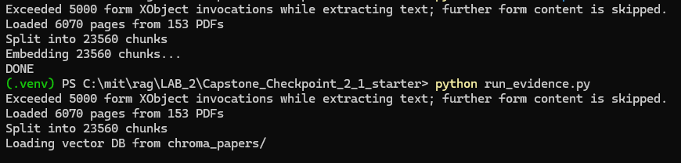

The image below shows the various scripts used for my labs.
capstone_corpus.py — PDF loading and chunking
capstone_retriever.py — BM25, vector, and fusion
run_evidence.py — the test harness
probe.py and list_titles.py — diagnostic tooling
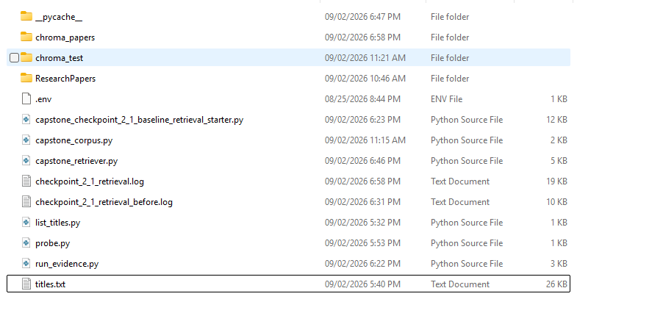
Here is some of my evidence around testing. The first two screenshots (Queries 1 and 4) show grounded answers with quoted source material.
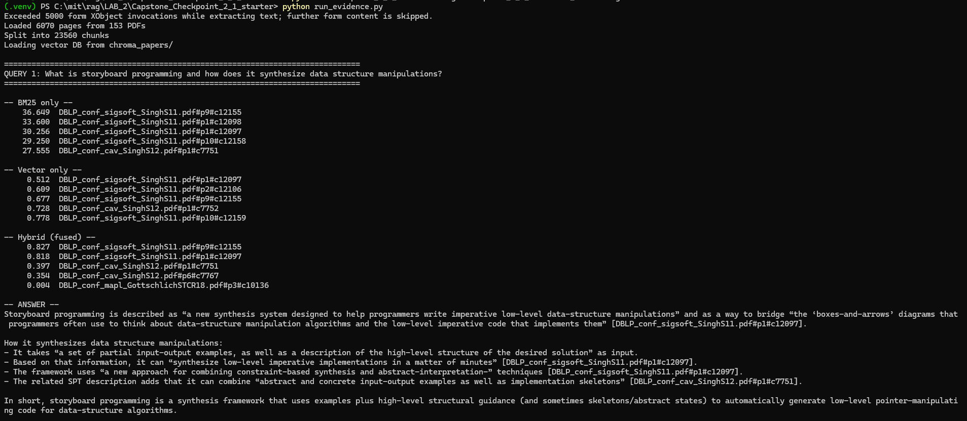
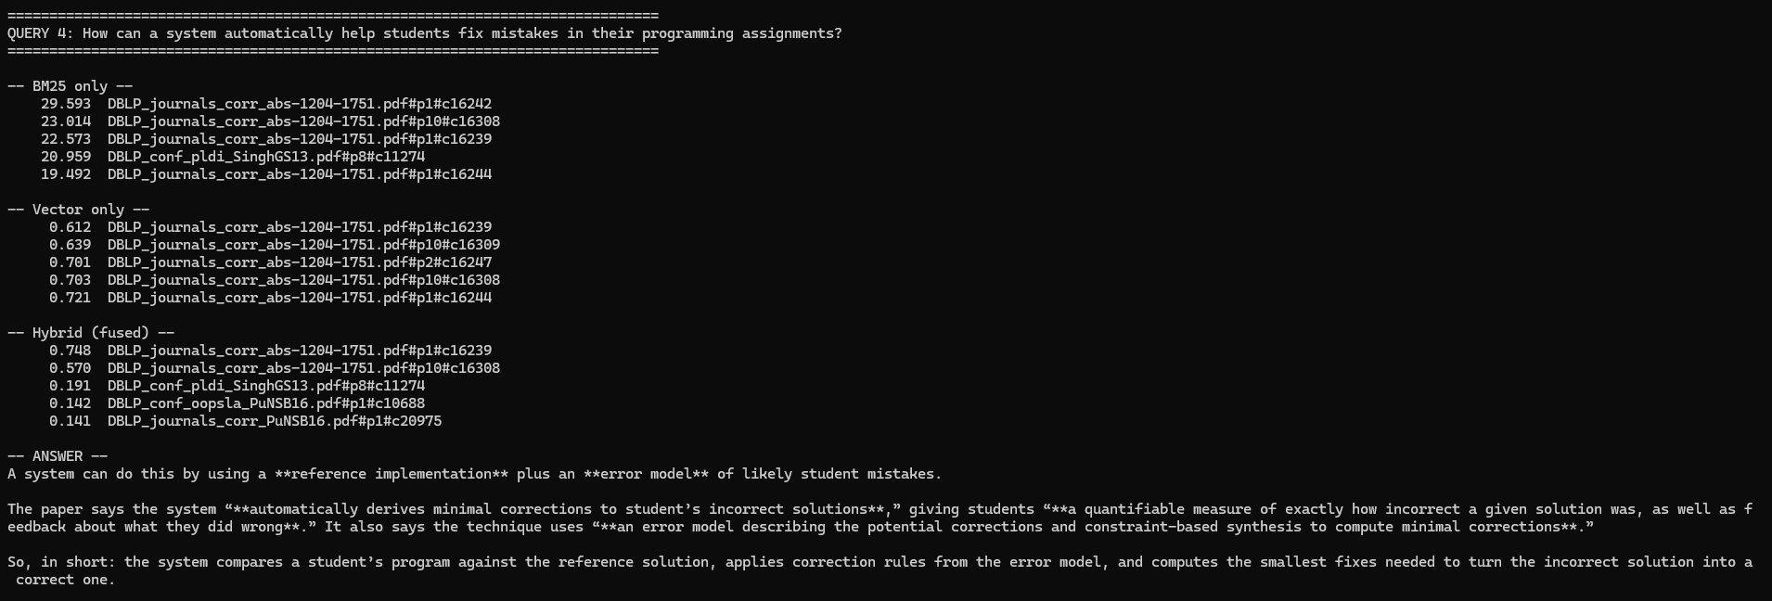

Query 5 exhibits the negative control by returning a correct refusal on an out-of-corpus question. This is a test with a known expected outcome.
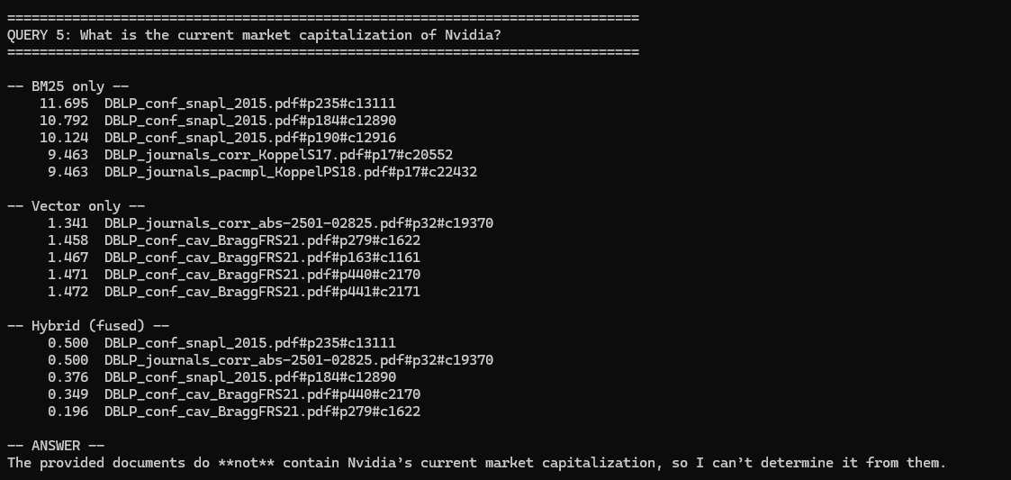

The table below shows a summary of the outcome of the 5 queries I ran
Query | Type | BM25 | Vector | Hybrid | Outcome
1 | Rare term | Passed | Passed | Passed | Correct, quoted
2 | Multi-doc | Passed | Passed | Passed | Retrieved, poor diversity
3 | Paraphrase | Failed | Failed | Failed | Failed – vocabulary gap
4 | Paraphrase | Passed | Passed | Passed | Correct, quoted
5 | Negative | n/a | n/a | n/a | Correctly refused

3. Representative Queries and Retrieved Results
- Provide three to five representative queries relevant to your scenario.
- Include the retrieved results for each query.
- Focus on showing how the retrieval system behaves across different types of information needs. Where possible, include a mix of precise, conceptual, or broader exploratory queries.
Query 1
Query:
QUERY 1: What is storyboard programming and how does it synthesize data structure manipulations?
Retrieved results:

-- BM25 only --
36.649 DBLP_conf_sigsoft_SinghS11.pdf#p9#c12155
33.600 DBLP_conf_sigsoft_SinghS11.pdf#p1#c12098
30.256 DBLP_conf_sigsoft_SinghS11.pdf#p1#c12097
29.250 DBLP_conf_sigsoft_SinghS11.pdf#p10#c12158
27.555 DBLP_conf_cav_SinghS12.pdf#p1#c7751

-- Vector only --
0.512 DBLP_conf_sigsoft_SinghS11.pdf#p1#c12097
0.609 DBLP_conf_sigsoft_SinghS11.pdf#p2#c12106
0.677 DBLP_conf_sigsoft_SinghS11.pdf#p9#c12155
0.728 DBLP_conf_cav_SinghS12.pdf#p1#c7752
0.778 DBLP_conf_sigsoft_SinghS11.pdf#p10#c12159

-- Hybrid (fused) --
0.827 DBLP_conf_sigsoft_SinghS11.pdf#p9#c12155
0.818 DBLP_conf_sigsoft_SinghS11.pdf#p1#c12097
0.397 DBLP_conf_cav_SinghS12.pdf#p1#c7751
0.354 DBLP_conf_cav_SinghS12.pdf#p6#c7767
0.004 DBLP_conf_mapl_GottschlichSTCR18.pdf#p3#c10136

-- ANSWER --
Storyboard programming is described as “a new synthesis system designed to help programmers write imperative low-level data-structure manipulations” and as a way to bridge “the ‘boxes-and-arrows’ diagrams that programmers often use to think about data-structure manipulation algorithms and the low-level imperative code that implements them” [DBLP_conf_sigsoft_SinghS11.pdf#p1#c12097].

How it synthesizes data structure manipulations:
- It takes “a set of partial input-output examples, as well as a description of the high-level structure of the desired solution” as input.
- Based on that information, it can “synthesize low-level imperative implementations in a matter of minutes” [DBLP_conf_sigsoft_SinghS11.pdf#p1#c12097].
- The framework uses “a new approach for combining constraint-based synthesis and abstract-interpretation-” techniques [DBLP_conf_sigsoft_SinghS11.pdf#p1#c12097].
- The related SPT description adds that it can combine “abstract and concrete input-output examples as well as implementation skeletons” [DBLP_conf_cav_SinghS12.pdf#p1#c7751].

In short, storyboard programming is a synthesis framework that uses examples plus high-level structural guidance (and sometimes skeletons/abstract states) to automatically generate low-level pointer-manipulating code for data-structure algorithms.
Observations:
What worked well.
Both retrievers independently converged on the correct source. BM25 scored 36.6 on its top hit which was by far the highest score across all five queries because "storyboard" is a rare, coined term with high inverse document frequency. The vector retriever agreed by returning distance 0.512 which was its tightest match anywhere in the test set. Fusing both together, the top two hybrid results scored 0.827 and 0.818, near the 1.0 ceiling reachable only when both retrievers rank a chunk highly. The resulting answer quoted the paper directly and accurately and correctly identifying the three components of a storyboard and the constraint-satisfaction encoding.

Limitations and unexpected behaviors.
Hybrid retrieval added no measurable value here as all three methods returned essentially the same documents, so the fusion step was redundant for this query type. In fact, the top 5 spanned only two distinct papers, with four of five chunks from sigsoft_SinghS11; the related cav_SinghS12 appeared only at rank 5. Because the corpus contains just two papers on this topic, that concentration was appropriate, but it exposes a system which does not have a diversity control. The same behavior produced worse outcomes in Queries 2 and 4 where more relevant papers existed and were crowded out.

Query 2
Query:
QUERY 2: How do these systems learn reusable libraries of program abstractions?

Retrieved results:
-- BM25 only --
19.791 DBLP_journals_pacmpl_BowersOWGTES23.pdf#p26#c21803
19.436 DBLP_journals_pacmpl_BowersOWGTES23.pdf#p19#c21777
18.378 DBLP_journals_pacmpl_BowersOWGTES23.pdf#p28#c21815
18.044 DBLP_conf_icml_GuJLSESS25.pdf#p39#c9213
18.030 DBLP_conf_nips_EllisMSST18.pdf#p9#c10289

-- Vector only --
0.670 DBLP_journals_pacmpl_BowersOWGTES23.pdf#p2#c21701
0.728 DBLP_journals_pacmpl_BowersOWGTES23.pdf#p26#c21804
0.735 DBLP_journals_corr_abs-2503-22625.pdf#p18#c19657
0.753 DBLP_journals_pacmpl_BowersOWGTES23.pdf#p2#c21703
0.781 DBLP_journals_pacmpl_BowersOWGTES23.pdf#p24#c21797

-- Hybrid (fused) --
0.500 DBLP_journals_pacmpl_BowersOWGTES23.pdf#p26#c21803
0.500 DBLP_journals_pacmpl_BowersOWGTES23.pdf#p2#c21701
0.422 DBLP_journals_corr_abs-2503-22625.pdf#p18#c19657
0.394 DBLP_conf_icml_GuJLSESS25.pdf#p39#c9213
0.318 DBLP_conf_nips_EllisMSST18.pdf#p9#c10289

-- ANSWER --
These systems learn reusable libraries by finding abstractions that capture common structure across many programs.

From the documents:

- Stitch’s related work says these systems “introduce the idea of learning abstractions that capture common structure across a set of programs.”
- One common method is “to search for common tree fragments across a corpus of programs, which can be introduced as new abstractions.”
- A more advanced approach “reasons about variable bindings to abstract out well-formed functions instead of just tree fragments.”
- Another related line of work proposes “a new algorithm for inducing reusable subroutines, based on Fragment Grammars.”

So, in short, they learn reusable libraries by abstracting repeated patterns from a corpus of programs—either as fragments, well-formed functions, or reusable subroutines.
Observations:
What worked well?
The search found relevant information and gave an accurate answer. Both BM25 and vector search worked reasonably well, and combining them helped find useful results that one method alone might have missed.

What limitations, challenges, or unexpected retrieval behaviors did you observe?
The search did not do well at finding information from different papers. The top five results came from only two unique papers, with several duplicate or closely related results taking up valuable spots. This caused other important papers, including DreamCoder and Library Learning for Neurally-Guided Bayesian Program Induction, to be left out.
As a result, the final answer sounded like it used several sources, but it actually relied mostly on one paper. This shows that simply selecting the top-ranked chunks is not enough when a question requires information from multiple documents. A better approach would limit how many chunks can come from the same paper, allowing the search to include a wider range of relevant sources.

Query 3
Query:
QUERY 3: How can a programmer leave gaps in their code for the computer to fill in automatically?

Retrieved results:
-- BM25 only --
14.640 DBLP_conf_tacas_InalaPQLS17.pdf#p527#c15519
14.618 DBLP_conf_snapl_2015.pdf#p284#c13320
14.490 DBLP_journals_corr_KoppelS17.pdf#p7#c20511
14.490 DBLP_journals_pacmpl_KoppelPS18.pdf#p7#c22391
13.950 DBLP_conf_snapl_2015.pdf#p266#c13244

-- Vector only --
0.941 DBLP_journals_corr_abs-1906-04604.pdf#p1#c17506
0.950 DBLP_conf_icml_GuJLSESS25.pdf#p30#c9159
0.969 DBLP_conf_mapl_GottschlichSTCR18.pdf#p1#c10124
0.971 DBLP_journals_corr_abs-1803-07244.pdf#p1#c16891
0.973 DBLP_conf_nips_EllisMSST18.pdf#p2#c10258

-- Hybrid (fused) --
0.500 DBLP_conf_tacas_InalaPQLS17.pdf#p527#c15519
0.500 DBLP_journals_corr_abs-1906-04604.pdf#p1#c17506
0.495 DBLP_conf_snapl_2015.pdf#p284#c13320
0.464 DBLP_journals_corr_KoppelS17.pdf#p7#c20511
0.464 DBLP_journals_pacmpl_KoppelPS18.pdf#p7#c22391

-- ANSWER --
The documents do not answer this directly.
They do mention related ideas about:
- “executing the partially-written code,” and
- code “transformed through each of them at runtime,” and
- “the user only writes code to translate between removed node types and their generic equivalents.”
But none of the provided text explains how a programmer can explicitly leave gaps in code for the computer to fill in automatically.

Observations:
What worked well?
Although the search results were weak, the model handled them correctly. Instead of guessing, it clearly said the available documents did not contain enough information to answer the question. This is better than giving a confident but incorrect answer.

What limitations, challenges, or unexpected retrieval behaviors did you observe?
This was the system’s biggest failure. Several papers in the collection directly answered the question, but none appeared in the search results.
BM25 returned irrelevant sections from very large documents because they contained some of the search words. Vector search found papers on similar topics, but they did not answer the specific question. Combining the two methods did not fix the problem because both were given equal weight.
The main issue was word choice. The question used everyday terms like “gaps” and “fill in,” while the papers used technical terms like “holes” and “sketch.” When the search used the word “holes,” it quickly found the correct definition: “A partial program (also called a sketch) is a program with holes.”
The tests also showed that a higher BM25 score does not always mean a better result. Another expected problem—confusion with papers about hand-drawn sketches—did not occur. Instead, most of the irrelevant results came from large conference documents containing many unrelated terms.
Overall, this test showed that vector search did not handle different wording as well as expected, while BM25 was affected by large, noisy documents. Better document preparation and improved handling of different search terms could make the retrieval more reliable.

Optional Additional Queries
Query 4:
QUERY 4: How can a system automatically help students fix mistakes in their programming assignments?

Retrieved results:
-- BM25 only --
29.593 DBLP_journals_corr_abs-1204-1751.pdf#p1#c16242
23.014 DBLP_journals_corr_abs-1204-1751.pdf#p10#c16308
22.573 DBLP_journals_corr_abs-1204-1751.pdf#p1#c16239
20.959 DBLP_conf_pldi_SinghGS13.pdf#p8#c11274
19.492 DBLP_journals_corr_abs-1204-1751.pdf#p1#c16244

-- Vector only --
0.612 DBLP_journals_corr_abs-1204-1751.pdf#p1#c16239
0.639 DBLP_journals_corr_abs-1204-1751.pdf#p10#c16309
0.701 DBLP_journals_corr_abs-1204-1751.pdf#p2#c16247
0.703 DBLP_journals_corr_abs-1204-1751.pdf#p10#c16308
0.721 DBLP_journals_corr_abs-1204-1751.pdf#p1#c16244

-- Hybrid (fused) --
0.748 DBLP_journals_corr_abs-1204-1751.pdf#p1#c16239
0.570 DBLP_journals_corr_abs-1204-1751.pdf#p10#c16308
0.191 DBLP_conf_pldi_SinghGS13.pdf#p8#c11274
0.142 DBLP_conf_oopsla_PuNSB16.pdf#p1#c10688
0.141 DBLP_journals_corr_PuNSB16.pdf#p1#c20975

-- ANSWER --
A system can do this by using a **reference implementation** plus an **error model** of likely student mistakes.

The paper says the system “**automatically derives minimal corrections to student’s incorrect solutions**,” giving students “**a quantifiable measure of exactly how incorrect a given solution was, as well as feedback about what they did wrong**.” It also says the technique uses “**an error model describing the potential corrections and constraint-based synthesis to compute minimal corrections**.”

So, in short: the system compares a student’s program against the reference solution, applies correction rules from the error model, and computes the smallest fixes needed to turn the incorrect solution into a correct one.

Observations:
What worked well?
This search worked well even though the question used simple everyday words like “students,” “mistakes,” and “assignments” instead of technical terms. Both BM25 and vector search found the correct paper. The answer was accurate and clearly explained the three main parts of the approach, namely, a reference solution, an error model, and the smallest correction needed.
However, the search worked mainly because the paper itself also used words like “students” and “assignments.” This suggests the system performs better when the question and the source use similar language, but may struggle when the source uses only specialized technical terms.

What limitations, challenges, or unexpected retrieval behaviors did you observe?
All five search results came from the same paper, even though another relevant paper in the collection described a different solution. This means the user would see only one approach and might not know that other options exist.
Another issue was incorrect file naming. Some filenames did not match the papers they contained. Although one such paper happened to be relevant, citing it using the filename could have credited the wrong source. This shows that filenames alone are not reliable for identifying or citing papers.

Optional Additional Queries
Query 5:
QUERY 5: What is the current market capitalization of Nvidia?
Retrieved results:
-- BM25 only --
11.695 DBLP_conf_snapl_2015.pdf#p235#c13111
10.792 DBLP_conf_snapl_2015.pdf#p184#c12890
10.124 DBLP_conf_snapl_2015.pdf#p190#c12916
9.463 DBLP_journals_corr_KoppelS17.pdf#p17#c20552
9.463 DBLP_journals_pacmpl_KoppelPS18.pdf#p17#c22432

-- Vector only --
1.341 DBLP_journals_corr_abs-2501-02825.pdf#p32#c19370
1.458 DBLP_conf_cav_BraggFRS21.pdf#p279#c1622
1.467 DBLP_conf_cav_BraggFRS21.pdf#p163#c1161
1.471 DBLP_conf_cav_BraggFRS21.pdf#p440#c2170
1.472 DBLP_conf_cav_BraggFRS21.pdf#p441#c2171

-- Hybrid (fused) --
0.500 DBLP_conf_snapl_2015.pdf#p235#c13111
0.500 DBLP_journals_corr_abs-2501-02825.pdf#p32#c19370
0.376 DBLP_conf_snapl_2015.pdf#p184#c12890
0.349 DBLP_conf_cav_BraggFRS21.pdf#p440#c2170
0.196 DBLP_conf_cav_BraggFRS21.pdf#p279#c1622

-- ANSWER --
The provided documents do **not** contain Nvidia’s current market capitalization, so I can’t determine it from them.

Observations:
What worked well?
The system correctly said the documents did not contain the requested information instead of guessing or using outside knowledge. This shows that the grounding rules worked as intended.
The vector scores also showed that the results were poor matches. Their distances were much higher than those from the valid questions, suggesting the system could detect when the available documents were not relevant.

What limitations, challenges, or unexpected retrieval behaviors did you observe?
The system could tell that the search results were poor, but it ignored that warning. Its scoring method still ranked the best of the bad results highly and sent five irrelevant documents to the model. The model refused to answer only because it was instructed not to guess.
BM25 also gave high scores to irrelevant results, showing that its scores cannot reliably tell whether a result is actually relevant. A simple score cutoff would not solve the problem because some correct results also had low scores.
A better approach would be to rank results differently or add a separate check to confirm that retrieved documents are relevant before sending them to the model.

4. Retrieval Performance Reflection
- Reflect on where your retrieval approach performs well and where it struggles.
- Consider how different query types affect retrieval quality, relevance, flexibility, or precision.
Retrieval strengths
Which types of queries did your retrieval strategy handle most effectively? What aspects of the approach contributed to these results?
The system performed best when the question contained a specific term such as “storyboard programming.” Because the term is rare, BM25 could easily identify the correct papers, while vector search also found a strong match.
The system also worked well when questions used simple words that appeared in the source material. For example, terms like “students,” “assignments,” and “mistakes” helped both search methods find the correct paper.
The system performed better when the answer could be found in a single paper. Its tendency to return several results from the same paper was helpful in these cases.
It also correctly refused to answer when the information was not in the collection. However, this was mainly because the prompt told the model not to guess, rather than because the search system recognized that nothing relevant was found.

BM25 worked well with specialized terms. Technical papers often use unique names such as “storyboard programming” and “JSKETCH.” BM25 is good at finding these rare terms, making keyword search particularly useful for this collection. Combining BM25 and vector search added confidence, while breaking papers into smaller sections improved search.
Searching more results before choosing the best five helped and I also noticed that keeping document details made results easier to check.
Overall, Hybrid search added reliability more than accuracy in these tests. For the successful questions, BM25, vector search, and the combined approach generally found the same documents. The main value of testing both methods was seeing where each one performed well and where each one failed.

Retrieval limitations or challenges
Which queries were more difficult for the retrieval system? What limitations or trade-offs became apparent?
The more difficult queries include those using different words from the papers, those requiring information from several papers and those not covered by the papers.
The system struggled when users used everyday words instead of the technical terms found in the papers. For example, the user said “gaps” and “fill in,” while the papers used “holes” and “sketch.” As a result, several relevant papers were missed. The search returned multiple results from the same papers instead of providing a wider range of sources. This made the final answer look like it came from several papers when it mostly relied on one.

As for limitation, it often failed when the question used different words from those in the papers. Sometimes one matching word made the difference.
It is also limited when one paper, or duplicate copies of it, could take up several result slots and push out other useful papers.
The system could not recognize when nothing matched. Even irrelevant results could receive high normalized scores, so the search always returned something.
Scores were not consistent across questions. A higher score did not always mean a better result, making a simple score cutoff unreliable.

The trade-offs came from chunk size, equal (50/50) weighting, depth versus variety and a comparison between more candidates and fewer final results.
Smaller chunks improved search accuracy but may lose some of the wider context of the paper. Several results from one paper provided more detail, but may have left out other useful sources.
Importantly, searching a larger pool improves the chance of finding good results, while limiting what goes to the model keeps processing costs down.

Patterns observed across different query types
What patterns did you observe when comparing retrieval performance across different query types?
I observed the following patterns around retrieval performances across the different queries.
- Matching words mattered most
- Higher BM25 scores did not always mean better results
- BM25 and vector search usually succeeded or failed together
- The two search methods failed differently
- Easy questions produced results from fewer sources
- Vector distance could help identify bad searches
- Hybrid search did not improve accuracy in these tests

How did these observations influence your understanding of the strengths and limitations of your chosen retrieval strategy?
1. I expected embeddings to handle paraphrase but they did not.
Before: Lab 2.1 and Lab 2.2 both say that vector search can understand differently worded questions that keyword search may miss. Based on this, I expected vector search to perform best on Query 3.
Evidence: Query 3 failed with all three search methods. Further testing showed that using the technical terms from the papers found the correct definition with a score of 26.38, while using everyday words failed with a score of 13.95.
After: Semantic search becomes less effective when there are many documents about similar topics. With 23,560 chunks covering the same subject area, many results appeared similar to the search, making it harder to identify the correct one.

2. I expected hybrid to outperform its components but it matched them.
Before: The main idea of Lab 2.2 was that combining two search methods should produce better results.
Evidence: For Queries 1 and 4, all three search methods produced almost the same rankings. For Query 3, all three failed. The combined method did not find a result that the two individual methods had not already found.
After: Combining the methods could help when one search method fails and the other succeeds, but that did not happen in these tests. With this collection of documents, both methods tended to succeed or fail together, so the expected benefit of combining them was not demonstrated.

3. I expected a score threshold would fix out-of-corpus queries, but it could not.
Before: Query 5 returned five unrelated chunks with scores as high as 11.7. A simple solution might be to remove results below a certain score.
Evidence: Further testing showed that a correct result had a BM25 score of 10.85, while an incorrect result scored higher at 11.38.
After: I noticed that BM25 scores are influenced by how rare the words are and the length of the document, not just how relevant the result is. The scores also cannot be reliably compared across different queries.

5. Retrieval Strategy Reflection
If you were continuing to improve this system, would you keep the same retrieval approach or make changes? Explain your reasoning.
Reflection
Response:
Yes, I will keep the Hybrid structure (both BM25 and vector search), chunking at 1000/150 and the grounding prompt
BM25 worked better on this collection because it is good at finding rare technical terms, but the test only used five queries. Query 3 was the one case where vector search might have helped on its own, but both methods failed, so removing one method based on this small test would be too soon.
Query 1’s vector distance of 0.512 shows the chunks were small enough to separate relevant passages, so there is no evidence that chunk size caused the problems.
The grounding prompt was the main reason Query 5 did not produce a made-up answer.

What will I change? I will replace min-max normalization with reciprocal rank fusion because it uses rank position instead of raw scores.
I will limit how many chunks can come from the same paper. Query 4 returned five chunks from one paper, while Query 2 lost a useful paper because duplicate results took up space. A limit of two chunks per source is a reasonable starting point.
I will get paper titles from the first page instead of filenames. Around 20 files are incorrectly named, and one of them appeared in Query 4. Using the actual title from the paper would make citations more reliable.

Supporting Materials
Additional Evidence (Optional):
If needed, include any additional screenshots, output excerpts, or code snippets that support your responses above. No additional files or repository link are required for this checkpoint.
In order to ensure that I include the correct texts in my queries, I wrote a script to create a simple list of paper filenames and their titles/opening text.
It loads research papers from the ResearchPapers folder using load_papers(), keeps only page 1 of each unique paper, avoiding duplicate entries, takes the first 110 characters of the cleaned text from page 1 which is expected to contain the paper's title or opening text, then writes the results to titles.txt and reports how many papers were processed.
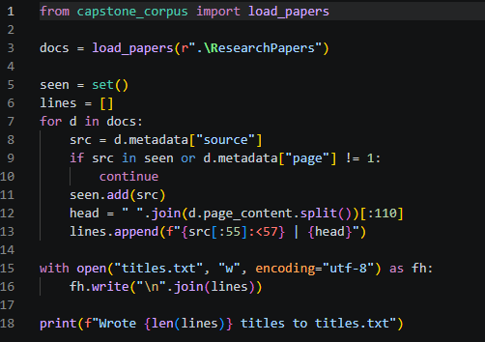
Text file output:
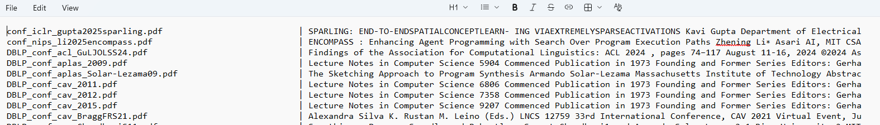

I also wrote a script that lets me quickly test how well BM25 finds relevant sections of my research papers for different search terms. This is very useful for comparing different ways of working on the same question and seeing how the BM25 results and scores change.
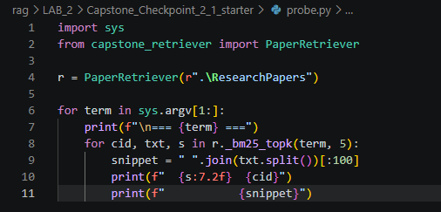

Sample output:
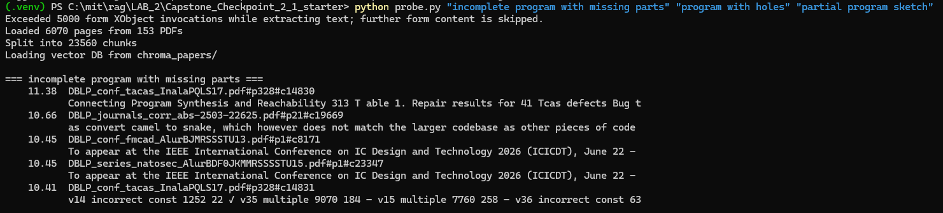

End of Required Capstone Checkpoint 2.1
Return to the assignment page in the learning platform to upload and submit your completed capstone checkpoint and complete any remaining items in this module.

