Required Capstone Checkpoint 4.1: Advanced Retrieval Implementation

Directions

Download this worksheet and save a copy to your device before you begin working. Use this worksheet to plan, organize, and complete your submission for Required Capstone Checkpoint 4.1. Type your responses directly into the document, save your completed work, and upload the finished file when you are ready to submit.
Completion Checklist
☐ Identification of a meaningful retrieval failure or limitation supported by evaluation evidence
☐ Analysis of the likely cause of the retrieval failure
☐ Selection and justification of an advanced retrieval strategy
☐ Evidence of implementation of the updated retrieval architecture
☐ Evaluation results comparing the updated system against the baseline system
☐ Reflection on the effectiveness of the architectural changes and any remaining limitations

Step 1. Retrieval Failure Identification
Identify a meaningful retrieval limitation in your current retrieval system.
- Describe the failure or limitation.
- Explain how the limitation affects retrieval performance.
- Reference evaluation evidence, test results, queries, or outputs that demonstrate the issue.
Retrieval failure or limitation
Response:
I see it as limitation. Retrieval fails when users and the papers use different words
The baseline struggles when users ask questions in everyday language, but the papers use specialized technical terms. In E3, the user asks how programmers can leave gaps in code for the computer to fill in. At least four papers cover this concept, but they call it holes, sketches, and partial programs. None were retrieved. E3 failed 10 out of 10 runs in Checkpoint 3.1 and 5 out of 5 in the 4.1 baseline.
Testing showed that even one word can make the difference. Using domain terms returned the correct definition, “A partial program (also called a sketch) is a program with holes”, as the top result with a BM25 score of 26.38. The everyday wording scored only 13.95 and returned irrelevant text from a proceedings volume. Similarly, “incomplete program with missing parts” fails, while “program with holes” succeeds.
BM25 cannot match words that are not present in the papers. The embedding retriever was meant to solve this problem but also failed. Across 23,560 chunks in the same narrow subject area, it found papers about similar topics but not the correct concept because almost everything is related to program synthesis.
This matters because a research-paper navigator is most useful to people who do not yet know the field’s technical vocabulary, but those are exactly the users this baseline struggles to help.

Evidence supporting the identified limitation
Response:
Speaking of limitations, it is a complete retrieval failure, not just weaker performance. Instead of finding less relevant versions of the correct papers, the system retrieves entirely different papers and builds its response from unrelated information.
One evidence of such is seen in E3. E3 failed every time: 10 out of 10 runs in Checkpoint 3.1 and 5 out of 5 in the Checkpoint 4.1 baseline. That is 15 consecutive failures across two independently configured judges.
The corpus contains four relevant papers: aplas_Solar-Lezama09 (The Sketching Approach to Program Synthesis), pldi_Solar-LezamaRBE05 (Programming by Sketching), and both copies of JSKETCH: Sketching for Java. None appeared in any of the three rankings. BM25 instead returned pages 527 and 284 of 500-page proceedings volumes, while vector search found related but incorrect papers such as Write, Execute, Assess and The Three Pillars of Machine Programming.
My testing confirmed that the word choice caused the failure. The everyday query, “programmer leave gaps in code computer fill in automatically,” scored 13.95 and returned unrelated proceedings text. Using technical terms such as “sketch holes synthesizer partial program” scored 26.38 and returned the correct definition at rank 1: “A partial program (also called a sketch) is a program with holes.”
Even one word changed the result. “Incomplete program with missing parts” failed, “program with holes” succeeded, and “partial program sketch” returned the JSKETCH title page. Simply adding “holes” changed the outcome.
The BM25 score itself could not detect the problem: a correct result scored 10.85, while an incorrect result scored 11.38, so a simple score threshold would not fix it.
The model did at least refuse rather than make up an answer, saying it could not find a more direct description of “leaving gaps.” However, this is still misleading because the corpus actually contains the answer.
Finally, more diverse results did not mean better retrieval. E3 returned 5 distinct papers which is the most diverse result in the evaluation and still failed, while successful items returned only 3 and 4. When the system cannot find the right paper, it tends to spread its results across several wrong ones.

Step 2. Failure Analysis
Analyze why the retrieval failure occurs. Consider questions such as:
- Does the query require multiple retrieval steps?
- Is relevant information distributed across multiple documents, conversations, or entities?
- Is excessive irrelevant information being retrieved?
- Are important relationships within the data not represented effectively?
- Are there other factors contributing to the failure?
Likely cause(s) of the retrieval failure
Response:
The likely cause is that the user and papers use different words. BM25 cannot match words that do not appear in the papers. The query uses gaps and fills in, while the papers use holes, sketch, and partial program. This leaves only common words like programmer, code, and computer, which have low IDF and are not specific enough to find the right papers.
In addition to that, the corpus is too similar for vector search. The vector retriever was supposed to handle this vocabulary gap, but it also failed. All 23,560 chunks are about program synthesis, so many papers look semantically similar. It returned related but incorrect papers such as “Write, Execute, Assess” and “Three Pillars of Machine Programming.”
There were other factors that made the problem worse. “Holes” appears only once in a 1,000-character chunk, so its meaning can get diluted in the embedding. The corpus also contains large proceedings volumes. For instance, E3's top BM25 results came from pages 527 and 284 of 600 and 350-page volumes, where common words appear often even when the content is not specifically relevant. Finally, the fixed 50/50 fusion gives BM25 a 0.5 weight even when it is returning noise, which can weaken useful signals from vector search.
Overall, the two retrievers were combined so one could help when the other failed. In E3, both failed together: BM25 failed because the right words were missing, while vector search failed because the corpus was too similar to distinguish the right paper. Hybrid retrieval only provides useful backup when the two retrievers fail for different, independent reasons. However, in this corpus, they do not.

Why the current retrieval architecture struggles
Response:
Here is what I see. The two retrievers do not provide much backup for each other. The design expects BM25 to find exact terms and embeddings to handle paraphrases, but both failed on E3. BM25 failed because the right words were missing, while embeddings struggled to separate relevant content from 23,560 chunks in the same subject area. Fusion can only re-rank what was found, as it cannot recover documents that both retrievers missed.
The system also searches using the user's exact wording, with no step to translate everyday language into the field's technical terms. This is a major problem for users who do not know the vocabulary. Query decomposition fixed E3, while the baseline had no way to do this translation.
Retrieval is also ranked by individual chunks rather than source papers. This means three strong chunks from one paper can beat useful chunks from three different papers, even when the question requires comparing multiple sources. This caused the E4 problem.
Lastly, the system assumes the corpus is clean, but it contains 15 proceedings volumes, about 27 duplicate pairs, and about 20 mislabeled filenames. Each caused visible retrieval problems, showing that corpus quality is also part of the architecture problem.

Step 3. Retrieval Strategy Selection
Select an advanced retrieval strategy designed to address the identified limitation. Examples may include:
- Query rewriting
- Query decomposition
- Retrieval fusion
- Multi-hop retrieval
- Relationship-aware retrieval
- Graph-based retrieval
- Another advanced retrieval approach
Selected retrieval strategy
Response:
Query decomposition was the strategy used to address this

Justification for the selected strategy
Response:
Query decomposition was chosen because the tests showed the main problem was vocabulary. In Checkpoint 3.1, “incomplete program with missing parts” failed, while “program with holes” succeeded. Since the problem happens before retrieval, the user's wording needs to be translated into the technical terms used by the papers before searching.
Other options were ruled out based on the results. Changing fusion weights would not help because both retrievers failed together. A score threshold would also fail because a correct result scored 10.85 while an incorrect one scored 11.38. Graph traversal was tested but made E3 worse because starting with the wrong papers simply led to more wrong papers.
Decomposition also helped with E4, where the question required several different aspects to be retrieved. Breaking the question into sub-queries naturally searches for those parts separately, meaning that one approach could address two known weaknesses.
Per the cost, it was also reasonable. One extra LLM call per query, with no index changes or re-embedding, and the document count remained at 5 for a fair comparison.
However, decomposition did not always improve results. E2 dropped from 100% to 80% because its everyday wording already matched the paper, while E5's sub-queries searched for Nvidia share prices even though that information was outside the corpus. This shows that decomposition works best when the user's vocabulary differs from the corpus and can hurt when it already matches, so it should be used selectively rather than on every query.

Step 4. Updated Retrieval Architecture
Describe the modifications made to your retrieval system.
- Summarize the architectural changes.
- Explain how the updated approach differs from the baseline system.
- Include implementation evidence where appropriate.
Description of architectural changes
Response:
Per the architectural changes I made, four improvements were added around the existing Checkpoint 2.1 hybrid retriever rather than replace it. The BM25 index, Chroma store, chunking, and min-max fusion remained unchanged.
First, a query decomposition stage was added before retrieval. One LLM call breaks the user's question into 2 – 4 sub-queries using research-paper terminology. Each sub-query goes through the existing hybrid retriever, and their scores are combined so that the chunks matching several sub-queries rank higher. If decomposition fails, it is clearly flagged instead of silently using the original query.
Second, a paper-level graph was built once and cached. After removing proceedings volumes, it contains 137 nodes and 482 edges with 382 similar_to edges based on mean chunk embeddings, using the top 5 per paper above 0.75 cosine similarity; 73 cites edges based on title matching in references and 27 duplicate_of edges based on nearly identical titles. Two other methods were tested and rejected: same_author covered only 106 of 138 papers and missed the E4 pair, while shares_topic found zero shared keywords between those papers.
Also, graph traversal was added after retrieval. The top 3 chunks are labelled PRIMARY and their papers are used to search 1 and 2-hop neighbours, with 2-hop results discounted by 0.4. The 2 best neighbouring papers each provide their best-matching chunk as CONTEXT, keeping the total at 5 chunks. duplicate_of links are used to remove duplicates rather than find more, preventing the preprint duplication problem seen in Checkpoint 2.1.
Lastly, the corpus was cleaned during graph building by excluding 15 proceedings volumes, some as long as 939 pages. These volumes had caused BM25 noise in E3 and acted as similarity hubs connected to many unrelated papers.
Two rules were kept throughout the experiment: every setup receives exactly 5 chunks for a fair comparison, and all four modes (baseline, decompose, graph, both) remain available so the effect of each change can be tested separately.

Implementation evidence (e.g., screenshots, code snippets, retrieval outputs, notebook excerpts)
Response:
Evidence showing graph exists and has the stated structure. This shows 137 nodes, 482 edges broken down by type, mean degree 7.0, the hub list, and the auto-validated Stitch → DreamCoder path in 1 hop.
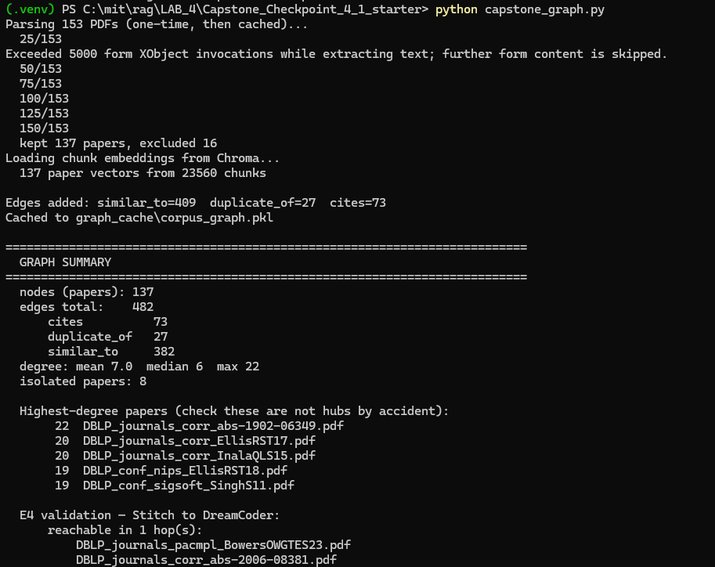
The critical edge is shown in image below. It proves the 73-edge citation layer supplied the link E4 depended on.

The following screenshots show evidence of where edge types were rejected
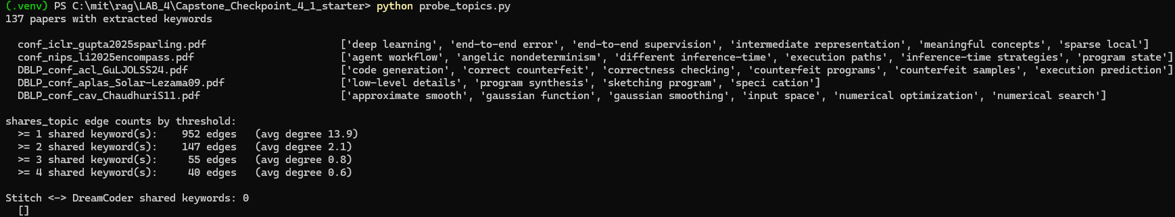

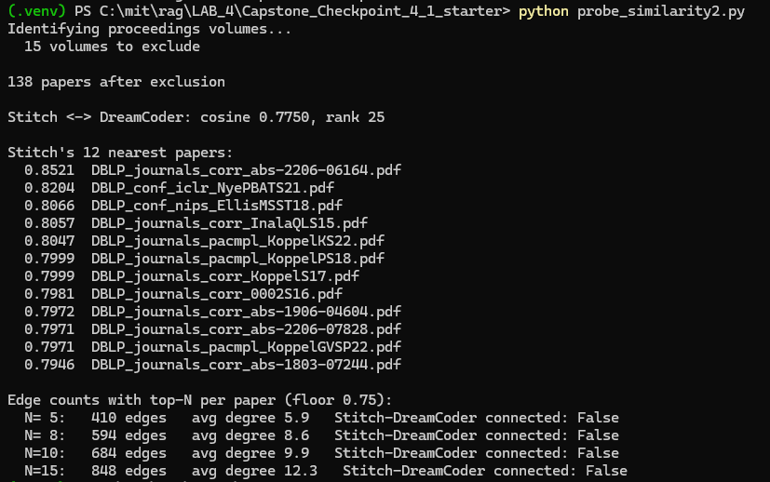

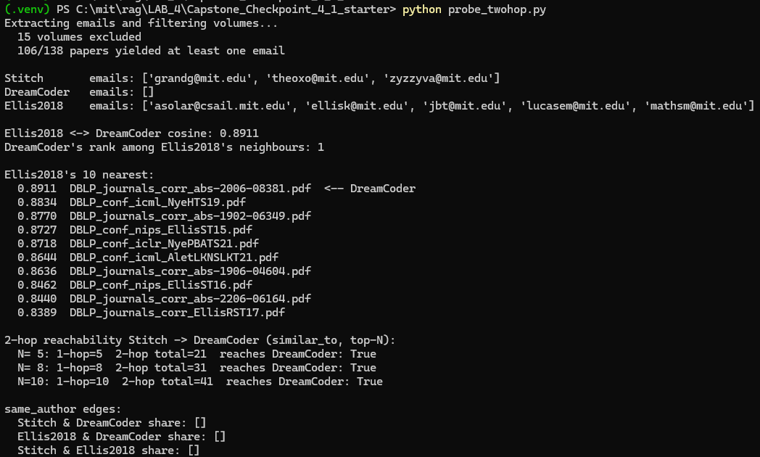

Evidence of measured improvement seen below, shows the n=5 per item when I ran capstone_eval_4_1.py. Two E1/E4 repeat runs showing baseline reproducing at 60%/60%.
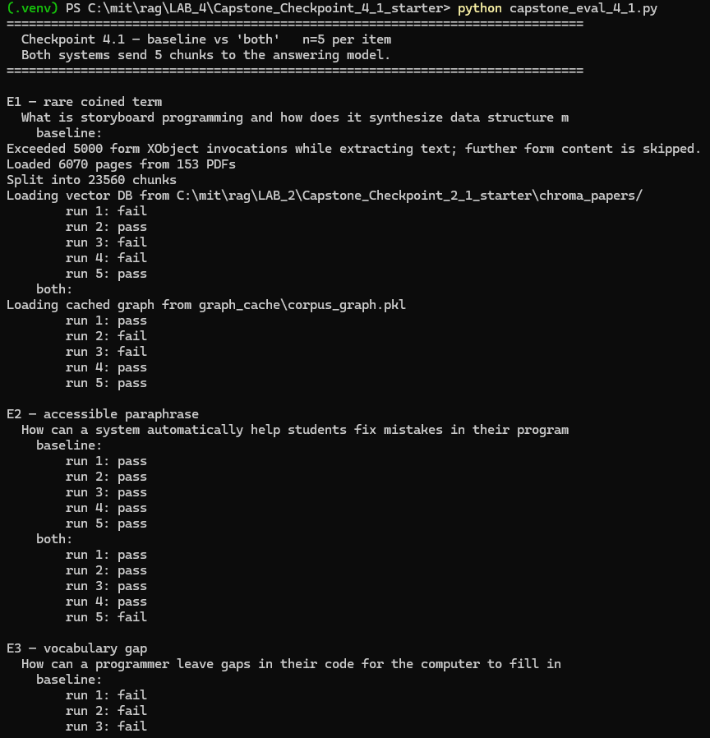
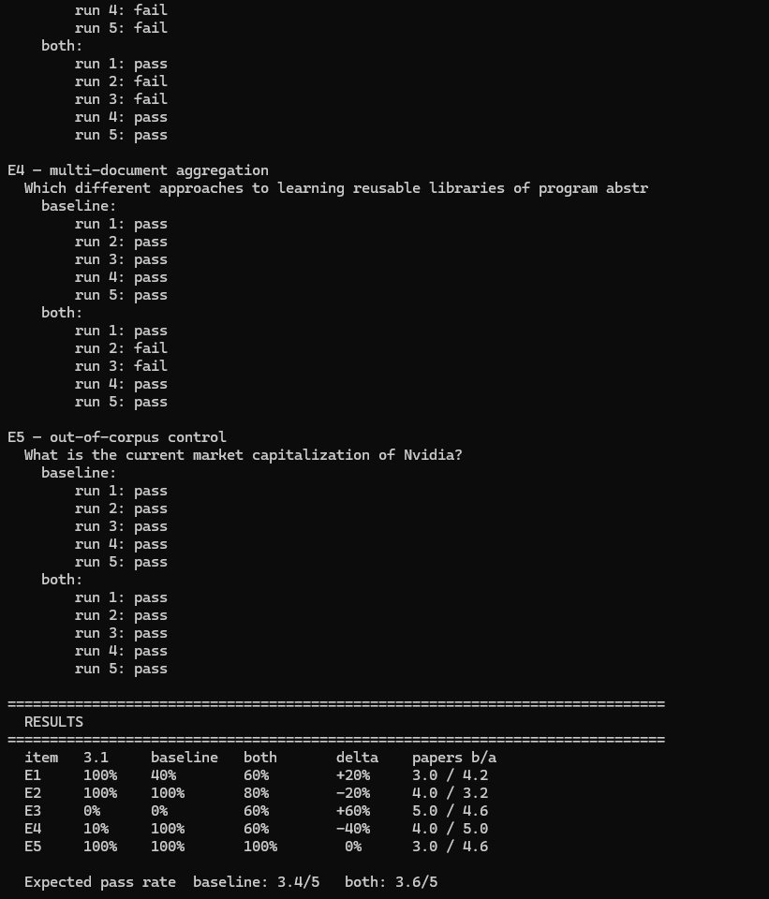
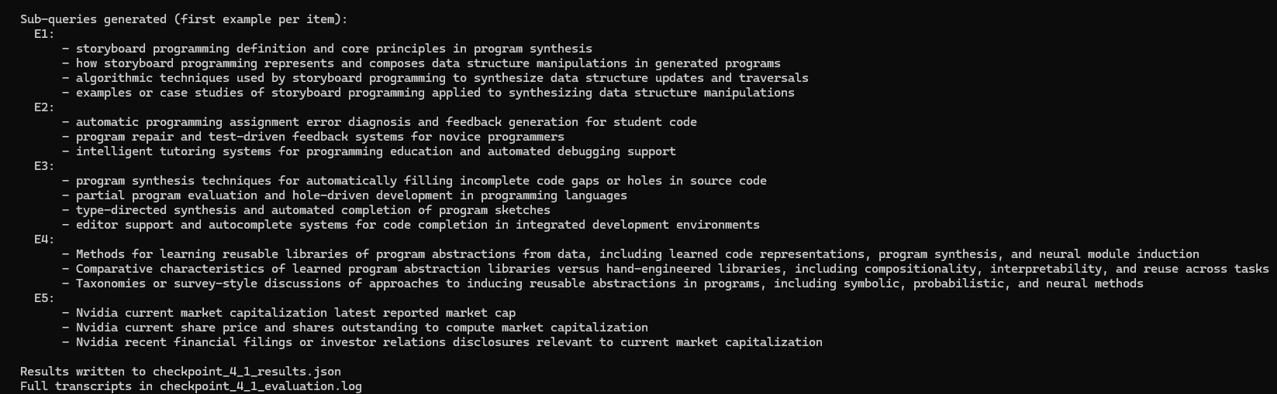

Step 5. Evaluation Results
Evaluate the updated system using the evaluation framework developed in previous modules.
- Present evaluation results.
- Compare performance against the baseline system.
- Include representative examples.
Evaluation Metric | Baseline Result | Updated Result
Overall pass rate (5 items × 5 runs) | 3.4 / 5 | 3.6 / 5
E1 — rare coined term | 40% | 60%
E2 — accessible paraphrase | 100% | 80%
E3 — vocabulary gap | 0% | 60%
E4 — multi-document aggregation | 100% | 60%
E5 — out-of-corpus control (refusal) | 100% | 100%
Avg. distinct source papers per query | 3.8 | 4.3

Example 1: Query, retrieved information, and result
Response: Query
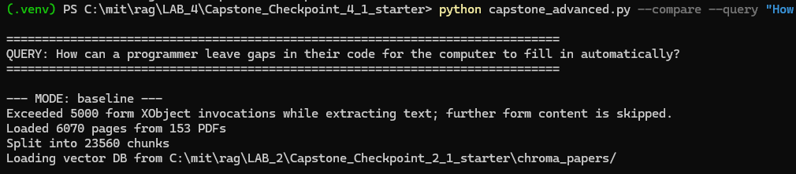
Retrieved Information
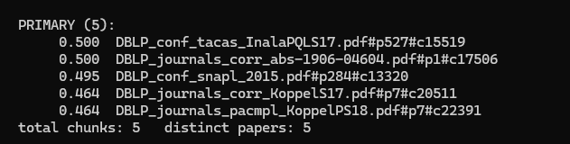

Result
FAIL
The response was an answer about Template Haskell code generation and "incremental parametric syntax." None of the four sketching papers were retrieved.

Example 2: Query, retrieved information, and result
Response:
Query
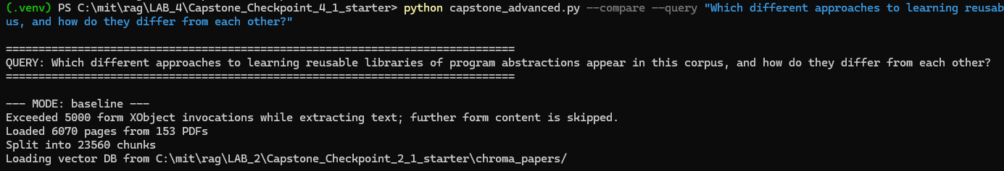

Retrieved Information
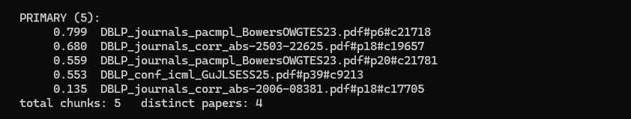
Result
It names Stitch only and describes four "approaches," three of which come from the same Bowers paper. It reads like a synthesis but is effectively single-source.

Example 3 (optional)
Response:

Step 6. Architectural Impact Analysis
Analyze the impact of the retrieval strategy.
- What improved?
- What remained challenging?
- Did the strategy address the original failure?
Improvements observed
Response:
What improved?
E3 showed the clearest improvement, moving from 0/15 across two checkpoints to 3/5. The decomposer added technical terms such as holes, sketching, and partial program, which earlier testing had identified as the key words needed for successful retrieval.
E1 also improved over 15 runs, from 53% baseline to 87% advanced. Breaking the question into definition, mechanism, and example sub-queries helped retrieve better chunks.
Source diversity increased from an average of 3.8 to 4.3 distinct papers per query. The duplicate_of feature also worked as intended as E4 improved from 4 distinct papers, including a duplicate preprint pair, to 5 distinct papers from the same 5 chunks.
E4's answer also appeared broader. The baseline named only Stitch, while the advanced version named six systems. However, this did not improve its pass rate.

Remaining limitations or challenges
Response:
First of them is Retrieval limitations
E3 now passes, but it still finds the answer from the wrong papers. The answer came from the SyntRec/TACAS paper discussing template programs instead of the main sources, The Sketching Approach to Program Synthesis and Programming by Sketching. So the content may be correct, but a user looking for the key literature could still be sent in the wrong direction.
Decomposition runs on every query, even when it is not needed. It helped E3 but hurt E2, and the system cannot currently detect which queries have a vocabulary gap.
Graph expansion depends heavily on the starting results. If the initial results are wrong, it can expand the error. On E3, it turned a weak answer into a complete refusal because it could not judge whether the starting papers were relevant.
The graph is also limited as it has only 73 citation edges based on simple title matching, and 8 papers have no connections at all. E4 worked partly because DreamCoder's title was extracted correctly, while papers with poorly extracted titles, such as sparling, can be missed. Two planned edge types are also unavailable: same_author covered only 106 of 138 papers and missed the paper needed for E4, while shares_topic found zero shared terms between the two key papers.
There was also the Evaluation limitations.
The evaluation method changed between checkpoints and affected the scores more than the system changes did. Testing the unchanged baseline with the new reasoning-first judge changed E1 from 100% to 53% and E4 from 10% to 60%. This means Checkpoint 3.1 and 4.1 scores cannot be directly compared.
With only five test items at n=5, the change from 3.4 to 3.6 out of 5 is too small to separate from normal variation. The test set also focuses on known failures, so it measures whether those specific problems remain rather than overall real-world performance.

Did the strategy address the original failure?
Response:
The measured failure was addressed. E3 failed 15 consecutive runs across two checkpoints and now passes 3 of 5. The mechanism is identified rather than assumed — the sub-queries visibly contain holes, sketching, partial program, the exact tokens the phrasing ladder isolated as the tipping point. Cause diagnosed, fix targeted at that cause, improvement measured.
However, the underlying failure isn't fixed, only routed around. The original limitation was that retrieval cannot reach the sketching papers when the query uses everyday vocabulary. Those papers — "The Sketching Approach to Program Synthesis", "Programming by Sketching", both copies of JSKETCH — are still not retrieved. E3 passes because a different paper's description of template programs happens to satisfy the rubric. A user asking to be pointed at the literature on this would still be sent to the wrong papers.
So I would say that the strategy fixed the symptom the metric measures rather than the retrieval gap itself. That distinction is worth stating plainly, because it's the difference between a system that answers correctly and one that navigates correctly — and navigation is what a Research Paper Navigator is for.

Step 7. Reflection and Next Steps
Reflect on the effectiveness of the architectural redesign.
- What did you learn from implementing this strategy?
- What would you improve next?
- Are there additional retrieval failures that still need to be addressed?
Reflection on the architectural redesign
Response:
First and foremost, regarding design, I would say that testing before building saved time. Four graph edge types were considered, but two were rejected before coding. same_author covered only 106 of 138 papers and missed the pair needed for E4, while shares_topic found zero shared keywords between those papers at every threshold. Testing these ideas first avoided building features that would not have helped.
The simplest method also produced the most useful connection. similar_to was the main design, with 382 embedding-based edges, while cites used basic title matching and created only 73 edges. Yet cites provided the key connection needed for E4. However, this partly worked by luck as DreamCoder's title was extracted correctly, while sparling's was not. If DreamCoder's PDF title had also been poorly extracted, that important connection would have been missed.
The changes also did not produce a clear overall improvement. The score moved only from 3.4 to 3.6, which is within normal variation. One item improved significantly, one became worse, and two were unchanged. This shows that fixing one known problem does not automatically improve the whole system.

Specific improvements or next steps
Response:
Regarding retrieval, I would use decomposition only when needed. It improved E3 by 60 points but reduced E2 by 20 points. A quick first retrieval could check for low scores or results spread across unrelated papers, then use decomposition only when there appears to be a vocabulary gap.
I would only use graph expansion when the starting results are strong. For instance, on E3, expanding from poor results turned a weak answer into a refusal. Graph expansion should be skipped when the primary results fall below an acceptable quality level.
On evaluation, I would say that the judge should also see the retrieved chunks, not just the final answer. This would help identify whether a failure came from retrieval or answer generation instead of requiring manual investigation.
I would replace simple pass/fail with pass/partial/fail so partly correct answers are measured more accurately. And finally, I would expand the evaluation set by keeping the existing 5 diagnostic questions but adding 15 – 20 new questions that are not based on known failures. With only 5 items at n=5, a change of 0.2 is too small to reliably measure.

End of Required Capstone Checkpoint 4.1
Return to the assignment page in the learning platform to upload and submit your completed capstone checkpoint and complete any remaining items in this module.

