Required Capstone Checkpoint 5.1: Designing and Evaluating an Agent-Based RAG System

Directions
Download this worksheet and save a copy to your device before you begin working. Use this worksheet to plan, organize, and complete your submission for Required Capstone Checkpoint 5.1. Type your responses directly into the document, save your completed work, and upload the finished file when you are ready to submit.

Completion Checklist
☐ Description of the agent-based system and task
☐ Explanation of how the system coordinates retrieval, reasoning, and multistep execution
☐ Evaluation results from 2-3 representative multistep test cases
☐ Description of refinements made to the system
☐ Analysis of the impact of those refinements
☐ Reflection on system strengths, limitations, and future improvements

Step 1. System Design
Describe the task that your agent-based system is designed to complete.
Examples may include generating reports, answering complex questions, synthesizing information across multiple documents, or completing another multistep task relevant to your capstone scenario.
Task description
Response:
The agent is a Research Paper Navigator that answers complex questions using a specialized collection of 137 research papers from one research group, focused on program synthesis and neurosymbolic methods. The papers are indexed into 23,560 searchable chunks.
It is designed for researchers and engineers who understand the general field but may not know the terminology used in these papers or which papers are most relevant.
The agent focuses on answering questions that require information from multiple papers, rather than generating reports. It handles four main types of questions:
- Cross-paper comparison - by comparing approaches described in different papers, even when they use different terminology.
- Lineage tracing - by identifying earlier work that a paper builds on by following citation relationships, rather than relying only on text matches.
- Vocabulary translation - by connecting questions written in everyday language to specialised or newly coined terms used in the papers.
- Scope resolution - by recognizing when a question is too broad to search effectively or falls outside the available collection.
Every answer must be supported by retrieved text with traceable, chunk-level sources. If the available evidence cannot support an answer, the system must decline to answer.

Agent workflow: Describe how your system works
Consider:
- How retrieval is incorporated into the workflow
- How the system performs reasoning or intermediate processing
- Any iterative or multistep behaviors
- Any prompts, tools, or workflow components used to guide agent behavior

The agent follows a decide–act–reassess cycle, with a maximum of four steps. At each step, the LLM receives the original question, considering all actions taken so far, and a summary of the retrieved chunks. These chunks are grouped by source paper and include each paper’s best fused score and how that score was obtained. The model then returns one JSON action with a one-sentence explanation. The loop ends when the agent chooses to answer, asks for clarification, or reaches the four-step limit.
First is Retrieval. This is a tool the agent can use when needed, rather than a fixed step in the process. It has four options: semantic_search (the Checkpoint 2.1 hybrid BM25 + vector retriever), decompose_and_search (the 4.1 sub-query rewriter), and two graph-based tools, follow_citation and find_similar_papers, which use the 482-edge paper graph built in 4.1.
Each retrieval adds relevant chunks to the agent’s accumulated context while recording where each chunk came from. This means retrieval can happen zero times, once, or several times using different strategies, depending on what the agent decides at runtime.
Three things happen between retrieval and the final answer. First, the agent reviews the quality of what it has found using the top fused scores and the number of distinct papers retrieved. This helps it judge whether a search was successful.
Second, during graph traversal, the system selects only the best-matching chunk from each neighboring paper. It does this using the question and already gathered text as a BM25 search query, rather than adding entire papers.
Third, before generating the answer, the accumulated chunks are reduced to exactly five, with a maximum of two chunks per paper. This keeps the final context focused and diverse, even if the agent retrieved much more material.
In terms of what guides the agent, the decision prompt contains routing rules based on the 4.1 measurements. The agent uses decomposition when a question is written in everyday language or when a normal search scores poorly. It uses citation traversal when the question asks what a paper builds on. It asks for clarification only when a request is relevant to the corpus but too broad, and answers directly when the question falls outside the corpus.
The answering prompt requires the response to be grounded in the retrieved chunks. It also prevents the agent from presenting cited work that was not retrieved as if it were part of the corpus.
Two additional safeguards operate outside the prompts. If the model returns a malformed decision, the system retries once. If parsing still fails and no context has been retrieved, the system refuses to answer rather than generating an unsupported response.
True multi-step retrieval occurred in one of five tasks, but for the other tasks, a single retrieval was enough. This suggests that the main value of the loop was choosing the right retrieval strategy, rather than repeatedly searching. Across the tasks, the agent used different strategies as needed, averaging 2.8 LLM calls per task, with a range of 1–4 calls, while usually requiring only one retrieval pass.

Step 2. Initial Evaluation
Develop and evaluate your system using 2-3 representative test cases for your capstone scenario. Each test case should require more than one retrieval step or action.
For each test case, compare the agent-based system with your fixed retrieval pipeline from Checkpoint 2.1 or 3.1. Record relevant differences in answer quality, completeness, retrieval behavior, model calls, latency, or cost.
Evaluation results
Summarize the results of your testing:
Evaluation results
The evaluation used three test cases, each requiring more than one action. Both systems passed exactly five chunks to the answering model, so differences in performance were not caused by giving the agent more context.
 | Fixed pipeline (2.1/3.1) | Agent | Number of calls
T1 — Lineage: what earlier work does Stitch build on, and what changed? | 1 search; top-5 = 3 papers, 2 Stitch chunks + 2 off-topic chunks (MathDSL, 0.261/0.204) | search → follow_citation on Stitch → DreamCoder chunk at score 1.000, top-ranked | 1 → 4
T2 — Vocabulary gap: how can a programmer leave gaps in code for the computer to fill in? | 0/10 pass (3.1), 0/5 (4.1 baseline). Retrieved TACAS p527, SNAPL p284, Koppel — none of the four sketching papers | decompose_and_search → retrieved aplas_Solar-Lezama09 ("The Sketching Approach to Program Synthesis") and corr_0002S16 ("a partial program (also called a sketch) is a program with holes"); 5 distinct papers | 1 → 4
T3 — Broad request: tell me about the synthesis work in this corpus | 1 search; returned reference sections and a proceedings table of contents (pp. 9, 11, 16), answer quoted "Programmable Program Synthesis . . . . 84" | clarify in 5 of 6 runs — asked which synthesis subtopic, retrieved nothing. The 1 run that searched reproduced the bibliography failure | 1 → 1

Answer quality and completeness
T1 — Paper lineage: The fixed pipeline based its answer only on Stitch. The agent went further, identifying Ellis et al. (2021), deductive refactoring, and guided top-down synthesis. It also identified the key improvement: a guiding utility function that made the approach 3–4 orders of magnitude faster while using 2 orders of magnitude less memory. This comparison was possible because the agent followed the paper graph to retrieve the relevant chunk.

T2 — Largest improvement: This test had failed 15 consecutive runs across two checkpoints. The agent successfully retrieved both canonical sources and used the corpus’s own definition. In comparison, the 4.1 decomposition method passed this test 3 out of 5 times but relied on a template description from a different paper. Only the agent reached the original sketching papers.

T3 — Knowing when not to answer: The fixed pipeline cannot recognize when a question needs clarification. The agent can. Asking for clarification prevented a failure that the fixed pipeline has no way to detect. In the one run where the agent searched instead, it produced the same type of result the fixed pipeline consistently returns.

Retrieval behavior, cost, and latency
The agent averaged 2.8 LLM calls per task, compared with 1 call for the fixed pipeline, with the agent ranging from 1–4 calls. It used 4 calls on T1 and T2 and only 1 on T3, meaning the extra cost appeared only when additional reasoning or retrieval was needed.
The pattern reverses when the agent decides to clarify or answer an out-of-scope question. In these cases, it performs no retrieval at all, no BM25 search and no embedding lookup. This makes these runs cheaper and faster than the fixed pipeline, which always retrieves five chunks before deciding it cannot answer.
Across six T3 runs, the agent averaged 1.3 LLM calls and zero retrievals.

Strengths observed
Response:
The agent’s main strength was its ability to adapt its approach to the question. It used standard search for technical questions and decomposition for everyday wording, helping bridge the gap between user language and research terminology.
It also solved a long-standing retrieval failure. A vocabulary-gap question that failed 15 consecutive runs across Checkpoints 3.1 and 4.1 was answered by retrieving both canonical papers, including the definition of a sketch as “a partial program…with holes.”
The agent used paper relationships dynamically. For the lineage question, it found Stitch, followed its citation to DreamCoder, and ranked DreamCoder first in the final context instead of relying only on the initial search result.
It also improved search queries automatically, adding useful technical terms such as holes and partial programs even when the user did not provide them.
Importantly, the agent knew when not to search or answer. For broad or out-of-scope questions, it stopped after 1–2 model calls with zero retrieval, avoiding unnecessary BM25 and embedding work. In contrast, the fixed pipeline always retrieved five chunks first.
Overall, cost scaled with task difficulty, averaging 2.8 LLM calls (range 1–4). When evidence was available, answers remained grounded in retrieved sources with chunk-level provenance and clearly acknowledged gaps in the corpus.

Weaknesses or challenges identified
Response:
The biggest risk was fabrication when retrieval failed. After a malformed JSON response left the agent with no retrieved chunks, it invented seven papers and quotations. This was fixed by retrying once and refusing to answer if no context is available, showing that structural safeguards are more reliable than prompts alone.
The multi-step loop provided limited benefit. True multi-step retrieval occurred in only 1 of 5 tasks; most gains came from choosing the right tool and improving the initial query. A simpler one-step classifier may provide similar benefits at lower cost.
The agent’s decision-making was inconsistent, even at temperature 0. For example, it did not always use `follow_citation` on the same lineage task, while clarification occurred in 5 of 6 runs on the broad task. Prompt changes also affected unrelated decisions, making behavior difficult to predict and tune.
The retrieval system still has filtering problems. The 15 proceedings volumes excluded from the 4.1 graph remain searchable, and broad queries can incorrectly prioritize reference sections and tables of contents.
Agency also introduced new failure modes, such as offering to fetch live market data despite having no tool to do so. In one test sweep, 2 of 5 runs used LLM calls but retrieved no useful context.
Lastly, the evaluation was small: only five tasks, mostly single runs, with no LLM-based scoring. Therefore, improvements over the fixed pipeline are mainly qualitative rather than statistically measured.

Step 3. System Refinement
Based on your evaluation results, make one or more improvements to your system. Examples may include:
- Improving system prompts
- Adjusting workflow structure
- Modifying retrieval behavior
- Improving how the agent uses retrieved information
Changes implemented
Response:
The change implemented: Separating scope conditions in the system prompt
The problem observed: The agent used clarification in the wrong situation. When asked for Nvidia’s market capitalization, which is clearly outside a research-paper corpus, it asked for clarification instead of refusing. Meanwhile, a genuinely broad request such as “tell me about the synthesis work in this corpus”, was answered using reference sections and a proceedings table of contents instead of asking the user to narrow the question.
Reason: The prompt said to clarify when a request was “genuinely ambiguous and searching would be guesswork.” This accidentally treated two different situations as the same: an in-scope but unclear request and an out-of-scope request. These require different responses.
What changed. Only the system prompt was updated; no code changes were needed. The `clarify` action is now limited to in-scope requests that are too broad to search effectively. Out-of-scope requests now use `answer`, which clearly states that the corpus does not contain the requested information. The agent is also prevented from offering information it has no tool to retrieve.
Measured outcome
 | Before | After
Out-of-corpus question | clarified; offered to fetch live market data it cannot access | answers correctly: "The provided documents do not contain Nvidia's current market capitalization". It called no retrieval tool at all
Broad in-scope request | searched; returned bibliographies and a table of contents | clarified in 5 of 6 runs, asking which synthesis subtopic

The out-of-corpus path now uses only 2 LLM calls and no retrieval, making it faster and cheaper than the fixed pipeline, which retrieves five irrelevant chunks before refusing.
Two key lessons emerged. First, prompt changes can affect unrelated decisions. Although the change focused on when to clarify or answer, it also changed the agent’s search strategy, causing some broad queries to use decomposition instead of plain search.
Second, one test run was not enough to judge the change. The first run still searched, making the fix appear unsuccessful. However, across six runs, it worked correctly 5 out of 6 times, showing the importance of repeated testing.

Justification
Response:
The evaluation showed that the agent made opposite routing mistakes. It asked for clarification when it should have refused and searched when it should have asked for clarification. This suggested the problem was with the prompt rules, not the model itself.
The issue was the instruction to clarify when “the request is genuinely ambiguous and searching would be guesswork.” For a question about Nvidia’s share price, searching a research-paper corpus is guesswork, so the agent was technically following the rule. The prompt failed to separate two different cases: an unclear in-scope question and a question the corpus cannot answer. These require opposite responses.
Changing the prompt was the simplest fix because the retrieval, graph, chunking, and answering systems were already working correctly. It required no code changes or re-indexing and could easily be reversed.
The change also improved safety. Previously, the agent offered to retrieve live market data despite having no tool to do so. The new rule tells it to clearly state when information is outside the corpus, restoring the refusal behavior that achieved 15 out of 15 successful runs in earlier fixed pipelines.
Finally, the change was easy to test because both problem cases had recorded results from before the update, allowing a direct before-and-after comparison.

Step 4. Impact of Refinement
Evaluate the updated system. Describe any changes in task completion, accuracy, relevance, or overall system behavior. Compare the refined agent-based system with both its initial version and the fixed baseline. Explain whether the refinement improved performance and identify any trade-offs.

Impact on system performance
Response:
The refinement fixed both routing errors. For the out-of-corpus question, the agent now correctly states that “The provided documents do not contain Nvidia’s current market capitalization,” instead of asking for clarification or offering to fetch live data it cannot access.
For the broad request, the agent now correctly asks for clarification in 5 out of 6 runs, instead of searching and returning irrelevant bibliographies.
 | Fixed baseline | Initial agent | Refined agent
Out-of-corpus | Correct refusal, after retrieving 5 irrelevant chunks | Wrong — clarified, offered unavailable data | Correct refusal, zero retrieval
Broad request | Reference sections and a table of contents | Same failure | Clarifies (5/6); the 1 search run reproduced the failure

For the broad request, the refined agent was the only system that avoided the failure. For the out-of-corpus question, it matched the baseline’s correct refusal while doing less work.
The refinement also restored a capability lost by the initial agent. The fixed pipelines correctly refused the out-of-corpus question in 15 out of 15 runs across Checkpoints 3.1 and 4.1. The initial agent failed this test, while the refined agent restored the correct behavior using only 2 LLM calls and no retrieval, making it faster and cheaper than the baseline, which always searches before refusing.
Overall, the refinement improved both targeted cases without harming the other three. The vocabulary-gap and lineage results remained unchanged, with the agent still retrieving papers that the fixed pipeline could not reach.
The main trade-off is that clarification delays the answer. On the broad request, 5 of 6 runs now ask the user to narrow the question. This prevents irrelevant results but requires an extra interaction and provides no immediate overview.
Routing also remains probabilistic. Even at temperature 0, the same question can still follow the wrong path, as shown by the 5-of-6 success rate.
Prompt changes can also affect unrelated decisions. This edit changed the agent’s search-versus-decompose choice, showing that every prompt change should be tested across the full evaluation set, not just its target cases.
Lastly, a single test run is not reliable. The first run after the change still failed, while repeated testing showed success in 5 of 6 runs. Prompt changes therefore need multiple runs to verify their impact.

Comparison of initial and refined systems
Response:
All changes below came from the agent choosing different actions, not from changes to the system itself.
Two questions improved: For the out-of-corpus Nvidia question, the initial agent asked for clarification and offered to fetch live data it could not access. The refined agent correctly states that “The provided documents do not contain Nvidia’s current market capitalization” and performs no search. For the broad synthesis question, the initial agent returned irrelevant references and a table of contents. The refined agent now asks the user to narrow the topic in 5 of 6 runs; the one run that searched still failed as before.
Three questions were unaffected: The vocabulary-gap question still uses decomposition and finds both canonical sketching papers. The lineage question still follows a citation to DreamCoder, and the cross-paper comparison still expands the query and covers both sides. No regressions were observed.
Overall, 2 of 5 questions moved from the wrong action to the correct one. The refusal case also became cheaper, requiring only 2 LLM calls and no retrieval, compared with the fixed baseline retrieving five irrelevant chunks.
One unexpected effect was that when the broad question did not trigger clarification, the agent switched from plain search to decomposition. This shows that prompt changes can affect decisions beyond their intended target.
The agent also remains non-deterministic even at temperature 0. Clarification occurs in 5 of 6 runs rather than every time, so the refinement improved the likelihood of the correct action but did not guarantee it.
At the end, a one-paragraph prompt change fixed both routing problems, caused no observed regressions, and reduced cost on one path. However, it also shows how strongly the system’s behavior depends on prompt wording, not just its architecture.

Step 5. Reflection
Reflect on your experience designing and evaluating an agent-based RAG system.
What contributed most to successful task completion?
Response:
Finding the cause before fixing it had the biggest impact. In Checkpoint 3.1, a simple test compared two versions of the same question. “Incomplete program with missing parts” returned poor results, while “program with holes” found the corpus’s exact definition at nearly twice the BM25 score. This showed that the main problem was vocabulary.
That finding guided later changes. Checkpoint 4.1 added decomposition to translate everyday wording into research terminology before retrieval. Checkpoint 5.1 then turned this into a routing rule: use decomposition when questions are written in everyday language. The agent correctly applied this rule to the original problem question.
Repeated testing was also essential. Single runs often gave misleading conclusions. A 3/5 pass rate became 3.1/5 over 10 runs, an item that appeared unstable at three runs proved deterministic at 10, and a clarification action that seemed unused fired in 5 of 6 runs when tested properly.
Testing ideas before building them saved unnecessary work. Of four planned graph edge types, two were rejected through quick tests: author emails covered only 106 of 138 papers and missed an important paper, while keyword overlap found zero shared terms between two key papers.
While good instrumentation made failures visible, chunk-level provenance, distinct-paper counts, and a parse-failure flag helped identify problems that retrieval metrics alone could not. Most importantly, the flag exposed a case where the agent fabricated seven papers after a parsing failure.
Keeping the comparison fair also mattered. Every system received exactly five chunks, ensuring that improvements came from better retrieval and routing rather than simply providing more context.
Lastly, simpler methods often contributed more than sophisticated ones. The embedding-based `similar_to` graph had 382 carefully filtered edges, but the useful connection came from 73 simple substring-matched citation edges. Likewise, true multi-step agent behavior helped in only 1 of 5 tasks; most of the improvement came from choosing the right retrieval strategy. Overall, understanding the actual failure consistently delivered more value than adding complexity.

What limitations remain?
Response:
Retrieval cannot reliably detect when nothing is relevant. Min-max normalization makes the best of several poor results look as strong as a genuinely good match. Simple score thresholds also do not work. One correct result scored 10.85, while an incorrect one scored 11.38. As a result, refusals still depend mainly on the prompt.
The corpus still contains indexing problems. The 15 proceedings volumes removed from the Checkpoint 4.1 graph remain searchable, and some still appear in results. Around 20 filenames do not match their actual contents, which can cause `chunk_id` citations to reference the wrong paper. Broad searches also tend to retrieve bibliographies and tables of contents.
Agent behavior is not fully reproducible. Even at temperature 0, tool choices vary between runs. Citation traversal occurred in 1 of 2 lineage runs, while clarification occurred in 5 of 6 broad-query runs. Answer quality remained stable, but specific actions cannot be guaranteed.
Evaluation metrics also remain incomplete. The planned cross-model judge comparison was never run, so possible self-preference bias remains untested. The judge sees only the final answer, not the retrieved chunks, making it difficult to separate retrieval failures from generation failures. The Checkpoint 5.1 agent answers were also not scored by the judge, so comparisons remain qualitative.
Also, grounding still relies heavily on prompt instructions. The fabrication incident showed that grounding worked when context was available but failed when there was none. A structural safeguard now blocks that specific failure, but the wider dependency on prompt wording remains.
Finally, latency and cost were not directly measured. The project used the number of model calls as a proxy, without measuring actual response times or costs.

What improvements would you prioritize next?
Response:
1. Filter the retriever by applying the existing filter for the 15 proceedings volumes to `PaperRetriever`. This is a small change that should remove irrelevant bibliography and table-of-contents results and improve retrieval across all questions.
2. Fix citation accuracy by using titles extracted from the first page or metadata from DBLP instead of filenames. This would correct the about 20 mislabeled files, make citations more reliable, and strengthen the current 73-edge citation graph.
3. Replace min-max fusion with Reciprocal Rank Fusion (RRF). RRF uses result ranking rather than raw BM25 scores, avoiding the problem that scores are not comparable across different queries. It could also support a more reliable way to detect when no relevant result exists.
4. Improve the evaluation framework by running the cross-model judge comparison planned in Checkpoint 3.1, giving the judge access to retrieved chunks so retrieval and generation failures can be separated, and scoring the Checkpoint 5.1 agent answers using the same method.
5. Expand the test set by keeping the existing five diagnostic questions and adding 15–20 new questions that are independent of previously identified problems. Five questions at n=5 are too few to reliably measure improvements.
My priority order would be to start with 1 and 2 because they are low-cost changes that benefit the whole system. Then complete 4 before evaluating further improvements, so later results can be measured reliably.

Supporting Materials
Use this section to list, describe, or link to any supporting materials included with your submission.
Supporting material | Location, link, or note
System prompts:
python capstone_agent.py --task 3 --repeat 6
Evaluation results:
=====================================================
COST SUMMARY
======================================================
run steps calls gathered used papers parse_fail status
1 1 1 0 0 0 0 clarified
2 1 1 0 0 0 0 clarified
3 1 1 0 0 0 0 clarified
4 1 1 0 0 0 0 clarified
5 2 3 5 5 5 0
6 1 1 0 0 0 0 clarified

Mean LLM calls per run: 1.3 (baseline pipeline = 1, Checkpoint 4.1 pipeline = 2)
Runs with >=1 parse failure: 0/6
Runs refused for lack of context: 0/6

Screenshots or diagrams:
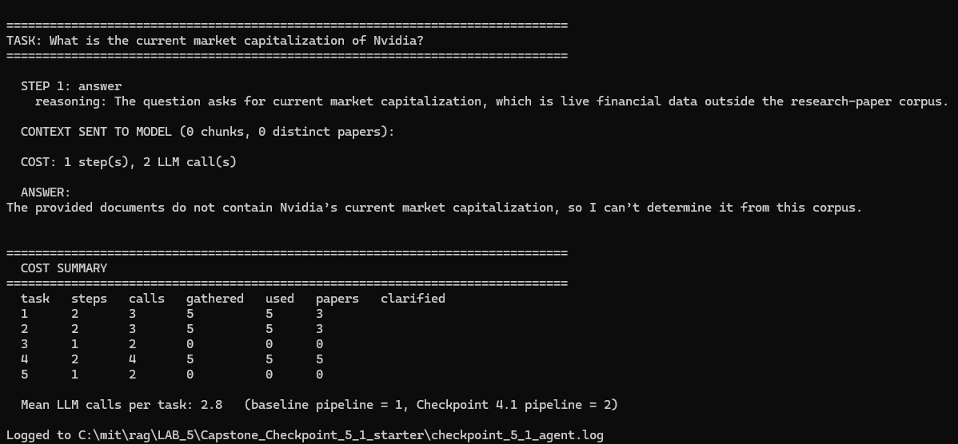

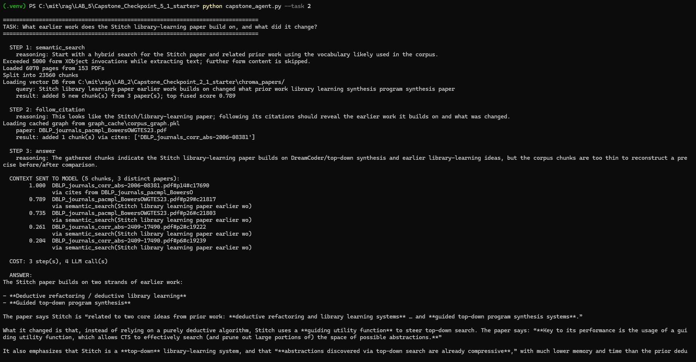

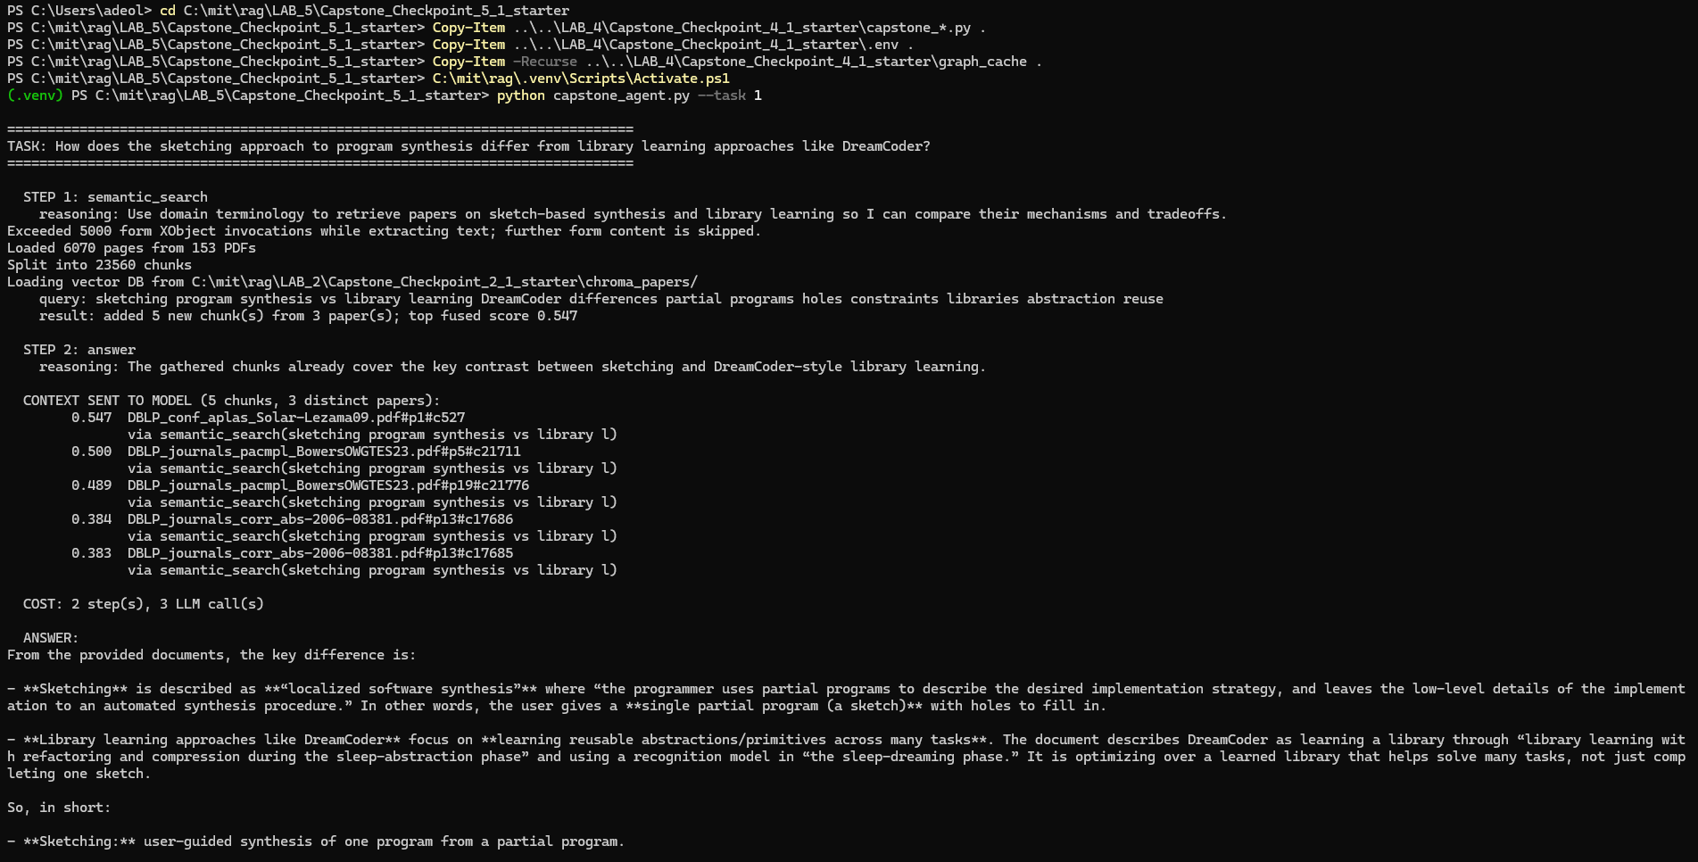
Code, notebook, or repository link:

Other supporting evidence:

End of Required Capstone Checkpoint 5.1
Return to the assignment page in the learning platform to upload and submit your completed capstone checkpoint worksheet and complete any remaining items in this module.

