To
The Deputy District Education Officer
Tehsil Model Town
Lahore
Subject: Report Regarding Complaint of Illegal Late Fee – Precent Model School, Shadman Lahore
Respected Sir/Madam,
With reference to the complaint received regarding alleged illegal collection of late fee amounting to Rs. 13,350 by a school named “Precent Model School, Shadman Lahore”, I visited the mentioned locality to verify the facts on ground.
During the visit, a thorough inquiry and physical verification of the area were conducted. It has been observed that no school exists with the name “Precent Model School” in the Shadman area of Lahore. Furthermore, inquiries from local residents and nearby educational institutions also confirmed that no such school is operating in the said vicinity.
In light of the above findings, the complaint appears to be unverified and not supported by ground realities, as the mentioned institution could not be traced. Therefore, no action can be initiated against the said school due to its non-existence in the reported location.
However, if the complainant provides correct details, exact address, or any documentary evidence, further investigation may be conducted accordingly.
Submitted for your kind information and further directions.
Yours faithfully,
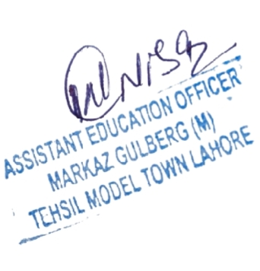

Assistant Education officer
Markaz Gulberg, Lahore

