Kanban Experiment.

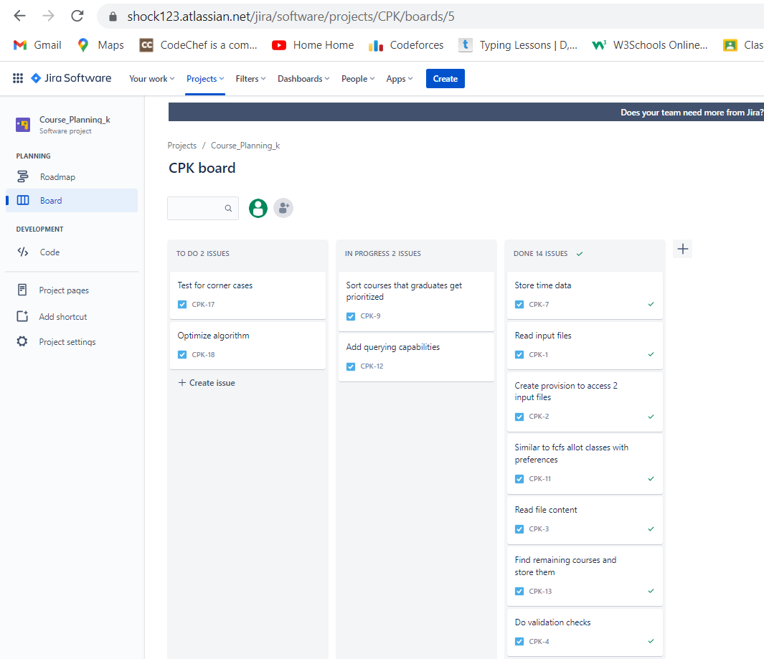

Conclusion:

1. Kanban methodology is a type of agile process, which helps in visualizing the work which is often vague.
2. This methodology helps in increasing productivity and speed up the development process.
3. As this is part of agile process, it is used in practical development scenarios.