EXPERIMENT NO. 2

Course Scheduling System using Agile Methodology using JIRA

Aim

Implement Course Scheduling System using SCRUM method on JIRA Tool.

- Identify at least 5 Epics & 15 user stories from the specification document .Use your own research & interpretation . Link above stories to Epics.
- Create Scrum project using free Jira account.
- Enter backlog in Jira(Epics,stories & subtasks)
- Start & complete one Sprint
- Submit screen shots of Epics,storie, subtasks , backlog ,scrum board & release plan.

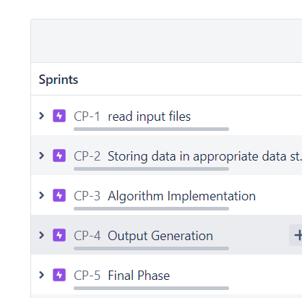
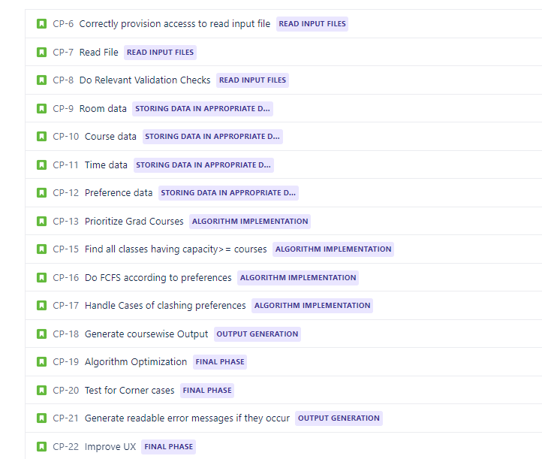
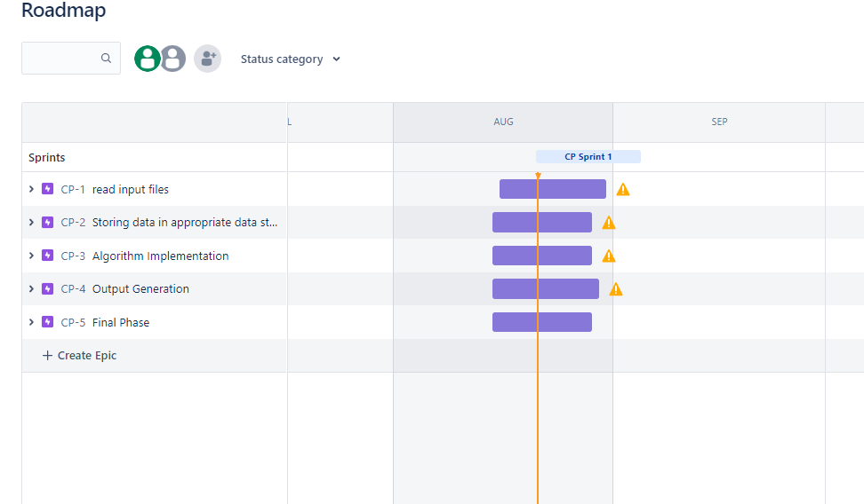
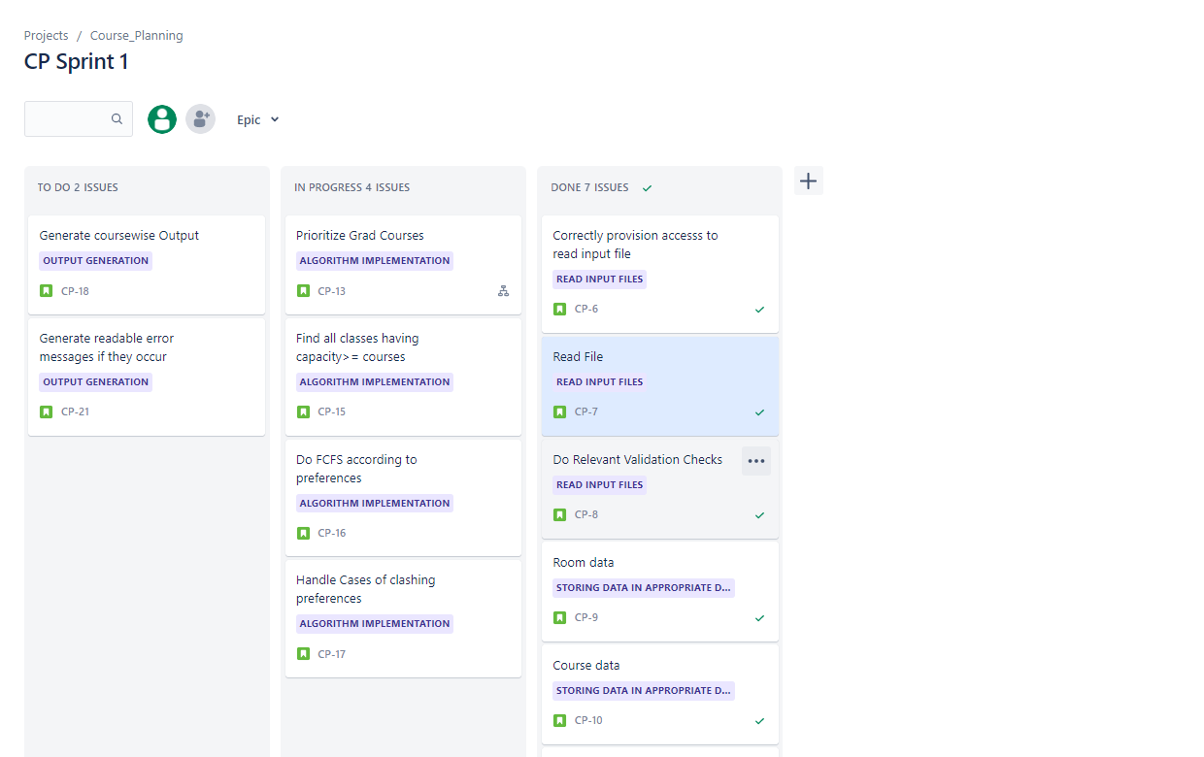
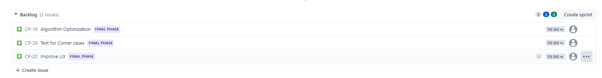
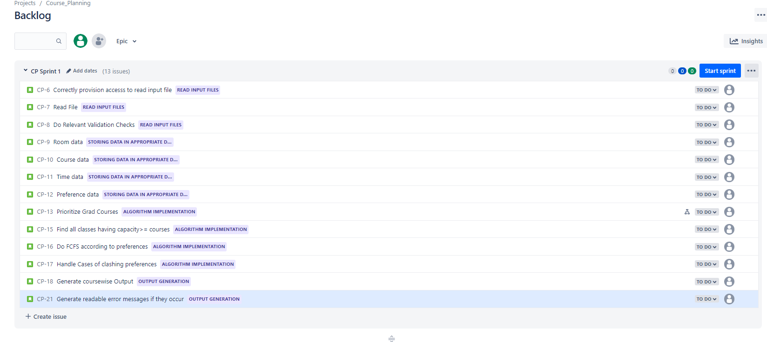

An SRS is basically an organization's understanding of a customer or potential client's system requirements and dependencies.

In SRS following aspects are addressed:
a) Functionality. What is the software supposed to do?

b) External interfaces. How does the software interact with people, the system’s hardware, other hardware, and other software?

c) Performance. What is the speed, availability, response time, recovery time of various software functions, etc.?

d) Attributes. What are the portability, correctness, maintainability, security, etc. considerations?

e) Design constraints imposed on an implementation. Are there any required standards in effect, implementation language, policies for database integrity, resource limits, operating environment(s) etc.

Conclusion: Write the learning in details on Agile Process as compared to traditional development
Following learning was attained during this experiment:
- Agile is an iterative approach to project management and software development that helps teams deliver value to their customers faster and with fewer headaches. Agile team delivers work in small, but consumable, increments.
2. With Agile methodology ,software products can be developed very fast.
3. This method is more focused on productivity rather than on bureaucracy, which makes agile methods standard choice in industry and natural choice for developers.

