

D.Y. PATIL COLLEGE OF ENGINEERING & TECHNOLOGY,

KASABA BAWADA, KOLHAPUR

A

Project Synopsis On

“Local Property Listing”

### Presented by:

Sr. No. Roll No. Name

### 00 Deon Chris Kiran Fernandes

1. 00 Hrushikesh Charudatta Shinde
2. 00 Romit Rakesh Shirke

Under the guidance of Mrs. Tejashri Deokar

DEPARTMENT OF COMPUTER SCIENCE AND ENGINEERING

(DATA SCIENCE)

(2022-2023)

Class: TY Division: A Batch: A1

INDEX



|  |  |  |
| --- | --- | --- |
| Sr. No. | Title | Page No. |
| 1 | Introduction | 1 |
| 2 | Problem statement | 1 |
| 3 | Objectives | 1 |
| 4 | Proposed System Architecture | 2 |
| 5 | Modules | 2 |
| 6 | System Requirement | 3 |
| 7 | Conclusion | 3 |
| 8 | Reference | 4 |

**1. Introduction**

The real estate process can be time-consuming, frustrating and full of back-and-forth discussions between a seller. But, if you’re able to optimize the sales process, buying process, not only will you save time, you can close deals quicker. Also, handling the real estate sales process properly can ensure a seller, buyer will turn to you next time they want to sell or buy another property.

The site offers free user-generated classified advertisements for urban population around the world. The ecommerce firm allows people to rent, buy and sell by posting advertisements. We will be responsible for creating the customer to customer (C2C) selling market segment in India that did not exist earlier beginning at a local level.

Our company provides a simple solution to the complications involved in selling, buying, trading, discussing, organizing, and meeting people near you, wherever you may reside.

This application will be available on two platforms:

1. Website

2. Mobile Application

**2. Problem Statement**

The problem with the already existing websites, is that they do not target the Paying Guests, Local Hostels, Rooms etc. at a Local Level. Thus, making it hard for Outsiders to find an optimal place for staying and food.

**3. Objective**

The objective of the project is to make a ‘Web - based Platform’ accessible to any user, to find a place to live, based on their budget, time of stay, accessibility.

A complete and efficient web application which can provide the online searching experience is the basic objective of the project.

Given below will be the main highlight of this application will be:

* To Provide a platform to be able to buy, sell, rent properties efficiently.
* Provide a online market presence, to attract more users.
* Provide filters, based on location, budget, duration of stay, etc.
* Provide a Image and Video Gallery to allow experience the property better.

**4. Proposed System Architecture**

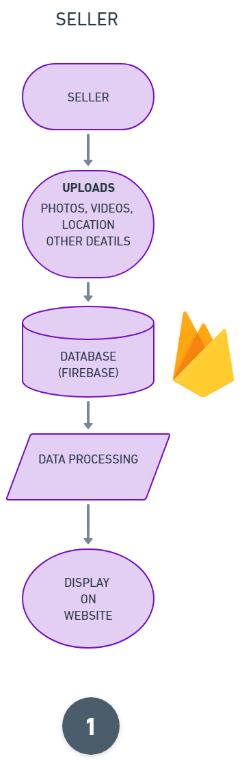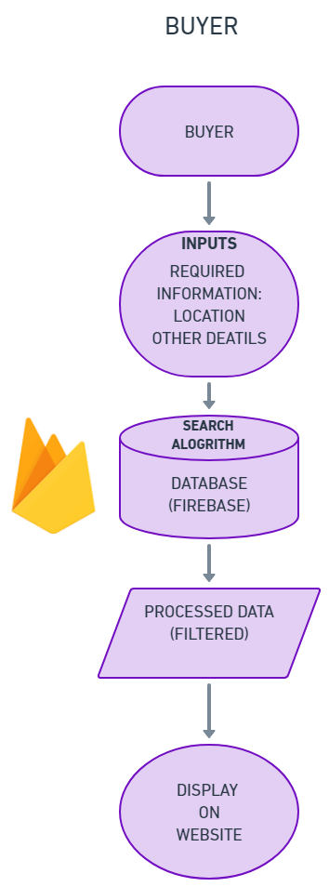

**5. Modules**

1. Login
2. Sign-up
3. Buyer
4. Seller

**6. System Requirement**

Hardware Requirements:

1. Operating System: Windows/ MacOS
2. Internet Access

Software Requirements:

* 1. Any Internet Browser

**7.** **Conclusion**

Our work will be able to provide more opportunities for students, job seekers, to find good living arrangements as well as individual home owners, to list their properties and make efficient deals, by attracting more customers by spreading and increasing their network.

This project will make easier, more efficient, less time consuming, the process of buying, selling and renting properties, creating an overall good experience.

**8. Reference**

* https://www.webguru-india.com/blog/10-must-have-features-for-your-property-listing-website/

A

Project 2 Synopsis On

“A Data Analysis on Netflix using Python”

Roll No Name Sign

07 Deon Chris Kiran Fernandes

15 Hrushikesh Charudatta Shinde

24 Romit Rakesh Shirke

Date: 21/04/2023

Place: Kolhapur