OmniaProcure®

The World-class Procurement System

DOCUMENTATION

JUNE 6, 2008

CHAPTER 1 - OVERVIEW

OmniaProcure is a web application written with the Python programming language. The application is built with an MVC (Model-View-Controller) web framework called Pylons.

The application consists of the following key components:

- The Views: These are the actual front-end components that the user sees and interacts with. They can also be called templates and are located in the templates directory in the application sub-directory, omnia. The views accept input from the user and passes them to the controller.

- The Controllers: These are the workhorse components of the application. Basically, they can be seen as the “processors” because they accept input or queries from the user, process them and send back the expected result or error, if an error occurs during the process. They do this processing with the help of another component called the model. The controllers can be found in the controllers directory in the application sub-directory, omnia.

- The Models: The models are the data objects of the application. These components are the closest to the database. They interact with the database through an object relational mapping or ORM for short. Just like its counterparts, the models are located in a directory named models.

CHAPTER 2 – SOURCE CODE

The application source code is shown below:

CATEGORY A: Views / Templates

- Sign In (index.html)

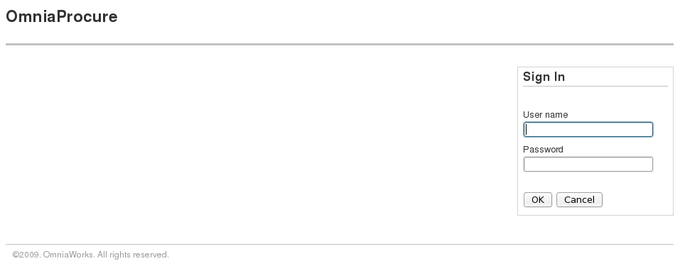
Fig. 1: Sign In

<%inherit file="base.html"/>

<%def name="title()">Home</%def>

<%def name="custom_js()">
<script src="/js/index.js"></script>
</%def>
<%def name="page_content()">

<div class="grid_12 alpha">&nbsp;</div>

<div id="sign-in" class="grid_4 omega auth">

<div class="widget">

<h4>Sign In</h4>

<div class="feedback">&nbsp;</div>

<form name="login" id="login" class="auth-form">
<fieldset>
<ol>
<li>
<label for="username">User name</label>
<input type="text" id="username" name="username"/><br/>
</li>
<li>
<label for="password">Password</label>
<input type="password" id="password" name="password"/><br/>
</li>
</ol>
</fieldset>

<fieldset>
<input class="submit" type="submit" value="OK"/>
<input type="reset" value="Cancel"/>
</fieldset>
</form>

</div>

</div>

<div id="footer" class="grid_16 alpha omega">
<p>&copy;2009. OmniaWorks. All rights reserved.</p>
</div>

</%def>

- Dashboard (dashboard.html)

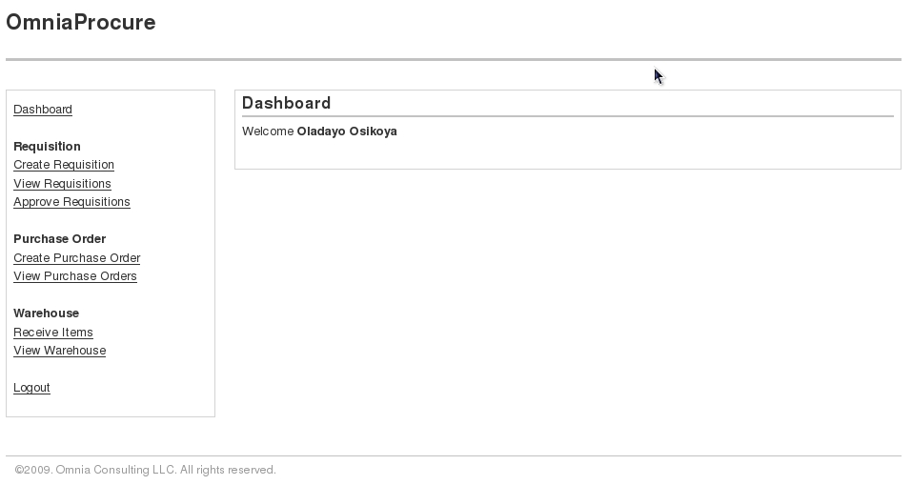
Fig 2. The Dashboard

<%inherit file="base.html"/>

<%def name="title()">Dashboard</%def>

<%def name="custom_js()">
<script>

$(function() {

$(".grid_4 .widget ul").html(role["${session['user'].roles}"]);

});

</script>
</%def>

<%def name="activity()">

<div class="grid_12 omega">
<div class="widget">
<h4>Dashboard</h4>
<p>
Welcome <b>${session['user'].firstname} ${session['user'].lastname}</b>
</p>
</div>
</div>

</%def>

<%def name="page_content()">

<div class="grid_4 alpha">
<div class="widget">
<ul</ul>
</div>
</div>

${self.activity()}

<div id="footer" class="grid_16 alpha omega">
<p>&copy;2009. Omnia Consulting LLC. All rights reserved.</p>
</div>

</%def>

- Create Requisition (create_requisition.html)

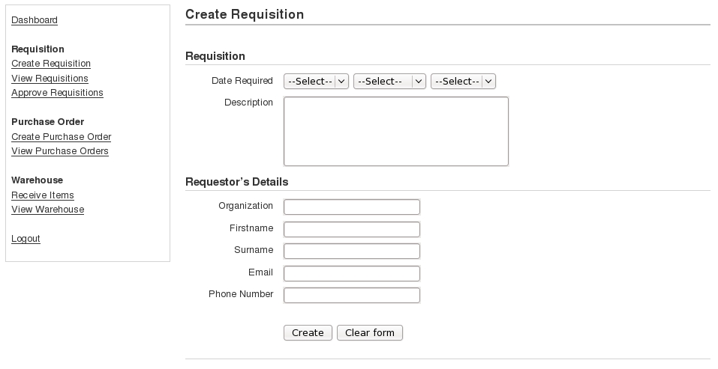
Fig 3. Create Requisition

<%inherit file="dashboard.html"/>

<%def name="title()">Create Requisition</%def>

<%def name="custom_js()">
<script src="/js/req.js"></script>
<script>

$(function() {

$(".grid_4 .widget ul").html(role["${session['user'].roles}"]);

var obj = new AjaxGet();

obj.get("/misc/get_days");
obj.get("/misc/get_months");
obj.get("/misc/get_years");

});

</script>
</%def>

<%def name="activity()">

<div class="grid_12 omega main">

<div class="widget">

<h4>Create Requisition</h4>

<div class="inner">

<form name="requisition-form" id="requisition-form" class="info-form"><!--{{{-->
<div class="feedback">&nbsp;</div>
<fieldset>
<ol>
<h6>Requisition</h6>
<li>
<label for="date-required">Date Required</label>
<select id="day"></select>
<select id="month"></select>
<select id="year"></select>
</li>
<li>
<label for="req-description">Description</label>
<textarea id="req-description" name="req-description" cols=40 rows=5></textarea>
</li>

<h6>Requestor&rsquo;s Details</h6>
<li>
<label for="organization">Organization</label>
<input id="organization" name="organization"/>
</li>
<li>
<label for="firstname">Firstname</label
<input id="firstname" name="firstname"/>
</li>
<li>
<label for="surname">Surname</label>
<input id="surname" name="surname"/>
</li>
<li>
<label for="email">Email</label>
<input id="email" name="email"/>
</li>
<li>
<label for="phone-number">Phone Number</label>
<input id="phone-number" name="phone-number"/>
</li>
</ol>
</fieldset>

<fieldset class="submit">

<input type="button" class="submit" value="Create" onClick="createReq();"/>
<input type="reset" value="Clear form"/>
</fieldset>
</form><!--}}}-->

</div>
</div>
</div>

</%def>

- Create Purchase Order (create_purchase_order.html)

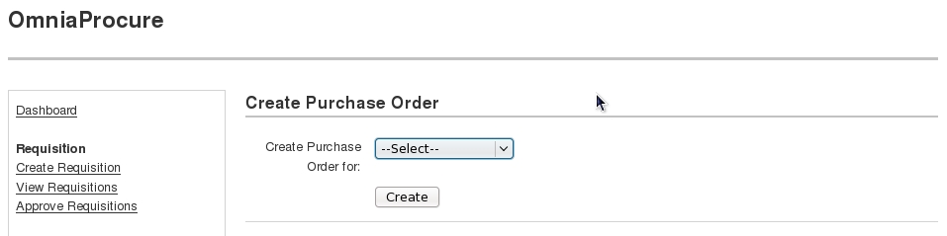
Fig. 4. Create Purchase Order

<%def name="title()">Create Purchase Order</%def>

<%def name="custom_js()"><!--{{{-->

<script src="/js/purchase_order.js"></script>
<script>
$(function() {
$(".grid_4 .widget ul").html(role["${session['user'].roles}"]);

var obj = new AjaxGet();
// Display only vendor objects which contain line items

obj.get("/vendor/get_vendors_with_line_items");
});
</script>
</%def><!--}}}-->

<%def name="actionlinks()"><!--{{{-->
<li><a href="">Add Item</a>
</%def><!--}}}-->

<%def name="task()"><!--{{{-->

<div id="create-PO">
<h4>Create Purchase Order</h4>
<form name="createPO-form" id="createPO-form" class="info-form">
<div class="feedback">&nbsp;</div>
<fieldset>
<ol>
<li>
<label for="create-PO">Create Purchase Order for:</label>
<select id="vendor" name="vendor"></select>
</li>
<input type="hidden" id="user-id" name="user-id" value="${session['user'].id}"/>
</ol>
</fieldset>

<fieldset class="submit">
<input type="button" class="submit" value="Create" onclick="createPO();"/>
</fieldset>
</form>
</div>
</%def><!--}}}-->

<%def name="view()"><!--{{{-->
<div id="purchase-order">
<h4>Purchase Order</h4>
<div id="po">
<ul>
<li>Purchase Order No. <span id="id"></span></li>
<li>Date <span id="date"></span></li>
${self.actionlinks()}
</ul>
</div>
<div id="line-items">
<ul>
<li>Total Price <span id="amount"></span></li>
</ul>
</div>
<div id="vendor">
<ul>
<li>Name of Vendor <span id="name"></span></li>
<li>Address <span id="address"></span></li>
<li>Phone Number <span id="phone"></span></li>
</ul>
</div>
</div>

</%def><!--}}}-->

<%def name="extra_actions()"></%def>

<%def name="container()"><!--{{{-->
<div class="grid_12 omega main">
<div class="widget">
${self.task()}
${self.view()}
</div>
${self.extra_actions()}
</div>
</%def><!--}}}-->

<%inherit file="purchase_order.html"/>
- Warehouse (warehouse.html)

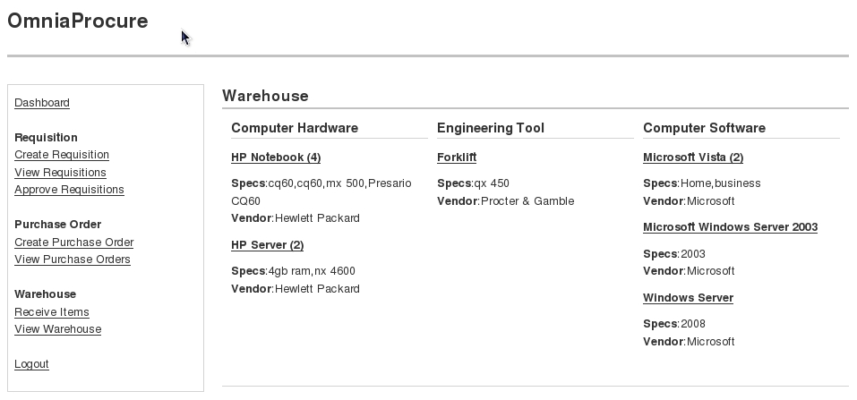
Fig. 5. Warehouse

<%inherit file="dashboard.html"/>

<%def name="title()">Warehouse</%def>

<%def name="custom_js()"><!--{{{-->

<script src="/js/warehouse.js"></script>
<script>

$(function() {
$(".grid_4 .widget ul").html(role["${session['user'].roles}"]);

var obj = new AjaxGet();
obj.get("/lineitem/get_types");
obj.get("/lineitem/get");

});

</script>

</%def><!--}}}-->

<%def name="activity()"><!--{{{-->
<div class="grid_12 omega main">
<div class="widget">
<h4>Warehouse</h4>
<div class="inner"></div>
</div>
</div>
</%def><!--}}}-->

CATEGORY B: Controllers

- Requisition (requisition.py)

import logging
import datetime

from omnia.lib.base import *
import omnia.model.helpers as h
from omnia.config.config import Config
from omnia.model.models import *

log = logging.getLogger(__name__)

class RequisitionController(BaseController):

def index(self):
return render("/requisitions.html")

def create(self):
return render("/create_requisition.html")

def add_line_item(self, id):
c.req_id = id
return render("/add_line_item.html")

def req_and_items(self, id):
c.req_id = id
return render("/requisition.html")

def doc_print(self, id):
c.req_id = id
return render("/print_requisition.html")

def approve(self):
return render("/approve.html")

@h.json_response
def get_by_id(self, id, **kwargs):
return ("req_object", Requisition.get_as_dict(id=id))

@h.json_response
def get(self, id=None, **kwargs):
return ("req_list", Requisition.get_as_dict(id=id))

@h.json_response
def get_open(self, **kwargs):
return ("openreqs_list", Requisition.get_open())

@h.json_response
def get_approved(self, **kwargs):
return ("approvedreqs_list", ApprovedRequisition.get_as_dict(id=None))

@h.json_response
@h.commit_or_rollback
def new(self, **kwargs):

date_required = request.params['datereq']
description = request.params['reqdesc']
organization = request.params['organization']
fullname = request.params['fullname']
email = request.params['email']
phone_number = request.params['phone']

req = Requisition.create(date_required, description, organization, fullname, email, phone_number)

config = Config()
server = config.get("mailserver", "server")
port = config.get("mailserver", "port")
username = config.get("mailserver", "username")
password = config.get("mailserver", "password")

sender = config.get("email", "sender")
recipient = email

subject = "Requisition Made"

message = "Hi " + fullname + "," + "\r\n" + "Your requisition has been made." + "\r\n\r\n"

h.send_mail(server, port, username, password, sender, recipient, subject, message)

return ("object", req.todict())

@h.json_response
@h.commit_or_rollback
def approve_req(self, id, **kwargs):

req = Requisition.get(id=id)
user_id = request.params['user_id']

req.approve(id, user_id)

@h.json_response
@h.commit_or_rollback
def close(self, **kwargs):
req_id = request.params['req_id']

items_status = LineItem.get_items_status(req_id)

# Check if items have been delivered

for item_status in items_status:
if item_status != 2:
return False

req = Requisition.get(req_id)
req.close()

return ("ok", "Requisition Closed")

- Purchase Order (purchase_order.py)

import logging
import simplejson

from omnia.lib.base import *
import omnia.model.helpers as h
from omnia.model.models import *

log = logging.getLogger(__name__)

class PurchaseOrderController(BaseController):

def index(self):
return render('/purchase_orders.html')

def create(self):
return render('/create_purchase_order.html')

def view(self, id):
c.po_id = id
return render('/purchase_order.html')

def edit(self, id):
c.po_id = id
return render('/edit_purchase_order.html')

def doc_print(self, id):
c.po_id = id
return render('/print_purchase_order.html')

def add_line_item(self, id):
c.po_id = id
return render('/add_po_line_item.html')

@h.json_response
@h.commit_or_rollback
def new(self, **kwargs):
vendor_id = request.params['vendor']
user_id = request.params['user']

return ("po_object", PurchaseOrder.create(vendor_id, user_id))

@h.json_response
@h.commit_or_rollback
def close(self, id, **kwargs):

location = request.params['location']
closed_by = request.params['closed_by']

po = PurchaseOrder.get(id)
ret_val = po.close(location, closed_by)

return ("ok", "Items Received")

@h.json_response
def get_by_id(self, id, **kwargs):
po_dict = PurchaseOrder.get_as_dict(id=id)

if po_dict:
return ("po_object", po_dict)
else:
return ("error", "No such Purchase Order")

@h.json_response
def get_invoiced(self, **kwargs):
return ("poid_list", Invoice.get_po_ids())

@h.json_response
def get(self, **kwargs):
return ("po_list", PurchaseOrder.get_as_dict())

@h.json_response
def is_invoice_received(self, id, **kwargs):
retval = id in simplejson.dumps([i.purchase_order_id for i in Invoice.get()])

if not retval:
return ("error", "Invoice not received")
else:
return ("ok", "Invoice received")

- Line Item (lineitem.py)

import logging

from omnia.lib.base import *
import omnia.model.helpers as h
from omnia.model.models import *

log = logging.getLogger(__name__)

def build_spec_list(items):
items_specs = {}
for i in names_set(items):

spec_lst = []

for j in items:
if i == j['name']:
spec_lst.append(j['specification'])
items_specs[i] = spec_lst
return items_specs

def names_set(items):
names = []
for i in items:
names.append(i['name'])

return list(set(names))

def items_set(items):
lst = []
for i in items:

if i not in lst:
lst.append(i)

return lst

class LineitemController(BaseController):

@h.json_response
def get(self, **kwargs):
items = LineItem.get_item_dict()

specs = build_spec_list(items)

for i in items:
i['specification'] = specs[i['name']]
i['quantity'] = len(specs[i['name']])

return ("item_list", items_set(items))

@h.json_response
def get_types(self, **kwargs):
types = LineItem.get_types()
type_set = list(set(types))

return ("item_type_list", type_set)

@h.json_response
def get_for_invoice(self, id, **kwargs):
po_id = request.params['po_id']

items = LineItem.get_for_invoice(id, po_id)
return ("itemname_list", items)

@h.json_response
def get_by_invoice_no(self, id, **kwargs):
items = LineItem.get_by_invoice_no(id)
return ("item_list", items)

@h.json_response
@h.commit_or_rollback
def new(self, id, **kwargs):
name = request.params['name']
itemtype = request.params['type']
specification = request.params['spec']
quantity = request.params['qty']
unitprice = request.params['unitprice']
vendor = request.params['vendor']

req = Requisition.get(id=id)

req.add_line_item(name, itemtype, specification, quantity, unitprice, vendor)

@h.json_response
@h.commit_or_rollback
def order(self, id, **kwargs):
unit_price = request.params['unitprice']
po_id = request.params['poid']

line_item = LineItem.get(id)
line_item.order(unit_price, po_id)

@h.json_response
@h.commit_or_rollback
def invoice(self, id, **kwargs):
specification = request.params['specification']
quantity = request.params['quantity']
unit_price = request.params['unit_price']
invoice_no = request.params['invoice_no']

line_item = LineItem.get(id)

if specification.strip().upper() != line_item.specification.strip().upper():
return ("error", "Specification does not match PO item specification")

if int(quantity.strip()) != int(line_item.quantity):
return ("error", "Quantity does not match PO item quantity")

if int(unit_price.strip()) != int(line_item.unitprice):
return ("error", "Unit price does not match PO item unit price")

ret_val = line_item.invoice(specification, quantity, unit_price, invoice_no)
return ("ok", ret_val)

@h.json_response
@h.commit_or_rollback
def deliver(self, id, **kwargs):
status = request.params['status']

line_item = LineItem.get(id)
line_item.deliver(status)

return ("ok", "Items Received")

- Receiving (receiving.py)

import logging

from omnia.lib.base import *

log = logging.getLogger(__name__)

class ReceivingController(BaseController):

def index(self):

return render('/receiving.html')

- Ware House (warehouse.py)

import logging

from omnia.lib.base import *
import omnia.model.helpers as h
from omnia.model.models import *

log = logging.getLogger(__name__)

class WarehouseController(BaseController):

def index(self):
return render ("/warehouse.html")

@h.json_response
def check(self, **kwargs):
location = request.params['location']
reg_location = Warehouse.get(1).location

if location != reg_location:
return ("error", "Unknown Location")

return ("ok", "Good to go")

- Invoice (invoice.py)

import logging

from omnia.lib.base import *
import omnia.model.helpers as h
from omnia.config.config import Config
from omnia.model.models import *

log = logging.getLogger(__name__)

class InvoiceController(BaseController):

def index(self):
return render('/invoices.html')

def create(self):
c.po_id = request.params['po_id']
return render('/create_invoice.html')

def view(self, id):
c.inv_no = id
return render('/invoice.html')

def edit(self, id):
c.inv_no = i
return render('/edit_invoice.html')

def add_item(self, id):
c.invoice_no = id
return render('/add_inv_item.html')

@h.json_response
def get_by_no(self, id, **kwargs)
return ("invoice_object", Invoice.get_as_dict(no=id))

@h.json_response
def get_by_poid(self, id, **kwargs):
return ("invoice_object", Invoice.get_by_poid(id))

@h.json_response
@h.commit_or_rollback
def new(self, **kwargs):
invoice_no = request.params['invoice_no']
amount = request.params['amount']
po_id = request.params['po_id']
vendor_id = request.params['vendor_id']
user_id = request.params['user_id']

po_amount = PurchaseOrder.get_amount(po_id)

if int(amount) != int(po_amount):
return ("error", "Invoice amount does not match PO amount.");

invoice = Invoice.create(invoice_no, po_id, vendor_id, user_id, amount)

warehouse = Warehouse.get(1)

# Send email
config = Config()

server = config.get("mailserver", "server")
port = config.get("mailserver", "port")
username = config.get("mailserver", "username")
password = config.get("mailserver", "password")

sender = config.get("email", "sender")
recipient = warehouse.manager_email

subject = config.get("email", "subject2")

message = "Hi " + User.get(warehouse.manager).firstname + " " + User.get(warehouse.manager).lastname + ",\r\n\r\n"

message += "Invoice %s has been received for purchase order %s. %sRegards %s" % (invoice_no, po_id, "\r\n\r\n", "\r\n\r\n")

h.send_mail(server, port, username, password, sender, recipient, subject, message)

return ("invoice_object", invoice)

CATEGORY C: Models

from sqlalchemy.ext.declarative import declarative_base
from sqlalchemy import *
from sqlalchemy.orm import *
from sqlalchemy.orm import exc as orm_exc
from traceback import print_exc

import datetime

from omnia.model import meta

Base = declarative_base()

meta.metadata = Base.metadata

class Misc(object):#{{{

@staticmethod
def days():

return {
1: 1,
2: 2,
3: 3,
4: 4,
5: 5,
6: 6,
7: 7,
8: 8,
9: 9,
10: 10,
11: 11,
12: 12,
13: 13,
14: 14,
15: 15,
16: 16,
17: 17,
18: 18,
19: 19,
20: 20,
21: 21,
22: 22,
23: 23,
24: 24,
25: 25,
26: 26,
27: 27,
28: 28,
29: 29,
30: 30,
31: 31
}

@staticmethod
def months():
return {
1: "January",
2: "February",
3: "March",
4: "April",
5: "May",
6: "June",
7: "July",
8: "August",
9: "September",
10: "October",
11: "November",
12: "December"
}

@staticmethod
def years():
return {
2009: 2009,
2010: 2010,
2011: 2011,
2012: 2012
}

#}}}

class User(Base):#{{{

__tablename__ = 'user'
__table_args__ = {'mysql_engine': 'innodb'}

id = Column(Integer, primary_key=True)
username = Column(String(50), nullable=False, unique=True)
password = Column(String(200), nullable=False)
firstname = Column(String(50), nullable=False)
lastname = Column(String(50), nullable=False)
roles = Column(String(255), nullable=False)

def __init__(self, username, password, firstname, lastname, roles):
self.username = username
self.password = password
self.firstname = firstname
self.lastname = lastname
self.roles = roles

@staticmethod
def create(username, password, firstname, lastname, roles):
user = User(username, password, firstname, lastname, roles)
meta.session.add(user)
return user

@staticmethod
def get(id=None, username=None):
try:
if id:
return meta.session.query(User).filter_by(id=id).one()
elif username:
return meta.session.query(User).filter_by(username=username).one()
else:
return [u for u in meta.session.query(User)]

except Exception, e:
print_exc()

def todict(self):
return {
'id': self.id,
'firstname': self.firstname,
'lastname': self.lastname,
'roles': self.roles
}#}}}

class Requisition(Base):#{{{

__tablename__ = 'requisition'
__table_args__ = {'mysql_engine': 'innodb'}

id = Column(Integer, primary_key=True, nullable=False)
date_required = Column(DateTime, default=datetime.datetime.now())
description = Column(Text, nullable=False)
organization = Column(String(100), nullable=False)
full_name = Column(String(100), nullable=False)
email = Column(String(100), nullable=False)
phone_number = Column(String(20), nullable=False)
date_created = Column(DateTime, default=datetime.datetime.now())
date_closed = Column(DateTime)
status = Column(Integer, default='0', nullable=False)

def __init__(self, date_required, description, organization, full_name, email, phone_number):
self.date_required = date_required
self.description = description
self.organization = organization
self.full_name = full_name
self.email = email
self.phone_number = phone_number
self.date_created = datetime.datetime.now()

def close(self):
self.status = 3
self.date_closed = datetime.datetime.now()

@staticmethod
def create(date_required, description, organization, fullname, email, phone_number):
req = Requisition(date_required, description, organization, fullname, email, phone_number)
meta.session.add(req)
meta.session.flush()
return req

@staticmethod
def get(id=None):
try:
if id:
return meta.session.query(Requisition).filter_by(id=id).one()
else:
return [r for r in meta.session.query(Requisition)]

except Exception, e:
print_exc()

@staticmethod
def get_as_dict(id=None):
try:
if id:
return meta.session.query(Requisition).filter_by(id=id)
.one().todict()
else:
return [r.todict() for r in meta.session.query(Requisition)]
except Exception, e:
print_exc()

STATUS_MAP = {
0: "Open",
1: "Approved",
2: "Disapproved",
3: "Closed"
}

def todict(self):
return {
"id": self.id,
"date_required": str(self.date_required),
"description": self.description,
"organization": self.organization,
"full_name": self.full_name,
"phone_number": self.phone_number,
"date_created": str(self.date_created),
"date_closed": str(self.date_closed),
"status": Requisition.STATUS_MAP[int(self.status)],
"lineitems": [lineitem.todict() for lineitem in self.lineitems]
}

def add_line_item(self, name, itemtype, specification, quantity, unitprice, vendorid):
self.lineitems.append(LineItem(name, itemtype, specification, quantity, unitprice, vendorid))

@staticmethod
def get_line_items(id):
line_items = [li.todict() for li in meta.session.query(LineItem).filter_by(requisitionid=id)]
return line_items

@staticmethod
def get_open():
reqs = [r.todict() for r in meta.session.query(Requisition).filter_by(status=0)]
return reqs

@staticmethod
def get_approved():
return [r.todict() for r in meta.session.query(Requisition).filter_by(status=1)]

def approve(self, id, user_id):
self.status = 1
self.approvedrequisition = ApprovedRequisition(id, user_id)

#}}}

class ApprovedRequisition(Base):#{{{

__tablename__ = 'approvedrequisition'
__table_args__ = {'mysql_engine': 'innodb'}

id = Column(Integer, primary_key=True)
requisitionid = Column(Integer, ForeignKey('requisition.id', ondelete='RESTRICT', onupdate='CASCADE'), nullable=False)

userid = Column(Integer, ForeignKey('user.id', ondelete='RESTRICT', onupdate='CASCADE'), nullable=False)
requisition = relation(Requisition, backref=backref('approvedrequisition', uselist=False))
user = relation(User, backref=backref('approvedrequisitions', order_by=id))

def __init__(self, req_id, user_id):
self.requisitionid = req_id
self.userid = user_id

def todict(self):
return {
"id": self.id,
"requisition_id": self.requisitionid,
"requisition": Requisition.get(self.requisitionid).description,
"user": User.get(self.userid).firstname + " " + User.get(self.userid).lastname

}

@staticmethod
def get_as_dict(id=None):
try:
if id:
return meta.session.query(ApprovedRequisition).filter_by(id=id).one().todict()
else:
return [ar.todict() for ar in meta.session.query(ApprovedRequisition)]
except Exception, e:
print_exc()

#}}}

class PurchaseOrder(Base):#{{{

__tablename__ = 'purchaseorder'
__table_args__ = {'mysql_engine': 'innodb'}

id = Column(Integer, primary_key=True)
vendor_id = Column(Integer, ForeignKey('vendor.id', ondelete='RESTRICT', onupdate='CASCADE'), nullable=False)
total_amount = Column(Integer, default='0', nullable=False)
status = Column(Integer, default='0', nullable=False)
created_by = Column(Integer, ForeignKey('user.id', ondelete='RESTRICT', onupdate='CASCADE'), nullable=False)
date_created = Column(DateTime, default=datetime.datetime.now())
storage_location = Column(String(100))
date_closed = Column(DateTime)
closed_by = Column(Integer, ForeignKey('user.id', ondelete='RESTRICT', onupdate='CASCADE'))

def __init__(self, vendor_id, user_id):
self.vendor_id = vendor_id
self.created_by = user_id
self.date_created = datetime.datetime.now()

STATUS_MAP = {
0: "Open",
1: "Closed"
}

@staticmethod
def create(vendor, user):
po = PurchaseOrder(vendor, user)
meta.session.add(po)
meta.session.flush()

return po.todict()

def todict(self):
return {
"id": self.id,
"vendor": Vendor.get_as_dict(self.vendor_id),
"total_amount": self.total_amount,
"status": PurchaseOrder.STATUS_MAP[int(self.status)],
"created_by": User.get(self.created_by).firstname + " " + User.get(self.created_by).lastname,
"line_items": [li.todict() for li in self.lineitems],
"date_created": str(self.date_created),
"date_closed": str(self.date_closed),
"closed_by": User.get(self.created_by).firstname + " " + User.get(self.created_by).lastname
}

def close(self, storage_location, closed_by):
self.status = 1
self.storage_location = storage_location
self.closed_by = closed_by
self.date_closed = datetime.datetime.now()

@staticmethod
def get(id=None):
try:
if id:
return meta.session.query(PurchaseOrder).filter_by(id=id).one()
else:
return [po for po in meta.session.query(PurchaseOrder)]
except Exception, e:
print_exc()

@staticmethod
def get_as_dict(id=None):
try:
if id:
return meta.session.query(PurchaseOrder)
.filter_by(id=id).one().todict()
else:
return [po.todict() for po in meta.session.query(PurchaseOrder)]
except Exception, e:
print_exc()

@staticmethod
def get_amount(id):
try:
return meta.session.query(PurchaseOrder).filter_by(id=id).one().total_amount
except Exception, e:
print_exc()

#}}}

class Invoice(Base):#{{{

__tablename__ = 'invoice'
__table_args__ = {'mysql_engine': 'innodb'}

id = Column(Integer, primary_key=True)
invoice_number = Column(Integer, unique=True, nullable=False)
purchase_order_id = Column(Integer, ForeignKey('purchaseorder.id', ondelete='RESTRICT', onupdate='CASCADE'), nullable=False)
vendor_id = Column(Integer, ForeignKey('vendor.id', ondelete='RESTRICT', onupdate='CASCADE'), nullable=False)
total_amount = Column(Integer)
created_by = Column(Integer, ForeignKey('user.id', ondelete='RESTRICT', onupdate='CASCADE'), nullable=False)
date_created = Column(DateTime, default=datetime.datetime.now())

def __init__(self, invoice_number, purchase_order_id, vendor_id, created_by, total_amount):
self.invoice_number = invoice_number
self.purchase_order_id = purchase_order_id
self.vendor_id = vendor_id
self.total_amount = total_amount
self.created_by = created_by
self.date_created = datetime.datetime.now()

@staticmethod
def create(invoice_number, purchase_order_id, vendor_id, created_by, total_amount):
invoice = Invoice(invoice_number, purchase_order_id, vendor_id, created_by, total_amount)
meta.session.add(invoice)
meta.session.flush()

return invoice.todict()

@staticmethod
def get(no=None):
try:
if no:
return meta.session.query(Invoice).filter_by(invoice_number=no).one()
else:
return [i for i in meta.session.query(Invoice)]
except Exception, e:
print_exc()

@staticmethod
def get_po_ids()
return [
id_dict(i.purchase_order_id) for i in meta.session.query(Invoice) if i.purchase_order_id in [
p.id for p in meta.session.query(PurchaseOrder).filter_by(status=0)
]
]

@staticmethod
def get_by_poid(poid):
try:

return meta.session.query(Invoice).filter_by(purchase_order_id=poid).one().todict()
except Exception, e:
print_exc()

@staticmethod
def get_as_dict(no=None):
try:
if no:
return meta.session.query(Invoice).filter_by(invoice_number=no).one().todict()
else:
return [i.todict() for i in meta.session.query(Invoice)]
except Exception, e:
print_exc()

def todict(self):

return {
"id": self.id,
"invoice_no": self.invoice_number,
"po_id": self.purchase_order_id,
"vendor": Vendor.get_as_dict(self.vendor_id),
"total_amount": self.total_amount,
"created_by": self.created_by,
"date_created": str(self.date_created)
}

#}}}

class Vendor(Base):#{{{

__tablename__ = 'vendor'
__table_args__ = {'mysql_engine': 'innodb'}

id = Column(Integer, primary_key=True)
name = Column(String(200), nullable=False, unique=True)
address = Column(Text)
phone = Column(String(20), nullable=False)

def __init__(self, name, address, phone):
self.name = name
self.address = address
self.phone = phone

@staticmethod
def create(name, address, phone):
vendor = Vendor(name, address, phone)
meta.session.add(vendor)
meta.session.flush()

@staticmethod
def get(id=None):
try:
if id:
return meta.session.query(Vendor).filter_by(id=id).one()
else:
return [v for v in meta.session.query(Vendor)]
except Exception, e:
print_exc()

@staticmethod
def get_as_dict(id=None):
try:
if id:
return meta.session.query(Vendor).filter_by(id=id).one().todict()
else:
return [v.todict() for v in meta.session.query(Vendor)]
except Exception, e:
print_exc()

def approved_line_items(self):
return [

vl.todict() for vl in meta.session.query(Vendor).filter_by(id=self.id).one().lineitems if vl.requisitionid in

[ar.requisitionid for ar in meta.session.query(ApprovedRequisition)]

and vl.status == 0
]

@staticmethod
def get_names():
return [name_dict(v) for v in meta.session.query(Vendor)]

@staticmethod
def get_vendors_with_line_items():
for v in meta.session.query(Vendor):
line_items = v.lineitems

[line_items.remove(l) for l in line_items if l.status == 1]
return [name_dict(v) for v in meta.session.query(Vendor) if v.lineitems != []]

def todict(self):
return {
"id": self.id,
"name": self.name,
"address": self.address,
"phone": self.phone,
"lineitems": self.approved_line_items()
}#}}}

class LineItem(Base):#{{{

__tablename__ = 'lineitem'
__table_args__ = {'mysql_engine': 'innodb'}

id = Column(Integer, primary_key=True)
name = Column(String(100), nullable=False)
itemtype = Column(String(100), nullable=False)
specification = Column(Text)
quantity = Column(Integer, default='0', nullable=False)
unitprice = Column(Integer, nullable=False)
totalprice = Column(Integer, nullable=False)
status = Column(Integer, default='0', nullable=False)

requisitionid = Column(Integer, ForeignKey('requisition.id', ondelete='RESTRICT', onupdate='CASCADE'))
vendorid = Column(Integer, ForeignKey('vendor.id', ondelete='RESTRICT', onupdate='CASCADE'))
purchaseorderid = Column(Integer, ForeignKey('purchaseorder.id', ondelete='RESTRICT', onupdate='CASCADE'))
invoiceno = Column(Integer, ForeignKey('invoice.invoice_number', ondelete='RESTRICT', onupdate='CASCADE'))

requisition = relation(Requisition, backref=backref('lineitems', order_by=id))
vendor = relation(Vendor, backref=backref('lineitems', order_by=id))
purchaseorder = relation(PurchaseOrder, backref=backref('lineitems', order_by=id))
invoice = relation(Invoice, backref=backref('lineitems', order_by=id))

STATUS_MAP = {
0: "Requested",
1: "Ordered",
2: "Delivered",
3: "Deployed"
}

def __init__(self, name, itemtype, specification, quantity, unitprice, vendorid):
self.name = name
self.itemtype = itemtype
self.specification = specification
self.quantity = quantity
self.unitprice = unitprice
self.totalprice = int(quantity) * int(unitprice)
self.vendorid = vendorid

@staticmethod
def get(id=None):
try:
if id:
return meta.session.query(LineItem).filter_by(id=id).one()
else:
return [li.todict() for li in meta.session.query(LineItem)]
except Exception, e:
print_exc()

@staticmethod
def get_names():
try:
return [li.name for li in meta.session.query(LineItem)]
except Exception, e:
print_exc()

@staticmethod
def get_types():
try:
return [li.itemtype for li in meta.session.query(LineItem)]
except Exception, e:
print_exc()

@staticmethod
def get_spec(name):
try:
return [
dict([('specification', li.specification), ('vendor', Vendor.get(li.vendorid).name)])
for li in meta.session.query(LineItem).filter_by(name=name)
]
except Exception, e:
print_exc()

@staticmethod
def count(name):
return len([li.name for li in meta.session.query(LineItem).filter_by(name=name)])

@staticmethod
def get_item_dict():
try:
return [
dict([
('name', li.name),
('itemtype', li.itemtype),
('specification', li.specification),
('vendor', Vendor.get(li.vendorid).name)
])
for li in meta.session.query(LineItem)
]
except Exception, e:
print_exc()

def todict(self):
return {
"id": self.id,
"name": self.name,
"itemtype": self.itemtype,
"specification": self.specification,
"quantity": self.quantity,
"unitprice": self.unitprice,
"totalprice": self.totalprice,
"vendor": Vendor.get(self.vendorid).name,
"requisitionid": self.requisitionid,
"purchaseorderid": self.purchaseorderid,
"status": LineItem.STATUS_MAP[int(self.status)],
}

@staticmethod
def get_items_status(req_id):
try:
items = meta.session.query(LineItem).filter_by(requisitionid=req_id).all()
return [item.status for item in items]
except Exception, e:
print_exc()

def remove_from_PO(self):
pass

def order(self, unit_price, purchase_order_id):
self.unitprice = unit_price
self.purchaseorderid = purchase_order_id
self.totalprice = int(unit_price) * int(self.quantity)
self.status = 1

po = PurchaseOrder.get(purchase_order_id)
po.total_amount = po.total_amount + self.totalprice

def invoice(self, specification, quantity, unit_price, invoice_no):
self.specification = specification
self.quantity = quantity
self.unitprice = unit_price
self.total_price = int(quantity) * int(unit_price)
self.invoiceno = invoice_no

def deliver(self, status):
self.status = status

@staticmethod
def get_for_invoice(vendor_id, po_id):
return [name_dict(li) for li in meta.session.query(LineItem).filter_by(invoiceno=None).filter_by(vendorid=vendor_id).filter_by(purchaseorderid=po_id).all()]

@staticmethod
def get_by_invoice_no(invoice_no):
return [li.todict() for li in meta.session.query(LineItem).filter_by(invoiceno=invoice_no).all()]

#}}}

class Item(Base):#{{{

__tablename__ = 'item'
__table_args__ = {'mysql_engine': 'innodb'}

id = Column(Integer, primary_key=True)
name = Column(String(200), nullable=False, unique=True)
type = Column(String(100), nullable=False)

def __init__(self, name, type):
self.name = name
self.type = type

@staticmethod
def create(name, type):
item = Item(name, type)
meta.session.add(item)
meta.session.flush()

def todict(self):
return {
"id": self.id,
"name": self.name,
"type": self.type,
}

@staticmethod
def types():
return lst_to_dictlst(set([i.type for i in meta.session.query(Item)]))

@staticmethod
def item_by_type(type):
return lst_to_dictlst([i.name for i in meta.session.query(Item).filter_by(type=type)])
#}}}

class Warehouse(Base):#{{{

__tablename__ = 'warehouse'
__table_args__ = {'mysql_engine': 'innodb'}

id = Column(Integer, primary_key=True)
location = Column(String(100), nullable=False)
address = Column(String(200), nullable=False)
manager = Column(Integer, ForeignKey('user.id', ondelete='RESTRICT', onupdate='CASCADE'))
manager_email = Column(String(100), nullable=False)

@staticmethod
def get(id=None, username=None):
try:
if id:
return meta.session.query(Warehouse).filter_by(id=id).one()
else:
return [w for w in meta.session.query(Warehouse)]
except Exception, e:
print_exc()
#}}}

def lst_to_dictlst(lst):

"""Convert a list to a dictionary with both key and value as list element"""

new_lst = []
for t in lst:
dct = {}
dct['id'] = t
dct['name'] = t
new_lst.append(dct)

return new_lst

def name_dict(object):
"""Return a dictionary of object's id and name"""
return {
"id": object.id,
"name": object.name
}

def id_dict(id):
return {
"id": id,
"name": id
}

#}}}

CATEGORY C: Models

- Creation of Databases (create.sql)

grant all on procure.* to 'procure'@'localhost' identified by 'procure'
grant all on procure_test.* to 'procure'@'localhost' identified by 'procure';

create database if not exists procure;
create database if not exists procure_test;

- Dummy data (data.sql) – For testing purposes

use procure;

insert into user (username, password, firstname, lastname, roles) values ("dayoo", md5("admin"), "Oladayo", "Osikoya", "Administrator");

insert into user (username, password, firstname, lastname, roles) values ("femio", md5("buyer"), "Olufemi", "Olusola", "Buyer");

insert into user (username, password, firstname, lastname, roles) values ("chukwudio", md5("procman"), "Chukwudi", "Ogwumba", "Procurement Manager");

insert into user (username, password, firstname, lastname, roles) values ("audue", md5("wareman"), "Audu", "Ernest", "Warehouse Manager");

insert into vendor (name, address, phone) values ("Hewlett Packard", "Oko Oloyun Street, Victoria Island", "08023456789");

insert into vendor (name, address, phone) values ("Microsoft", "Bishop Oluwole Street, Ikoyi", "08038388888");

insert into vendor (name, address, phone) values ("Procter & Gamble", "Asaba, Delta State", "08054673456");

insert into item (name, type) values ("HP Server", "Computer Hardware");
insert into item (name, type) values ("Windows Server", "Computer Software");
insert into item (name, type) values ("Microsoft Outlook", "Computer Software");
insert into item (name, type) values ("Microsoft Vista", "Computer Software");
insert into item (name, type) values ("HP Notebook", "Computer Hardware");
insert into item (name, type) values ("Microsoft Windows Server 2003", "Computer Software");
insert into item (name, type) values ("Forklift", "Engineering Tool");
insert into item (name, type) values ("Oil Drill", "Engineering Tool");
insert into warehouse (location, address, manager, manager_email) values ("Ikeja", "Oba Akinjobi Way, G.R.A", 4, "deone@example.com");

