INTRODUCTION

In this rapidly changing landscape of e-commerce, it’s more important than ever to understand consumer behavior. Businesses are depending more and more on data-driven strategies to improve customer loyalty, retention, and satisfaction as a result of the growth of digital platforms. In addition to completely changing the traditional retail industry, the rise of online shopping has given businesses a ton of new opportunities to use consumer data to their advantage. This dissertation uses a combination of simulated data and modern analytical models to advance e-commerce strategies through advanced customer segmentation and behavioral analysis techniques.

A key component of marketing strategy is customer segmentation, which is breaking up a customer base into discrete groups according to qualities they have in common. In the past, segmentation has been carried out using simple transactional or demographic data, enabling companies to focus their marketing efforts on particular customer segments. However, as customer data has grown more complex and diverse, the limitations of traditional methods have become obvious. Advanced techniques utilizing machine learning and data analytics have been developed in response to the need for more precise and nuanced segmentation methods. By using these methods, companies can gain a deeper understanding of consumer behavior and develop more individualized and successful marketing campaigns.

RFM analysis (Recency, Frequency, and Monetary), which evaluates clients based on their past purchases, is one of the most popular techniques for customer segmentation. RFM analysis looks at how recently, how often, and how much customers spend to identify high-value customers. It's a simple way to find customers who make purchases. Although many businesses have found RFM analysis to be a useful tool, it frequently lacks the ability required to handle complex and diverse data. In order to overcome these challenges, professionals have started combining multiple clustering algorithms with conventional RFM analysis. By combining the advantages of several algorithms, these approaches improve segmentation accuracy and provide more accurate and useful customer insights.

Predicting the Customer Lifetime Value (CLV), in addition to RFM analysis, has become an essential part today's e-commerce strategy. Businesses can prioritize high-value customers and make the most use of their marketing budgets by estimating the future value that a customer will bring with the aid of CLV prediction.

Understanding consumer behavior has also made the integration of data from multiple sources more important. Nowadays, e-commerce platforms have access to a multitude of data from different sources, such as social media activity, transactional data, online browsing patterns, and customer reviews. Through the use of data the union techniques, businesses can combine these various sources of data to create complete client profiles that offer an in-depth view of customer behavior. This multi-source data integration helps businesses understand not only what their customers are buying, but also why they are buying it, which makes it especially useful for creating specific advertisements. Using insights from various data sources enables businesses to develop more customized and successful marketing strategies that connect with their target market.

Geospatial analysis is another area of great interest in e-commerce analytics. Gaining knowledge about the shopping patterns and geographic distribution of customers can be extremely beneficial in identifying regional trends and preferences. We can visualize customer data on a map by using geospatial analysis tools. For companies trying to grow into new markets or target particular areas with their marketing campaigns, this geographic viewpoint is essential. Additionally, by combining geospatial data with other behavioral metrics like RFM scores or CLV predictions, businesses can gain a deeper knowledge of customer behavior and create targeted and successful marketing campaigns.

This dissertation aims to create a comprehensive system that combines advanced customer segmentation and behavioral analysis techniques to improve e-commerce strategies. The system will offer actionable insights that help businesses increase customer engagement, retention, and overall satisfaction by utilizing hybrid clustering methods, real-time data processing, multi-source data integration, and geospatial analysis. To replicate real-world customer data, the study will make use of simulated datasets created with the Python "Faker" library. This strategy addresses privacy issues and guarantees adhering to ethical standards, while enabling the study of complex analytical models.

The dissertation will concentrate on a few key objectives in order to accomplish the above goal. The first step will be the implementation of clustering technique, which handle different data characteristics and increase segmentation accuracy by combining K-Means and DBSCAN algorithms. In order to generate thorough customer profiles, it will also combine customer geospatial data, transactional data, and behavioural data. RFM analysis and CLV prediction will be performed in order to identify high-value clients and maximize marketing efforts. We will also carry out geospatial analysis to comprehend regional trends and choices, giving customer segmentation a geographic component. Lastly, in order to display the analysed data, a prototype application with a front end built with React and a back end built with Django will be developed.

To sum up, the goal of this dissertation is to improve e-commerce strategies by combining advanced behavioral analysis and customer segmentation methods. The research attempts to provide a more accurate and complex understanding of customer behavior by integrating multi-source data integration, modern machine learning algorithms, and traditional methods. The results of this dissertation will add up to the existing information on e-commerce analytics and provide useful guidance to companies seeking to improve customer engagement and retention.

OBJECTIVES

This dissertation's objective is to create a complete structure that uses advanced data analytics methods to improve customer segmentation and behavioral analysis in order to improve e-commerce strategies. In order to obtain deeper insights into consumer behavior and help businesses develop more focused and successful promotional strategies, the focus is on integrating various methodologies. In order to accomplish this, the dissertation sets out a number of particular goals intended to fill in the gaps in the field of e-commerce analytics and offer feasible suggestions for practical applications.

Objective 1: Simulate Data Using the Python "Faker" Library

It is crucial to use datasets that closely resemble actual customer data in order to develop and test the suggested methodologies. The creation of simulated datasets that imitate different behavioral metrics, and customer transactions details, and other customer interactions is necessary. The "Faker" library for Python will be used to accomplish this, as it enables the creation of realistic synthetic data while upholding data security and privacy regulations. This dissertation attempts to provide a secure setting for testing various analytical techniques by simulating diverse datasets, ensuring that the suggested approaches are flexible and applicable to a broad range of e-commerce scenarios.

Objective 2: Conduct RFM Analysis and CLV Prediction to Identify High-Value Customers

The next goal is to identify high-value clients by combining customer lifetime value (CLV) prediction with recency, frequency, and monetary (RFM) analysis. RFM analysis will be conducted by calculating three key metrics for each customer: Recency (time since last purchase), Frequency (number of purchases), and Monetary value (total spend). RFM analysis is a well-established technique for assessing clients based on their purchasing patterns, offering a simple approach to divide clients into various value categories. However, future customer value is not taken into account by RFM analysis alone. By combining RFM analysis with CLV prediction, which calculates the future value a customer will bring to the business, this objective seeks to provide a more forward-looking approach to customer segmentation. Following this, machine learning models like linear regression and decision trees will be applied to predict Customer Lifetime Value (CLV) based on historical RFM data and additional customer features. To further improve the segmentation process, this goal includes grouping customers according to their RFM scores. The CLV prediction models will be evaluated using performance metrics such as Mean Absolute Error (MAE) and R-squared to assess the models' accuracy and reliability in forecasting future customer value. By combining these two strategies, companies will be able to better target their marketing efforts and give priority to their most valuable clients, which will increase long-term profitability.

Objective 3: Implement Hybrid Clustering Techniques

In order to achieve more precise and dependable customer segmentation, the first goal is to apply hybrid clustering techniques, which combine the advantages of multiple clustering algorithms, specifically DBSCAN and K-Means. Conventional clustering techniques, like K-Means, are frequently employed for splitting clients into groups according to similarity, yet, they are open to outliers and assume spherical clusters. On the other hand, DBSCAN is more immune to noise and can detect clusters of different sizes and shapes, but it requires precise adjustment of parameters like the epsilon distance and minimum number of points. This goal is to develop a more adaptable and reliable segmentation strategy that can better manage the diversity of customer data in e-commerce by combining these algorithms into a hybrid model. The silhouette score and Davies-Bouldin index, two cluster validity indices, will be used to assess the hybrid clustering model's efficiency. By measuring the compactness and separation of clusters, these indices will aid in making sure that the segmentation process successfully discerns between various customer behavior and preferences. Businesses will be able to recognize different customer groups more precisely thanks to this improved segmentation accuracy, which will result in more individualized and powerful marketing campaigns.

Objective 4: Perform Geospatial Analysis to Understand Regional Trends and Preferences

Using geospatial analysis to investigate and visualize the geographic distribution of clients and their purchasing patterns is the next goal. Businesses hoping to enter new markets or target particular geographic areas with their strategies must have a thorough understanding of the geographic distribution of their customers and the regional variations in their preferences. Using Geographic Information Systems (GIS) tools, this goal involves mapping customer data and spotting regional trends. In order to provide a broader understanding of customer behavior that takes into account both behavioral and geographic dimensions, this dissertation integrates geospatial data with other customer metrics, such as RFM scores and CLV predictions. Businesses can use the observations collected from geospatial analysis to create more focused marketing strategies that suit local consumer preferences and trends.

Objective 5: Develop a Prototype Application to Demonstrate Practical Applications

The creation of a prototype application displaying the real-world implementation of the advanced customer segmentation and behavioral analysis methods this dissertation suggests is the fifth goal. This prototype will be constructed with React on the front end and Django on the back end to offer a stable and expandable framework for applying the techniques discovered during this study. Users will be able to enter customer data into the application, and it will use the integrated models to produce reports on behavioral analysis and segmentation. The functionality of the prototype will be evaluated by means of performance benchmarking and user testing. Measurements will be made of key performance indicators (KPIs) like response time, usability, and accuracy of data processing to make sure the application successfully illustrates the real-world uses of the developed methodologies. This objective aims to close the knowledge gap between theory and practice by offering a concrete example of the research findings and demonstrating how advanced analytics can be used to drive business outcomes in real-world e-commerce scenarios.

Objective 6: Evaluate System Performance Using Synthetic Data

The proposed methodologies will be rigorously tested using synthetic data to evaluate their scalability and efficiency, which is the next objective. This involves evaluating the system's performance in diverse e-commerce scenarios and its ability to manage a range of data types and volumes. Synthetic data eliminates the limitations and ethical challenges that come with using actual customer data, allowing a thorough evaluation. The effectiveness of the system in forecasting consumer behavior, the dependability of the segmentation and clustering models, and the methods' scalability to manage datasets from the real world will all be examined. This goal makes sure that the suggested methods are both practically and theoretically sound for use in actual e-commerce environments.

Objective 7: Address Ethical and Privacy Considerations

While some privacy concerns are eliminated when working with synthetic data, it is important to make sure that the methodologies developed adhere to ethical standards and data privacy regulations such as GDPR. This goal focuses on recognizing and resolving potential ethical problems with behavioral analysis and customer segmentation, such as biases in models and data, fairness in segmentation, and openness in data use. This dissertation seeks to promote responsible use of advanced data analytics in e-commerce and to establish trust by making sure that the developed techniques are both ethically sound and privacy-compliant.

In conclusion, the goals of this dissertation are to combine modern data analytics methods with real-world applications in order to progress the field of e-commerce analytics. This research aims to provide businesses more accurate, thorough, and useful insights into customer behavior by filling in the gaps that currently exist in segmentation of customers and behavioral analysis. This will ultimately improve businesses' capacity to engage and retain customers in a competitive digital marketplace.

METHODOLOGY

This dissertation's methodology focuses on creating a solid framework for improving e-commerce strategies using behavioral analysis and customer segmentation. This section describes the particular procedures, tools, methods, and issues that must be taken into account in order to accomplish the objectives of the dissertation.

**1. Data Generation**

Simulated Data Creation Using the "Faker" Library

Given the constraints of using real customer data due to privacy and security concerns, this dissertation employs synthetic data generation using the Python "Faker" library. This approach allows us to create realistic, anonymized datasets that closely mimic real-world customer behavior and demographics without compromising privacy.

**1.1. Customer Data creation**

to create accurate synthetic customer profiles that reflect the complexity and diversity of actual customer bases by including demographic and geographic data.

Steps and Techniques:

1. Customer ID Generation:

The function generate_unique_customer_id creates a unique 5-digit customer ID for each customer by randomly generating an integer between 10000 and 99999. The uniqueness of each ID is ensured by checking against a list of already generated existing IDs (existing_ids).

1. Customer Demographic Attributes:

* Age Distribution: Each customer's age is assigned by the select_age function using a weighted probability distribution over six age ranges (18-24, 25-34, 35-44, 45-54, 55-64, 65+). The probabilities reflect typical age demographics of online shoppers.
* Gender Distribution: The select_gender function uses a weighted random choice to assign a gender (Male or Female) to each customer based on a predefined distribution (46.9% female and 53.1% male), which is consistent with data from the general population.
* Location Data: To provide geographic context, a city name, latitude, and longitude are generated for each customer using the Faker library with a UK locale (fake_uk). This resembles the variation in customers' locations.
* Join Date: To represent the first time a customer interacted with the e-commerce platform, the function generate_date_last_15_years generates a random date within the last 15 years. This makes it possible to simulate long-term customer engagement and conduct more dynamic long-term customer behavior analysis.

1. Data Storage:

After being created, the customer data is saved in a Python list called customer_data and subsequently transformed into a pandas Dataframe called customer_df. For later use, this Dataframe is saved as a CSV file called "customers.csv."

**1.2. Transaction Data Creation**:

to produce accurate transaction records for every customer, including information on the product category, payment method, transaction amount, and other elements of purchasing behavior.

Steps and Techniques:

1. Sequential Customer ID Assignment: The function generate_transaction_data loops sequentially through the list of customer IDs (customer_ids) to guarantee that every generated transaction is linked to an existing customer ID generated earlier. This ensures that each customer completes at least one transaction, enabling a thorough examination of customer behavior.
2. Transaction Attributes:

* Amount: A uniform random distribution within the range of 10 and 1,000 pounds is used to generate the transaction amount. Larger amounts are occasionally generated to represent scenarios where customers might make exceptionally large purchases, simulating outliers.
* Other Attributes: Additional attributes such as transaction_id (a unique UUID), transaction_date (a random date within the current year), product_category (e.g., Electronics, Clothing), payment_method (e.g., Credit Card, PayPal), quantity, unit_price, discount, transaction_status (e.g., Completed, Pending) are also generated to provide a complete picture of each transaction. The inclusion of a variety of attributes, including product category, payment method, and discount, allows for a multifaceted analysis of customer purchasing patterns and preferences.

1. Data Storage: After being created, the transaction data is saved in a Python list called transaction_data and subsequently transformed into a pandas DataFrame called transaction_df. For later use, this DataFrame is saved as a CSV file called "transaction.csv."

**1.3. Behavioral Data Creation**

To produce behavioral data, such as frequency of logins, page views, and time spent on the site, that mimics user interactions with the e-commerce platform.

Steps and Techniques:

1. Behavioral Attributes:

* Login Data: Attributes like last_login_date, total_login_count, and pages_visited are generated to simulate a customers usage of an the e-commerce platform. The last_login_date is randomly selected from the past two months, indicating recent activity.
* Engagement Metrics: Metrics such as time_spent_on_site (in minutes), num_transactions, referral_source (e.g., Search Engine, Social Media), device_used (e.g., Mobile, Desktop), average_order_value, promo_clicks, sessions_per_day, and social_shares provide detailed insights into customer behavior. These metrics provide a deeper understanding of the devices that customers use, how they interact with the platform, and the success of various marketing channels.

1. Data Storage: After being created, the behavioral data is saved in a Python list called behavioral_data and subsequently transformed into a pandas Dataframe called behavioral_df. For later use, this Dataframe is saved as a CSV file called "behavioral.csv."

**1.4. Data Validation and Matching**

With a particular focus on customer IDs to confirm that every customer has corresponding entries in the transaction and behavioral datasets, we want to make sure that the generated data is consistent and prepared for analysis.

Steps and Techniques:

1. Intersection of Customer IDs: Sets are created from the customer IDs in each DataFrame (customer_ids_customers, customer_ids_transactions, customer_ids_behavioral). To find out how many customers have corresponding entries in the transaction and behavioral data, the intersections of these sets are computed.
2. Consistency Check: To make sure the data aligns properly, the number of common customer IDs between the transaction, behavioral, and customer datasets is computed and printed. To ensure accurate analysis and preserve data integrity, this step is essential.

**2. Recency, Frequency, and Monetary (RFM) Analysis**

RFM analysis is a customer segmentation technique that uses three factors to identify high-value customers:

* Recency (R): Number of days since the customer's last transaction.
* Frequency (F): Total number of transactions made by the customer.
* Monetary (M): Total amount spent by the customer.

Steps for RFM Analysis:

2.1. Data Preparation:

* Convert Transaction Dates: pd.to_datetime() is used to convert the transaction_date column in the transaction DataFrame (transaction_df) to datetime format. To calculate dates correctly, this conversion is required.
* Determine Latest Transaction Date: transaction_df['transaction_date'].max() is used to determine the dataset's latest transaction date. This date is used as a reference to determine how recent each customer's transactions are.

2.2. RFM Analysis

Recency, Frequency, and Monetary (RFM) analysis is a customer segmentation technique that evaluates customers based on their purchase history using the following criteria:

* Recency (R): How recently a customer made a purchase.
* Frequency (F): How often a customer makes a purchase.
* Monetary (M): How much money a customer spends on purchases.

Steps for RFM Analysis:

* Recency Calculation: The code calculates recency by determining the difference between the current (latest) transaction date and the last transaction date for each customer.
* Recency (R)=Latest Transaction Date−Last Transaction Date

This metric tells us how recent a customer's last transaction was.

* Frequency Calculation: Frequency is computed as the count of transactions for each customer:

Frequency (F)=Number of Transactions

A higher frequency suggests a more loyal or engaged customer.

* Monetary Calculation: The total amount spent by each customer is calculated by summing the transaction amounts:

Monetary (M)=∑Transaction Amounts

This value shows the total revenue generated by each customer.

* Normalization: RFM values are normalized using StandardScaler to bring all three metrics (R, F, M) to the same scale:

Standardized Value=Value−MeanStandard Deviation

This ensures that no single metric disproportionately influences the results during clustering.

2.3. RFM Scoring

**Tools**:

* The seaborn and matplotlib library is used for generating and display the plot.
* The pandas library is used to manipulate and prepare the data.

RFM scoring is used to convert the RFM values into quantile-based scores, which are then used to segment customers. This is done using the pd.qcut() function, which divides each RFM metric into quantiles and assigns a score.

* R Score: Customers with lower recency values (i.e., more recent transactions) get higher R scores.

R_Score = 5 if most recent purchase  
 1 if least recent purchase

* F and M Scores: Customers with higher frequency and monetary values get higher F and M scores.

F_Score, M_Score = 5 if highest value  
 1 if lowest value

These scores are combined into an overall RFM score, such as "555" for the most valuable customers and "111" for the least valuable ones.

2.4. Customer Segmentation Using RFM Scores

The function dynamic_segment_customer uses the RFM scores to segment customers into predefined groups based on their Recency, Frequency, and Monetary scores.

Segmentation Logic:

* VIP: High Recency, Frequency, and Monetary (R >= 4, F >= 4, M >= 4)
* Loyal: Moderate Frequency and Monetary (R >= 4, F >= 3, M >= 3)
* Recent: High Recency (R >= 4), regardless of spending or frequency
* Big Spender: High Monetary (M >= 4), moderate Frequency (F >= 3)
* Lost: Low Recency, Frequency, and Monetary (R <= 2, F <= 2, M <= 2)
* At Risk: Low Recency but moderate Frequency (R <= 2, F >= 3)
* Others: Catch-all for customers not fitting the above categories

Customers are assigned an R_Score, F_Score, and M_Score based on their RFM values. Higher scores indicate better customer behavior (e.g., recent purchases, frequent transactions, and higher spending). This segmentation helps in identifying which customers are most valuable, at risk, or recently acquired.

2.5. Behavioral Data Integration

RFM data is merged with behavioral data to enhance customer profiling. Behavioral data includes metrics such as

* Total login count
* Pages visited
* Time spent on site
* Number of transactions

These features provide deeper insights into customer engagement beyond RFM analysis.

2.5.1. Loyalty and Churn Risk Scoring

Two important metrics are calculated to enhance customer insights: Loyalty Score and Churn Risk Score.

* Loyalty Score:

Loyalty Score = (Total Login Count × 0.2) + (Pages Visited × 0.3) + (Time Spent on Site × 0.5)

This score weighs various customer activities to identify the most engaged and loyal customers.

* Churn Risk Score:

Churn Risk Score = (Recency×0.5) + 1/ (Frequency×0.3) + 1/ (Total Login Count×0.2)

This score identifies customers at risk of churning based on their recent inactivity, low frequency of purchases, and low engagement.

2.5.2. Monetary Value and Purchase Consistency Scoring

* Monetary Value Score:

Monetary Value Score = (Monetary × 0.7) + (Average Order Value × 0.2) + (Number of Transactions × 0.1)

This score provides a holistic view of the customer’s financial value.

* Purchase Consistency Score:

Purchase Consistency Score = (Frequency × 0.5) + (Number of Transactions × 0.3) + (1/ (Recency×0.2))

This score evaluates how consistently customers make purchases, combining both frequency and recency.

2.6. Data Visualization of the RMA analysis

**Visualizing the customer segments**

The purpose of this plot is to provide a visual summary of the customer segmentation based on the RFM scoring system and the dynamic segmentation process. The bar plot represents the number of customers that fall into each of the predefined customer segments such as VIP, Big Spender, Loyal, Lost, and others.

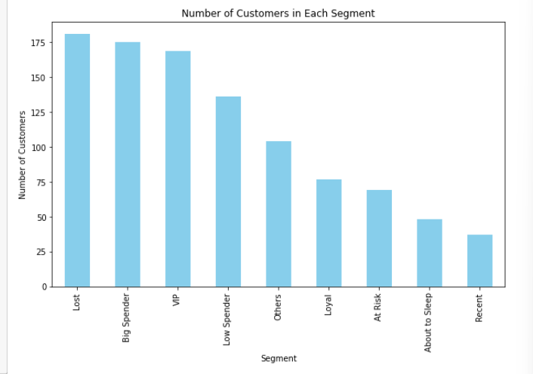

The resulting bar chart helps businesses quickly assess the distribution of their customer base. For instance, segments with a high number of customers, such as "Lost" or "Big Spender," can be targeted with specific retention or promotional strategies, while segments with fewer customers, like "Recent" or "Loyal," may require further analysis to improve engagement.

**Customer Cohorts and Segment Distribution**

Cohort analysis is used to group customers based on their recent activity (Recency). Customers are divided into cohorts based on how many days have passed since their last purchase.

Cohort Binning Logic:

Customers are divided into cohorts using pd.cut() function, with bins for recency, These bins represent different levels of recency.

<30 Days, 30-90 Days, 90-180 Days, 180-365 Days, >365 Days

A heatmap is generated using seaborn.heatmap(), color-coding the customer counts across cohorts and segments, providing a visual understanding of customer distribution. This helps businesses understand how customer engagement changes over time.

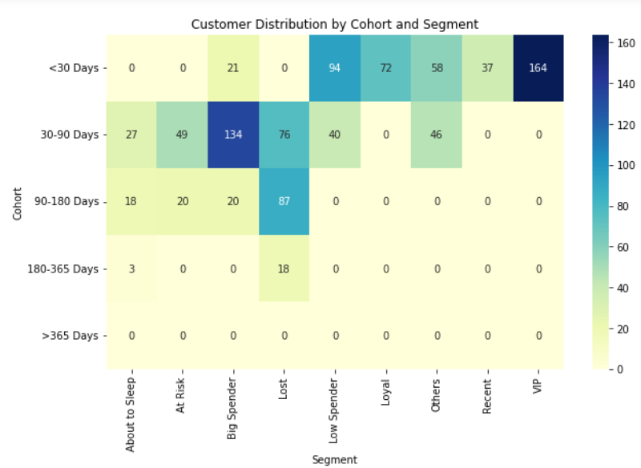

The plot shows that many customers in the "VIP" or "Big Spender" segments belong to the <30 Days cohort, indicating frequent and high-value transactions. Conversely, the "Lost" segment might be more prevalent in the >365 Days cohort, highlighting customers who have not interacted with the business in a long time.

By analyzing the distribution across cohorts, businesses can tailor marketing strategies to re-engage at-risk or lost customers, while also nurturing high-value customers.

**Visualization of the distribution of customers based on Frequency and Monetary**

The frequency histogram shows the number of customers who made a certain number of purchases, and the monetary histogram shows the number of customers who have spent certain total amounts.

The range of values is divided into 20 bins. Each bin represents a range of frequency and monetary values, and the height of the bar represents the number of customers whose frequency falls within that range.

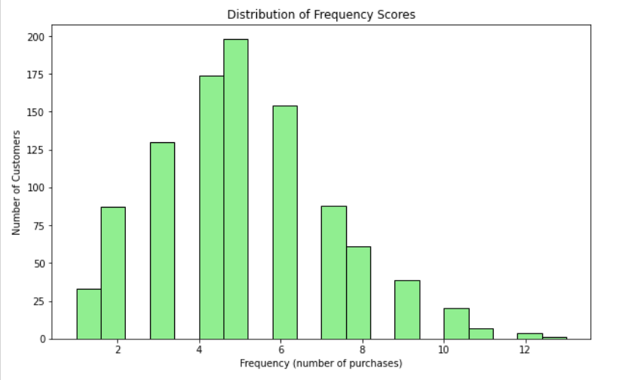

The histogram provides insight into how frequently customers make purchases. Typically, you will see that a large number of customers have made fewer purchases, with a tapering off as the frequency increases. This information helps to identify whether the majority of the customer base consists of repeat buyers or one-time purchasers.

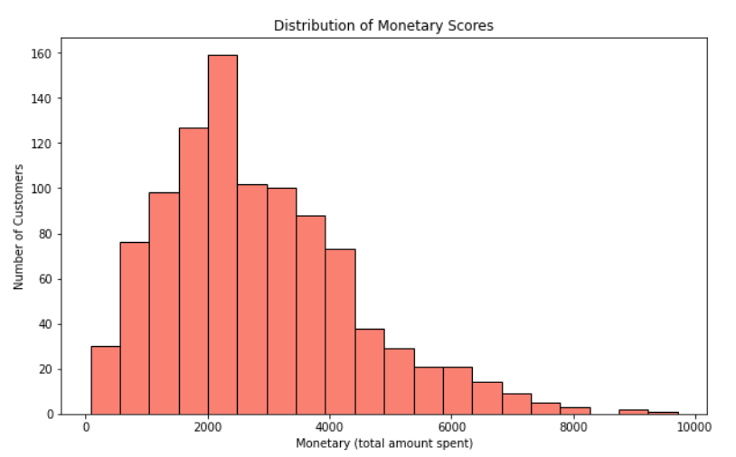

The monetary histogram helps identify how much money customers spend over time. This distribution often shows that most customers spend within a particular range, and only a few customers may be contributing to significantly higher revenues.

**ROC Curve and AUC Analysis**

The ROC Curve (Receiver Operating Characteristic) and AUC (Area Under the Curve) are critical tools for evaluating the performance of binary classification models. In the context of RFM (Recency, Frequency, Monetary) analysis, these metrics help predict customer behaviors like churn and loyalty by assessing the model’s ability to classify customers effectively.

RFM scores (Recency, Frequency, Monetary) are calculated for each customer, along with additional behavioral data (e.g., login counts, time spent on the website).

These serve as features for a binary classification model to predict customer churn or loyalty.

* ROC Curve: Plot showing the performance of a binary classifier.
* AUC: Represents the model's ability to distinguish between classes.

Plot summary:

* The X-axis represents the False Positive Rate (FPR), which measures the proportion of incorrectly classified negatives.
* The Y-axis represents the True Positive Rate (TPR), measuring the proportion of correctly classified positives.
* A diagonal line (dashed) represents a random classifier with AUC = 0.5, while a model that curves towards the top-left corner represents a good classifier.
* The AUC (Area Under the Curve) score of 0.95 suggests that the model is very effective at differentiating between the positive and negative classes.

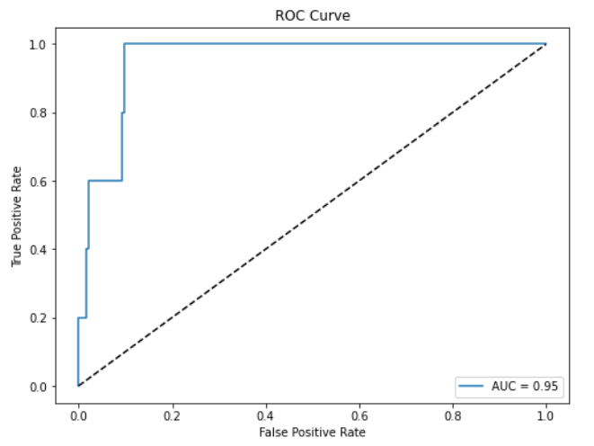

ROC Curve and AUC are invaluable for evaluating how well RFM and behavioral data predict customer behaviours such as churn or loyalty, helping businesses refine their strategies.

1. K-Means and DBSCAN Clustering
   1. Merging RFM and Behavioral DataFrames

The first step involves merging two datasets—RFM data and behavioral data—on a common column. This step combines customers’ purchasing behaviors with additional behavioral metrics like login counts, time spent on the website, and pages visited using a function pd.merge(). Merging these datasets allows for a more comprehensive understanding of customer activity.

* 1. Feature Selection:

The next step selects relevant features for clustering analysis. The selected features include both RFM metrics (Recency, Frequency, Monetary) and behavioral data such as total_login_count, pages_visited, and time_spent_on_site. These features represent customer behaviors and spending habits.

* 1. Standardizing the Features:

Since the features have different scales, standardization is performed using StandardScaler to normalize the feature values to have a mean of 0 and a standard deviation of 1. This ensures that no single feature dominates the clustering process due to scale differences.

Function Used: StandardScaler()

Formula: Xscaled = (X−μ)/ σ

Where μ is the mean and σ is the standard deviation.

* 1. Dimensionality Reduction Using PCA:

Principal Component Analysis (PCA) is applied to reduce the dimensionality of the feature space to two components. Reducing the dimensions simplifies the clustering process and helps visualize the data in a 2D space without losing much information.

Function Used: PCA(n_components=2)

Formula: PCA works by projecting the data onto new axes (principal components) that maximize variance, essentially capturing the most informative dimensions.

* 1. Elbow Method for Optimal k:

The Elbow Method is used to determine the optimal number of clusters, k, for K-Means clustering. Inertia is calculated for different values of k and plotted to visualize the "elbow" point, which represents the optimal number of clusters. This is done using a function KMeans() with kmeans.inertia_. After determining the optimal number of clusters, each customer is assigned to a cluster based on proximity to the nearest centroid.

* 1. Visualizing Clusters After PCA:

The clustered data is visualized in 2D using the two principal components. Each point represents a customer, and the color corresponds to the cluster assignment.

#Cluster Visualization

* 1. Cluster Summary Statistics:

The mean values of important features like Recency, Frequency, and Monetary are calculated for each cluster to summarize the behavior of customers in different clusters. These insights can be used for targeted marketing strategies.

#summary stats

* 1. Valuation of Clustering Quality:

Two metrics are used to evaluate the quality of the clustering:

Silhouette Score: Measures how well-separated the clusters are, with higher scores indicating better-defined clusters.

Davies-Bouldin Index: Measures the average similarity ratio of each cluster with the cluster that is most similar to it, where lower values indicate better clustering.

* 1. DBSCAN Clustering:

Density-Based Spatial Clustering of Applications with Noise (DBSCAN) is applied to detect outliers (noisy points) and dense clusters. Unlike K-Means, DBSCAN does not require the number of clusters to be specified and can detect arbitrarily shaped clusters. It also identifies outliers, which are labeled as "-1".

Function Used: DBSCAN(eps=0.25, min_samples=5)

* Formula: DBSCAN forms clusters based on a core point with at least min_samples points within an eps radius.

#DBSCAN viiz

**Outlier Detection with DBSCAN**: DBSCAN is particularly effective for detecting outliers in customer data. Customers who fall outside the core clusters (labeled as -1 by DBSCAN) are identified as potential outliers. These customers may represent anomalies in purchasing behavior.

#outlier viz

1. **Silhouette Score and Davies-Bouldin Index for DBSCAN**:

The quality of DBSCAN clustering is also evaluated using the silhouette score and Davies-Bouldin index, focusing only on non-noise points. If there are sufficient non-noise clusters, these metrics provide insights into how well DBSCAN performed in separating dense clusters.

1. **High-Value Customer Visualization**:

High-value customers are visualized within the clustering space, with additional attention given to those identified by both K-Means and DBSCAN. This allows for a deeper understanding of how high-value customers differ from the general customer base.

**#High-Value Customer Visualization**