farmer Banking and loan database

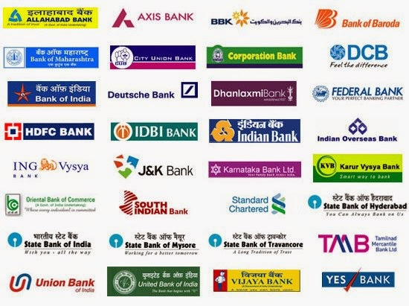

*By:*

*Deon Victor Lobo (4NM17CS054)*

*Joyston Meneses (4NM17CS074)*

*15th September 2019*

*5th Semester CSE (Section-B)*

A Synopsis of the above Management System

Schema Diagram:

|  |  |  |  |  |  |
| --- | --- | --- | --- | --- | --- |
| **BranchID** | **BankID** | **BranchName** | **BranchCity** | **IFSC** | **MICR** |

**BRANCH**

|  |  |  |
| --- | --- | --- |
| **BankID** | **BankName** | **Headquarters** |

**BAnk**

|  |  |  |  |  |
| --- | --- | --- | --- | --- |
| **AccNo** | **BranchID** | **Balance** | **Interest** | **AccountType** |

**ACCOUNT**

|  |  |  |  |  |
| --- | --- | --- | --- | --- |
| **FarmerID** | **FName** | **PAN** | **AadharNo** | **Address** |

**FaRMER**

|  |  |
| --- | --- |
| **FarmerID** | **AccNo** |

**DEPOSITOR**

|  |  |  |  |  |  |  |
| --- | --- | --- | --- | --- | --- | --- |
| **LoanID** | **BankID** | **LoanType** | **Margin** | **Repayment_Period** | **LoanInterest** | **InterestPeriod** |

**BORROW**

**CROP_LOAN**

|  |  |  |  |  |
| --- | --- | --- | --- | --- |
| **LoanNo** | **AccNo** | **LoanID** | **Amount** | **LoanDate** |

|  |  |  |  |  |
| --- | --- | --- | --- | --- |
| **LoanNo** | **AccNo** | **LoanID** | **Amount** | **Loan_Date** |

**Tractor_loan**

|  |  |  |  |  |
| --- | --- | --- | --- | --- |
| **LoanNo** | **AccNo** | **LoanID** | **Amount** | **Loan_Date** |

**Drip_irrigation_Loan**

|  |  |  |  |  |  |
| --- | --- | --- | --- | --- | --- |
| **LoanNo** | **AccNo** | **LoanID** | **Amount** | **Loan_Date** | **Purpose** |

**Diary_Loan**

|  |  |  |  |  |
| --- | --- | --- | --- | --- |
| **LoanNo** | **AccNo** | **LoanID** | **Amount** | **Loan_Date** |

**PoultRy_loan**

|  |  |  |  |  |
| --- | --- | --- | --- | --- |
| **LoanNo** | **AccNo** | **LoanID** | **Amount** | **Loan_Date** |

**fisheries_loan**

Synopsis of the schema:

Here we have created a Banking system designed particularly for Farmers .Each farmer will be associated with an account created in a particular bank . The bank may have any number of branches. The BORROW table contains the types of loans provided by different banks and its details like the repayment period and the interest. The farmer can avail any loan provided by the bank based on his requirement. The tables CROP_LOAN,TRACTOR_LOAN,DRIP_IRRIGATION_LOAN,DIARY_LOAN, POULTRY_LOAN and FISHERIES_LOAN contains the principle loan amount taken by the farmer and keeps track of the loan date , loan repaid and the interest applied on the amount annually.

ER -Diagram:

1

BANK

BELONGS_TO

N

ACCOUNT_ BRANCH

N

BRANCH

ACCOUNT

1

N

LOAN_ BRANCH

DEPOSITOR

N

CROP_LOAN

1

1

1

1

1

N

N

N

N

N

1

1

Borrow

TRACTOR_LOAN

DRIP_IRRIGATION_LOAN

DIARY_LOAN

POULTRY  
_LOAN

FISHERIES_ LOAN

FARMER

Software Requirements:

1. Wampserver
2. JetBrains DataGrip (BackEnd Application)
3. Microsoft Visual Studio Code (FrontEnd Application)

Expected outcomes:

At the end of this project we will be creating a system which will produce the following results:

1. Keeping track of the farmers bank account .
2. Updating the account based on the transactions made.
3. Allowing the farmer to avail the loans based on requirement.
4. The farmer will be able to avail more than one loan and the loan can be provided by any bank.
5. After a particular period interest will be applied on the principle amount and the principle amount is increased.
6. It will also display the accounts which have exceeded their repayment period.
7. The front end will make it easy for the farmer to choose the best loan between different loans provided by different banks .
8. Using this system the government can keep track of the farmers who are in debt and provide assistance accordingly .