1. Creating and Renaming Files/Directories
Create a directory named test_dir using mkdir.
Inside test_dir, create an empty file called example.txt.
Rename example.txt to renamed_example.txt using mv

mkdir test_dir
cd test_dir
touch example.txt
mv example.txt renamed _example.txt
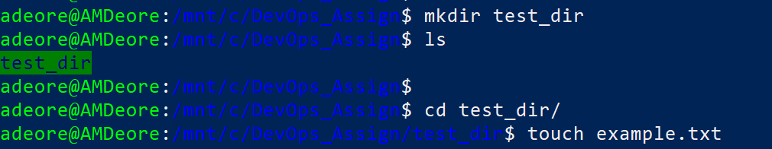
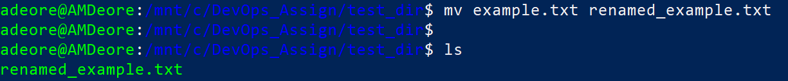

2. Viewing File Contents
Use cat to display the contents of /etc/passwd.
Display only the first 5 lines of /etc/passwd using head.
Display only the last 5 lines of /etc/passwd using tail.

cat /etc/passwd
cat /etc/passwd | head -5
tail -5f /etc/passwd

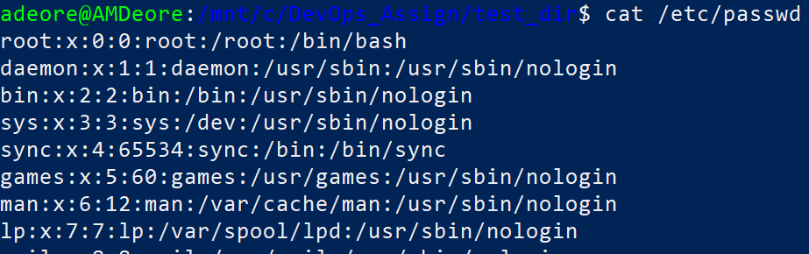

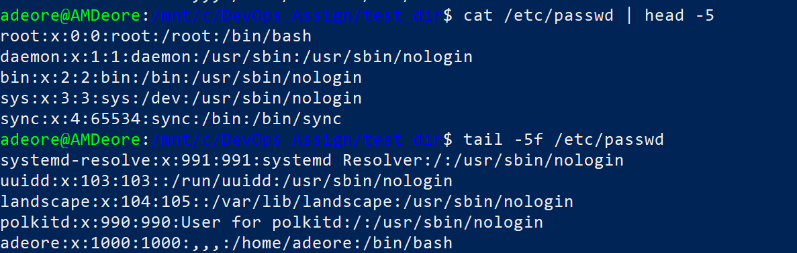

3.Searching for Patterns
Use grep to find all lines containing the word "root" in /etc/passwd.

grep “root” /etc/passwd

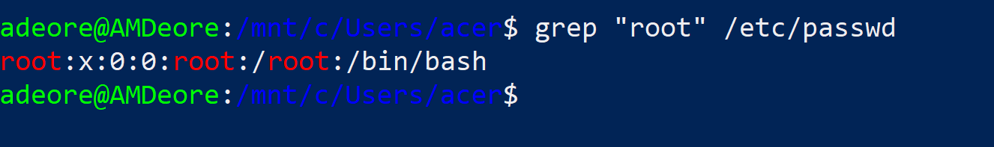

4. Zipping and Unzipping
Compress the test_dir directory into a file named test_dir.zip using zip.
Unzip test_dir.zip into a new directory named unzipped_dir.

zip -r test_dir.zip test_dir
unzip test_dir.zip -d unzipped_dir

5. Downloading Files
Use wget to download a file from a URL (e.g., https://exampl e.com/sample.txt).
wget https://github.com/deoreamol54-ghub/AMD_docs.git
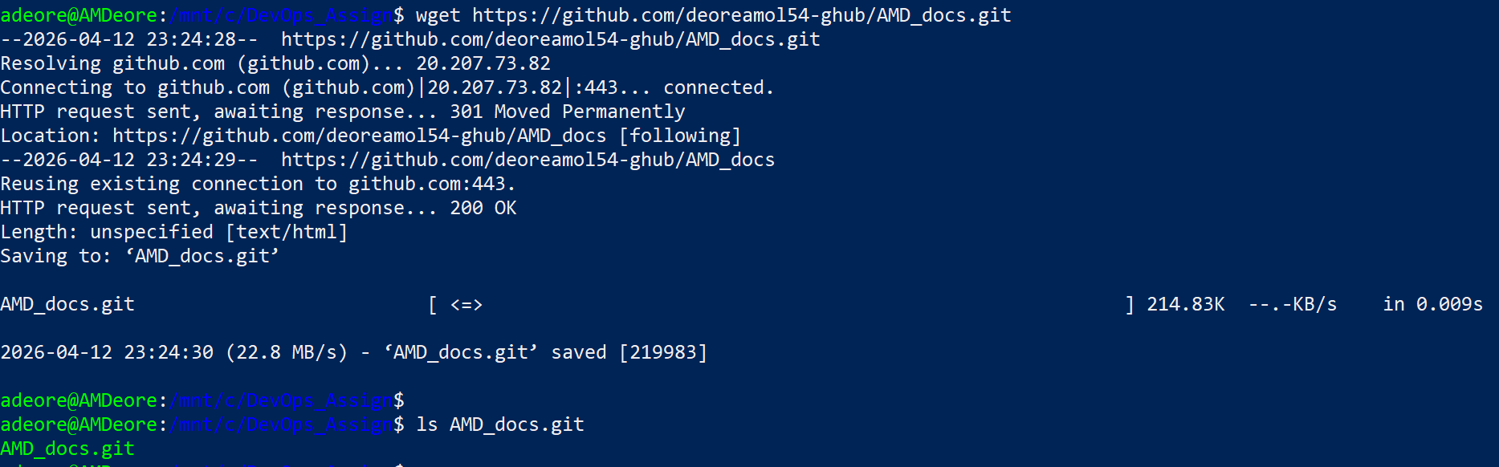

6. Changing Permissions
Create a file named secure.txt and change its permissions to read-only for everyone using chmod.
chmod 444 secure.txt

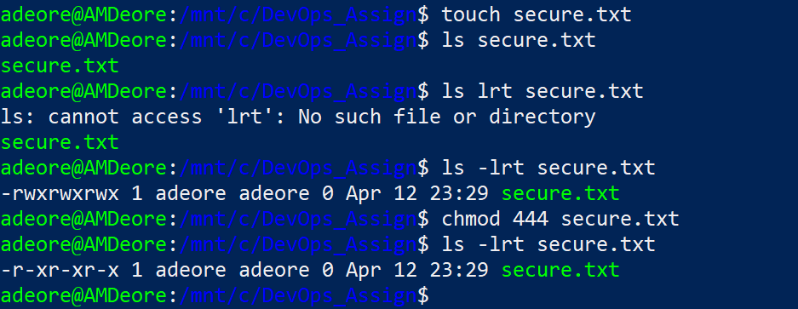

7. Working with Environment Variables
Use export to set a new environment variable called MY_VAR with the value "Hello, Linux!".

Export MY_VAR=”Hello, Linux!”
Echo $MY_VAR
