You are required to deploy a Flask backend and an Express frontend application using AWS and Terraform. Follow the steps below to deploy the applications in different configurations.

All below three project inside this git hub url:
AMD_docs/terraform_all at main · deoreamol54-ghub/AMD_docs

Part 1: Deploy Both Flask and Express on a Single EC2 Instance
Git url for project1: AMD_docs/terraform_all/tf_app1 at main · deoreamol54-ghub/AMD_docs

Objective: Deploy both the Flask backend and the Express frontend on a single EC2 instance using Terraform.
  - Provision the EC2 instance with Terraform.
  - Configure the instance with:
    - A user data script or a configuration management tool (e.g., Ansible or Cloud-Init) to install dependencies (Python, Node.js).
    - Scripts to start the Flask backend and the Express frontend.
  - Ensure both applications are running on different ports (e.g., Flask on port 5000 and Express on port 3000).
- Expected Deliverables:
  - Terraform configuration files (main.tf, variables.tf, etc.).
  - A working EC2 instance with Flask and Express running and accessible via the instance's public IP.
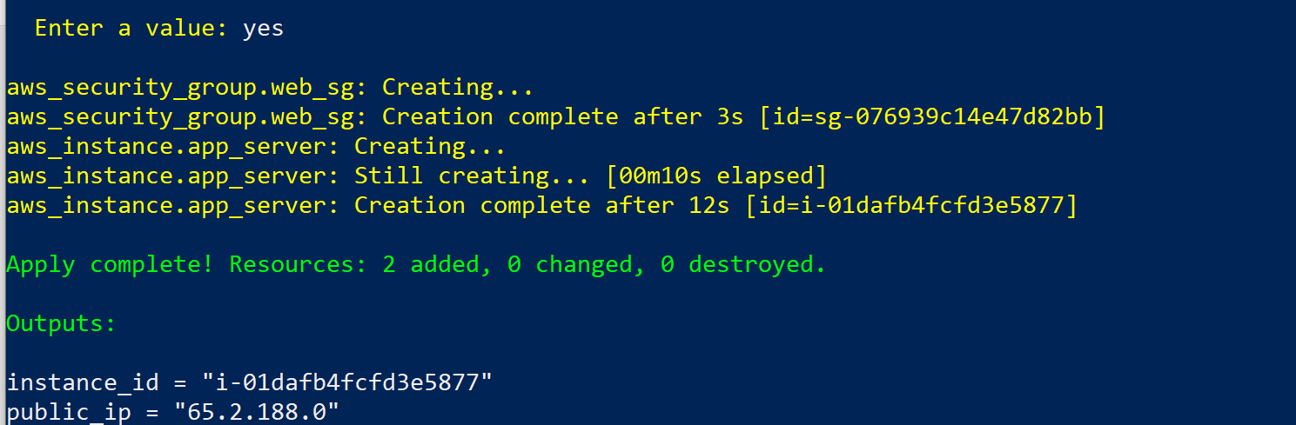

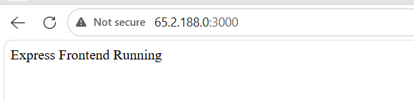
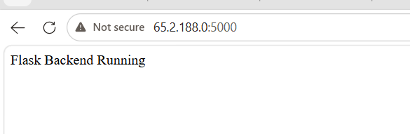

Part 2: Deploy Flask and Express on Separate EC2 Instances
Git url for project2: AMD_docs/terraform_all/tf_app2 at main · deoreamol54-ghub/AMD_docs
- Objective: Deploy the Flask backend and the Express frontend on two separate EC2 instances using Terraform.
  - Provision two EC2 instances using Terraform:
    - One for the Flask backend.
    - One for the Express frontend.
  - Configure security groups to:
    - Allow communication between the two instances.
    - Expose both applications to the internet on their respective ports.
- Configuration:
  - Use Terraform to define networking resources, such as VPC, subnets, and security groups.
  - Use user data scripts to automate the installation and startup of both applications.
- Expected Deliverables:
  - Terraform configuration files.
  - Two working EC2 instances: one running Flask and one running Express.
  - Security groups configured to allow proper communication and public access.

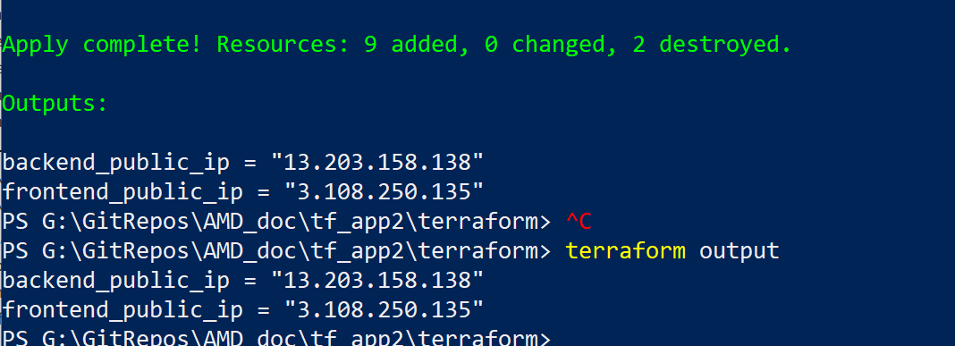

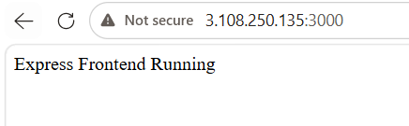
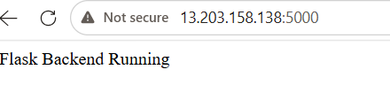

Part 3: Deploy Flask and Express Using Docker and AWS Services
Git url for project3: AMD_docs/terraform_all/tf_app3 at main · deoreamol54-ghub/AMD_docs
- Objective: Deploy Flask and Express as Docker containers using AWS ECR, ECS, and VPC with Terraform.
- Steps:
  - ECR:
    - Use Terraform to create two Elastic Container Registry (ECR) repositories: one for the Flask backend and one for the Express frontend.
    - Build Docker images for both applications and push them to their respective ECR repositories.
  - VPC:
    - Use Terraform to create a VPC with subnets, route tables, and security groups.
  - ECS:
    - Use Terraform to set up an ECS cluster.
    - Create two ECS services:
      - One for the Flask backend.
      - One for the Express frontend.
    - Use ECS Fargate or EC2 launch type to deploy the containers.
  - Load Balancer:
    - Use Terraform to provision an Application Load Balancer (ALB).
    - Configure ALB listeners to route requests to the appropriate ECS service.
- Expected Deliverables:
  - Terraform configuration files for ECR, ECS, VPC, and ALB setup.
  - Docker images pushed to ECR.
  - ECS services running and accessible via the ALB.
